FUTURES THINKING TOOLKIT

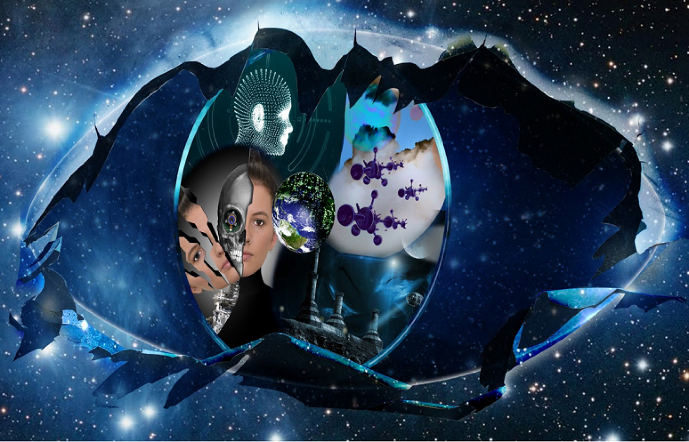

What are your ideas about the future? What decisions would you make and why?

Explore your ideas. Delve more deeply. Work out what you think and why.

Here are some topics to think about or you could create your own.

Thinking about:

- future foods
- future fuels
- future medical care

Using the Futures thinking toolkit

The futures thinking toolkit is designed to be adapted to suit the topic or issue that your students are exploring. For example, you can use the toolkit to help students develop scenarios related to future foods, future fuels or future medical care – or you can customise the prompts to suit a different topic or issue.

Students in the early stages of thinking about the future may tend to focus on the future as it affects them – that is, personally and locally. As their thinking becomes more advanced, this may extend to national and global trends and drivers.

- Explore with your students how advances in technology and science have changed how we live now compared with how our grandparents and great grandparents lived – positive and negative.

- Use the futures thinking image to prompt and shift thinking from a ‘more of the same – normalised future’ to a ‘futuristic thinking – using your imagination’ way of thinking. Use the following as discussion starters. What might the images represent? What images would you prefer to see as a projection of the future? What is missing or not represented?
- How will changes in technology impact our lives in the future and the lives of future generations?
- What role/s do we as citizens have in the future? Will we be part of the production of new innovations?
- Will we be the drivers or the users of new innovations – or both? What values may guide us in how new innovations and technology are funded, created and used?

- Watch trailers of movies with a futuristic theme and discuss elements as they are portrayed in the movie (optional).

- Download the toolkit in word and modify the question prompts as appropriate. You can also remove some of the columns. The worksheet is designed to be printable on A3 sheets of paper.

Note: Before students proceed with this activity, we recommend that you explore the issue and the purpose of futures thinking to establish a foundation for informed decision making. It’s also important to establish a classroom environment that supports students in sharing their perspectives and listening to others with respect so students feel supported and able to openly evaluate ideas, weigh up evidence, detect bias and justify their decisions.

For more ideas, see Teaching futures thinking.

THINKING ABOUT FUTURE FOODS: Identify changes in eating habits over time and explore what might happen in the future.
Existing situation: What types of foods are eaten and why?
Individual | Local | National | Global
Trends: What differences are there between the food eaten now and the food our parents ate when they were young?
Individual | Local | National | Global
Drivers: What has caused the changes in the types of foods people eat?
Individual | Local | National | Global
Possible futures: What foods might be available in the future? Why?
Individual | Local | National | Global
Wild cards: For example, what would happen if we could not grow our own food?
Individual | Local | National | Global
Preferable futures: What foods do you think should be available in the future?
Individual | Local | National | Global
THINKING ABOUT FUTURE FUELS: Identify changes in energy supply over time and explore what might happen in the future.
Existing situation: What is electricity used for? What natural resources are used to generate this electricity?
Individual | Local | National | Global
Trends: How has the use of electricity changed over time? What changes have occurred in availability of electricity and how it is generated?
Individual | Local | National | Global
Drivers: What has caused the changes in electricity use and generation?
Individual | Local | National | Global
Possible futures: How important will electricity be in the future? What will be used to generate the electricity?
Individual | Local | National | Global
Wild cards: For example, what could happen that would drastically change how electricity is used and/or generated?
Individual | Local | National | Global
Preferable futures: What do you want your future to look like in terms of electricity availability and use?
Individual | Local | National | Global

THINKING ABOUT FUTURE MEDICAL CARE: Identify changes in medical care over time and explore what might happen in the future.
Existing situation: What medical care do you have access to should you need it?
Individual | Local | National | Global
Trends: What changes have occurred in medical care over time?
Individual | Local | National | Global
Drivers: What has been behind the changes in medical care?
Individual | Local | National | Global
Possible futures: What medical care might be available in the future? Who will have access to it?
Individual | Local | National | Global
Wild cards: For example, what could happen that would drastically change what medical care is available, and who has access to it?
Individual | Local | National | Global
Preferable futures: What medical care do you think should be available in the future?
Individual | Local | National | Global
THINKING ABOUT FUTURE ...........………….:
Existing situation:
Individual | Local | National | Global
Trends:
Individual | Local | National | Global
Drivers:
Individual | Local | National | Global
Possible futures:
Individual | Local | National | Global
Wild cards:
Individual | Local | National | Global
Preferable futures:
Individual | Local | National | Global

