ACTIVITY: Naming the whetū in te kāhui o Matariki

Activity idea

In this activity, students use online and/or paper-based resources to identify and label the nine whetū of Matariki and learn about their associations with wellbeing and the environment.

By the end of this activity, students should be able to:
- identify the name and location of each star in the Matariki star cluster
- recognise te ao Māori association and/or significance of each star with an aspect of wellbeing and the environment.
- consider te ao Māori in the placement of the stars within the cluster.
- develop observation skills
- practise comparing and interpreting representations.

For teachers

Introduction/background

Matariki is the name for a cluster of stars, and it also signals the start of the Māori new year. In te ao Māori, it is a time to celebrate new life, remember those who have died and make plans for the future. The star cluster is visible for most of the year but disappears from view in April/May before reappearing in June/July. Māori use Matariki and maramataka as guides for harvesting, planting, fishing and hunting.

Star clusters – tātai whetū

Matariki is a star cluster – a group of stars that are connected (held together) by gravity. The whetū in Matariki came from the same cloud of dust about 100 million years ago. There are about a thousand stars in Matariki, but only nine are visible without the use of a powerful telescope. This is different to a constellation. A constellation is a group of stars that appear to be close together in an imaginary outline or pattern but they may actually be really far apart. Māhutonga/Southern Cross is an example of a constellation.

The individual whetū in Matariki

Each star has an association with wellbeing and the environment. Tūpuna (ancestors) would read the stars – study their visibility – to foretell the coming weather and how it would affect food sources. If one of the whetū was brighter than the others, the food resources (or weather) associated with that whetū would be more abundant or favourable. If the whetū was dim or hard to see, the opposite would happen.

The positions of the whetū within the cluster are meaningful. For example:
- Waipuna-ā-rangi and Ururangi are above the other whetū because they represent the rain and the wind
- Waitī is above Waitā because freshwater flows down to the ocean
- Tupu-ā-rangi is above Tupu-ā-nuku because the sky (food from up high) is above the Earth (food that grows in the ground).

Naming Matariki

Use the interactive Te iwa o Matariki or the paper version in the student handout to name the nine stars of Matariki. Use some of the questions below to deepen student understanding, encourage discussion and develop student ideas.

This is just a taste of information about the whetū in Matariki. Explore further with the Hub articles Matariki star cluster and tātai arorangi (astronomical knowledge). Refer to the Useful links section for other resources.

Please note that the stories of Matariki differ between different iwi and hapū groups and so does the spelling of the stars’ names. Note that some spellings use hyphens and others do not. The student handout is in Word. Please edit the document to suit your situation.

Questions to deepen student understanding

The following questions may be helpful to deepen student understanding and engagement when working with the interactive Te iwa o Matariki.

- Look at the image Matariki (Pleiades) star cluster.
- What do you observe in this image?
- When you look at the night sky, is this what you see? Why might your view or observations be different?
- Why do you think the stars appear to be blue in the image? (Blue stars are the hottest type of star.)
- Do you observe different coloured stars when you look at the night sky?

- View the images of Matariki (Pleiades) star cluster and Te kāhui o Matariki.
- How does each image represent the star cluster?
- Why do you think each image is presented in the particular way it is – for example, a photo and a graphic image?
- Are you able to match the stars in the photo with their representations in the graphic image?
- How do the images help with your understanding of Matariki as a star cluster and as a meaningful tohu and event in te ao Māori?

- Review the names of the whetū and their associations with wellbeing and the environment.
- How and why do you think wellbeing is connected with the environment?
- What is the significance of the placement of the whetū within the cluster?
- When the whetū appeared bright and clear, the predictions were for warmer growing seasons and abundant harvests. Why do you think this is so?
- Do our present-day methods of growing/harvesting food from the land and the water alter the significance of these predictions? Why or why not?
- How might climate change impact these tohu and predictions?

Te kāhui o Matariki – answers
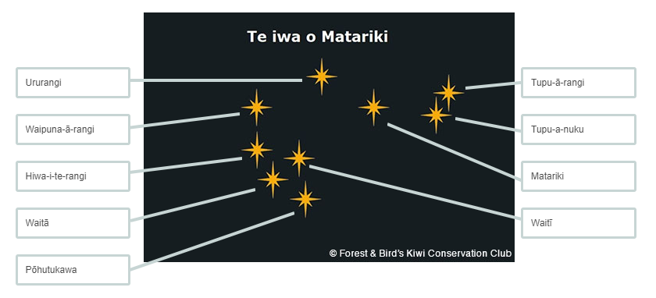

For students

There are nine visible whetū (stars) in the Matariki star cluster. In te ao Māori, each of the whetū is associated with an aspect of wellbeing and the environment. This image contains visualisations of each association.

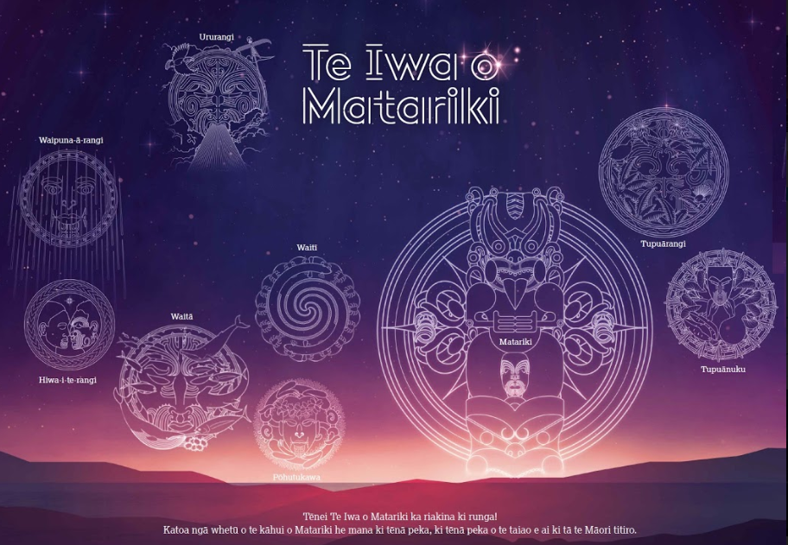

Matariki is the carer to the other eight whetū and is connected to people’s health and wellbeing. This whetū signifies hope, reflection, our connection to the environment and our gatherings as friends and family.

Pōhutukawa is the oldest whetū and is associated with those who have passed on.

Waitī is associated with freshwater bodies (pūkaki, roto, awa, repo) and the foods sustained by these waters.

Waitā is associated with the ocean (moana) and the food sources that come from it.

Waipuna-ā-rangi is associated with rainfall.

Tupu-ā-nuku is associated with food that is gathered or harvested from the soil (oneone).

Tupu-ā-rangi is associated with things that grow in the trees, including fruits, berries and birds.

Ururangi is associated with the winds.

Hiwa-i-te-rangi is the youngest whetū and is associated with the granting of wishes and helping us attain our goals in the coming year.

