ACTIVITY: Te Kāhui o Matariki – interpreting infographics

Activity idea

In this activity, students observe and interpret infographics from the Ministry for the Environment and Stats NZ’s Environment Aotearoa 2022 report. The activity includes probing questions to help students understand the ways in which infographics present information.

By the end of this activity, students should be able to:
- develop literacy skills for interpreting the information in an infographic
- discuss the purpose of an infographic
- discuss how an infographic gets the message across
- discuss information they have gathered from an infographic of interest to them.

For teachers

Introduction/background

Science knowledge is often communicated through visual representations – graphs, diagrams and infographics. Each type of visual representation has literacy components that students may need support to understand. The science capability ‘Interpret representations’ encourages students to think about how data is presented, what the representation tells us and how it gets the message across.

Tables and graphs present data in an organised manner. Interpreting information from these types of visual representations requires the reader to draw a conclusion from the data. Infographics also provide visual representations of data but they are designed to tell a story or guide the reader to a particular conclusion.

Infographics contain three components – the visual component, the content component and the knowledge component. The visual component includes things like graphics, colour, font and layout. The content component features information – for example, text, figures, lists and statistics. The knowledge component is the insight that comes from the information. Learn more about infographics in the article Understanding infographics.

An example of how visual and content components are used in an infographic

The infographic Waitā and our marine environment uses visual and content components to effectively communicate information about its two subthemes, which are:
- our wellbeing and connections to the marine environment
- the pressures we place on marine ecosystems.

Visual components include:
- images and actions associated with wellbeing are primarily pictured in blue
- images and actions associated with pressures are primarily pictured in grey
- the river connects pressures associated with land use
- a red horizon line denotes threats not immediately associated with land use
- colour in the circle (lower right-hand corner) represents degradation and loss such as:
  - pollutants in the fish
  - pāua shell reduced in size
  - bleached sponge
  - loss of fish species represented by outlines rather than images.

Content components include:
- text that provides succinct background information
- content vocabulary.

Interpreting infographics

Use the questions that follow to deepen student understanding of one or more of the Environment Aotearoa 2022 infographics. The infographics are found in the student handout Infographics from Environment Aotearoa 2022 or can be downloaded as PDFs:
- Te Kāhui o Matariki
- Pōhutukawa – reflecting on our environmental actions
- Tupuārangi and Tupuānuku – reflecting on the whenua and biodiversity
- Waitī – freshwater environments
- Waitā and our marine environment
- Ururangi and Waipunarangi – reflecting on our atmosphere and climate
Questions to deepen student understanding
Use the following questions to support students to develop literacy skills when interpreting infographics.
1. Generic questions for all infographics:
- Who created the infographic?
- Who is the intended audience?
- Infographics have a central theme – what is this infographic trying to communicate?
- Are there subthemes within the infographic?
- Does the infographic show relationships or connections between the subthemes? How does it do this? (For example, through arrows, colour or repeated graphics/images.)
- What is the infographic communicating – general information, statistics, comparisons, processes or something else?
- Is there a starting point for reading the infographic?
- Does the infographic have a specific pathway that you need to follow? (For example, top to bottom, left to right as when reading text.)
- Does this affect the message?
- How is colour used to present information?
- How do the graphics present information?
- What makes the message credible?
- What might have been left out?
- What other information might you need to understand the infographic?
- Where can you find the information that might fill in these gaps?

2. Questions for the infographics from Environment Aotearoa 2022:
- How do the graphics help to place these infographics within an Aotearoa New Zealand context?
- What is the significance of the graphics of the whetū?
- What is the significance of the graphics of the environmental domain?
- Why does water feature in each of the infographics?
- Why do you think some of the information is isolated in a circle instead of being part of the larger graphic?
- What knowledge components/insights have you gained from viewing the infographic?
- Where can you find the information that might fill in these gaps? (This introductory article has links to articles about each of the whetū/environmental domains in Te Kāhui o Matariki).

Extension idea

The activity Using infographics includes a simple framework for creating an infographic. Students can use this framework to create an infographic about an environmental issue of interest to them.
For students

Infographics from Environment Aotearoa 2022

Te Kāhui o Matariki

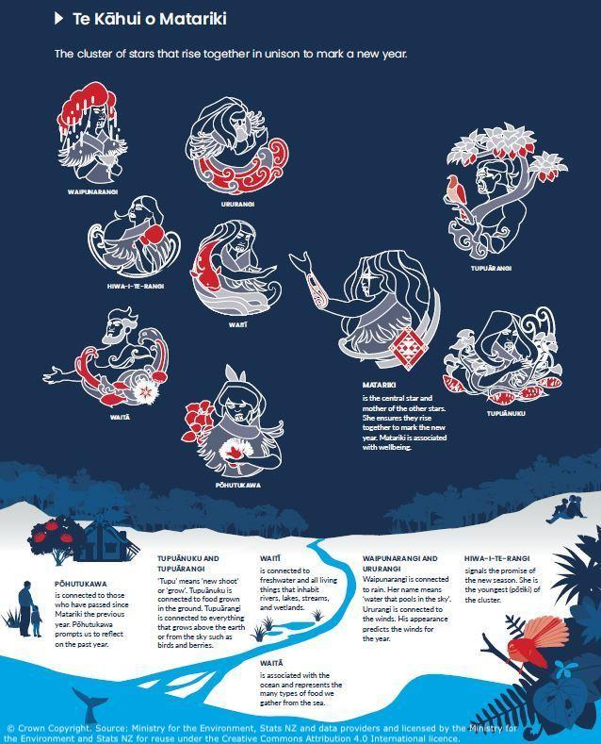

Pōhutukawa – reflecting on our environmental actions
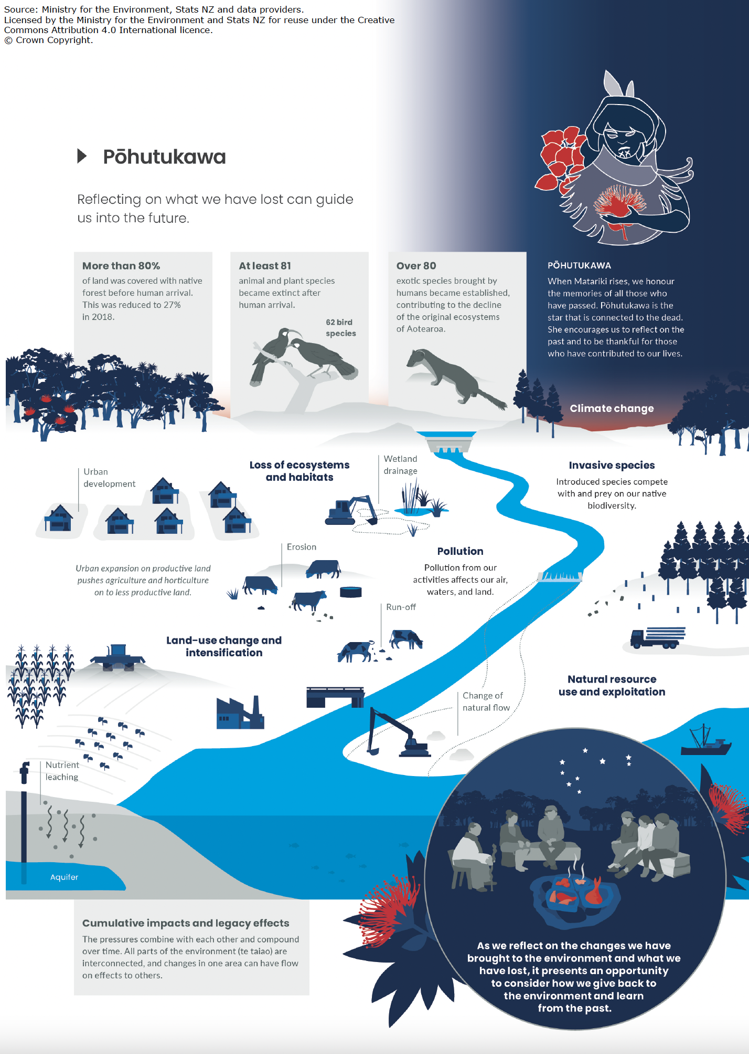
Tupuārangi and Tupuānuku – reflecting on the whenua and biodiversity

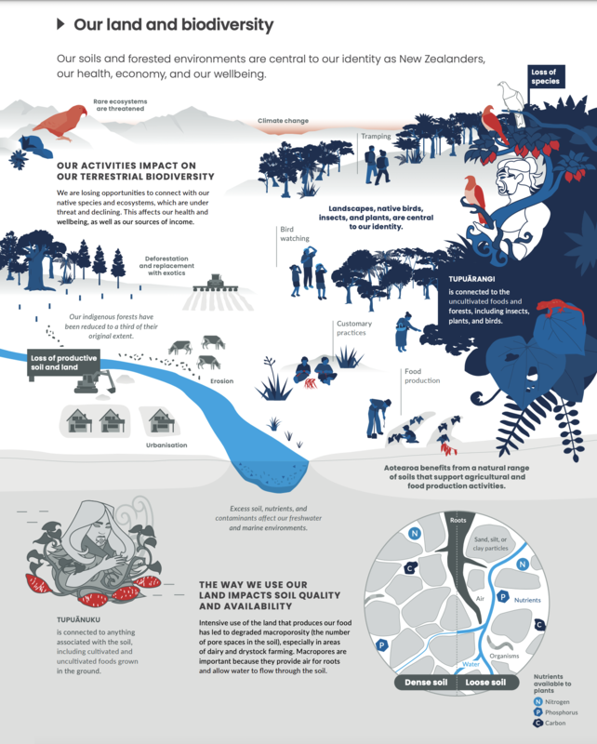
Waitī – freshwater environments

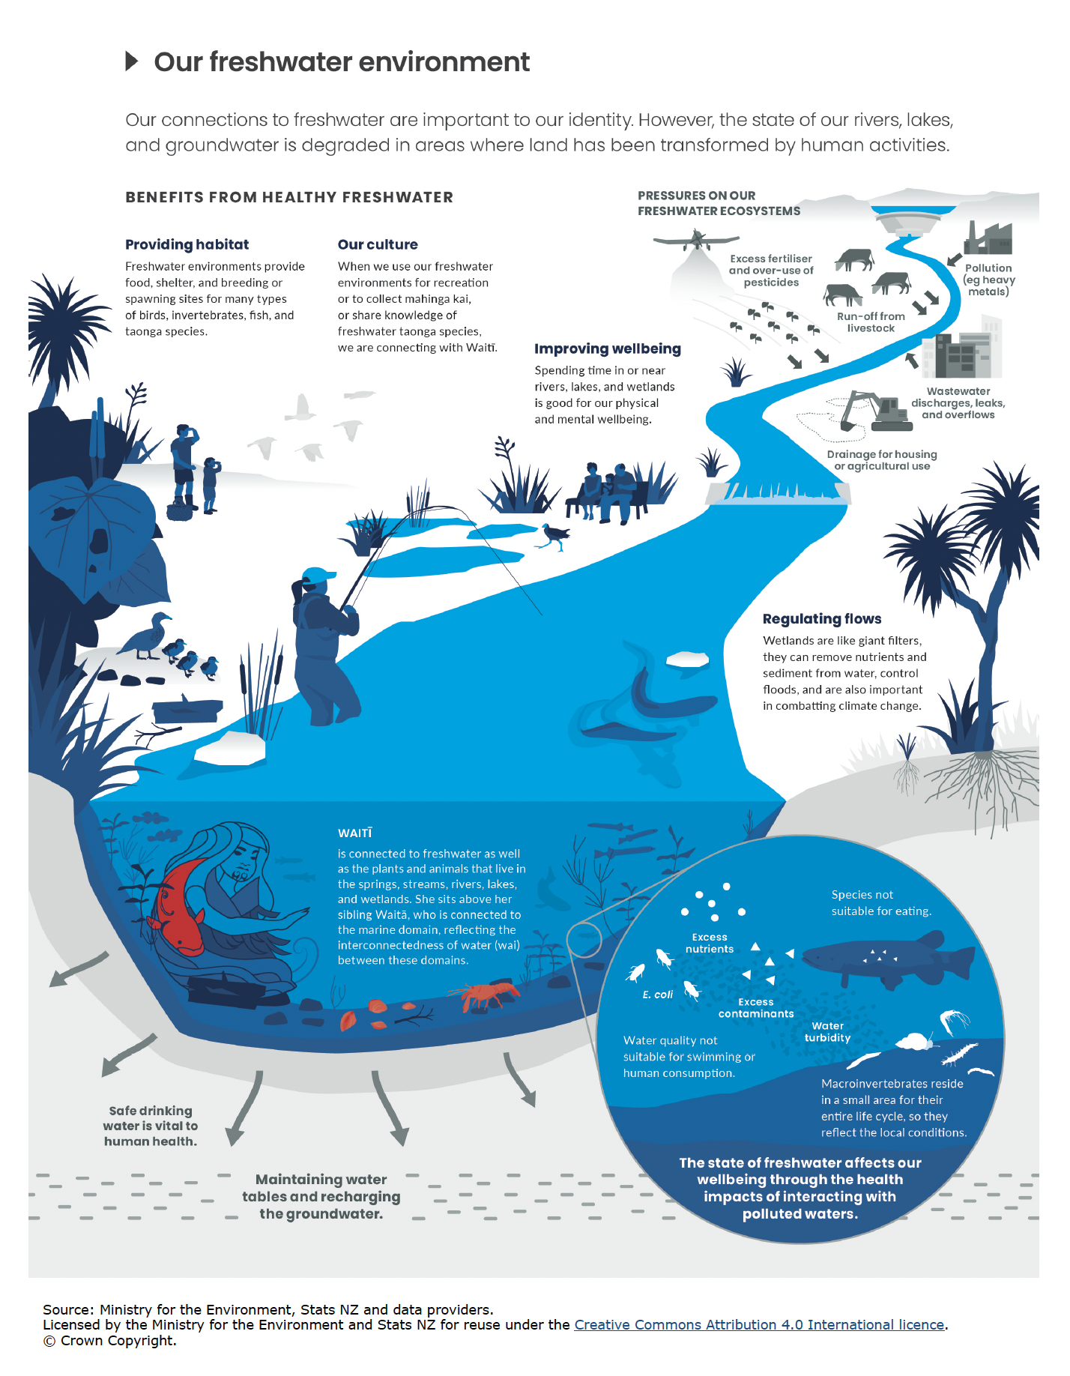
Waitā and our marine environment

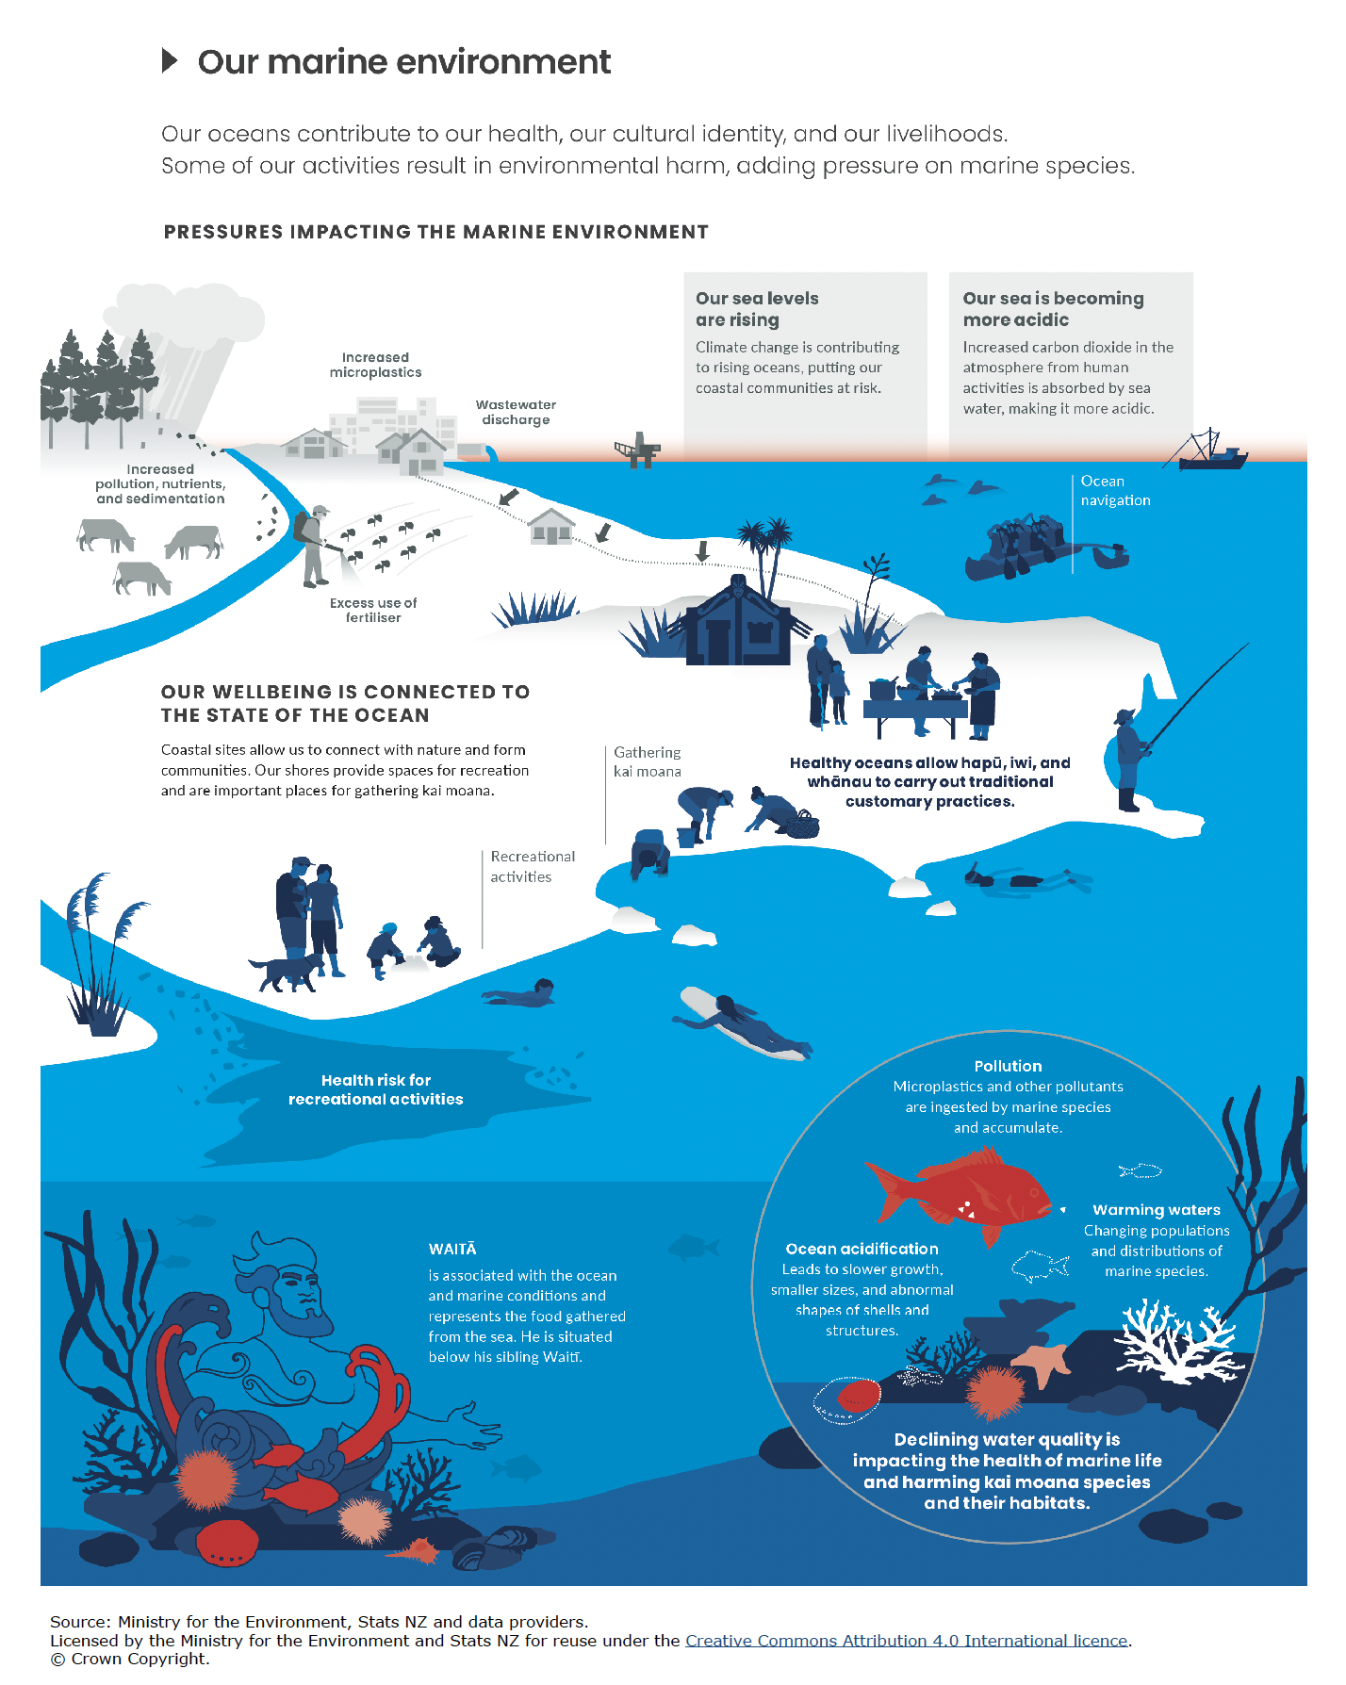
Ururangi and Waipunarangi – reflecting on our atmosphere and climate

