ACTIVITY: RNAi – making science-informed responses

Activity idea

In this activity, students use a variety of resources to consider personal, societal and science perspectives and make a science-informed response to the use of RNAi as a means of pest control.

By the end of this activity, students should be able to:
- use resources to aid understanding of the basic biology that underpins genetic technologies
- use resources to aid understanding of the threats posed by varroa and myrtle rust
- use resources to aid understanding of te ao Māori perspectives regarding gene technologies for pest control
- use resources to aid understanding of public perspectives of the benefits and risks associated with gene technologies
- use concept cartoons to consider aspects of genetic modification and RNAi
- use concept cartoons to justify/position their ideas on the issues
- discuss/create a science-informed response to the potential use of RNAi as a means of pest control.

For teachers

Introduction/background

Genetic modification (GM) – also known as genetic engineering (GE) – is any process that changes the genetic material of an organism (plant, animal, bacteria or virus) in order to make it capable of producing new substances or performing new or different functions. Gene editing is using genetic technologies to add, remove or alter genetic information in specific places.

RNA interference (RNAi) is a biological process in which RNA inhibits gene expression. It is a natural process in cells, often in response to viral double-stranded RNA. RNAi was hailed by the journal Science as the “Breakthrough of the Year” in 2002, and the scientists who discovered it won the Nobel Prize in Medicine or Physiology in 2006.

Since its discovery, much of the science that underpins RNAi has become well established.

As a biotechnology tool, RNA interference ‘silences’ a gene by using a synthetic RNA sequence to prevent translation. While RNAi is used widely to study gene function, in medical therapeutics and in agriculture, this activity looks specifically at pest control.

The articles Using RNAi to control varroa mites and Using RNAi to combat myrtle rust briefly explain the issues, and the benefits and limitations of using RNAi.

Genetic modification in Aotearoa

New Zealand’s Ministry for the Environment notes that the country’s laws and regulations governing GM are among the most rigorous in the world. Many date back to 1996–2001.

In 2019, a Royal Society Te Apārangi expert panel concluded: “It’s time for an overhaul of the regulations. There’s an urgent need for wide discussion and debate about gene editing within and across all New Zealand communities.”

The panel also noted, “New Zealand needs to have its own perspective given our unique cultural heritage and environment, and the special challenges we face in maintaining our biodiversity.”

Making a science-informed response to a socio-scientific issue

Socio-scientific issues promote multiple learning opportunities. They:
- enable students to build and consolidate their knowledge of biological processes within an authentic context
- encourage students to consider a range of perspectives, including their own
- help students develop their critical-thinking and problem-solving skills
- help students consider how the values and needs of a society influence both scientific endeavours and public policies
- provide an opportunity for students to gather and synthesise relevant information to make an informed response
- encourage students to act on this information.

What you need

- Student handout: Concept cartoons
- Student handout: Statements to begin a discussion
- Student handout: Suggested resources

Teaching suggestions

This activity allows educators to take a variety of pathways to meet student needs at different curriculum levels.

The concept cartoons are designed to help students consider a range of viewpoints, justify their own ideas, clarify their thinking and consider others’ ideas. After discussion and/or research, students can use blank templates to create their own concept cartoons. The article Using concept cartoons provides information about pedagogical methodologies and approaches when using concept cartoons.

The statements to begin a discussion also help students consider a range of viewpoints. Encourage students to use some of the suggested resources to justify the statements or to find statements that reflect their personal views. The article Managing classroom discussions has tips on facilitating discussions in a positive, safe atmosphere.

Use the suggested resources to support students with:
- NCEA level 1.1 Demonstrate understanding of a science-informed response to a local issue (pest control)
- Living World – Evolution, levels 7 and 8
- Nature of science – Participating and contributing, levels 5–8
- Te ao tangata Social sciences – Interactions change societies and environments.

For students
Concept cartoons
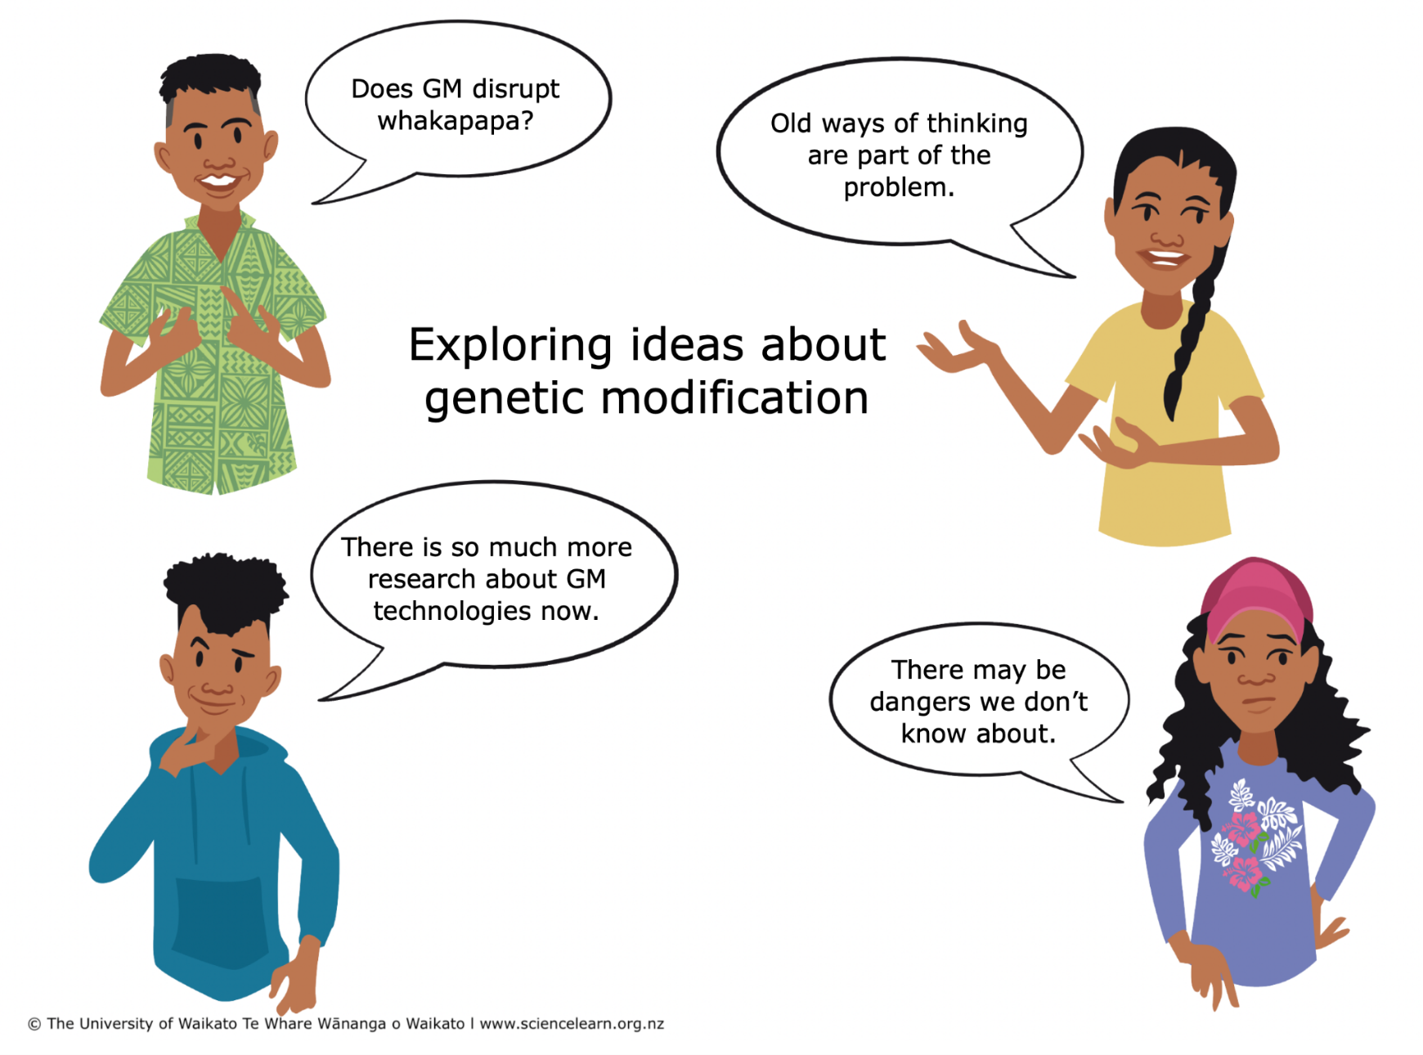
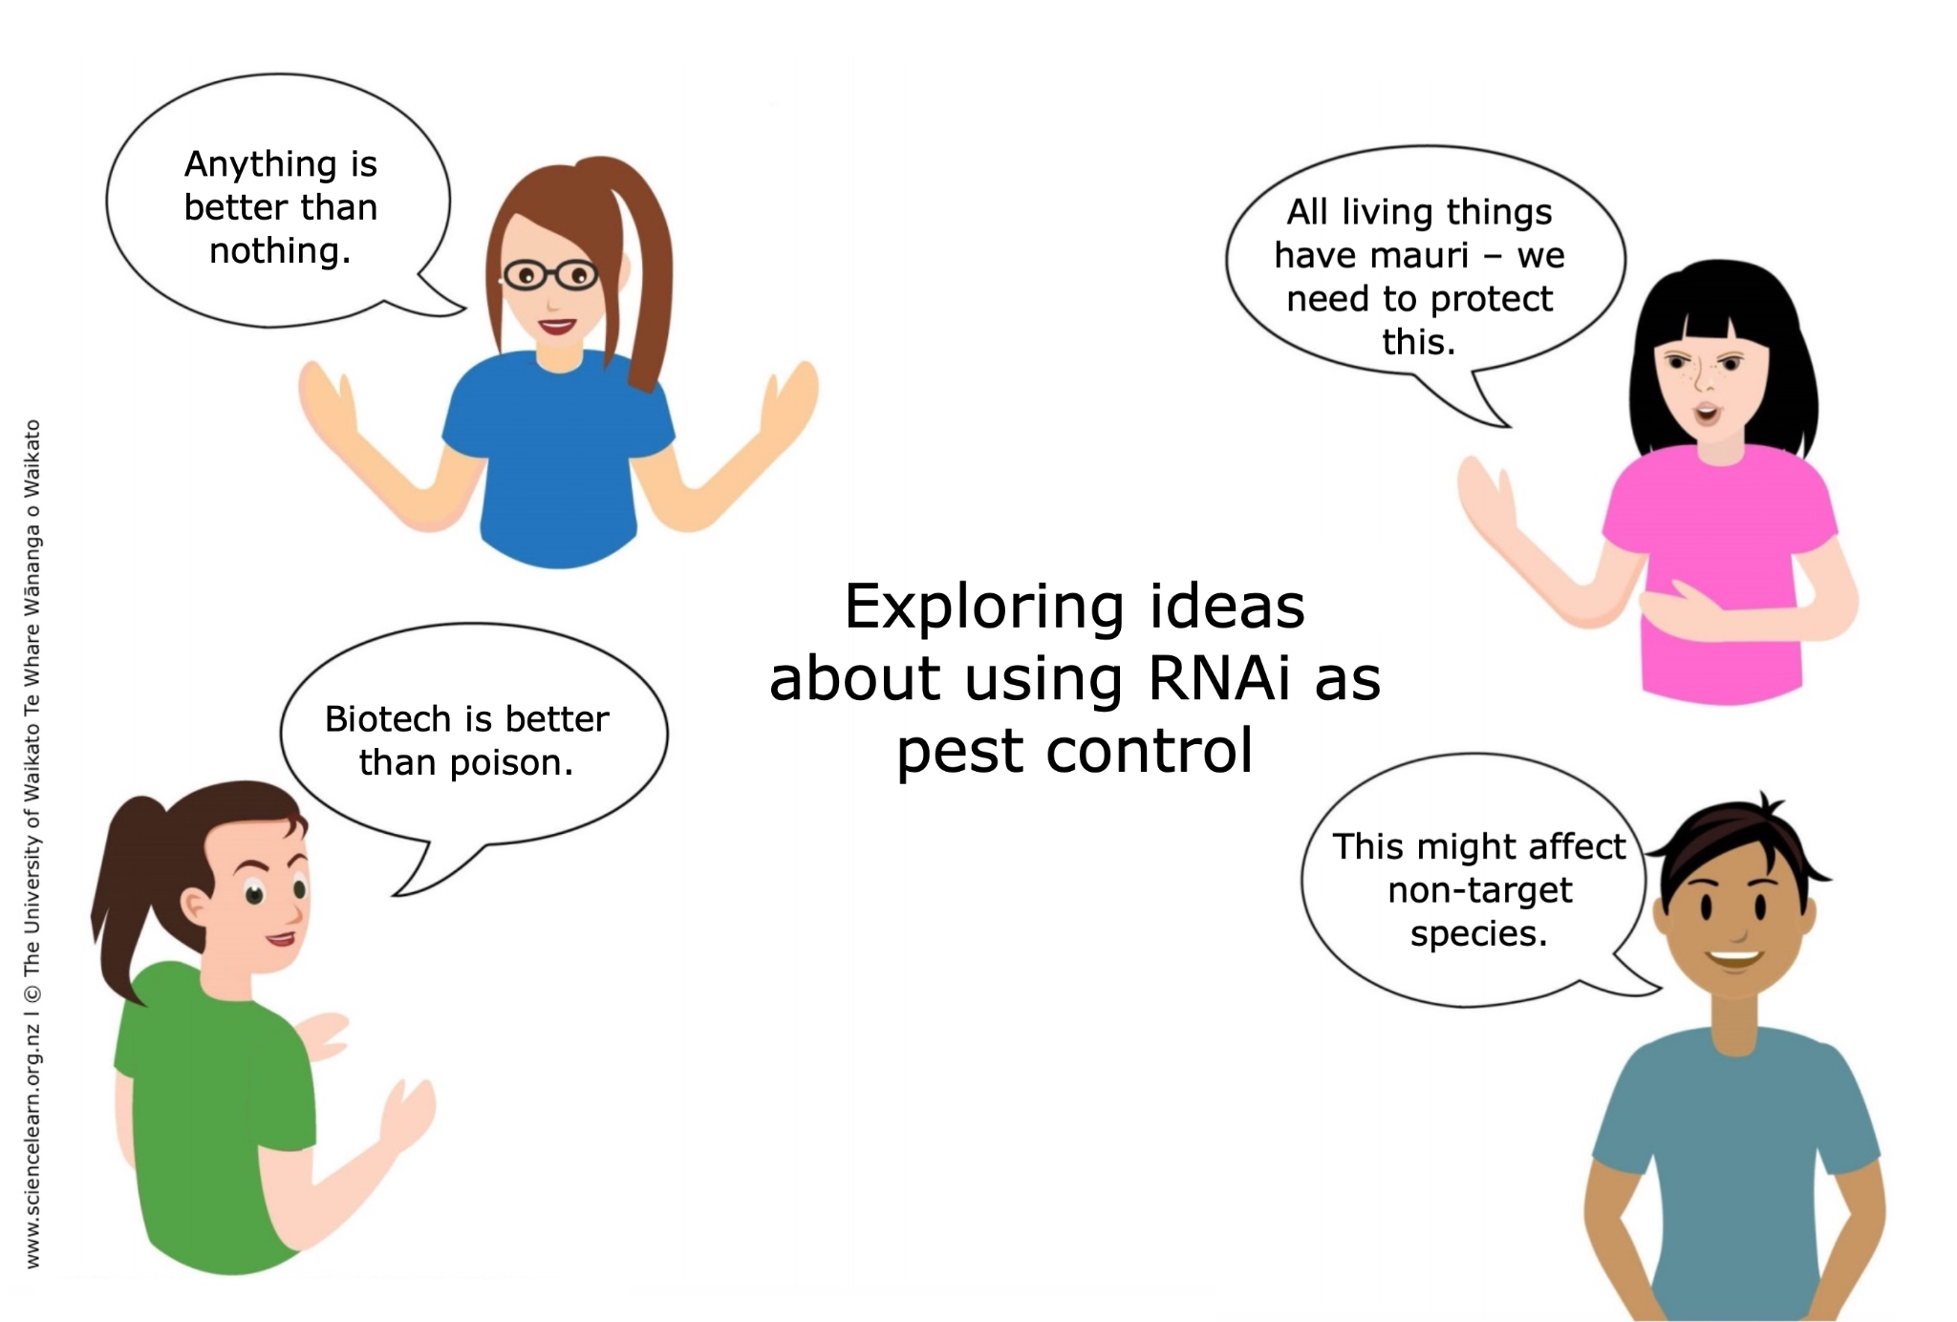

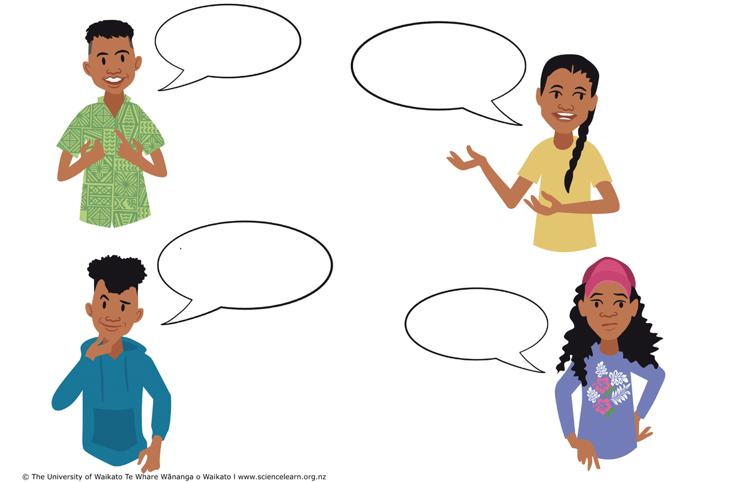

Statements to begin a discussion

RNAi was hailed by the journal Science as the “Breakthrough of the Year” in 2002, and the scientists who discovered it won the Nobel Prize in Medicine or Physiology in 2006. Since its discovery, much of the science that underpins RNAi has become well established. (Science Learning Hub Pokapū Akoranga Pūtaiao, 2023)

New Zealand’s laws and regulations governing genetic modification are among the most rigorous in the world, and strike a balance between protecting our health and environment and preserving opportunities for all types of production genetically modified and non-genetically modified. (Ministry for the Environment, 2004)

Tikanga refers to Māori customs and traditions. It is important for the correct Māori customs to be followed if new tools are used for pest control in Aotearoa New Zealand. (Science Learning Hub Pokapū Akoranga Pūtaiao, 2023)

There is a need to move on from a black and white view of “GM or not GM” – to a much more nuanced view that recognises a wide range of applications of the technology, some of which may be more acceptable to New Zealand communities than others. (Dr David Penman, Royal Society expert, 2019)

New Zealand needs to have its own perspective given our unique cultural heritage and environment, the special challenges we face in maintaining our biodiversity and a viable and productive primary industry, and our unique regulatory environment. (Dr David Penman, Royal Society expert, 2019)

Across all scenarios, feedback from Māori participants highlighted the importance of whakapapa and mauri, involving tangata whenua around indigenous species, protection of data, and intellectual property implications of gene editing taonga species. (Professor Barry Scott, Royal Society expert, 2019)

There is an urgent need for a wide and well-informed discussion across New Zealand’s diverse communities about their preferences for application of gene editing, in order to inform any regulatory change. (Professor Barry Scott, Royal Society expert, 2019)

There are widely differing views on genetic modification. Many people insist that genetic modification is safe if done carefully and monitored closely. Others consider the potential risks to be too great to allow the release of genetically modified organisms but will support laboratory research. Some say that all genetic modification goes too far in “tampering with nature” and should be completely stopped. (Ministry for the Environment, 2004)

BioHeritage Challenge survey (2017) on public attitudes to new pest control technologies, which include gene drive, found:
- 32% were comfortable with these developments
- 18% felt they should never be used
- 50% were undecided or wanted strong controls
- 42% supported trojan female techniques (where females pass on genes that make male offspring infertile)
- 52% supported a species-specific toxin.

Modern genetic modification (GM) technologies such as gene-editing offer potential new opportunities for boosting productivity, improving health outcomes, reducing biosecurity risks, and responding to climate-change risks and other environmental problems effectively and efficiently. The regulatory framework for GM tools was last reviewed in 2001 and does not reflect technological advances since that time. The Government should review the GM regulatory framework, to ensure it is fit for purpose and supports domestic innovation. This review should include wide engagement with industry, Māori and the general public. It should assess consumer attitudes, and the potential impacts on New Zealand firms who wish to retain GM-free status, and on New Zealand’s reputation and brand more generally. (New Zealand Productivity Commission, 2021)

The gene genie cannot be put back into the bottle. Once a modified organism is introduced to an environment, it cannot be called back. We have unique flora and fauna in this country, found nowhere else on the planet. Surely, we have a guardianship responsibility to preserve this for future generations. Introducing GMO, even with virtuous intentions, puts it all at risk and is an abdication of our responsibility. (Prem Maan, executive chairman at Southern Pastures, Stuff, 2021)

Currently, our biological heritage is under threat, which includes declining biodiversity, increasing pressures on our biosecurity system and changing environmental states. Issues such as use of outdated technology, critical knowledge gaps, and lack of public awareness due to the poor links between science and action make this problem complex. (Science Learning Hub Pokapū Akoranga Pūtaiao, 2023)

Suggested resources

Use these resources to gather information. All Science Learning Hub Pokapū Akoranga Pūtaiao have related content and useful links, which may be beneficial.

Biology basics
- RNA interference
- RNA interference – key terms
- DNA, chromosomes and gene expression
- Proteins – what they are and how they’re made
- Cell biology and genetics
- Gene editing technologies – Royal Society Te Apārangi

Varroa mites
- Using RNAi to control varroa mites
- Honey bee heroes
- Fighting a little bee mite
- Protecting honeybees from the Varroa destructor mite – Greenlight Biosciences
- New direction for varroa control research – University of Arkansas

Myrtle rust
- Using RNAi to combat myrtle rust
- Myrtle rust
- Myrtle rust surveillance map
- Kauri ora – BioHeritage National Science Challenge
- Myrtle ora – BioHeritage National Science Challenge
- Scientists tackle rusty plant threat – University of Queensland

Te ao Māori perspectives
- RNAi for pest control – te ao Māori considerations
- Kaitiakitanga with Tame Malcolm – webinar
- Tame Malcolm – indigenous pest management – webinar

New Zealand Government reports and regulations
- Genetic modification – the New Zealand approach – Ministry for the Environment, 2004
- Hazardous Substances and New Organisms Act 1996 – New Zealand Legislation, 1996
- Report of the Royal Commission on Genetic Modification – Ministry for the Environment, 2001

New Zealand science organisations
- Our views on genetic modification – Plant & Food Research
- Public perceptions of new pest control methods – BioHeritage National Science Challenge
- Gene editing – Office of the Prime Minister’s Chief Science Advisor
- Gene editing in Aotearoa – Royal Society Te Apārangi
- Gene editing: Reflections from the panel co-chairs – Royal Society Te Apārangi
- Gene editing for pest control – Royal Society Te Apārangi

