ACTIVITY: Game design for viruses and vaccines

Activity idea

In this activity, students use their knowledge of viruses, methods of viral transmission and infection, and defence strategies – including our immune systems and vaccines – to design a game. The game can take many forms – a visual representation, diorama with 3D models and/or digital technology.

By the end of this activity, students should be able to:
- observe some of the basic structures of a virus
- discuss methods of viral transmission and infection
- discuss some of the ways our immune system protects us from viral infection
- discuss some defence strategies that we can use to protect ourselves from viral infections
- use this information to create characters in a physical or digital game
- use this information to create a narrative about viruses, transmission and defence strategies
- use this information to create a game or game idea.

For teachers

Introduction/background

Game design offers authentic learning experiences. Designers use their knowledge to shape a narrative and provide experiences that support an intended purpose or outcome. Throughout the design process, ākonga become immersed in the narrative – experiencing it first-hand, learning through the game’s creation and development and potentially becoming an expert who can share the information with others.

Learning about viruses

This activity uses game design ideas created by The Science of Medicines – Whakatere Waka project. Project participants use game design to learn about viruses and how humans can stay safe by defeating and/or avoiding them. Find out more in the article Gaming and medicine – D-Bug Game Design Challenge.

In this activity, ākonga design characters, consider the game environment and rules and then develop a storyline that puts all of the elements together. Through character development, ākonga learn about the structure and function of viruses. Creating a game environment encourages ākonga to consider how viruses spread and how they might be contained or defeated. The storyline can become more elaborate – and scaffold more complicated content – by adding levels to the game via virus mutation or evolution.

Things to consider

Game design can take many forms – visual representations via board games, 3D models via clay sculptures and dioramas and virtually via digital games.

Game design and development takes time – especially when using digital technologies. Consider the time and resources available. There is an abundance of free software to create digital games. However, ākonga will likely require help with coding. It is estimated that upper primary-age students will require 16–20 hours to design and create a short digital game. Gamefroot and Scratch use block coding interfaces for game creation. Blender is useful for 3D applications and animations, and games can be created using logic bricks as well as coding.

Consider the resources at hand, physical and digital, and the interests and abilities of ākonga when choosing the type of game design to pursue. The Science of Medicines team found that all participants enjoyed physical model making (clay sculptures and diorama-type game setups pictured in the student handout). Those with an interest in digital technologies were motivated to use software to create a working game. The overall goal of the project – and this activity – is to learn aspects about viruses, the human immune system and how vaccines protect us. Creating a playable game is a secondary consideration.

Teaching suggestions

Resources for general background information

Serious games are designed for purposes other than pure entertainment. Use these Hub resources to provide background information about viruses and vaccines. The resources contain images, video and animations that are helpful for deciphering complex information.
- Microorganisms – friend or foe?
- Infection
- Virus strains
- Vaccines and therapies
- Coronavirus

Having a novel storyline adds excitement and interest for designers and users. Use the activity Viruses and immunity – interpreting infographics to delve into the factsheets/infographics created for the D-Bug Game Design Challenge. These resources combine scientific information with engaging graphics.

Resources for learning about viruses and their structures

Use the following resources to provide an understanding of viruses and their structures. This information will aid character development for the games.
- Observe images of viruses such as this generic virus and the coronavirus and discuss aspects of their structure.
- Use the text and observe the graphics in D-Bug Fun Facts: Deadly Looks and D-Bug Fun Facts: Vaccines & Antivirals.
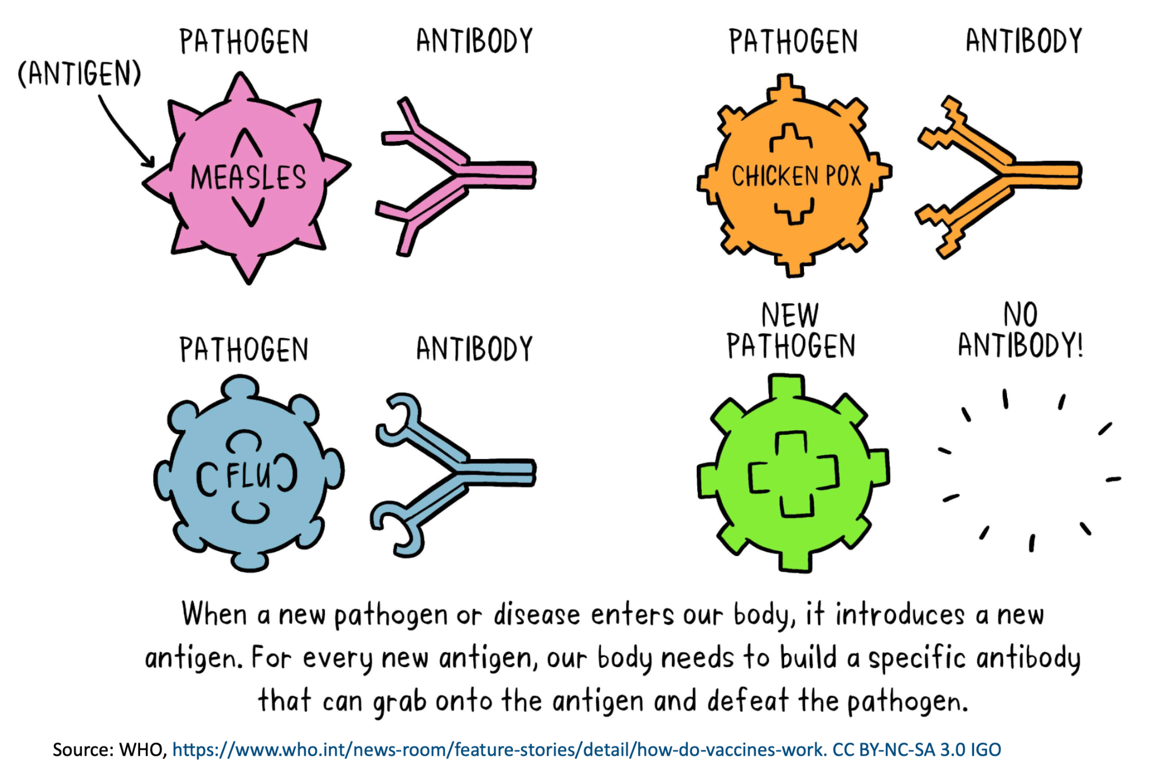
- Watch the video Virus replication to view the virus structure and how it replicates. If the voiceover seems too complex for those viewing the video, consider muting the sound and providing a simpler explanation.
- Use the text and graphics in D-Bug Fun Facts: Transmission & Infection to learn about modes of transmission.
- Watch the video The D-Bug Game Design Challenge from the 2:30 timestamp. Listen to the participants’ stories and pause the video to observe what they have created.

Character development and design

The characters are central to the game. While creating characters, encourage ākonga to consider:
- the structure of the virus – including how an antibody can grab onto it
- how the virus spreads – its mode of transmission
- how the virus affects its victims – the symptoms it causes
- how the virus can get stronger – via mutations or a conducive environment
- how the virus can be stopped via an antibody or vaccine – the hero or the enemy depending on context
- where the virus lives – encourage creativity
- the abilities of the protagonist – including how it finds/discovers the virus
- which defence strategies the protagonist uses – immune responses, vaccinations and/or disinfecting surfaces.

Game environment and rules

Think about where the game will take place. The game environment will depend on the characters. Encourage ākonga to consider these questions:
- What does the physical environment look like?
- Where does the virus hide out or lurk?
- Are there rules about how the virus can move?
- Is the virus able to replicate so the protagonist needs to fight multiple characters?
- Is the virus able to mutate and become stronger?
- Are there areas that encourage transmission, like a crowded shopping mall or a location with a shortage of hand soap or tissues?
- Are there restrictions in place to control the spread of the virus?
- Are there obstacles to overcome or collisions to avoid?
- Are there levels to the game?
- How do the characters operate at higher levels? Do they have different colours or abilities?
- What new information does the user need to know at these levels?
- What is needed to win the game?

Creating a narrative

The narrative (storyline) ties everything together. Encourage elements of creativity and fantasy, but as this is a serious game, the narrative should be underpinned by scientific information.

Encourage discussion about physical or digital games students like to play. Discuss whether simple versions of these games can be adapted to suit their own game design.

Think about how ākonga will develop their narratives. For example, a planning storyboard, sketches and audio or video recordings can be used to record ideas and document progress as it develops.

Getting started

Watch the video The D-Bug Game Design Challenge. Discuss examples mentioned in the video:
- Omar created a digital maze similar to blood vessels.
- Callum created a world in which viruses have taken over and the last doctor in the world has to travel on a quest to defeat the viruses.
- Anya created White Blood Cell and Mafia Boss. White Blood Cell collects antibodies and gobbles up small viruses to take down Mafia Boss.

Look at the images in the student handout. They feature two sets of characters and dioramas – as well as an example of a board game.

For students

Characters and environments from The D-Bug Game Design Challenge

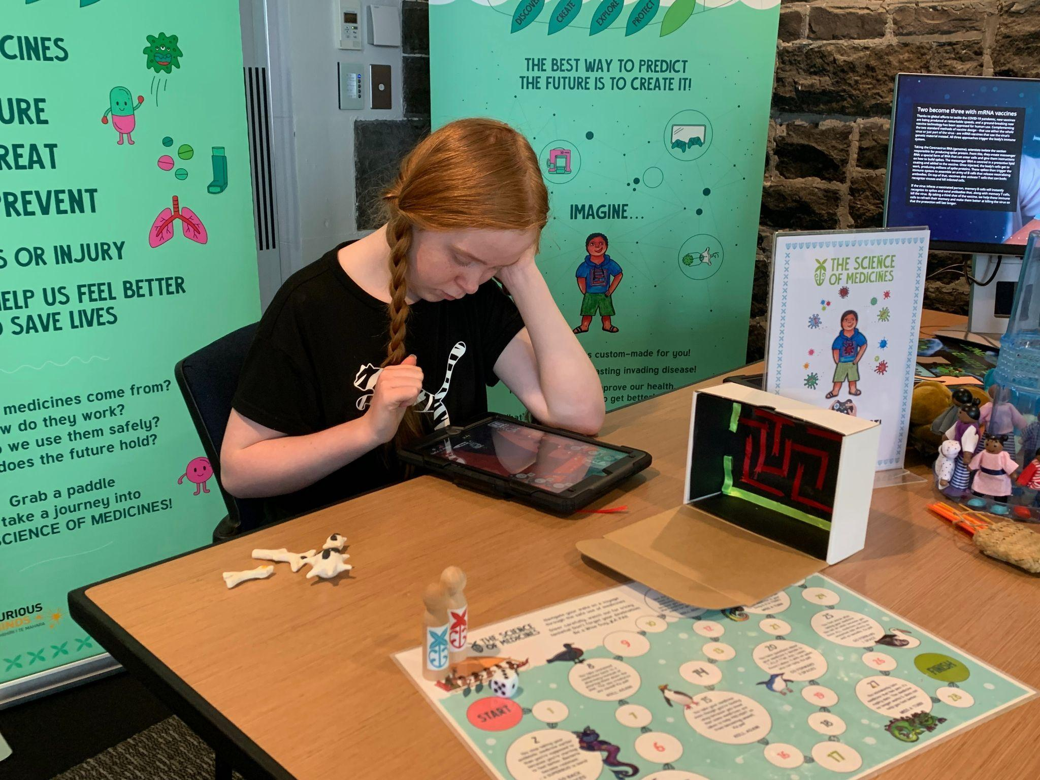

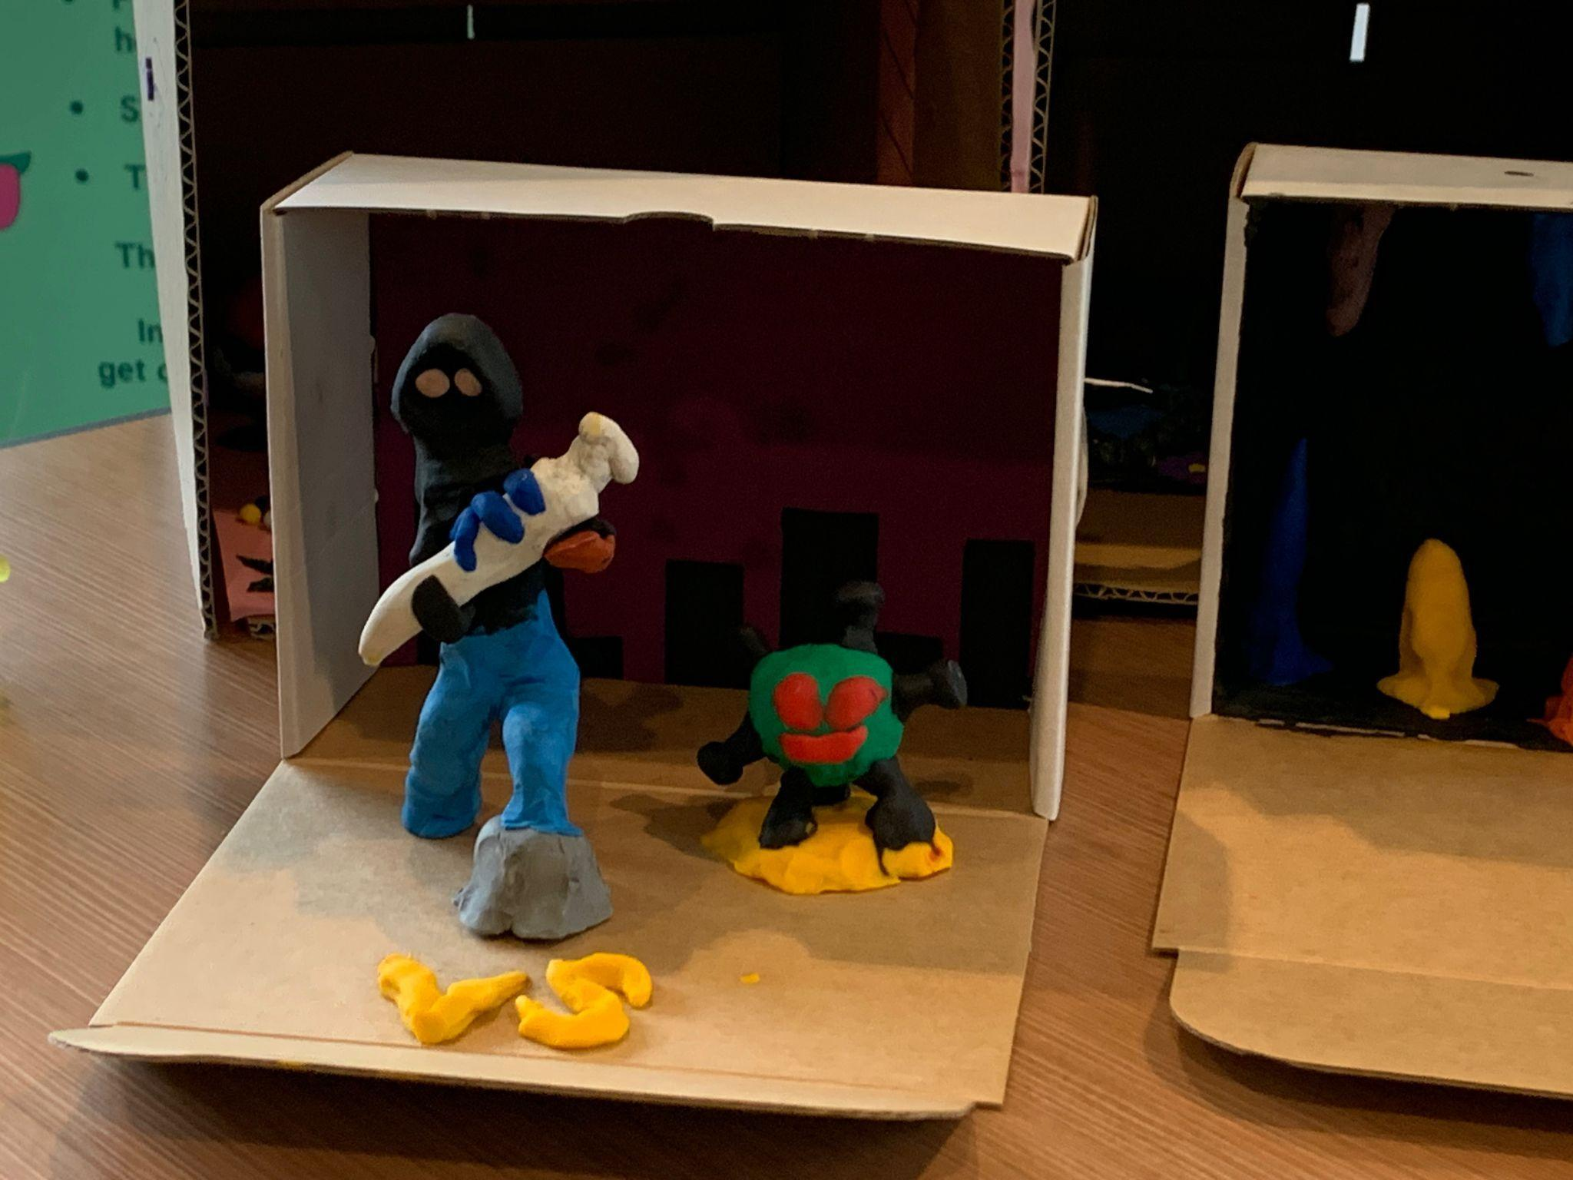
Planning storyboard

(sketch)

(text)

