ACTIVITY: Modelling stalactite and stalagmite formations

Activity idea

In this activity, students use an Epsom salts solution to model the formation of stalactites and stalagmites in cave systems.

By the end of this activity, students should be able to:
- recognise that Epsom salts dissolve in water – forming a solution that is a mixture of both substances
- recognise that mineral compounds remain when water in the solution evaporates
- discuss how this activity models the formation of stalactites and stalagmites
- discuss the limitations of this activity in modelling the formation of stalactites and stalagmites.

For teachers

Introduction/background

Stalactites and stalagmites are geological formations that occur when water dissolves limestone and other minerals.

The mineral-rich water seeps through cracks and into a cave. In the right conditions, the minerals in the water can precipitate out and be left behind as thin white rock coatings on the ceiling or floor of a cave.

Over thousands of years, these coatings can build up in layers. The formations that build up in this way are called speleothems. Speleothems on cave ceilings are called stalactites and those on cave floors are called stalagmites.

This activity uses Epsom salts – a mineral compound made up of magnesium, sulfur and oxygen – that dissolve in hot water. The reversal of the dissolving process results in the formation of stalactites and stalagmites.

The activity is a simple model of a much more complex and lengthy process. The articles Carbonate chemistry and Limestone landscapes provide in-depth information regarding the chemical processes of cave, stalagmite and stalactite formation.

What you need

- 350–500 g of Epsom salts
- 250 ml of very hot water
- Food colour or dye (optional, but it highlights the solution on the string)
- Mixing bowl
- Spoon
- Measuring cup
- 2 glass jars
- 30 cm of natural cotton or wool string
- 2 paper clips
- Plastic tray

Teaching suggestions

This activity can be used from the early years to senior students. Consider the following for differentiated learning.

- Dissolution/dissolving – Epsom salts (a mineral compound) dissolves in water to become a solution.
  - Younger students often confuse the concept of dissolving with melting or disappearing. Explicitly observe and discuss what happens when the salts are mixed with the hot water. Visit Melting and dissolving for pedagogical information.
  - Introduce older students to dissolution and cave systems in the articles Carbonate chemistry and Limestone landscapes.

- Models in science – a model is a representation of an idea, an object, a process or a system that is used to describe and explain phenomena that cannot be experienced directly.
  - Discuss the similarities between what students are modelling and what occurs in real life – for example, dissolution of minerals in water and the formation of stalactites and stalagmites as each drip deposits minerals.
  - Discuss the differences between the model and natural occurrences. For younger students, the key differences are time and colour if dye is used. For older students, the model does not reflect the complex geological and chemical processes that underpin speleothem formation – for example, the differences in chemistry between Epsom salts and calcium carbonate and the differences in conditions between a classroom and a cave.

- Developing scientific vocabulary – identifying and explicitly teaching specific scientific terms.
  - Decide which terms are relevant and plan how to introduce them – considering both context and students’ prior knowledge.
  - Hub resources have a glossary tab under most resource titles that provides a list of all glossary terms and definitions in the resource. There is a download link to convert the terms to a .docx file for editing or simplifying.

What to do

- Discuss local cave systems that ākonga have visited or know about. If images are available, discuss what ākonga know about any formations in the images.

- If appropriate, observe the image Preserving climate signals in stalagmites. Discuss the process of rainfall percolating through the soil, dissolving minerals and entering the cave.

- Discuss why scientists use models. Discuss the purpose for creating this model in the classroom.

- Follow the steps on the student worksheet to construct the model.

Extension idea

The article Why caves matter notes how scientists use speleothems like stalactites and stalagmites to learn about past weather events, climate changes and changes to surface vegetation. The image Growth layers in a stalagmite shows different-coloured layers representing different growth periods over thousands of years. Think about how you could model these types of layers and then test and see if your model works.

For students

It can take thousands of years for stalactites and stalagmites to form in caves. With this activity, the process is much quicker! As you work through the activity, think about how this model is similar and different to what really happens in caves.

What you need

- 350–500 g of Epsom salts
- 250 ml of very hot water
- Food colour or dye (optional)
- Mixing bowl
- Spoon
- Measuring cup
- 2 glass jars
- 30 cm of natural cotton or wool string
- 2 paper clips
- Plastic tray

What to do

- Make a solution in the mixing bowl by adding the Epsom salts and water.

- Stir in as much of the salts as possible until they are dissolved.

- Add a few drops of food colour or dye and stir. This makes it easier to observe what is happening as the solution travels along the string.

- Tie the paper clips to the ends of the string – they act as weights to hold the string in the jars.

- Dip the string into the solution to moisten it.

- Use the measuring cup to add equal amounts of the solution to the jars.

- Place the jars on the tray leaving a 5–10 cm gap between them.

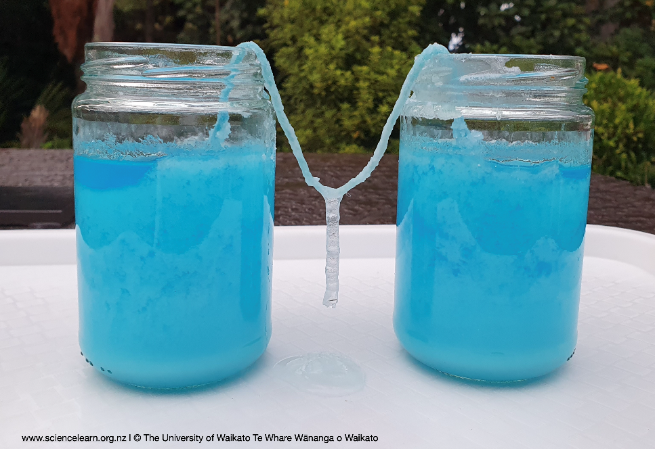
- Put the ends of the strings into the jars. The string should have a dip in the middle – below the top of the solution but not touching the tray.

- Place the tray in a location where it is easy to observe but kept safe from bumps and direct sunlight or air conditioning, which can dry the string.

- Observe what happens over time as the solution is carried along the string and forms drops at its lowest point.

