ACTIVITY: Living or non-living?

In this activity, students use an interactive or paper-based graphic organiser to explore their ideas about the characteristics of living things and the characteristics of animals. This activity can be done individually, in pairs or as a whole class.

By the end of this activity, students should be able to:
- describe the characteristics of living things
- describe the characteristics of animals
- classify things as living or non-living/animal or not, based on these characteristics.

Introduction/background notes
What you need
What to do
Extension ideas
Images for classifying
Graphic organiser worksheet: Living or not?
Graphic organiser worksheet: Animal or not? (found within Living or Not?)

Introduction/background

This activity has two separate graphic organisers:
- Living/non-living/not sure
- Animal/not an animal/not sure

In science, the broadest groupings are living and non-living. This may sound simple, but it is sometimes difficult to decide whether something is truly alive or not.

All living things share life processes such as growth and reproduction. Most scientists use seven life processes or characteristics to determine whether something is living or non-living.

For more information, see the science ideas and concepts article Characteristics of living things.

Visit the Science Continuum website for more information about common student alternative conceptions related to living things and classification.
www.education.vic.gov.au/school/teachers/teachingresources/discipline/science/continuum/Pages/relationships.aspx

What you need

- Access to the interactive graphic organisers Living or not? and the second interactive graphic organiser Animal or not? on the student activity Living or non-living or the images for classifying and graphic organiser worksheets Living or not? and Animal or not?
- Access to the science ideas and concepts article Characteristics of living things

What to do

- Allow the students sufficient time to complete the graphic organiser Living or not? either individually or in small groups on a computer. This can also be a whole class activity via an interactive whiteboard (IWB). If using an IWB, encourage students to come up and move the image cards to the appropriate box and to move an image card if they do not agree with its position. If the internet is unavailable, use the paper-based version. Provide the images for classifying (cut up into individual images) and ask students to place them in the appropriate box on the graphic organiser worksheet Living or not?

- If the students worked in small groups, bring them back together.

- As a class, come up with a list of characteristics of living things. Revisit the interactive and give students the opportunity to revise their choices. Ask them to explain any changes. Use this time to address any alternative conceptions that arise.

- If appropriate, allow students time to research any things/image cards they are unsure about. This research could be web-based or using a print out of the article Characteristics of living things.

- Repeat the steps above with the second interactive graphic organiser Animal or not? on the student activity Living or not?.

Extension ideas

- If you have an interactive whiteboard with voting capability, you could set this up as an anonymous voting activity as a useful way to gauge the understanding of the class.
- Groups of students may like to gather a number of artefacts from around the classroom or playground and do a ‘live’ version of this activity with younger students. The older students will be responsible for explaining any incorrect answers to the juniors.

Images for classifying

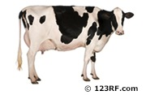
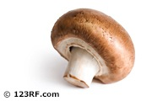
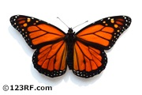 | 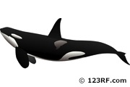
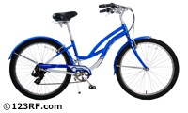 | 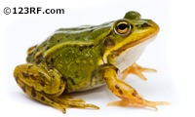
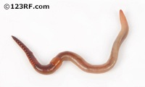 | 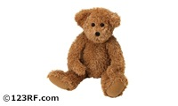
 | 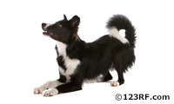

Living or not?
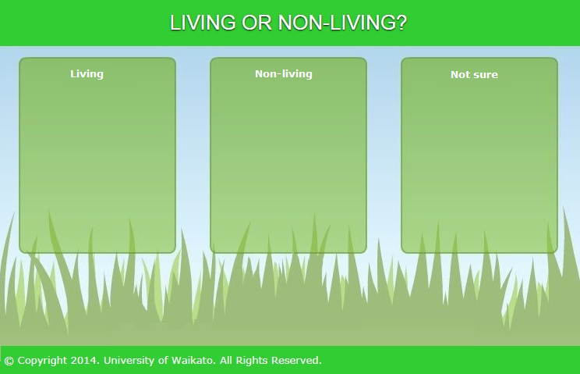

Animal or not?
