STUDENT ACTIVITY: Plant parts

Activity idea

In this activity, students relate commonly eaten foods to different parts of the flowering plant life cycle. They use an interactive or paper-based graphic organiser.

By the end of this activity, students should be able to:
- recognise different parts of flowering plants (roots, stems, leaves, flowers, seeds, fruit)
- understand the roles these parts play in the life cycle of flowering plants.

Introduction/background notes
What you need
What to do
Extension ideas
Food cards
Graphic organiser worksheet
Teacher answer sheet

Introduction/background

Most of the fruit and vegetables we eat come from flowering plants, which all have the same basic life cycle. Different parts of the plants appear at different stages of the life cycle and have different functions. Before doing this activity with your class, read the article Flowering plant life cycles, which outlines the functions of different plant parts. Make sure students know something of roots, stems, leaves, flowers, seeds and fruit. You might like to get students to discuss what is meant by ‘fruit’ and ‘vegetable’. To a botanist, a fruit is part of a flower that develops to protect seeds – that includes pumpkins, chillies and cucumbers, but you won’t find those in the fruit section of the supermarket.

Botanists classify plant parts by their functions more than by what they look like. This can cause confusion to non-botanists, who tend to identify plant parts by appearance alone. For example, a potato grows underground and looks like a rounded root, but structurally and functionally, it is a specialised stem. Your students will base their plant part identifications on appearance and their own experience, because normally they will not have the equipment or knowledge to investigate detailed structures and functions. Use the teacher answer sheet to point out where appearance alone can be deceptive. The extension ideas also include some plant parts that can cause confusion, should you choose to add these foods yourself.

What you need

- Access to the interactive graphic organiser or the printed food cards and graphic organiser worksheet.
- Optional: access to the article Flowering plants.

What to do

- Allow the students sufficient time to complete the interactive graphic organiser, either individually or in small groups on a computer. This can also be a whole class activity via an interactive whiteboard (IWB). If using an IWB, encourage students to come up and move the food cards to the appropriate box and to move a food card if they do not agree with its position. Ask them to say why they made the change. If the internet is unavailable, use the paper-based version. Provide cut out food cards and ask students to place them in the appropriate box on the graphic organiser worksheet.

- Invite students to share their choices with the class. If there is disagreement, allow time for students to research foods they are disputing.

Extension ideas

Introduce some other plant foods for students to discuss or ask for their suggestions. If using the paper-based activity, add your own fruit and vegetable food cards. Be aware that it is not always obvious what part of a plant a vegetable is:
- Potatoes and kūmara look a bit like roots and they grow underground, but they are special stems called tubers. They store nutrients to help a plant survive winter or drought and are a form of vegetative reproduction.
- An onion is a bulb – a special underground stem surrounded by modified leaves. It is for vegetative reproduction.
- Ginger is an underground stem called a rhizome, used for vegetative reproduction.
- A leek looks like a white stem with green leaves at the top, but everything that you see is leaves.
- Strawberries are unusual because they have seeds on the outside of the fruit. Fruit are normally formed from the ovary of a flower, but strawberries are formed from the end of the stem that the flower attaches to. Botanists sometimes call them ‘accessory fruit’.

Explore some of the other uses of flowering plants – clothing, medicine, paper, building material, energy, perfumes, art and decoration. Remember that not all useful plant material comes from flowering plants. For example, softwoods are sourced from pine trees, which are not flowering plants.

Explore Māori uses of New Zealand native flowering plants, including the different parts use
Food cards
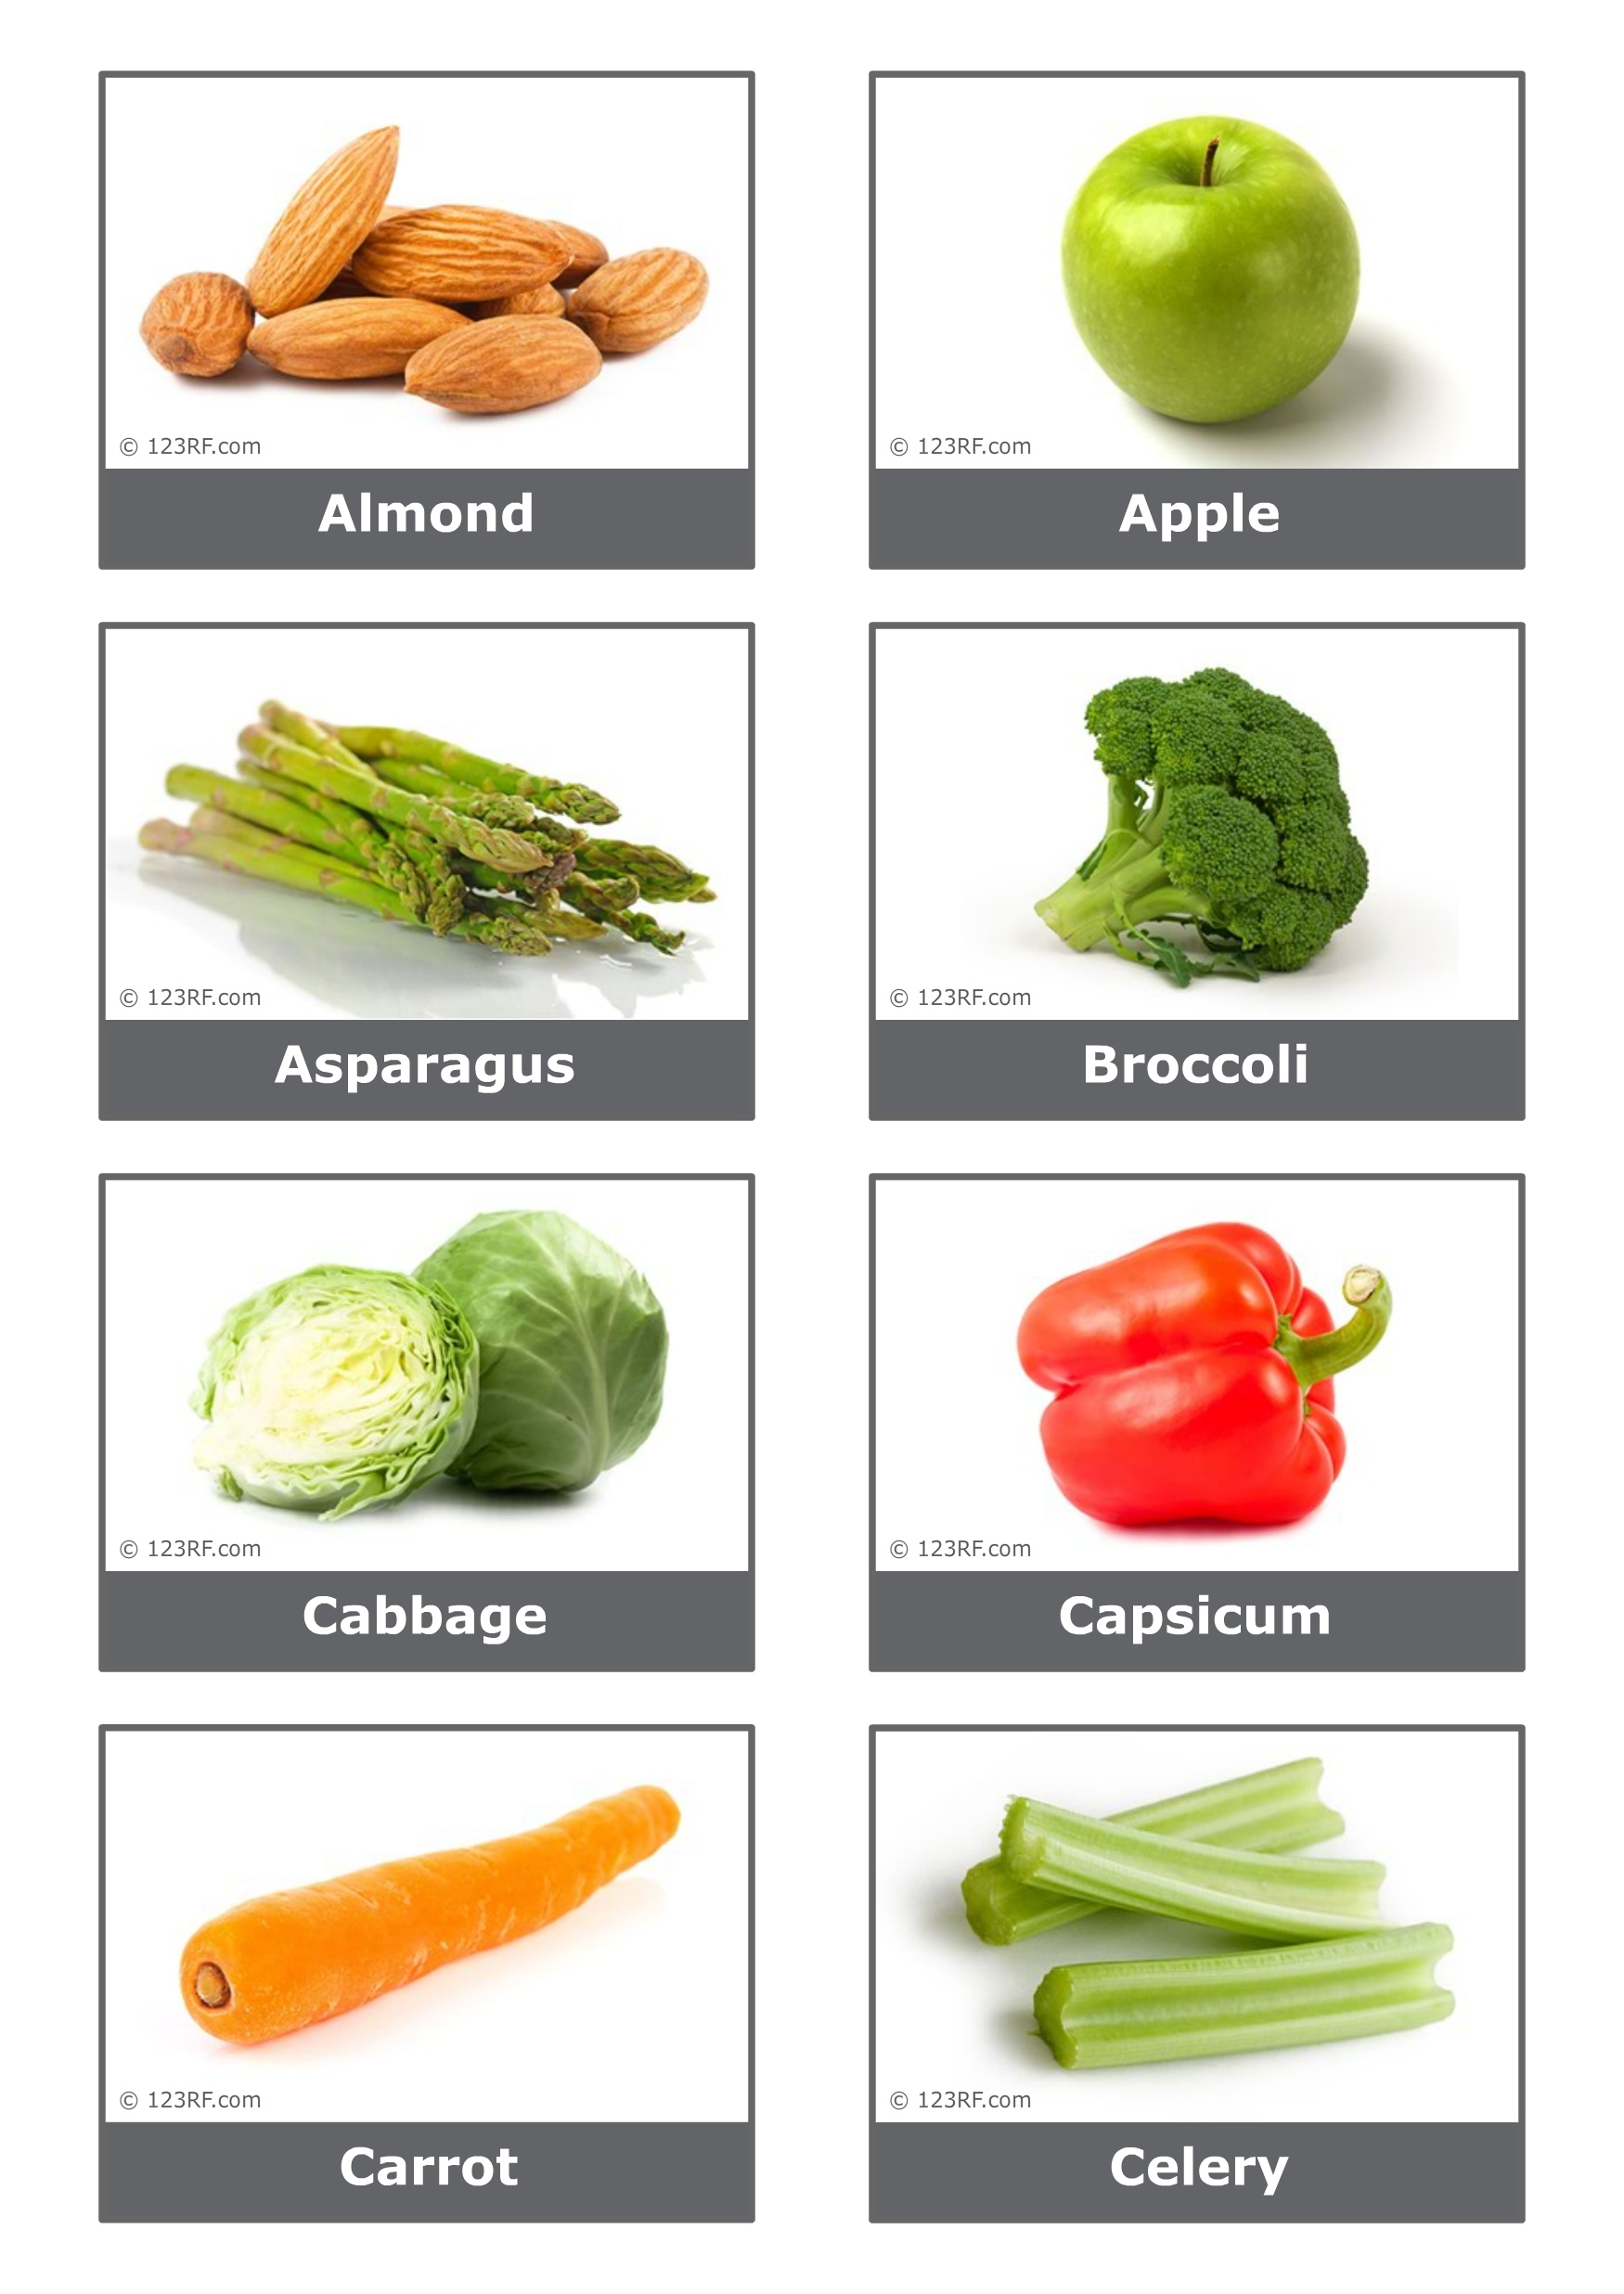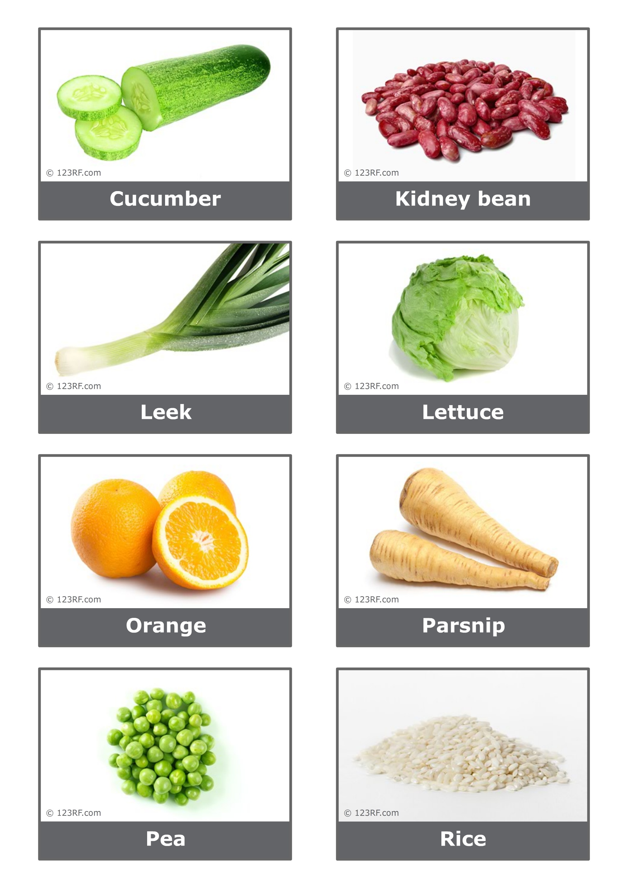
Graphic organiser worksheet

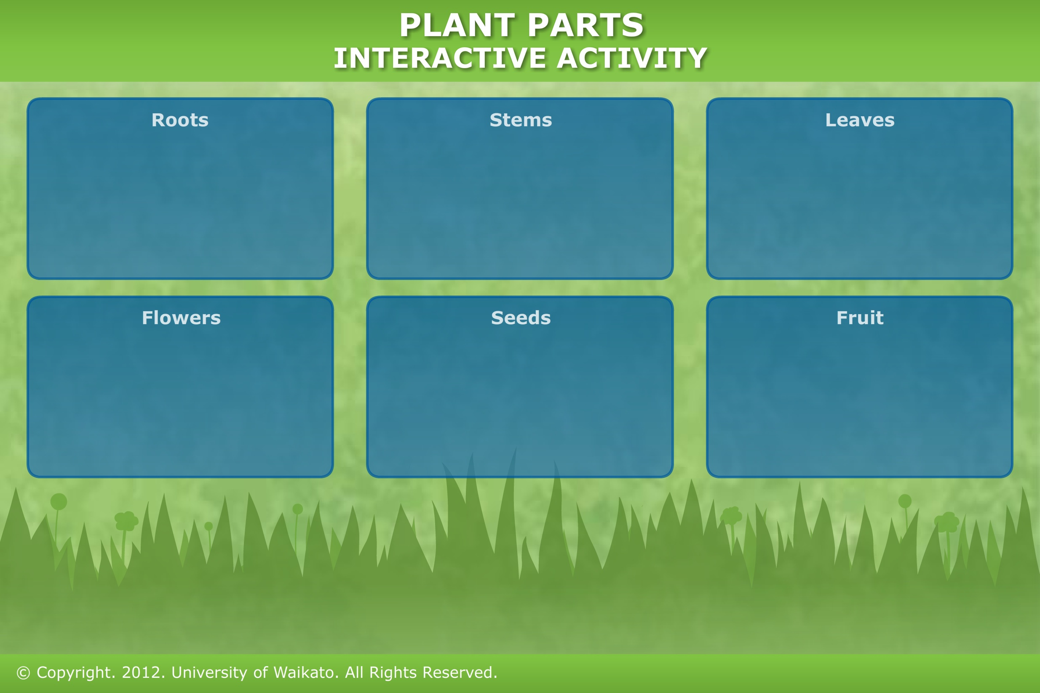
Teacher answer sheet

Food | Plant part | More information
Celery | Stem | What we call a celery stalk is technically the stem of a leaf, called a petiole.
Asparagus | Stem | The asparagus we eat is the young stem or shoot – once it starts to produce leaves, it gets too woody to eat.
Carrot | Root
Parsnip | Root
Lettuce | Leaves
Cabbage | Leaves
Leek | Leaves | Leeks are tight bundles of leaves – if you let them flower, you will see a stem up the middle. Leeks are related to onions, which are round bundles of leaves.
Broccoli | Flowers | What we eat are really the buds, as broccoli is picked before it blooms.
Peas | Seeds | Each pea is a seed – botanically, the pod is a fruit.
Kidney beans | Seeds
Rice | Seeds | The rice plant is a grass.
Almond | Seeds | An almond we eat is a seed that has had the hard covering (shell) of the fruit removed.
Apple | Fruit | Botanically, the core is the actual fruit of an apple – it develops from the ovary and contains seeds. The fleshy part that we eat develops from the base of the flower.
Orange | Fruit
Cucumber | Fruit | Botanically, this is a fruit containing seeds, but we normally call it a vegetable.
Capsicum | Fruit | Botanically, this is a fruit containing seeds, but we normally call it a vegetable.

