ACTIVITY: Bird hotel

Activity idea

In this activity, students take on the role of migrating birds. By participating in a physically active simulation, they experience the journey from summer breeding grounds to winter feeding grounds. As the activity progresses different scenarios affect these areas and the ability to successfully migrate.

By the end of this activity, students should:
- understand the importance of estuaries for bird migration
- understand wider food web links, for example, the potential impact on migrating birds of estuary pollution or a reduction in the numbers of cockles
- be able to discuss some of the impacts that humans have on estuaries and some ways that these impacts can be reduced.

Introduction/background notes
What you need
What to do
Discussion questions
Activity area set-up
Scenarios

Introduction/background

Large numbers of birds regularly migrate to different regions in order to breed. After the breeding season, they return to a winter feeding ground that offers better food resources and weather conditions. Their summer breeding grounds may be a short distance away from their winter feeding grounds or, in some cases, thousands of kilometres away.

Many birds travel huge distances between their summer breeding grounds and winter feeding grounds. Estuaries act as essential stop-over sites. We can think of estuaries as ‘hotels for birds’ – somewhere to rest and refuel on a long journey. Estuaries also make good winter feeding grounds for many migrating birds. They are commonly sheltered spots with plentiful food sources and until relatively recently were free of bird predators such as cats, rats and stoats.

In New Zealand, many species migrate internally moving from one part of the country to breed and returning to a winter feeding ground, for example, the South Island pied oystercatcher, the wrybill plover and the pied stilt. New Zealand estuaries are also visited by a number of bird species that risk dangerous long distance journeys to seek out better winter conditions. For example, godwits, plovers and lesser knots travel 11,000 kilometres from Siberia and Alaska to spend their winter in our estuaries. These birds arrive in huge numbers – as many as 100,000 godwits have been observed at one time. They remain for about 5 months before making the 6–8 day journey back to Alaska.

New Zealand has approximately 300 estuaries, and many of these are important for local species that migrate within New Zealand as well as for international migratory birds. However, many estuaries are at risk from human activities including increasing urbanisation, pollution, agricultural run-off, overfishing and introduced species. These changes can have a significant impact on the bird species that rely on our estuaries. Birds are part of the marine food web even if they only spend part of their year in the habitat.

Estuaries are at risk from many human activities and whole food webs may be affected, for example, phytoplankton blooms and bioaccumulations of toxins in shellfish in New Zealand estuaries may impact on birds from as far away as Alaska.

The Ramsar Convention is an international treaty that aims to protect estuaries and wetlands that are used by migratory birds. New Zealand currently has 6 sites that are included in the convention.

Historically, people came up with many reasons to explain the disappearance of birds at various times of the year. Now, with advancements in communication and tagging techniques, scientists work together to monitor the migration of birds. Birds may be tagged in one area and then observed many thousands of kilometres away and their details recorded. Satellite transmitters are also sometimes used to record specific routes and journey lengths.

What you need

- A large area, for example, a school field, court or hall.
- Hula hoops – the number will depend on the number of students participating, but you will need approximately 1 hoop per 3 students at each of the 3 areas, for example, a class of 30 requires 10 hoops in each area. (If no hula hoops are available, a paper plate/A4 piece of card or a loop of string can be used.)

What to do

- Discuss as a class what the students know about bird migration. The discussion could focus on: what birds need to survive, bird lifecycle, why birds migrate, dangers they may face along the way and any local examples (see useful links for more information).

- Outline the 3 important areas for migratory birds – summer breeding grounds, stopover sites (bird hotels) and winter feeding grounds. It might be useful to write these up on the board and brainstorm features of the 3 areas.

- Set up the activity area as shown in the diagram on the next page.

- Each student now takes on the role of a migrating bird. It is important to make it clear that this activity is a simulation and each student actually represents thousands of birds. (It is a common alternative conception that organisms shown in food webs represent individuals rather than populations.)

- Explain the activity layout and the 3 areas to the students and what they need to do:
- The 3 areas laid out represent their summer breeding grounds, winter feeding grounds and a stop-over site (bird hotel).
- Their goal is to migrate between the summer breeding grounds and the winter feeding grounds, but they will need to rest at the bird hotel along the way.
- Each hula hoop represents the amount of space required by the migrating birds in each area. There is only room for 3 students per hoop, and they need to stand inside the hoop in order to be ‘safe’.
- If they cannot find space, then the birds they represent ‘die’ and they have to move to the waiting area and line up. If conditions are right, they might get to join in again if new birds are ‘born’.
- Encourage them to flap their arms and make appropriate bird sounds as they migrate. Add in other actions that are appropriate to your class.

- Have all students begin at the summer breeding grounds and do a trial run so all students arrive safely at the winter feeding grounds, stopping at the bird hotel on the way. Every time you call ‘migrate’ they can move to the next area.

- Read out the 1st negative scenario and remove the specified hoops. When you call out ‘migrate’, 6 students will not be able to find a hoop at the bird hotel and will need to move to the sideline.

- Have the students move through a number of migration cycles. Use your judgement about when to read a negative scenario card and when to add a positive scenario card. When a scenario card results in hoops being added, students on the sideline at the front of the line get the opportunity to re-enter the activity. These new hoops represent birth of new birds. You may also like to ask students to come up with a scenario that would result in the addition of a hoop and incorporate this into the game.

Discussion questions

- What sort of habitat does the bird hotel represent?
- Why did the birds ‘die’ if they couldn’t find space in a hula hoop?
- Is there a difference between the number of birds at the start and at the end?
- What factors caused the number of birds to decrease?
- What factors caused the number of birds to increase?
- How many of the scenarios were due to human activity?
- Can you think of any other positive or negative scenarios that have not been included?
- Is there anything we can do to help protect estuaries (and therefore protect migratory birds?)?
- What changes would need to be made to increase the number of migratory birds? What actions could we take?

Activity area set-up
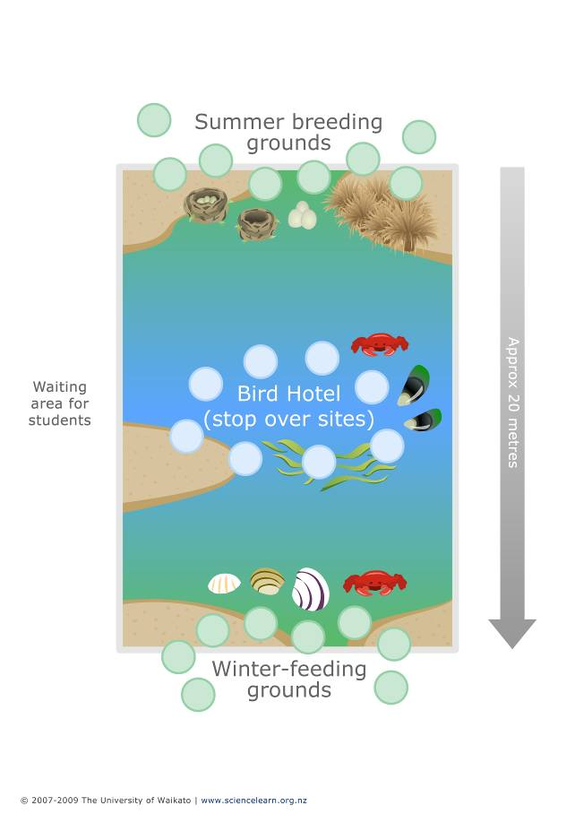
Scenarios

Negative scenarios | Outcome
- There is a big increase in the number of commercial fishing companies in the area. The number of fish available as a food source drops. | 2 hoops lost from the bird hotel
- The number of wild/feral cats hunting for food in the area increases. This puts nesting birds and their eggs in danger. | 3 hoops lost from the summer breeding grounds
- Pollution in the area is building up in the cockles. Birds that eat them get sick and die. | 3 hoops lost from the winter feeding grounds
- A new tourist resort is built on the edge of the estuary. | 2 hoops lost from the winter feeding grounds
- Farming increases in the area and causes a phytoplankton bloom. This causes a mass die-off of bird food sources including fish. | 4 hoops lost from the bird hotel
- A new marina is built on the estuary as more people take up boating and fishing. | 3 hoops lost from the summer breeding grounds

Positive scenarios | Outcome
- A conservation group works hard to restore native planting and cleans up the rubbish in their local estuary. | 1 hoop added to the bird hotel
- Farmers in the area introduce new methods to prevent run-off from their farms entering the estuary. | 1 hoop added to the winter feeding grounds
- The Department of Conservation runs a pest eradication programme in the area, reducing the number of rats and stoats that eat birds or their eggs. | 1 hoop added to the summer breeding grounds
- Dredging for shellfish is banned so the number of cockles and mussels increases in the estuary. | 1 hoop added to the bird hotel

