ACTIVITY: Introduction to DNA

Activity idea

In this activity, students learn to extract DNA from a tomato.

By the end of this activity, students should be able to:
- extract and observe DNA from a tomato
- explain that DNA is common to all plants and animals
- explain that DNA holds genetic information for plants and animals.

Introduction/background notes
What you need
What to do
Student instructions: Making DNA from a tomato

Introduction/background

This activity follows on from Introduction to cells and Inside a cell. Recap: living things are made up of cells; there are approximately ~10¹³ cells in the human body; we have cells with different jobs, such as muscle cells, skin cells or brain cells; the cells get their instructions from the DNA kept in the nucleus; this information allows the cells to make the specific proteins it needs to function.

DNA is in the nucleus of all cells, except for mature red blood cells. During development, red blood cells get rid of the nucleus so they have more room to carry oxygen around the body.
Therefore, if we eat something that is made up of cells, we will be eating DNA. Bread, meat, fish, apples, oranges, broccoli, potatoes, tomatoes – these are all made up of cells containing DNA. One of the few things we eat that does not have DNA in it is oil (olive oil, corn oil), which is pressed out of seeds (but seeds do have DNA).

In this activity, students isolate DNA from tomato cells. DNA is like a long piece of string all bunched up in a ball, sitting inside a nucleus, which is inside the tomato cell. We need to break open both the cell membrane and the membrane around the nucleus. As these are made from fat, we can break them open by adding soap (detergent). We then add salt to help get the DNA to stick together. However, DNA dissolves in water, so we can’t see it. As a final step, we add ethanol (laboratory alcohol) and the DNA can no longer remain dissolved. It clumps together and forms a stringy solid. This process is called precipitation.

Web links
- The method described below is based on a method by Petra Frey (http://ucbiotech.org/edu/edu_aids/TomatoDNA.html)
- Another method of DNA extraction: http://learn.genetics.utah.edu/content/labs/extraction/howto/

What you need
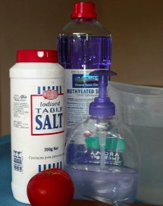
- Copies of Making DNA from a tomato

For class:
1 tomato chopped up into small pieces (1cm or less) – frozen tomatoes also work well. Remove skin before cutting up. Start with 1/8 tomato per group.
- Liquid hand soap – make sure it contains lauryl sulphate, EDTA and citric acid
- Salt solution made from 1tsp table salt in 850ml water
- Methylated spirits (cold – keep in chilly bin with ice)
- Pipette (to transfer methylated spirits) or have ability to pour small volumes (2–3ml). A straw may be sufficient – immerse the straw in the methylated spirits, put your thumb over the top to form a vacuum, lift the straw out of the methylated spirits and transfer to the test tube of tomato mixture.
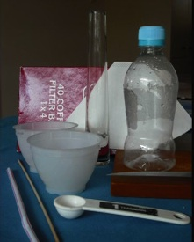
- Paper towels
- Rubbish bag

For each group (2–3 per group):
Two small plastic containers (such as small yoghurt pottles)
- Squashing mechanism (upturned small drink bottle with flat lid)
- Coffee filter
- Narrow glass tube-like container – narrow bottle, vase or test tube
- Wooden skewer

What to do

- Introduce the activity and explain the concept of DNA:

Vegetables, fruits, cereals and meat – all plant and animal products – contain DNA in various amounts. DNA is the carrier of genetic information – the recipes or blueprints of an organism – and is made up of four different chemical units. These can be digested and used just like any other nutrient in our food. A head of broccoli, for example, contains about 3g of DNA.

Usually DNA is degraded during cooking, but even if DNA is eaten uncooked (in apples, a tomato or a salad), the DNA is degraded rapidly in our stomach. Eating DNA should not be a concern – even mothers’ milk contains high amounts of DNA.

In this experiment, we will isolate the DNA of a piece of tomato to see what DNA actually looks like. It will also give us an idea of the amount of DNA we eat and of some of its physical properties.

- Hand out copies of Making DNA from a tomato and discuss.

- Divide the class into groups and assist students to gather the equipment and materials they need and conduct the experiment.

- Discuss the results.

Making DNA from a tomato

- Collect a piece of tomato in one of your small plastic containers.  - Add 2tsp of salt solution and one squirt of hand soap. | 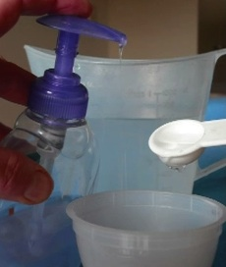
- Grind the mixture for 1 minute to a fine slurry using an up-ended bottle. Try to avoid making a lot of bubbles. | 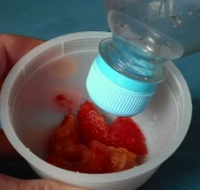
- Strain the well blended tomato through a coffee filter into a plastic container. You may need to squeeze the filter paper gently. This may take a few minutes – be patient. | 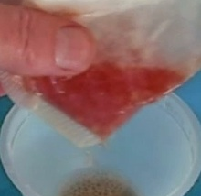
- Pour 2–3ml of the strained mixture into a test tube. | 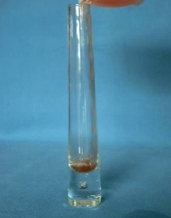

- Get your teacher to add 2–3ml of cold methylated spirits by pouring it down the side of the tube. The methylated spirits should float on top of the tomato mixture, but don’t worry if it mixes a bit. | 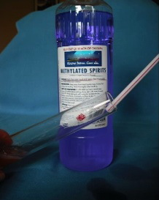
 | 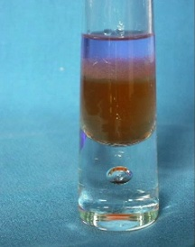
- At the layer between the tomato juice and methylated spirits, you will see a whitish, snotty-looking substance. This is DNA. Carefully swirl the tube to get more DNA. With a wooden skewer, reach in and hook the stringy DNA.  Congratulations, you’re now on your way to becoming a genetic engineer! | 