ACTIVITY: Drama with microbes

Activity idea

In this activity, students use drama to model science ideas about immune response to pathogenic microorganisms.

By the end of this activity, students should be able to:
- explain some basic ideas about the working of the immune system
- explain and model immune system response to bacteria and viruses.

Introduction/background notes
What you need
What to do
Teacher cards
Student cards
Mind map example

Introduction/background

The immune system is vital for our health. It fights infection to keep our bodies healthy. So much is going on within our bodies that we are not aware of. The immune system is an extremely complex interaction of cells that is still baffling scientists.

It can be taught to younger students (years 5–8) in a fairly simple way while making them aware that it is more complex – even for scientists. The advantage of teaching younger students is that they become aware of their immune system and what they can do to help it overcome infection.

Not all the cells in the immune system have been included in this context. This is to keep the ideas simple and to reduce the number of new terms.

This drama activity has been trialled in a year 5–6 class – the two video clips (made by students) show some students acting out immune response.

Before you start, make sure you are familiar with the Science Ideas and Concepts articles Cells, The body’s second line of defence and Microorganisms – friend or foe?

The teaching and learning activity The wars within should be taught as a precursor to this activity.

What you need

- Copy of the teacher cards
- Access to the video clips Meningococcal B and Chickenpox
- Access to the animation The immune system
- Copies of the student cards

What to do

- As a class, use the teacher cards to practise identifying the cells, antibody and virus and discuss their functions.

- Explain to the students that they are going to plan and perform a role-play to depict an immune response to a pathogen (virus or bacteria) entering the immune system. Show them video clips of the student role-plays Meningococcal B and Chickenpox. (Students may like to watch these again before they perform their own role-plays.)

- Divide the students into groups and have each group decide what type of infection (virus or bacteria) they would like to depict. Give them copies of the student cards they need to portray a part of that immune response. For example, in the case of a virus, a small group might decide to show immune response involving just the killer T cell (rather than including B cells and antibodies). In this case, the cards needed might include a virus, a macrophage, T helper cell, T killer cell, dendritic cell and suppressor T cell.

- Each student should get a card and assume that role (e.g. they might be a T helper cell). Students can research their role in immune response by:
- reading the Science Ideas and Concepts article The body’s second line of defence
- working through and discussing the animation The immune system with their group
- individually researching their ‘character’ on the internet or with books
- writing about or making a list of some of the immune responses of their ‘character’ (e.g. As the dendritic cell, I move around the lymph system looking for a foreign substance. I ingest some pathogenic material and ‘show’ it to T helper cells until one of them recognise what I have)
- drawing their character and mind mapping its functions – see example for a T helper cell.

- Have groups plan and practise their role-play and present to the class.

- Discuss each group’s performance.

Student cards
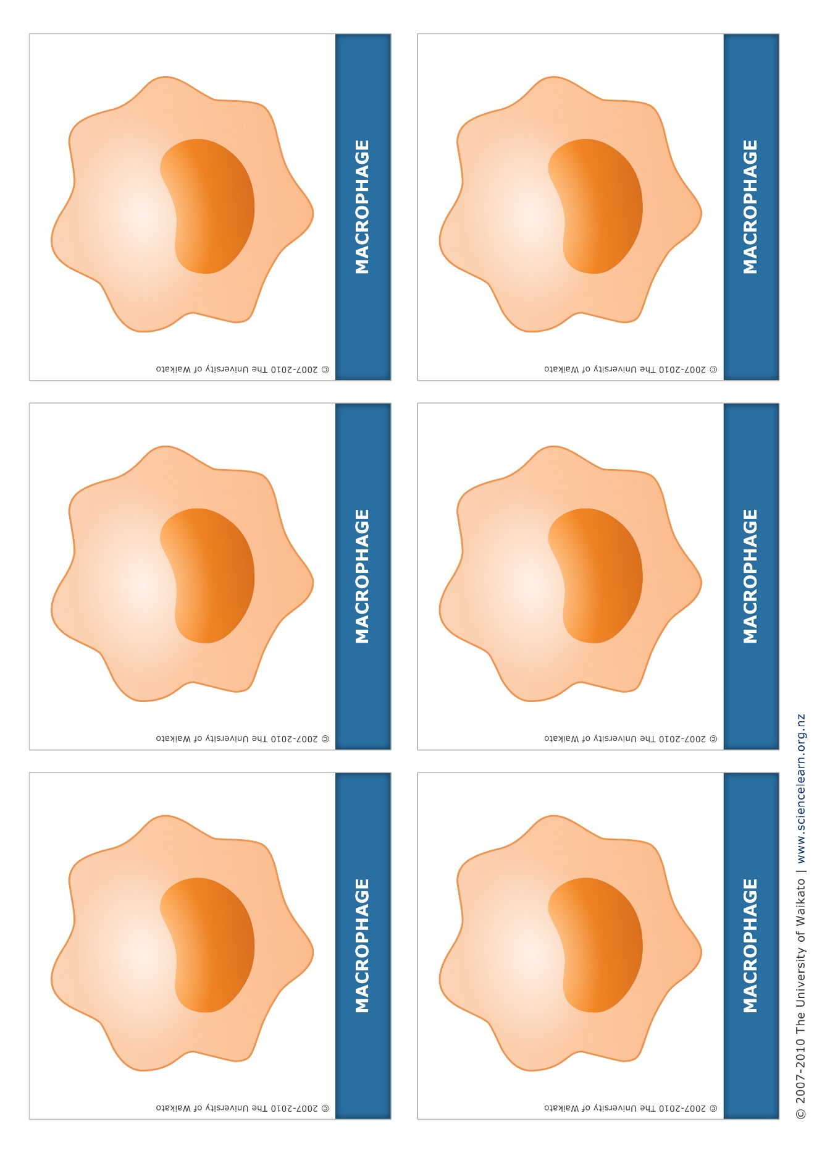
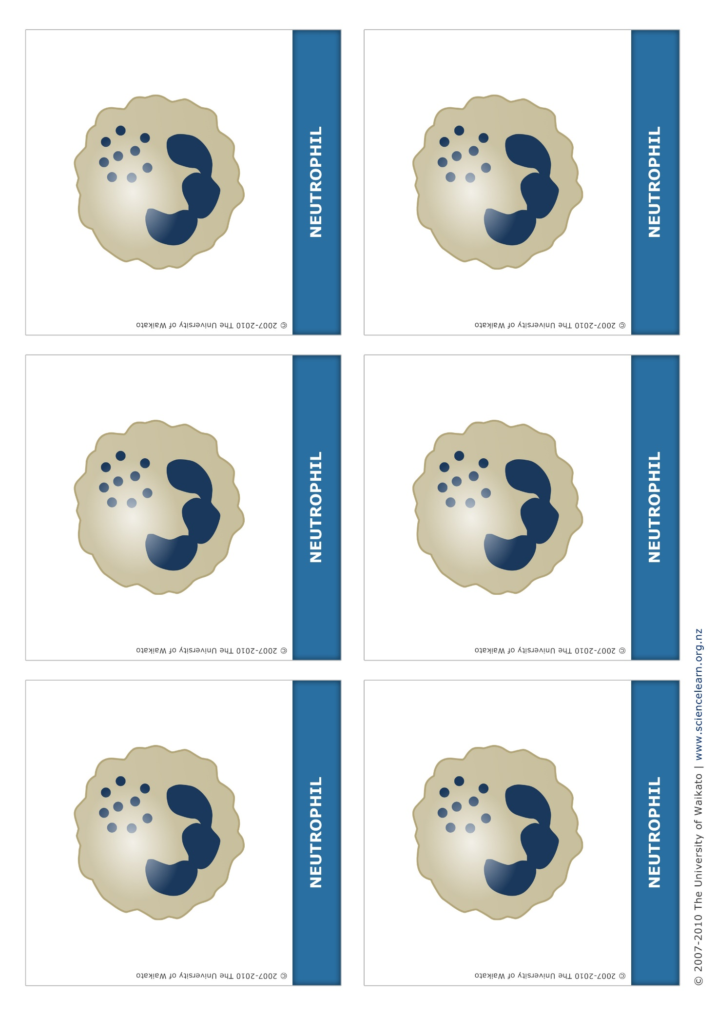
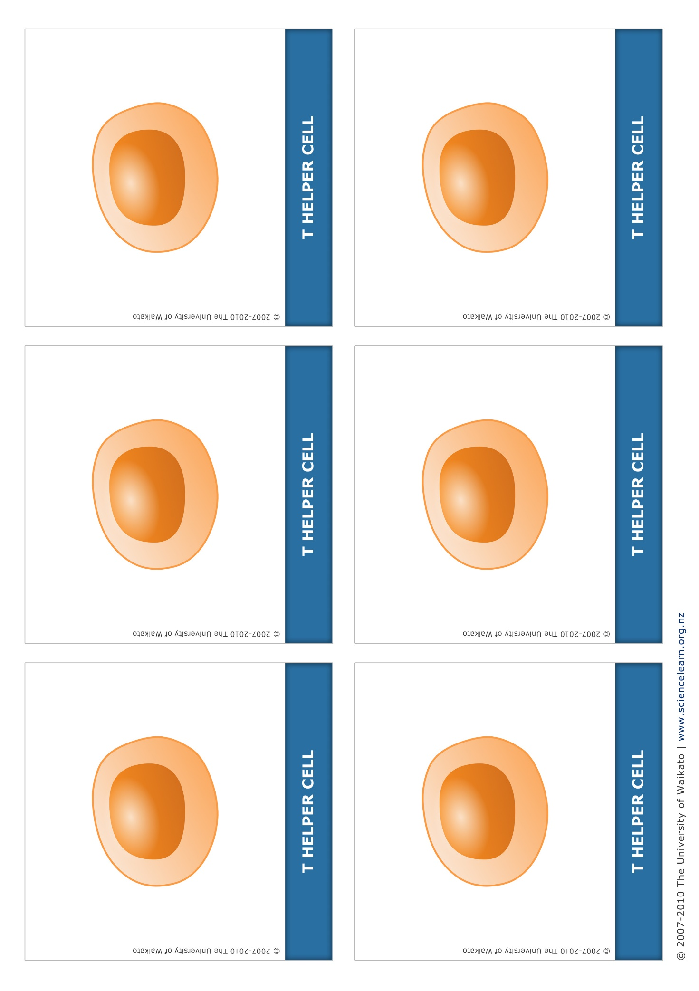
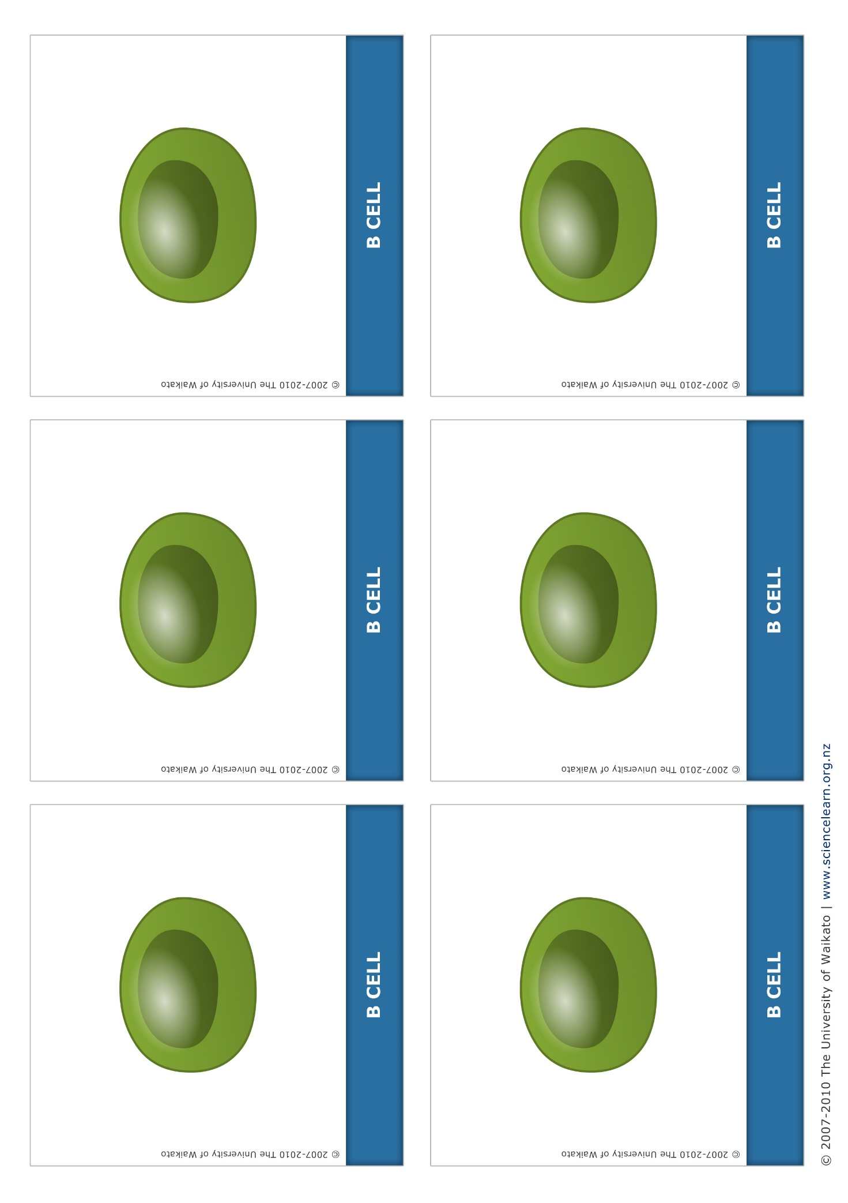
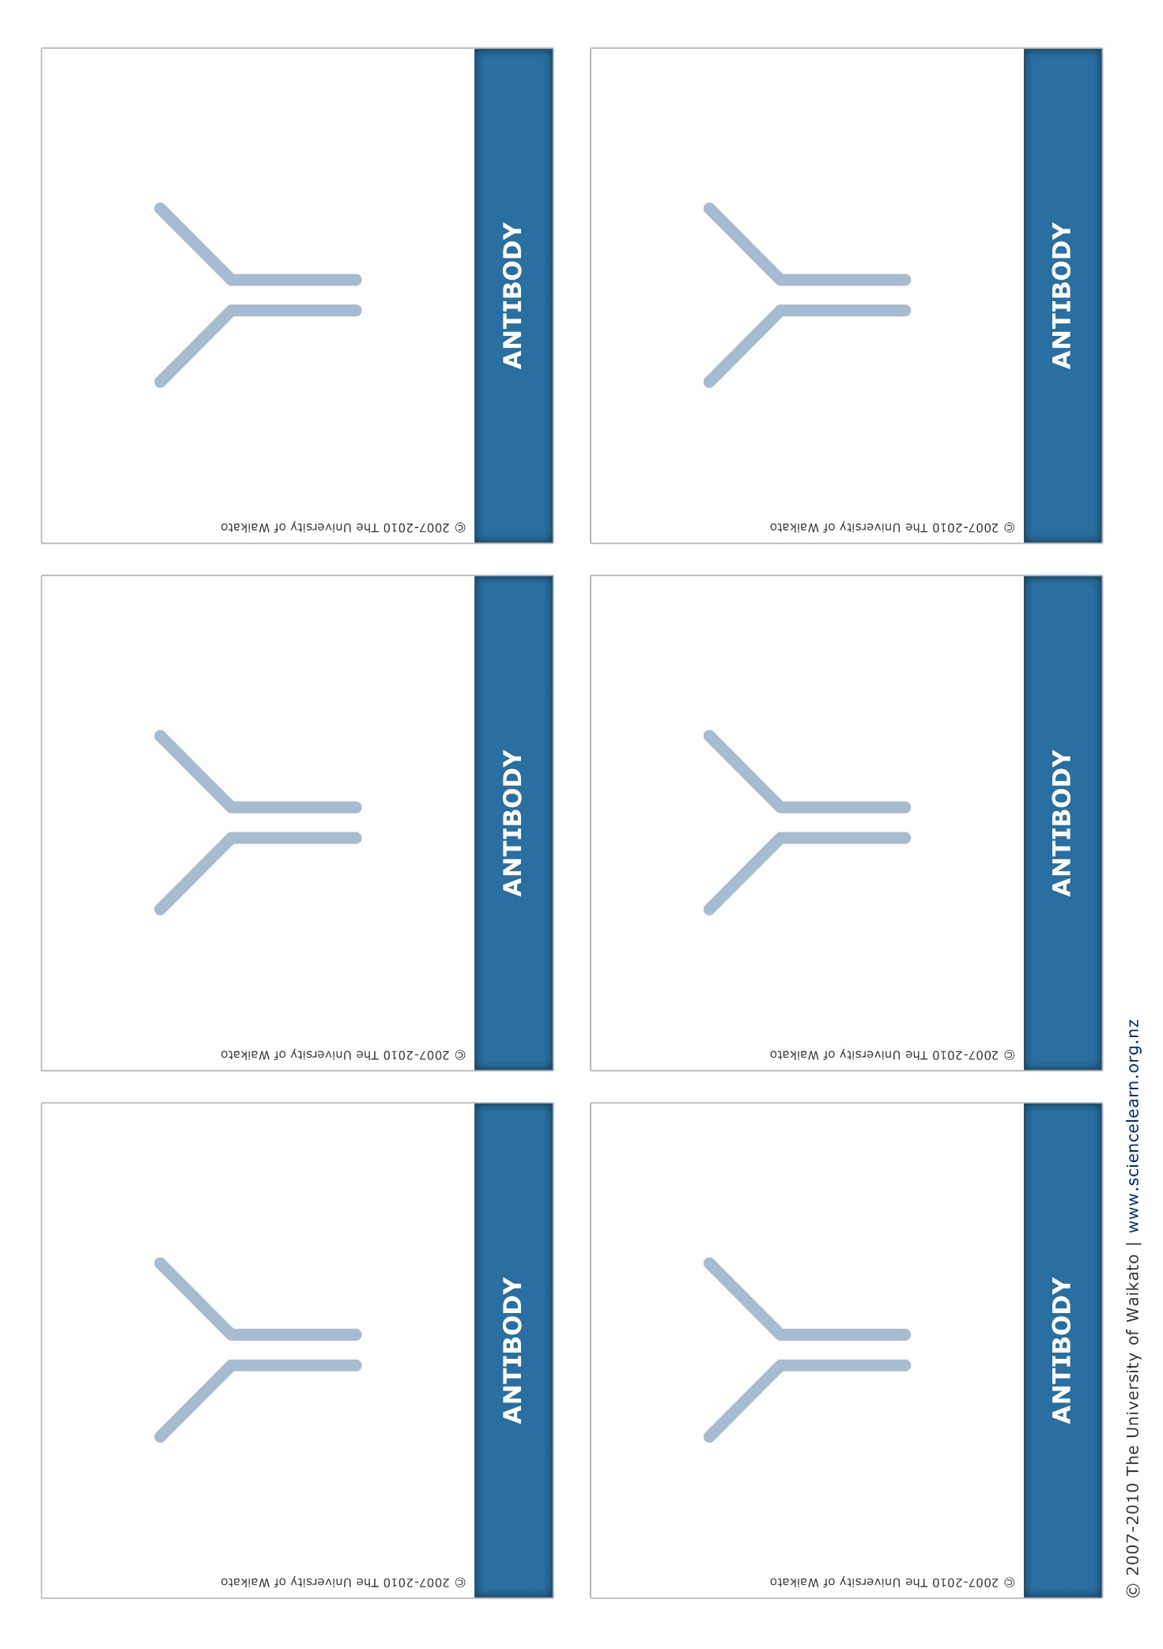
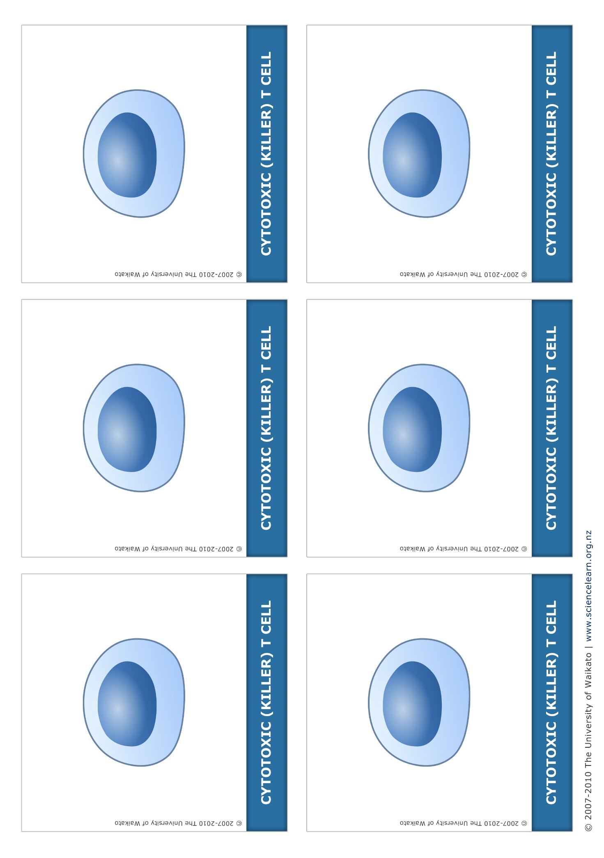
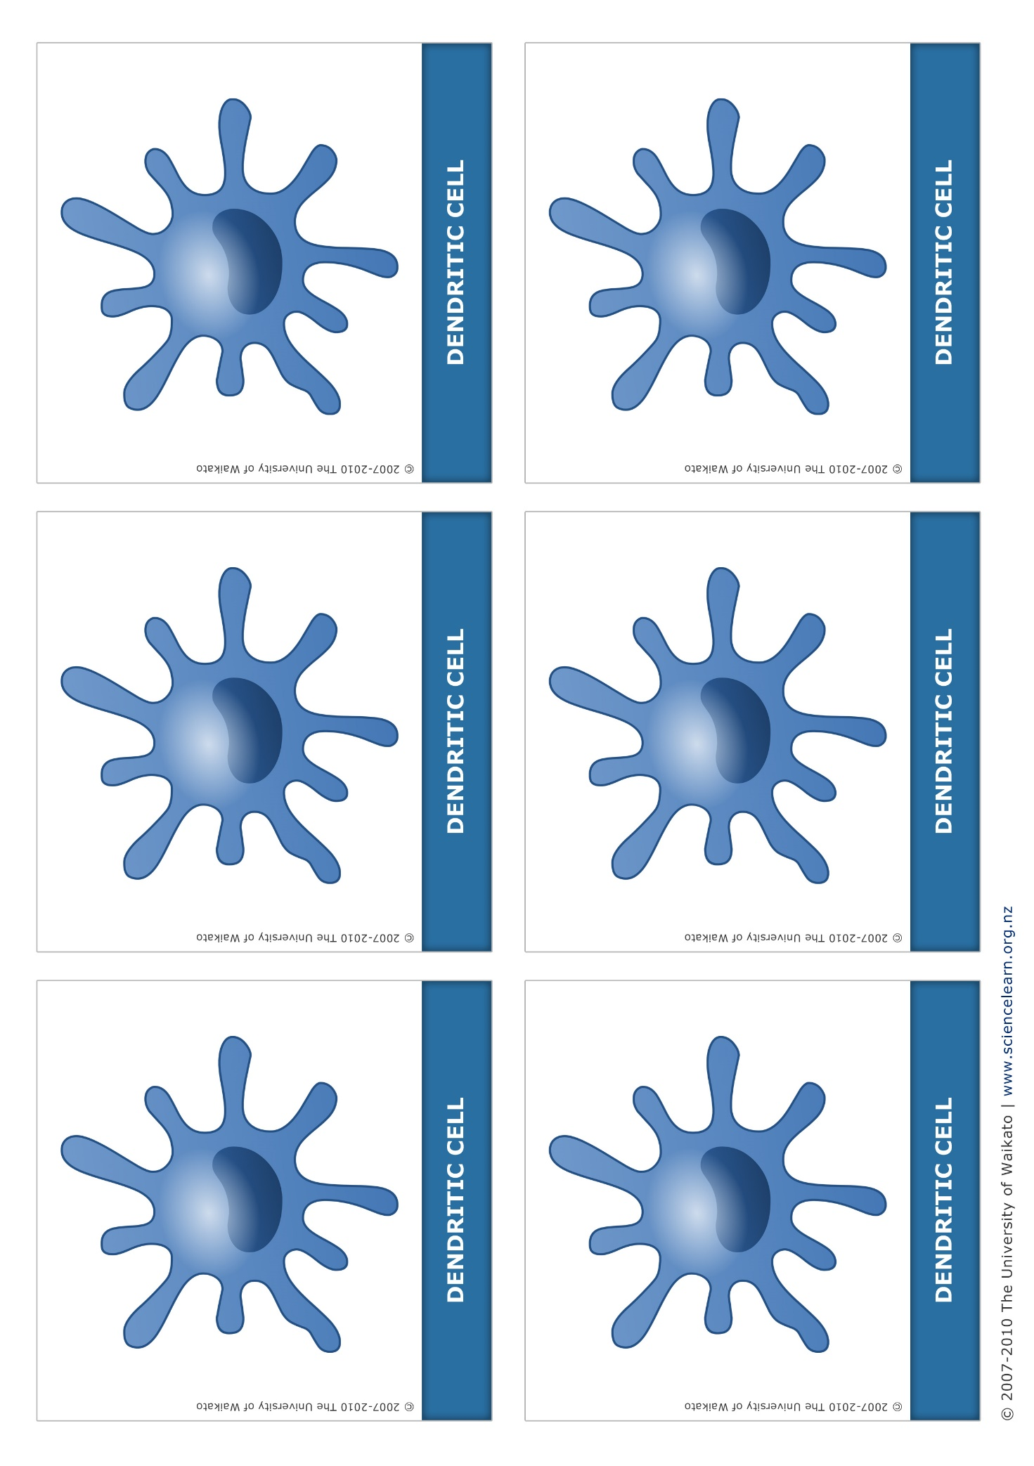
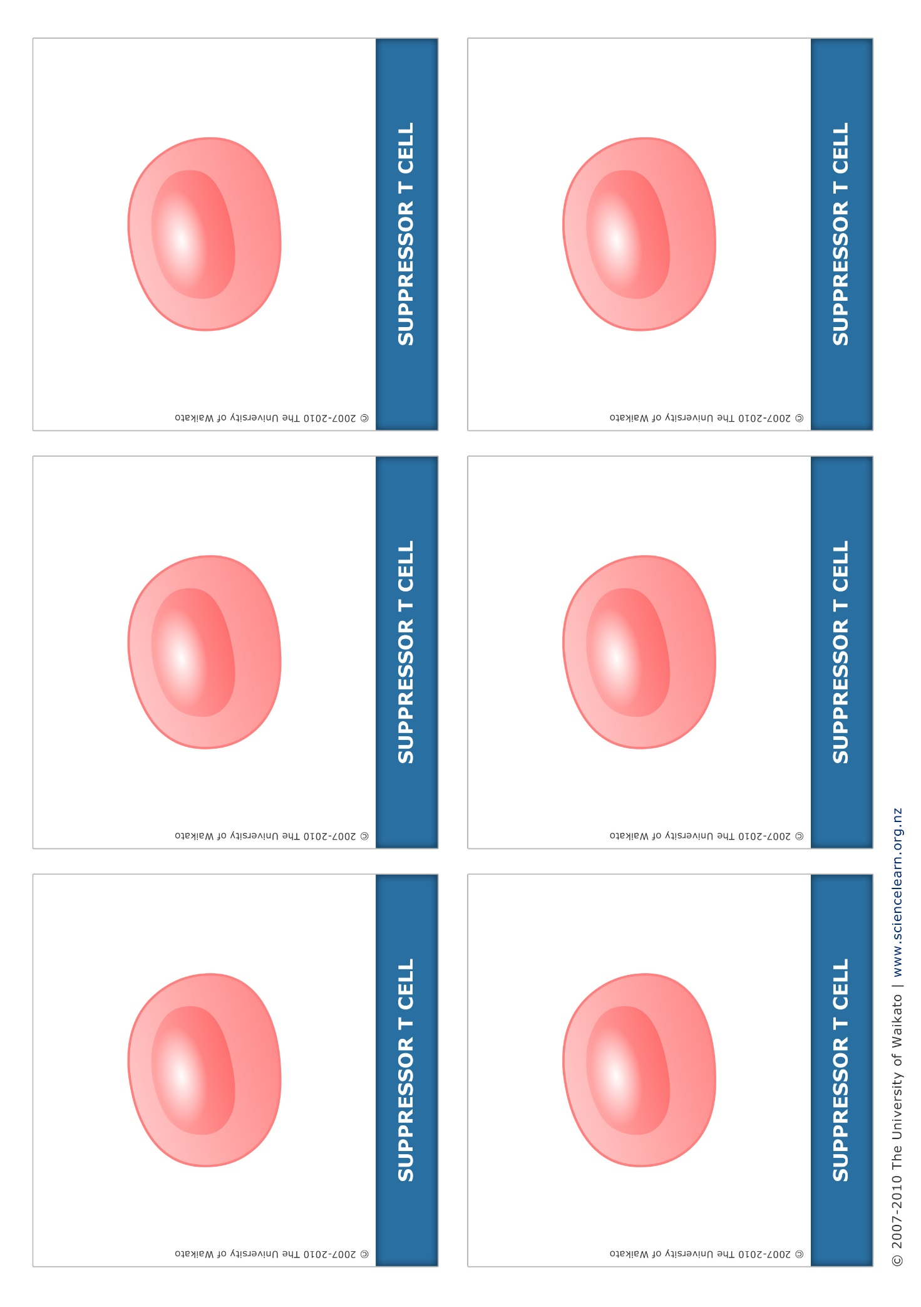
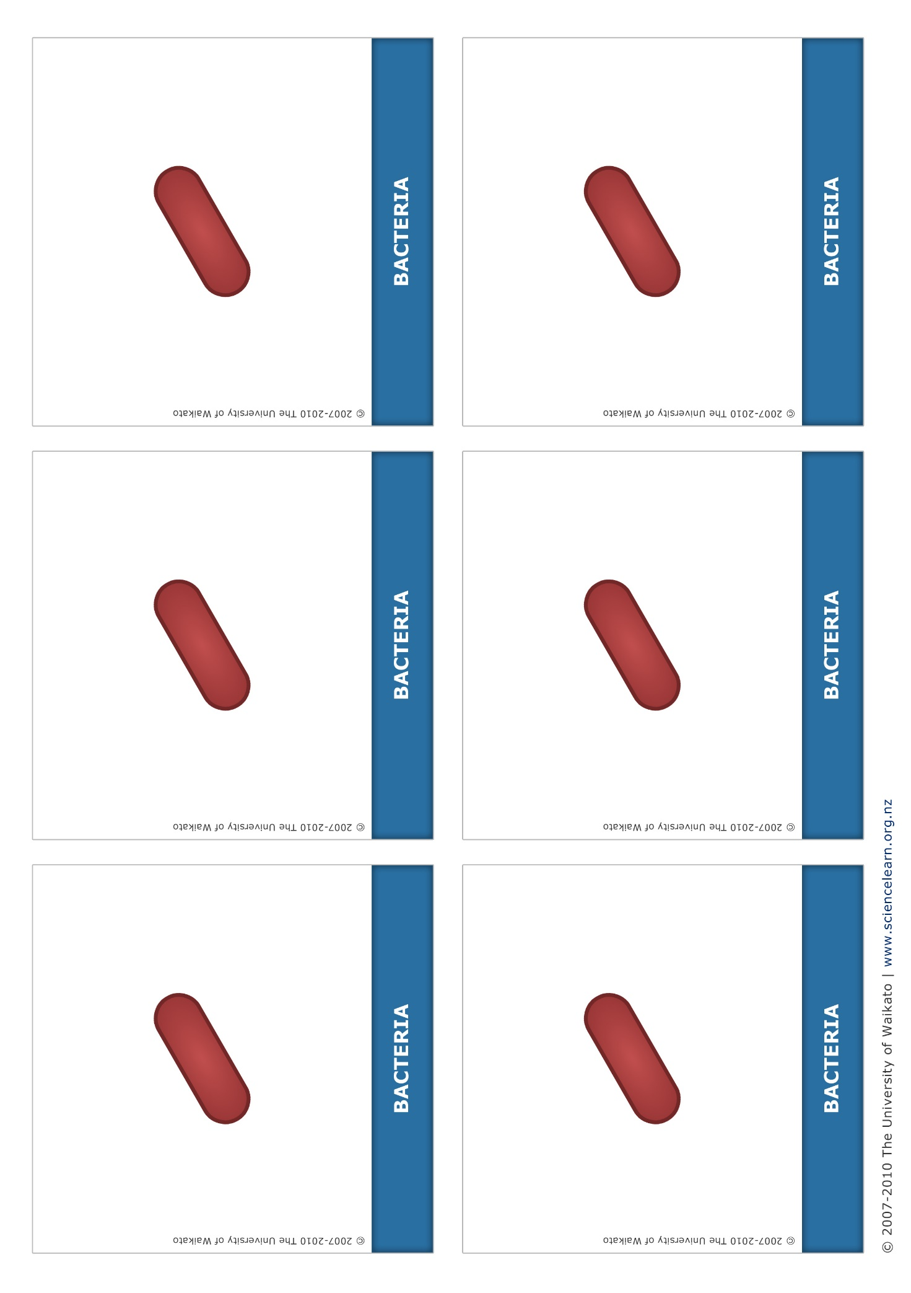
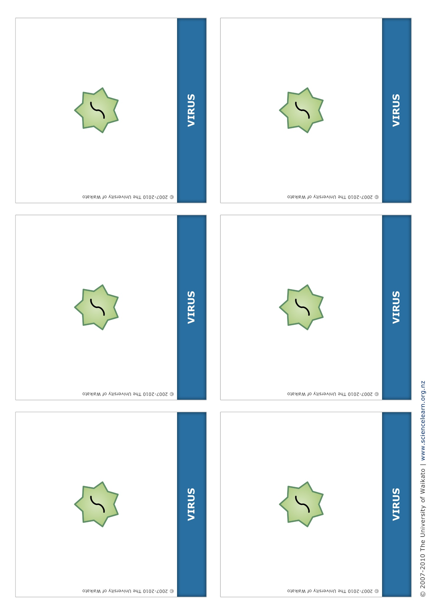

Teacher cards
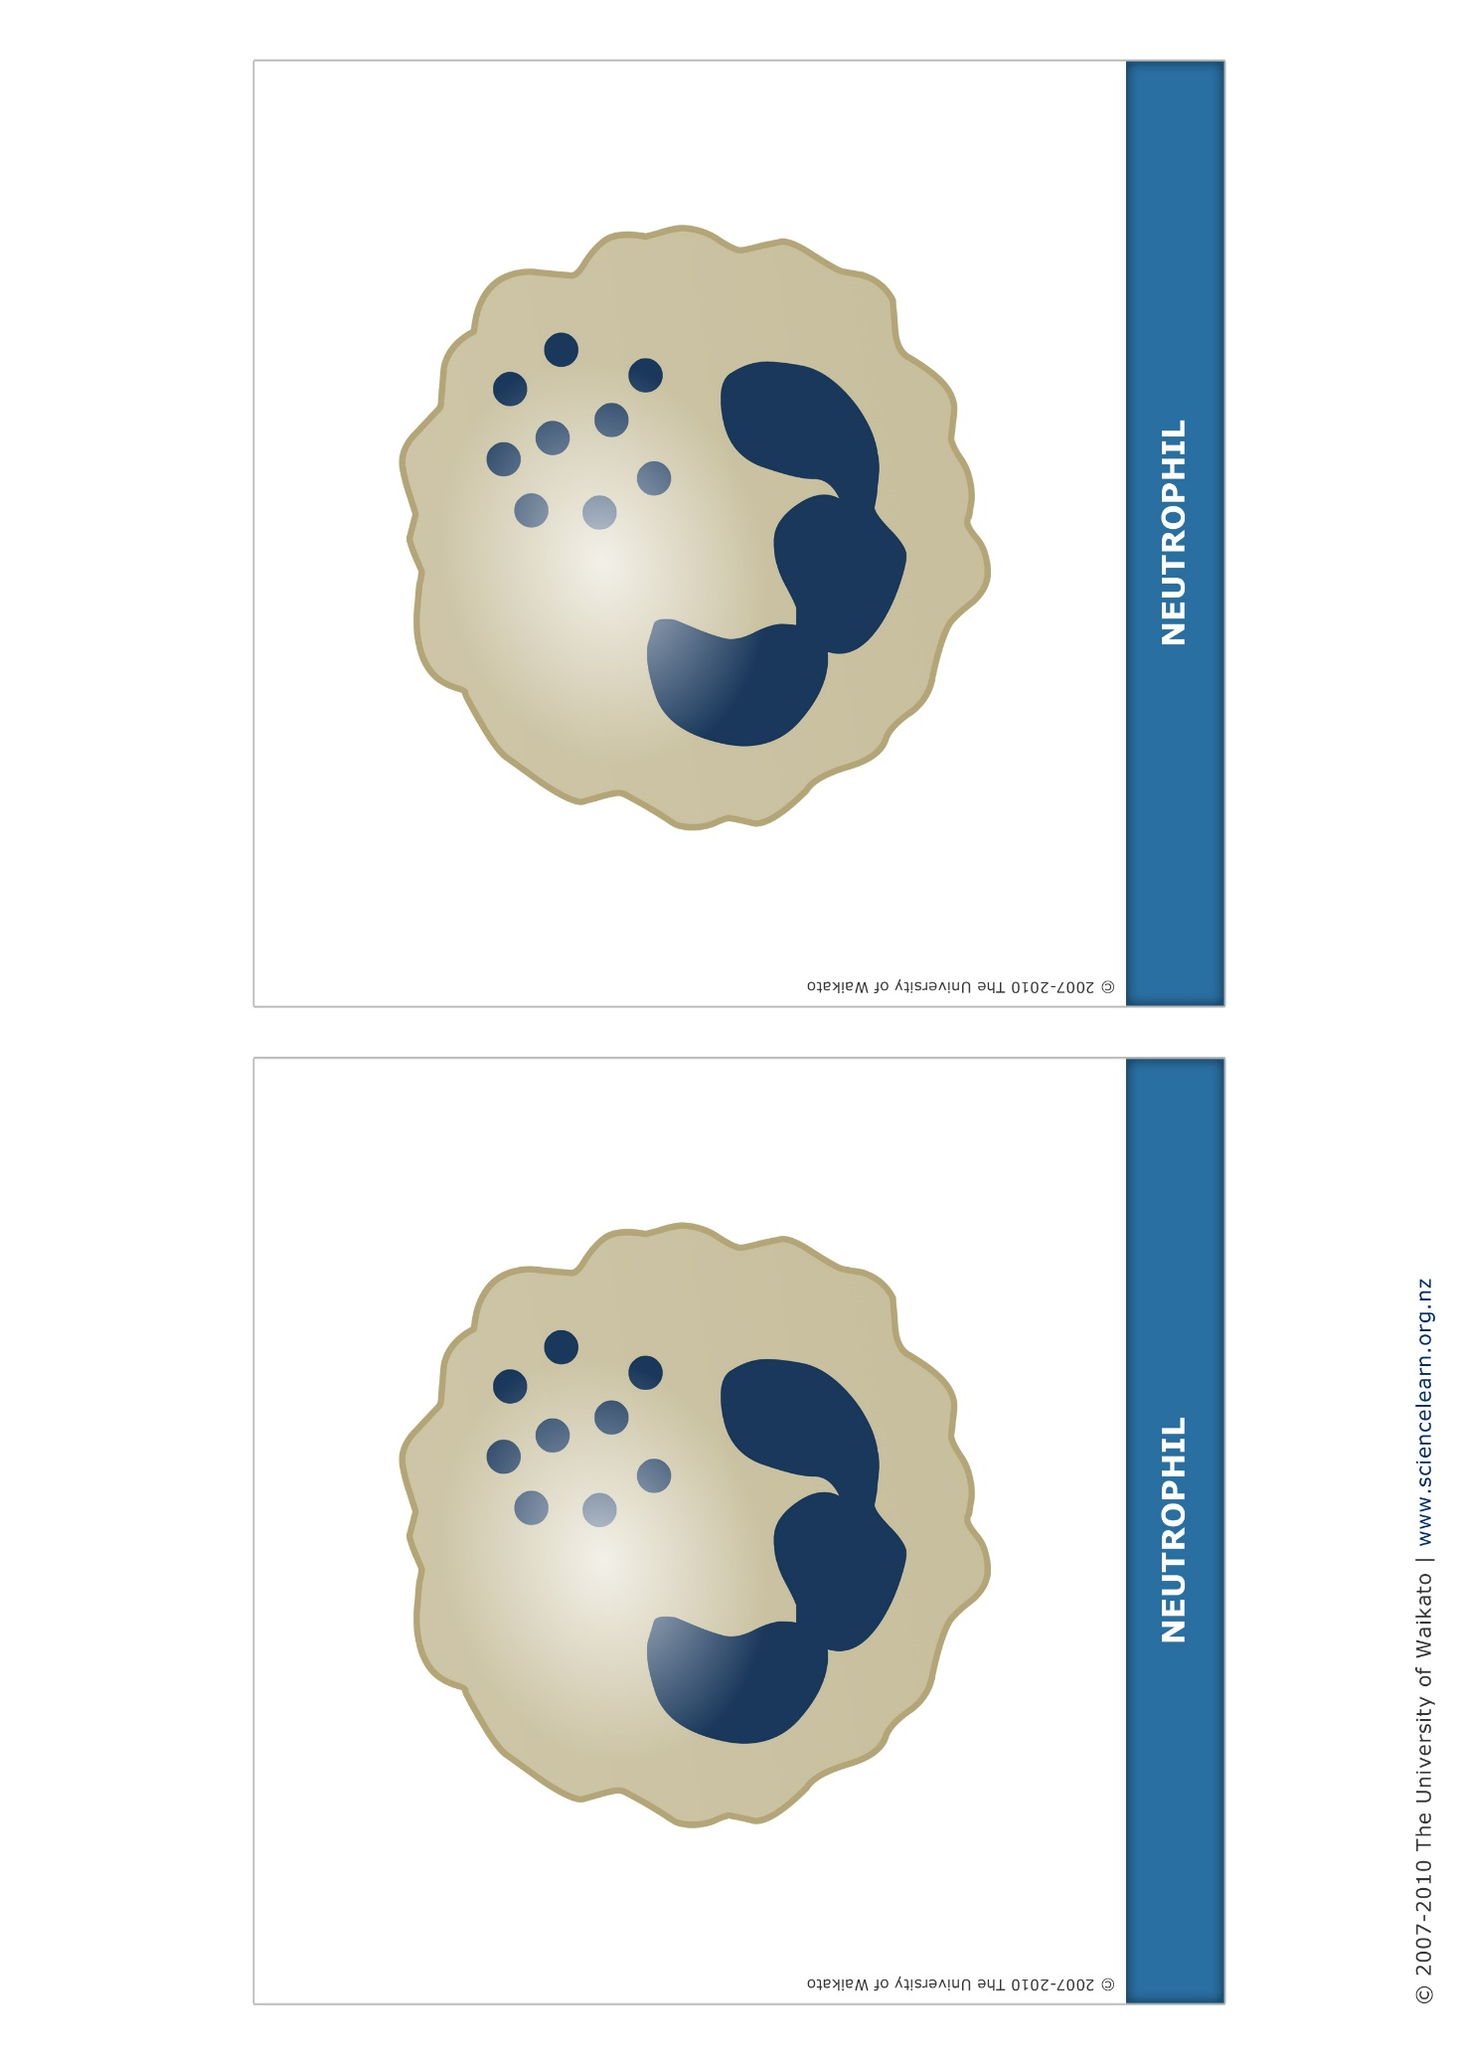
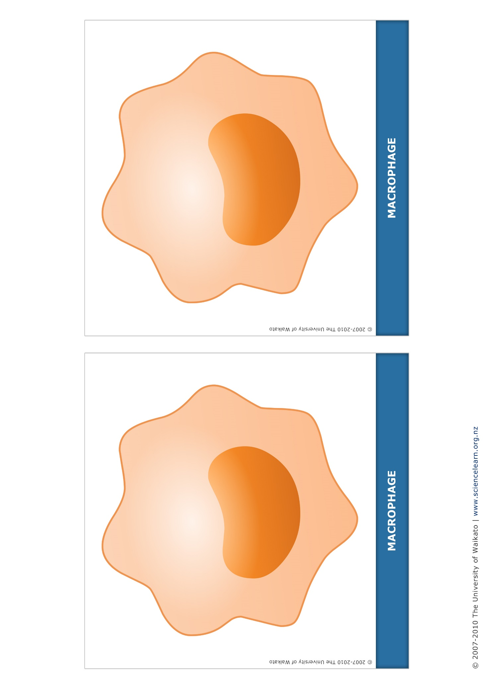
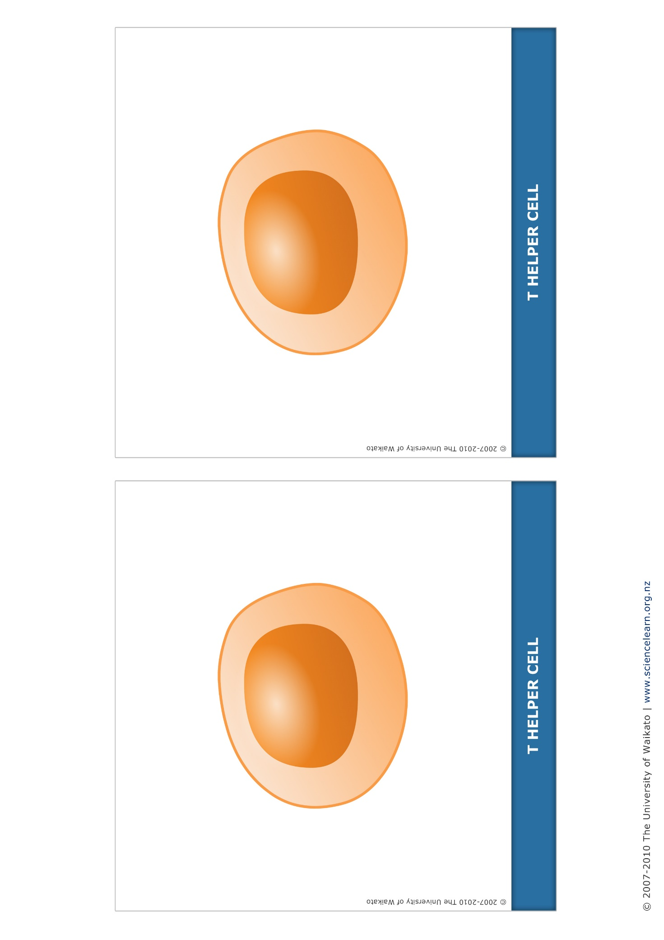
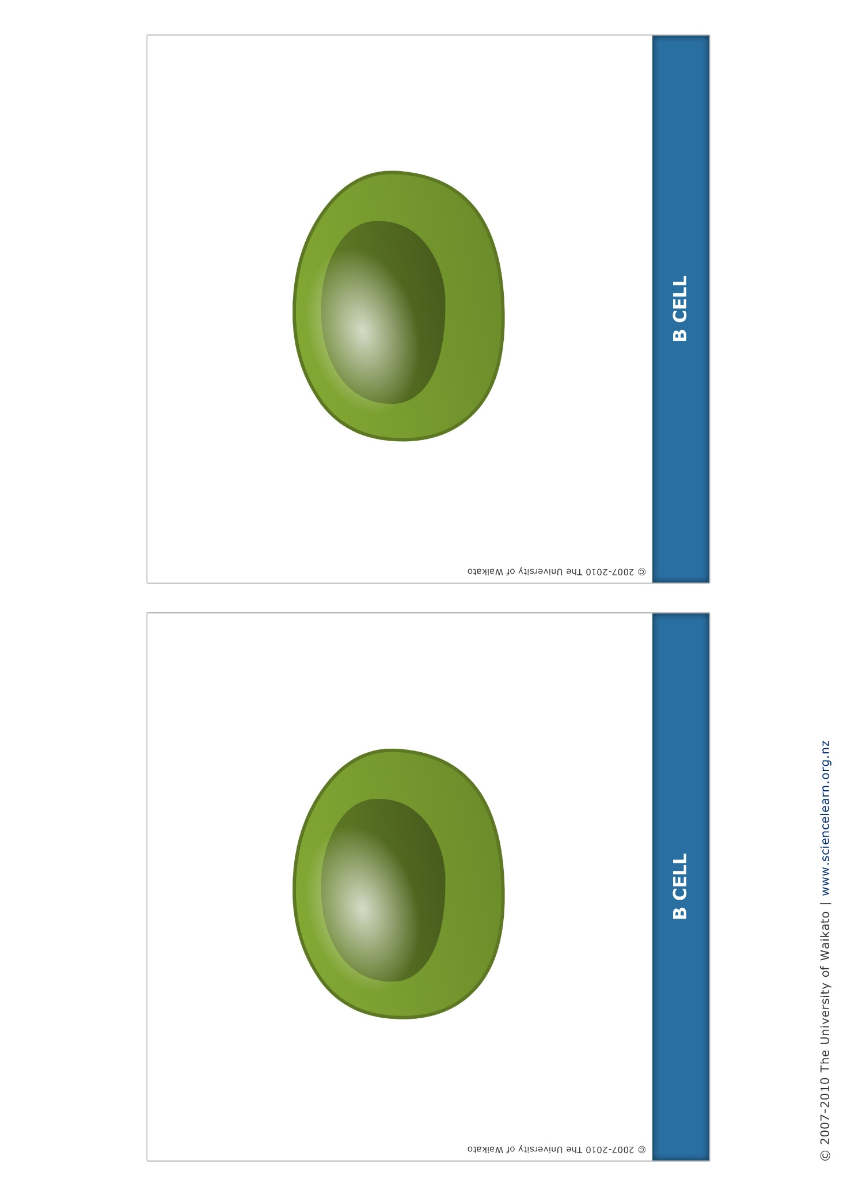
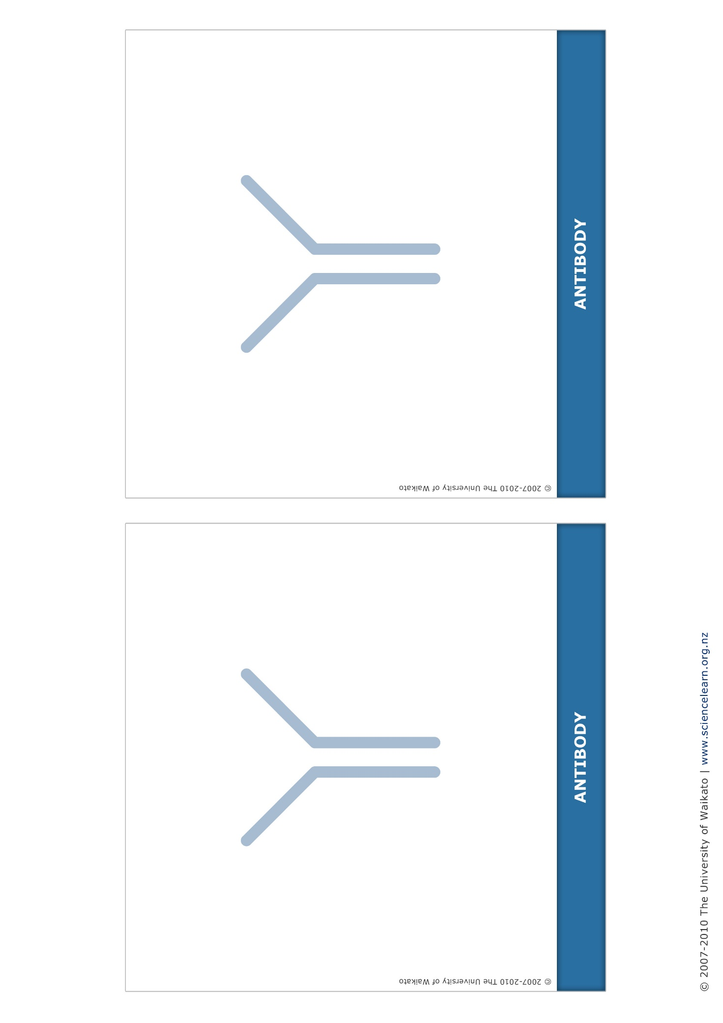
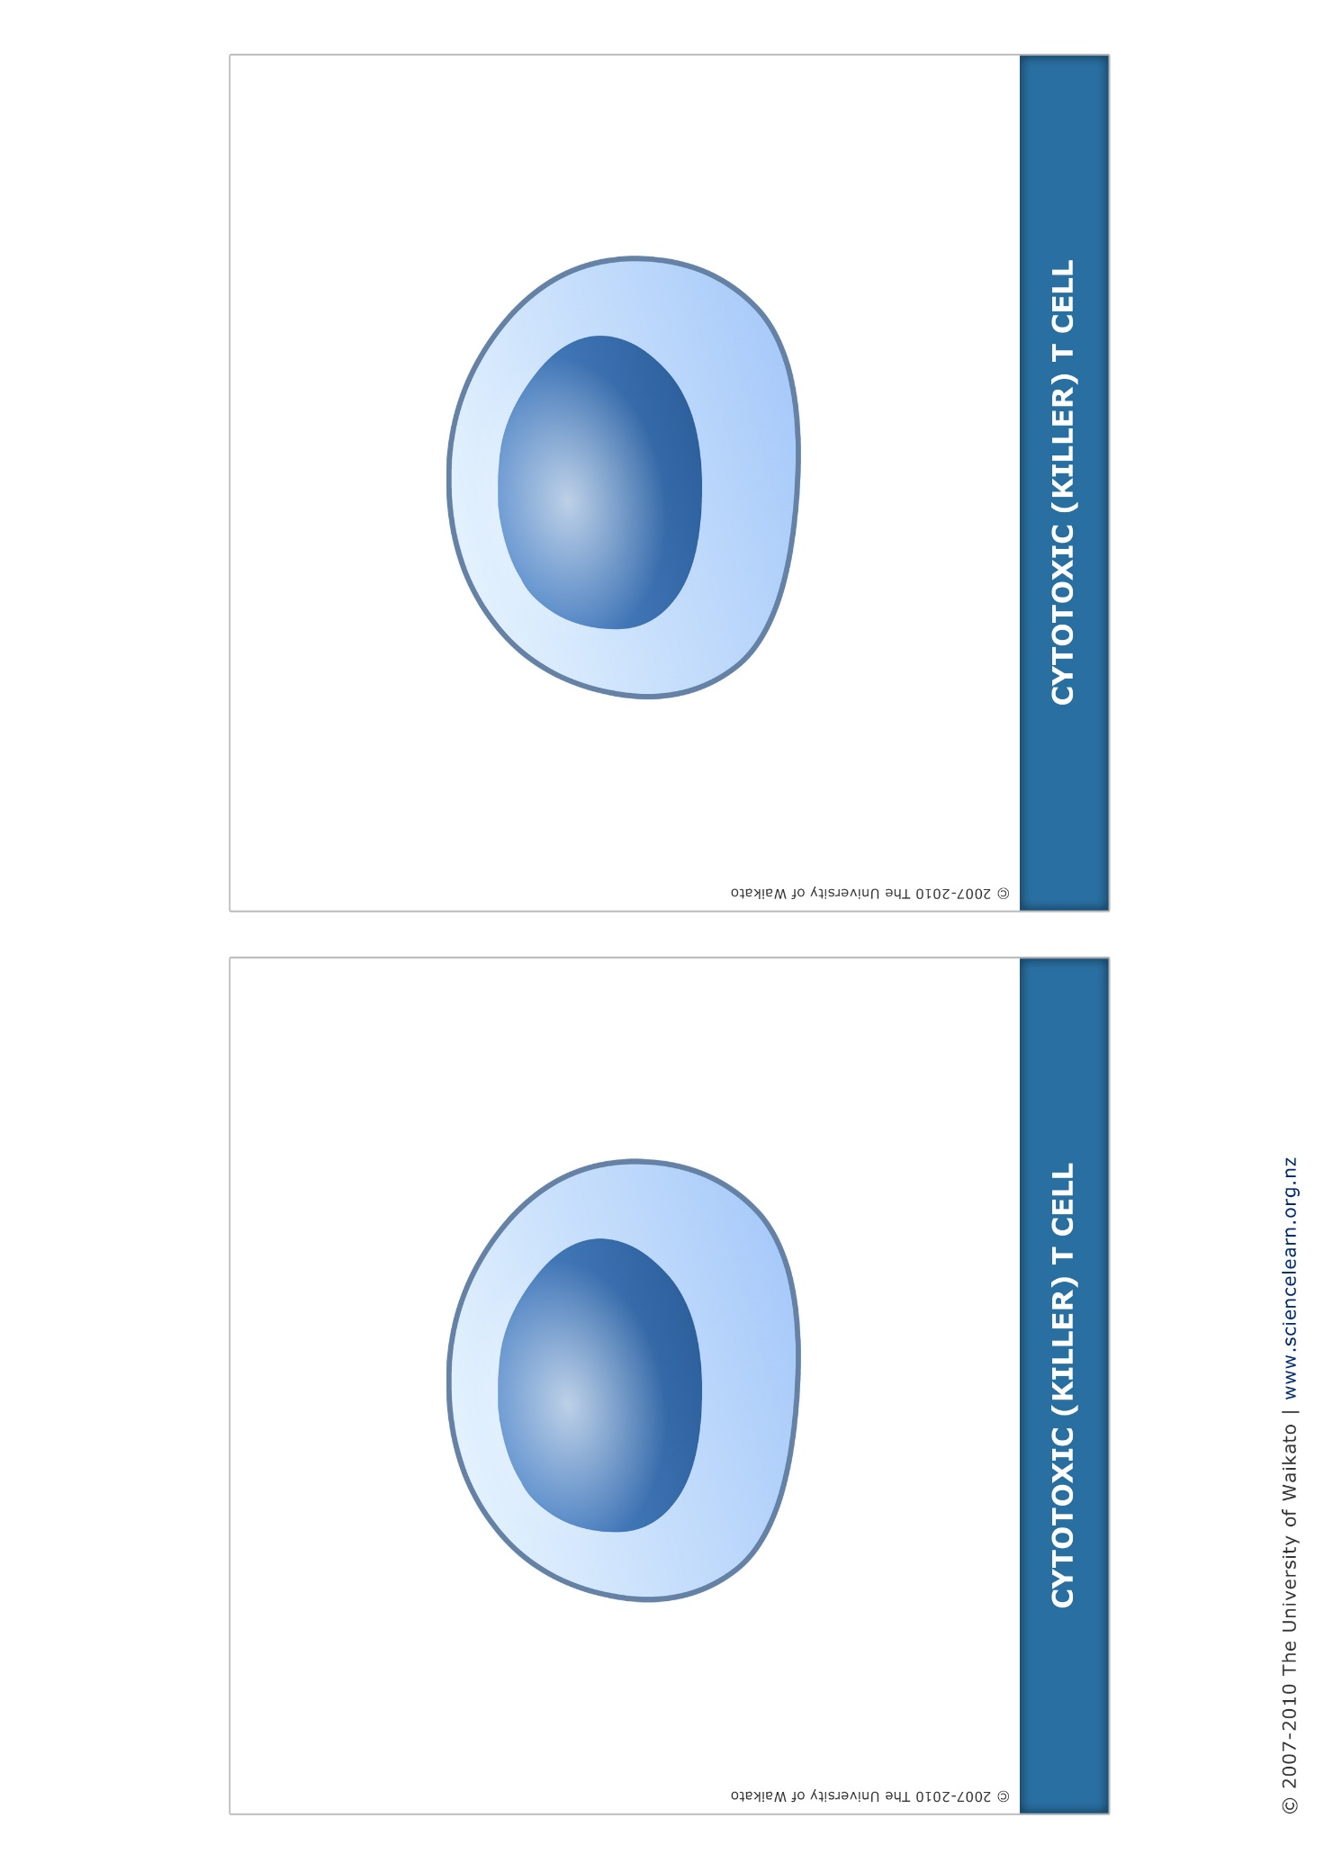
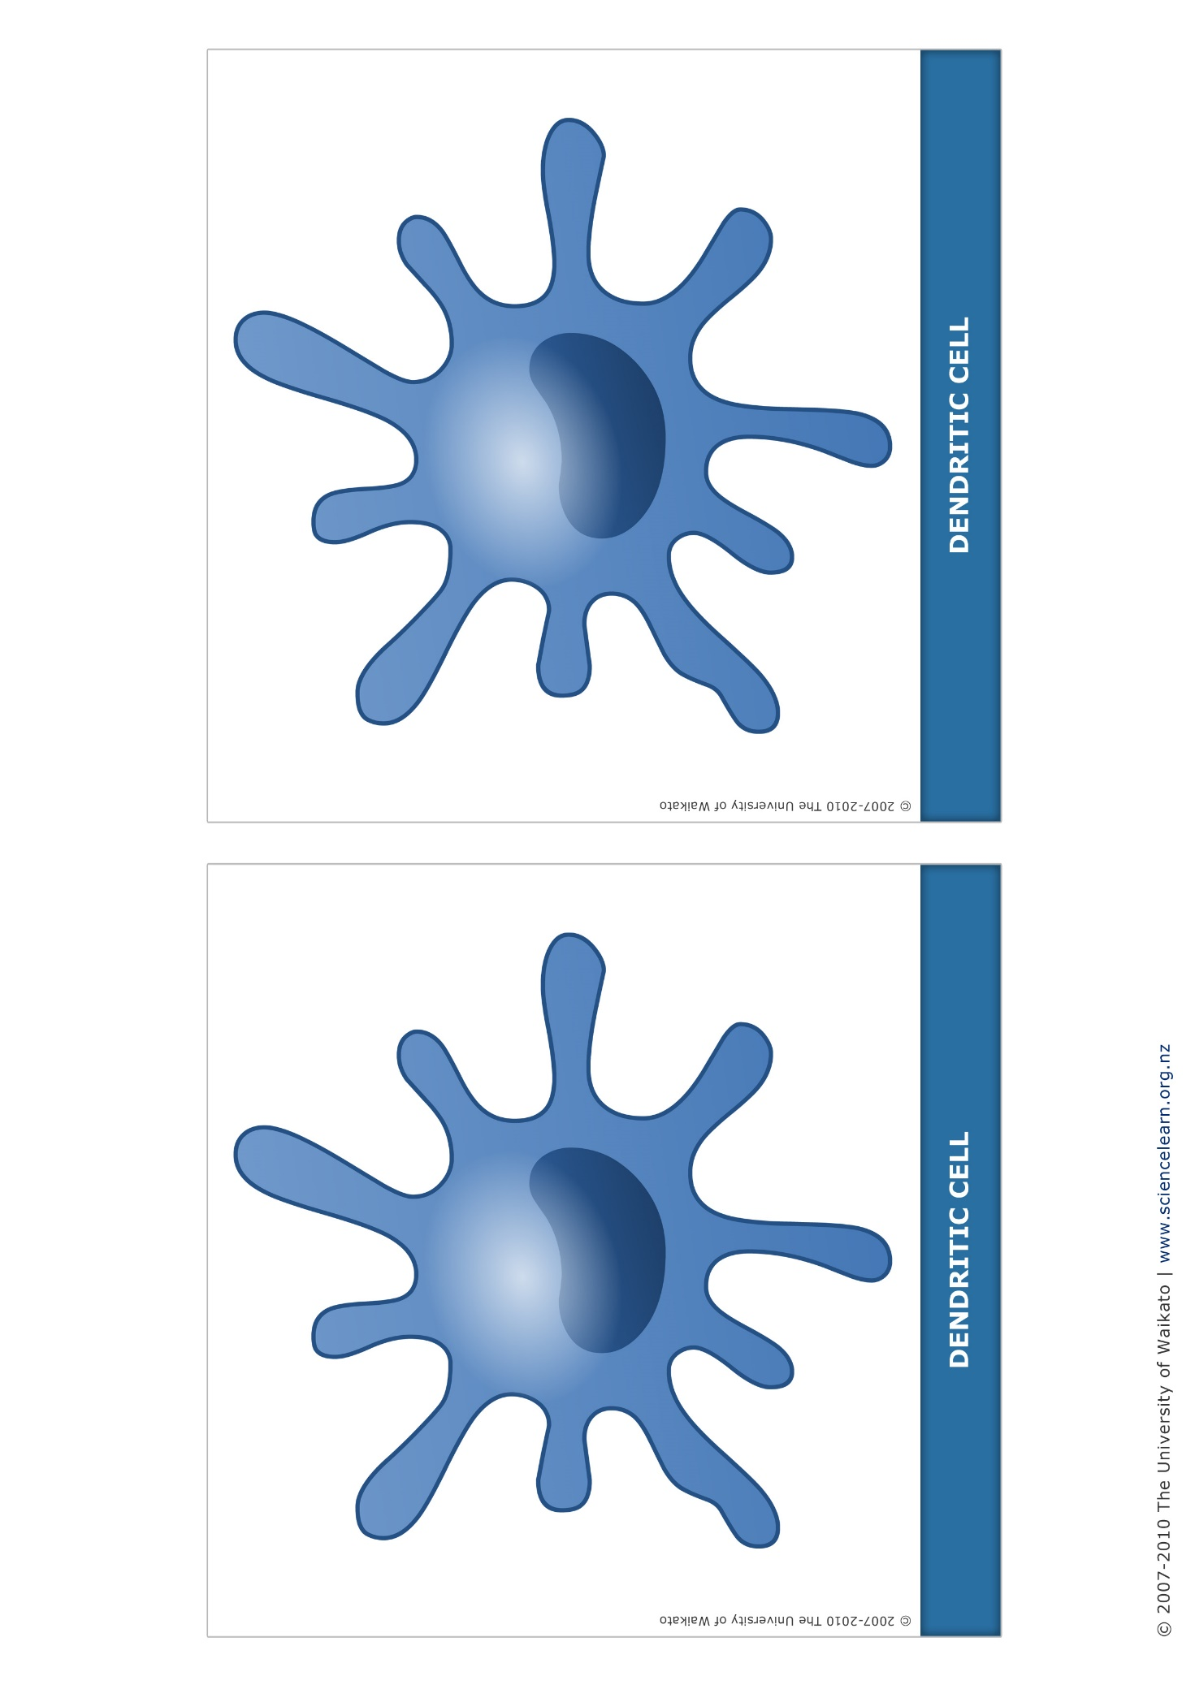
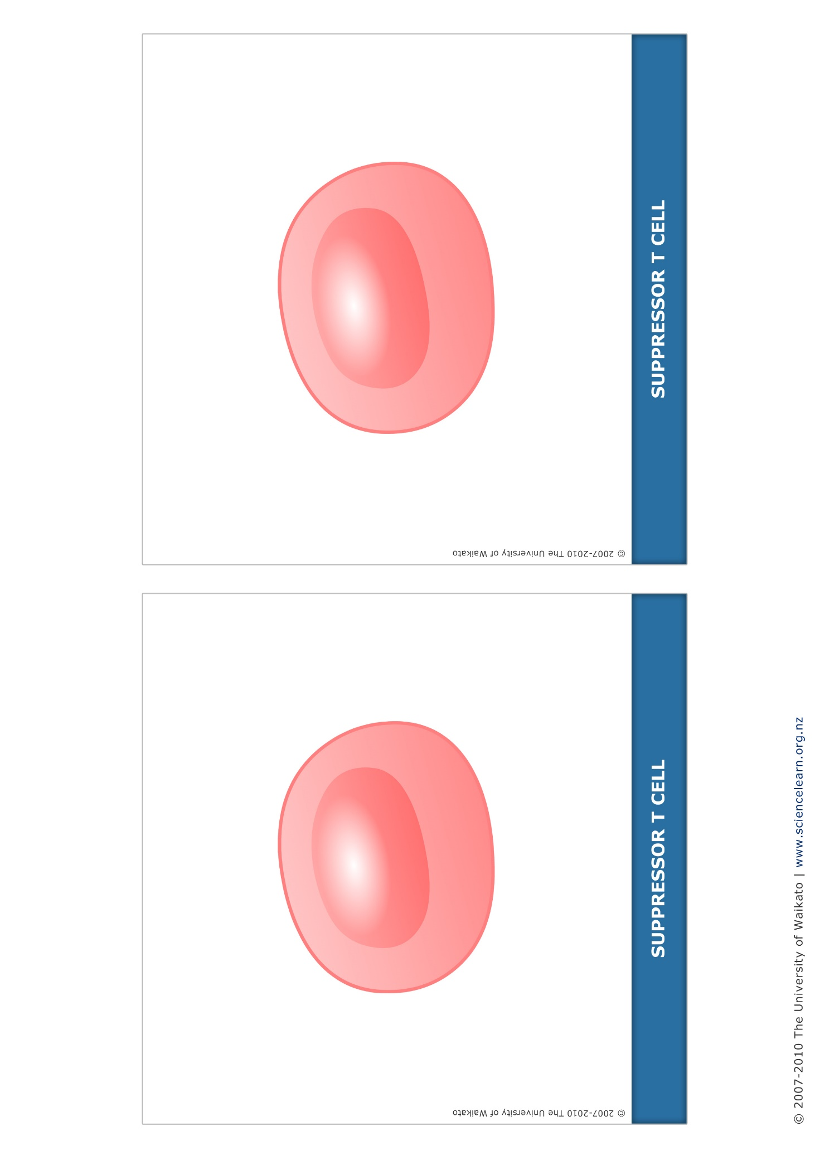
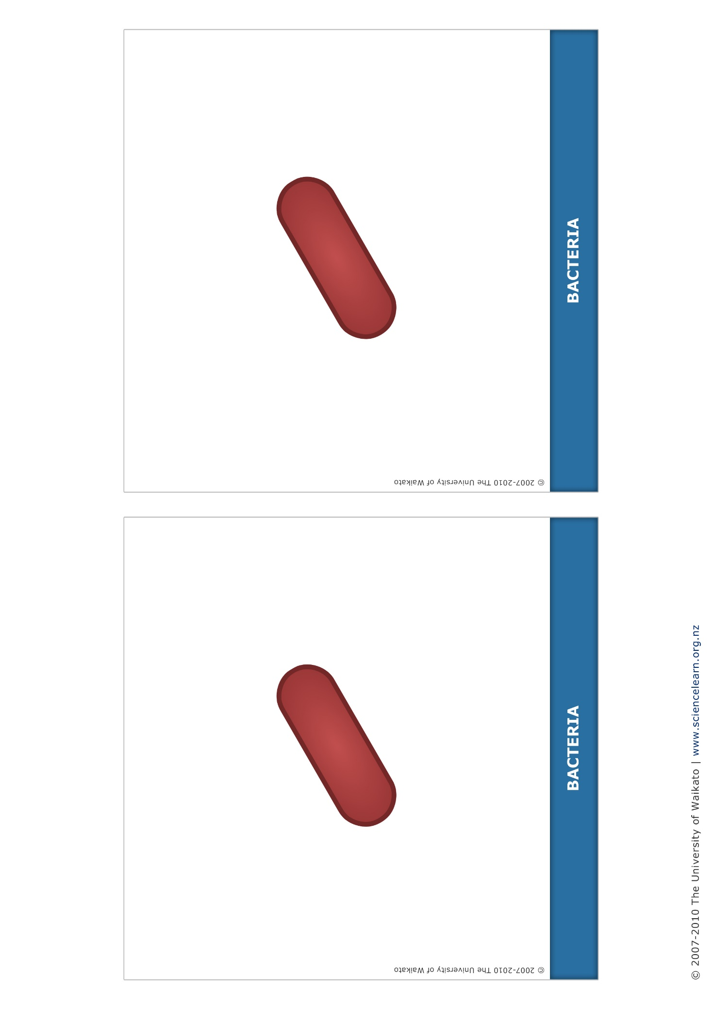
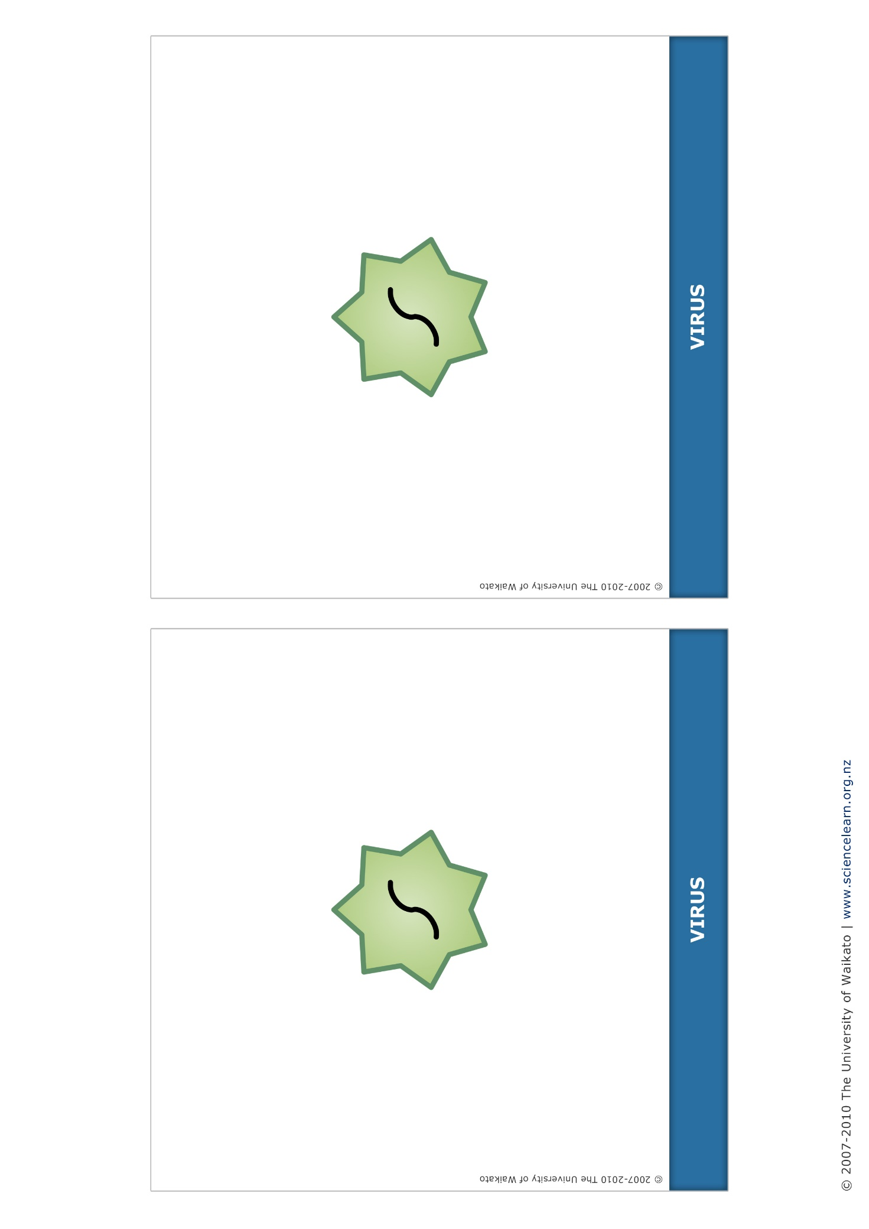
Mind map

