ACTIVITY: Making snot

Activity idea

In this activity, students are hooked into ideas about immunity by making fake snot. Students discover what snot is and how it is an important part of the body’s defence against infection.

By the end of this activity, students should be able to:
- explain what mucus (snot) is and how it’s an important part of the body’s defence against infection.
- Discuss how/why scientists use models to explain science concepts.

Introduction/background
What you need
What to do
Fake snot recipes

Introduction/background

As disgusting as it might sound, get your students to make some fake snot! It’s a fun activity (for most students) to engage them and get them thinking about what snot actually is and why the body makes it.

Snot is simply mucus that is produced by a special membrane in the nose. The purpose of snot is to trap dust particles, germs and pollen that are inhaled and to prevent them from getting into the lungs. When the inhaled particle and the surrounding mucus that surrounds it dry and solidify, you get what most people call ‘bogeys’.

Runny noses and lots of snot can be really annoying during the winter. Colds and flu can lead to increased nasal mucus production, but even those in good health can find themselves sniffing and snotting when they walk from the cold outside air into a well heated room. This is because mucus will thicken outside in the cold, but in a heated room, the mucus thins and becomes runny.

Normally the mucus is a clear, thin fluid, which filters the air that you breathe. If your snot turns yellow, it means you have an infection. If it becomes green, your infection has got worse and it’s time to visit the doctor.

We actually produce a cupful of nasal mucus every day, and much of it ends up getting swallowed!

Here are four recipes for making snot. It gives you a choice depending on what ingredients you might have at hand. The first one uses protein and sugar, which is what real snot is mostly made of – though, of course, it is made from different sugars and proteins. The long, fine strings you can see in your fake snot when you move it around are protein strands. These protein strands make snot sticky and capable of stretching.

The second recipe works quickly (you have to wait about 30 minutes for the first one) and is effective, but don’t let the students taste or eat it. Borax is sodium borate, which is a mild alkali. It is used in cosmetics and washing powders. Although it’s not poisonous, it’s not good for you either. Students should wash their hands after using it.

The third recipe uses psyllium husks, which are a plant-based product – made mainly of cellulose. Cellulose absorbs water easily and swells into a jelly like substance.

The fourth recipe uses borax and guar gum. Guar gum is a vegetable gum commonly used as a food thickening agent and in gluten-free baking.

What you need

- Access to the article Infection
- Access to the video clip What is snot?
- Access to the YouTube clips
  - How to Make Fake Snot – gelatine and glucose (corn syrup)
  - How to Make Fake Snot – borax and glue
- Fake snot recipes
- Ingredients for chosen recipe

What to do

- Ask students what they think snot is and what it is for before making it. Collate ideas.

- As a class, read the article Infection and discuss:
- What is infection?
- Why do people sneeze and cough?

- As a class, watch the video clip What is snot? and discuss:
- Why is snot a good thing?

- If you choose to make the first recipe, watch the YouTube clip How to Make Fake Snot. (The recipe below makes a smaller amount.) Discuss what was done and if appropriate to your students’ abilities and understanding, how the model snot is similar/different to actual snot.

- Divide students into groups of 2–3, hand out copies of the appropriate fake snot recipe(s) and ask them to make fake snot according to the recipe they have been given. For any of the recipes, a drop of yellow or green food colouring can be added for effect.

- Discuss the texture of their fake snot (stringy, stretchy). Tell students real snot is made of proteins and sugars (just like in recipe 1 – but not the same proteins and sugars, of course). The stringy, stretchy texture of real snot is because of the proteins it is made from.

- Fake snot is a model of actual mucus. Discuss how/why scientists use models in science. Are there other models you know about? (A glove is a model of the Earth, weather charts are models, skeletons, etc.)

- Ask students again what snot is and what it is for. Compare with their original answers.

1. How to make fake snot using gelatine and syrup

What you need

- Hot tap water
- A cup
- A teaspoon
- Gelatine
- Glucose syrup or corn syrup
- A fork

What to do

- Put 50ml of hot tap water in a cup.

- Add 6 teaspoons of gelatine.

- Stir.

- Leave for 20–30 minutes.

- Add a spoonful of glucose syrup or squirt of corn syrup.

- Trail fingers or fork through the mixture.

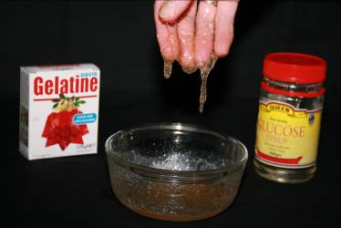
2. How to make fake snot using borax and glue

What you need

- Glue – gel glue gives translucent, slimy snot; white glue gives opaque snot
- Teaspoon
- 10–15 small dishes or saucers
- Warm water
- Borax solution – stir 1 tablespoon of borax powder (you can get borax from a pharmacy) into 250ml warm water. (This will be enough for the whole class.)

What to do

- Put 2tsp of either white or gel glue into a small dish.

- Add 3tsp of water.

- Stir.

- Add 1tsp of the borax solution to the glue mixture.

- Stir or squish. The mixture will react immediately. As the mixture firms up, you could divide it up and share your snot among your group.

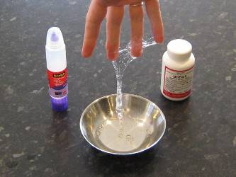
3. How to make fake snot using psyllium (Metamucil)

What you need

- Psyllium husks (you can buy Metamucil from the supermarket)
- Spoon
- Water
- Cups

What to do

- Add some psyllium husks to water in a cup.

- Trail your fingers through the mixture – try to pick it up. It has snot-like properties.

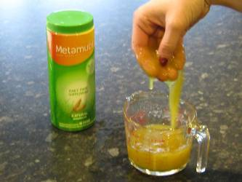
4. How to make fake snot using guar gum and borax

What you need

- Coloured guar gum solution – mix 2 teaspoons of guar gum in 1 litre of water and a couple of drops of green food colouring
- Borax solution – 1 tablespoon of borax in 1 cup of water
- Zip lock bags

What to do

- Pour half a cup of coloured guar gum solution into the bag.

- Add 1 teaspoon of borax solution.

- Seal the bag.

- Move the contents around – rub and squeeze between your hands.

- Tip the ‘snot’ out to see what it feels like.

