ACTIVITY: Obesity risk factors

Activity idea

In this activity, students participate in a simulation that demonstrates that both genetic make-up and environmental factors influence an individual’s likelihood of becoming obese.

By the end of this activity, students should be able to:
- describe some of the factors that contribute to obesity
- explain that the likelihood of becoming obese has a genetic component that can be positively or negatively influenced by environmental factors
- describe some possible lifestyle changes that can help to maintain a healthy weight.

Acknowledgement: This activity was adapted from Risk Continuum, a resource created by the Genetic Science Learning Center, University of Utah (http://learn.genetics.utah.edu).

Introduction/background notes
What you need
What to do
Discussion questions
Extension ideas
Lifestyle cards

Introduction/background

Obesity is simply defined as having too much body fat for your particular weight or height. It is usually measured by an internationally recognised system known as body mass index (BMI). BMI is calculated by comparing your height to your weight.

There are many different factors that contribute to obesity. An average figure from research studies estimates that obesity is about 40% genetic and 60% due to environmental factors.
Environmental factors refer to things like the types of food you eat, how much food you eat, amounts of sugary drinks consumed, fruit and vegetable consumption, physical activity level, television viewing, computer use, the type of job you have and the sports you play. The impact of these factors is different for everyone. For some people, the most effective technique to prevent or reduce obesity might be to reduce food portion size. For others, it might be to cut out sugary drinks or increase physical activity. This makes it difficult to manage obesity on a population or country level, as some initiatives might help some and do nothing for others.

A genetic predisposition to obesity means that some people find it more difficult to maintain a healthy weight than others. We can’t change our genes, but we can make lifestyle choices that can help us reduce our likelihood of becoming obese. An awareness of environmental or risk factors for obesity is an important starting point.

Special note
Obesity is obviously a sensitive topic for many. The teacher resource Managing classroom discussions may provide some useful tips to facilitate a respectful discussion. Alternatively, you may choose to alter this activity to focus on a different condition, such as diabetes, cancer or heart disease, if this is more appropriate for your class. For example, see the Learn Genetics Risk Continuum activity, which focuses on what it means to be in a risk group for developing heart disease.

What you need

- Enough space for your students to line up facing you, shoulder to shoulder
- Individual lifestyle cards in a suitable bag or container – a class of 30 requires 10 copies of the lifestyle card sheet.
- Access to the video clips Factors that cause obesity and Obesity intervention projects

What to do

- Watch the video clip Factors that cause obesity and discuss as a class, using the following prompt questions:
- What is obesity?
- What are some of the factors that increase a person’s risk of becoming obese?
- How much of your risk is genetic?
- What does Rachael mean by viewing your genes as an optimist or a pessimist?

- Ask the students to line up facing you, shoulder to shoulder.

- Explain to the students that they now represent people in a continuum that simulates the likelihood of becoming obese. Divide the line roughly into thirds based on genetic risk groups – high risk, medium risk and low risk. Ask students to remember what genetic risk group they are in.

- Discuss what is meant by genetic risk or genetic predisposition and ask students for their comments.

- Ask students if they can think of any environmental factors that can influence the likelihood of becoming obese.

- Ask each student to choose a lifestyle card without looking.

- Have one student at a time read out what type of card they have and adjust their place on the risk continuum. (Divide the total number of students by 6 to calculate the number of spaces to move, for example, 30 students ÷ 6 = 5 spaces.)
- Positive – move x spaces to the right.
- Neutral – remain in the same spot.
- Negative – move x spaces to the left.

- Repeat with each student until a new continuum is formed.

- Divide the line into 3 categories again – high likelihood of obesity, medium likelihood of obesity, low likelihood of obesity.

- Ask students to comment on whether their risk of becoming obese has changed based on their lifestyle card.

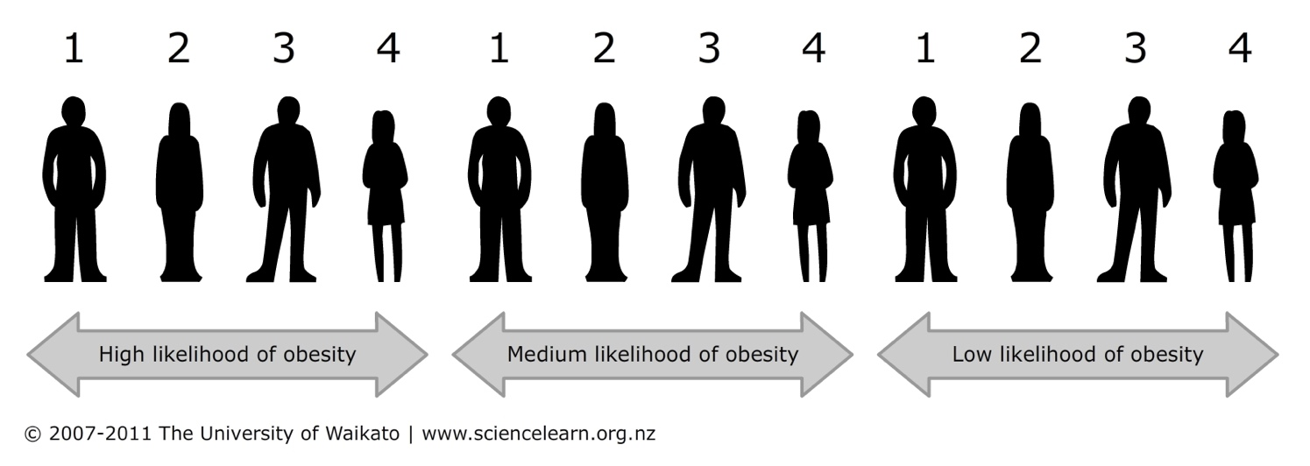
- Within each third, ask the students to number off from 1–4. (It doesn’t matter if the groups don’t contain whole multiples of 4.)

- Ask the following students to sit down:
- In the high likelihood of obesity group: all number 1s.
- In the medium likelihood of obesity group: all number 1s and 2s.
- In the low likelihood of obesity group: all number 1s, 2s and 3s.
The students standing represent the people who have become obese. The students sitting represent the portion of people in each group who have not become obese. (In some cases, someone who has high genetic risk and negative lifestyle choices may not become obese due to other factors.)
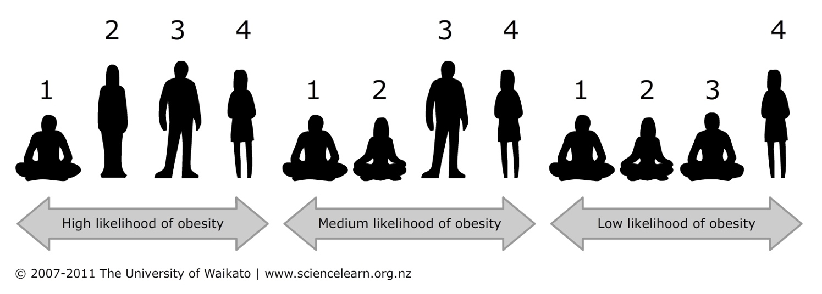
Discussion questions

- What determined the initial risk group you were in?
- Did you have any control over this? Do you have any control over your genes?
- Which group had the highest number with obesity? Why do you think that is?
- Did anyone in the high-risk group not develop obesity? Why do you think that is?
- Did anyone in the low-risk group develop obesity? Why? What other factors could have been involved?

Extension ideas

- Watch the video clip Factors that cause obesity again. Class discussion: why do you think obesity is on the rise in New Zealand and worldwide?
- Watch the video clip Obesity intervention projects. In pairs or small groups, ask students to brainstorm their ideas for an intervention project that they think would work for teenagers in New Zealand. Ask groups to share their ideas with the class.

Lifestyle cards
