ACTIVITY: Kites

Activity idea

In this activity, students will learn about types of kites, some kite history and how kites fly before making and flying a kite themselves.

By the end of this activity, students should be able to:
- use some kite terminology when discussing kites
- demonstrate a basic understanding of how kites fly
- make a kite
- fly a kite.

Introduction/background notes

What you need

What to do

Sled kite instructions

Introduction/background

Kites are some of the earliest known flying machines. History books record that the Chinese first built kites around 1000 BC. Ancient Māori also made and flew kites (see Flight mythology).

There are many different types of kites. Fast fighting kites that don’t have tails come from Korea and Japan. An Australian, Laurence Hargrave, invented the box kite in 1892. These kites were used for holding radio aerials aloft during air-sea rescues. Kites have been used for many applications, for example, signalling over vast distances, providing military observation, fishing, measuring and discovering the secrets of the atmosphere, pulling sleds and kiteboarding.

Kite vocabulary
- Bridle – the towing line attached to the kite.
- Flying line or tethering string – the line attached to the bridle that you hold to fly your kite.
- Centre of pressure – the aerodynamic force (a combination of the lift force and the drag force) acting on the kite.
- Frame – the structural part of the kite to which the sail is attached.
- Sail – any material used to cover the kite (the wing material).
- Tow point – the connection point for the flying line to attach to the kite.

The science behind kites
A kite is heavier than air so there needs to be an upward force of lift if it is to fly. Most of the force comes from the wind pushing against the face of the kite sail. For this, the kite must be at the right angle of attack (see Wings and lift).

The rest of the force comes from the upper surface of the kite acting like an aeroplane wing (aerofoil). Low air pressure is produced on the upper surface.

This means that the air on the lower surface of the kite pushes more on the wing than the air above, producing lift (see the kite section in Gliders and kites).

Flying a kite depends on the relative size of the forces (lift, drag, weight, force of the wind and tension in the bridle line) acting on the kite. To determine the stability and trim of the kite you need to be concerned with balancing out these forces so that the kite stays in the air.

The centre of pressure is the combination of the lift force and the drag force acting on the kite. The weight force pulling the kite downwards acts through the centre of gravity. The tension in the towing line needs to balance out these forces.

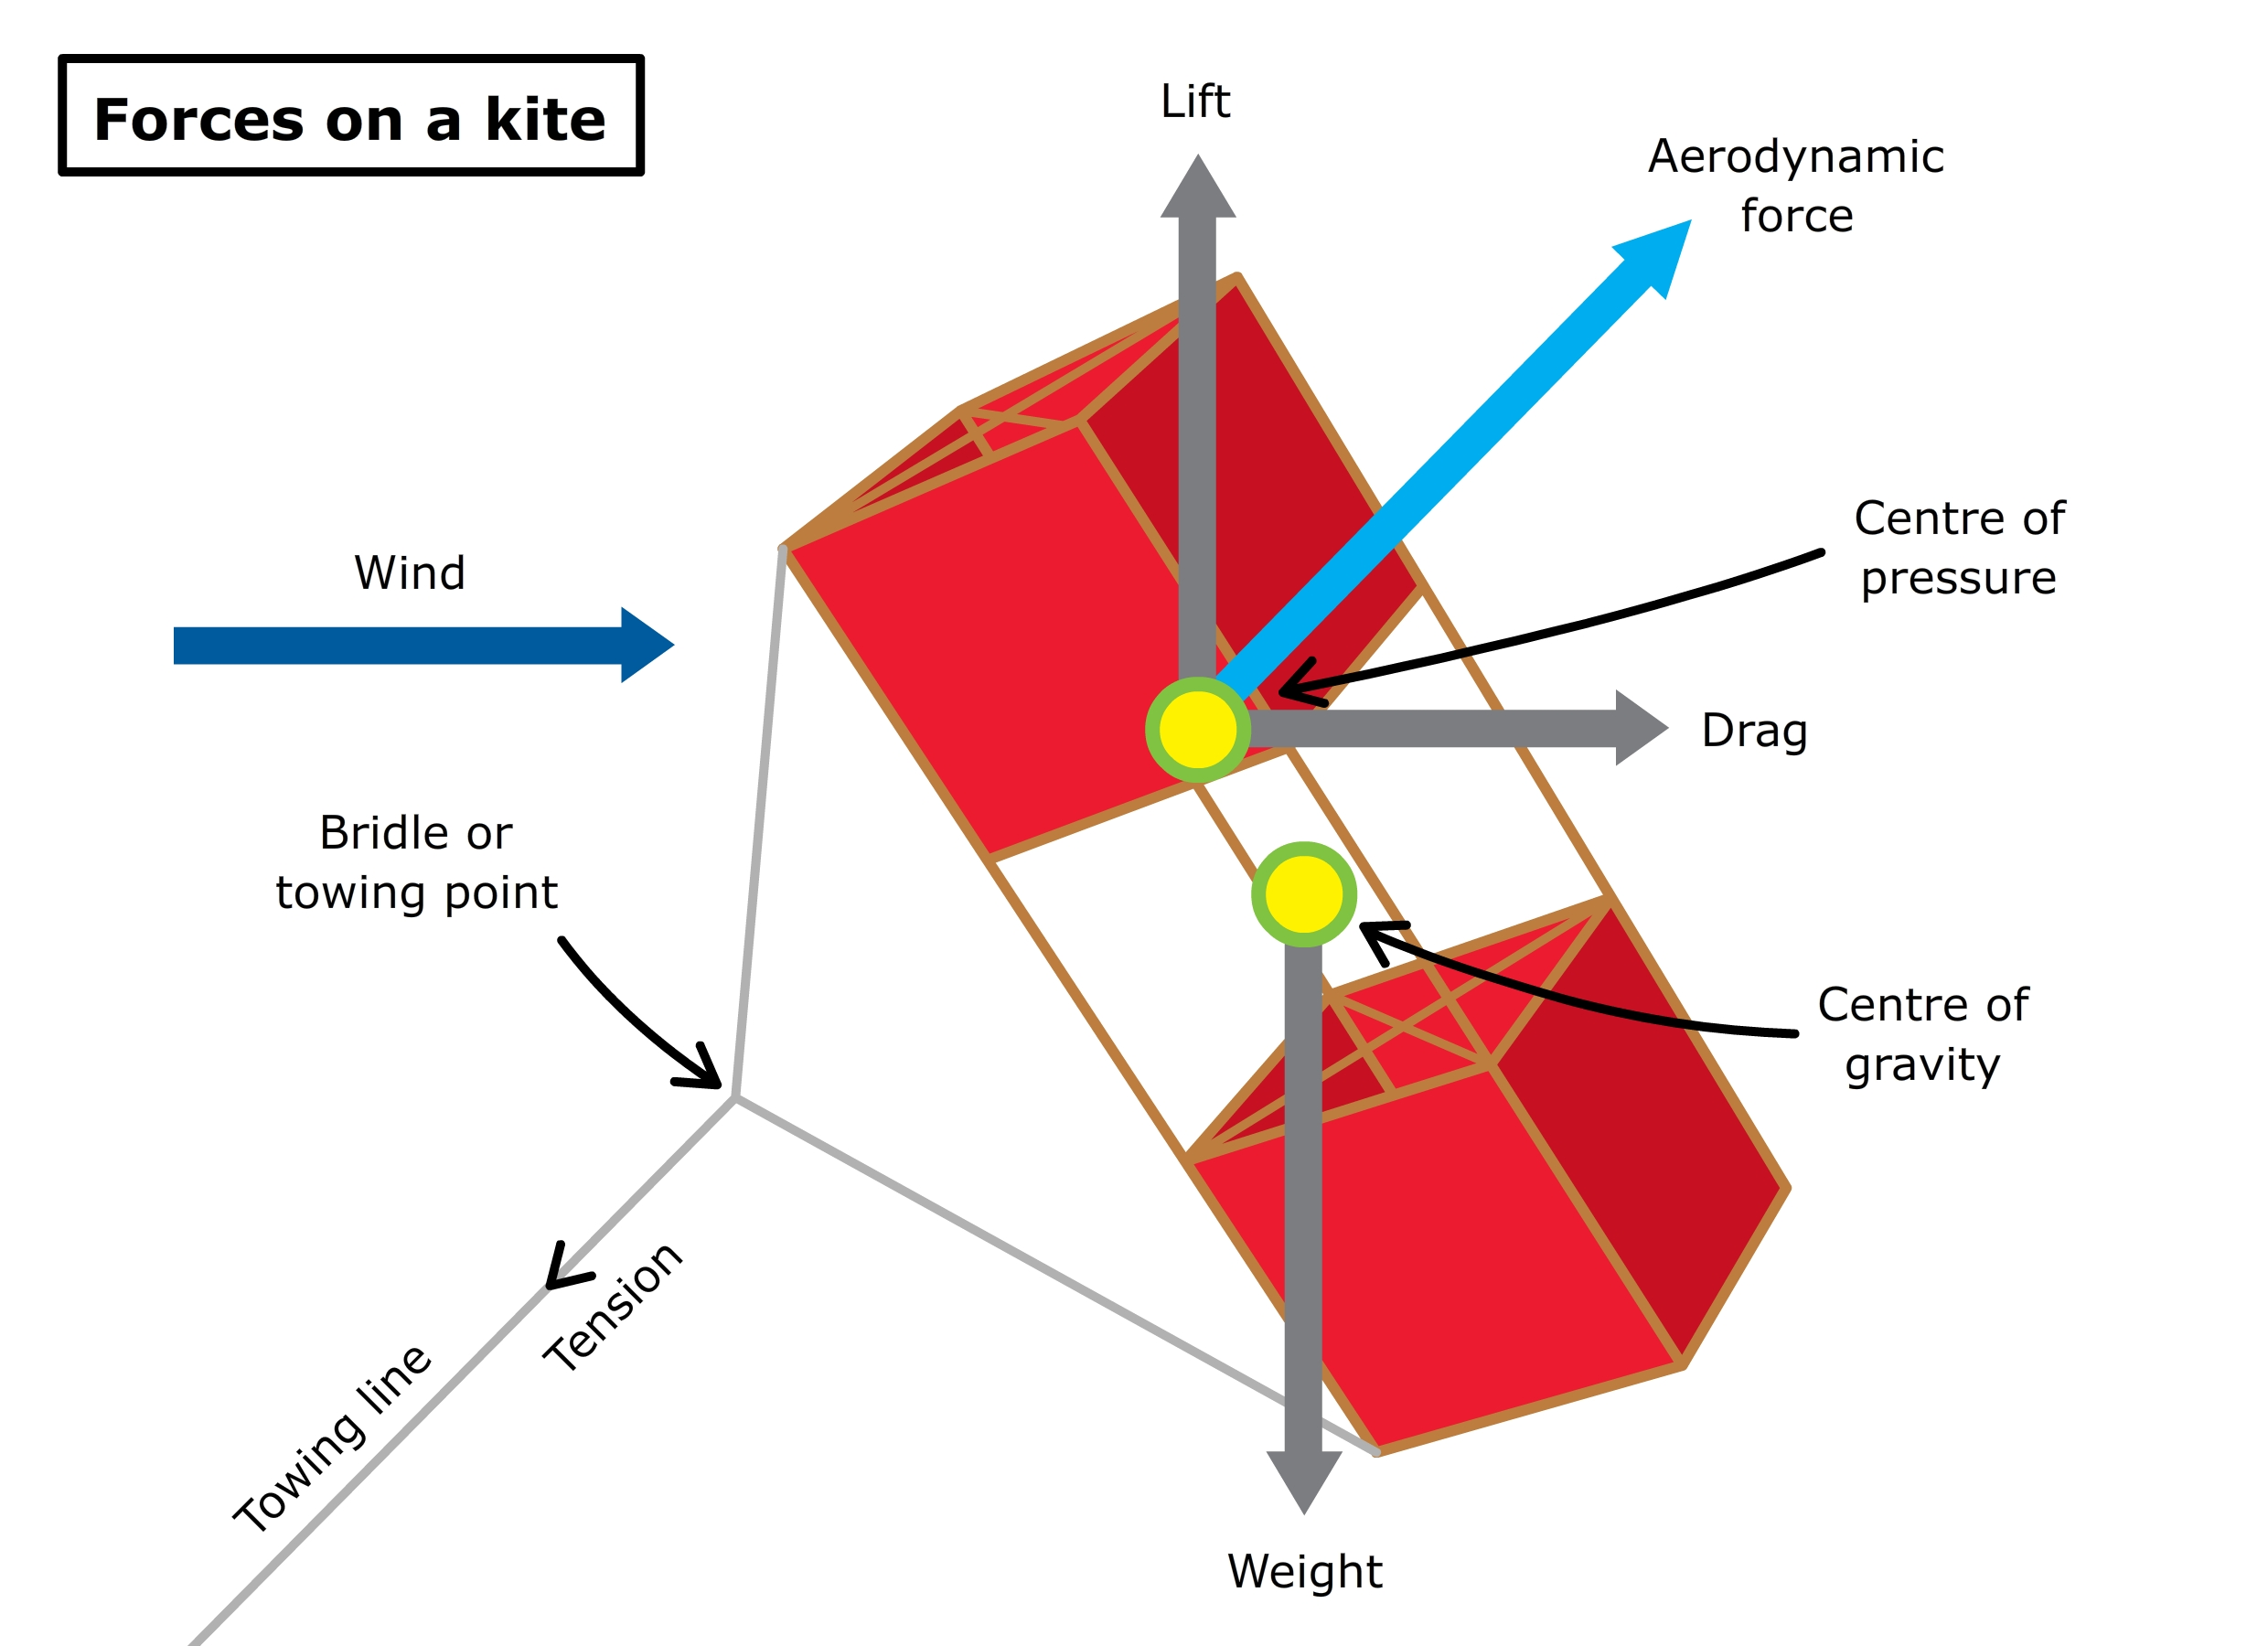

Experimenting with the position of the bridle point helps to find the place where the forces balance best with the kite flying well.

You can also stabilise the kite by adjusting the tail as well as the towing point:
- If the kite rotates to the right or left, the towing point may be too far forward or the kite may need more tail to stabilise it.
- If the kite dips from side to side, you can move the towing point forward or add more tail.

Experiment with the bridle placement and/or tail to get the best flight.

Carrying out the activity

Sled kites have a very flexible frame or no frame at all. They are easy to make and fly and do not break if they crash. They are excellent learning project kites for students so they make good starter kites.

This activity may be carried out in two ways depending on the capabilities of your class:
- Kite history and simple flying principles can be discussed and then students follow instructions to make a kite. They can then tweak their kite to improve its flying ability.
- More able students can discuss kite history and flight principles and then design and make their own kite. The assessment could be that it flies! Students could follow instructions to make the sled kite first to become familiar with making kites and to learn some of the principles before making their own.

Teachers should practise making kites themselves to discover the difficulties and anticipate the support their students might need.

Discuss kite safety with students and appropriate places for flying kites (not near power lines, buildings or trees).

What you need

- Access to or copies of Flight mythology
- Access to or copies of Gliders and kites
- Access to or copies of Wings and lift
- Copies of Sled kite instructions (which lists materials)

What to do

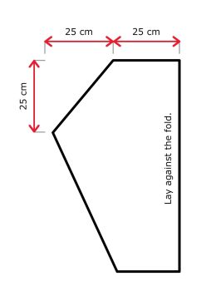
- Explore kite history and different types of kites using Flight mythology, the internet (such as www.my-best-kite.com/types-of-kites.html) and library books. Student groups could research the history of a particular kite or use of kites and present their projects to the class, for example, during World War II, kites were used as gunnery targets (http://robroy.dyndns.info/targetkites/).

- Discuss how kites fly (see Wings and lift and Gliders and kites). The depth of discussion would depend on student capability.

- Discuss places to fly kites (avoiding power lines, trees and houses).

- Give out copies of the Sled kite instructions and have students make the kite. For younger students, you could create a template out of heavy paper to use as a guide for cutting out the kite (see image). The template represents half a kite, so don’t open out the plastic bag. Cut it open along one side and across the bottom and lay the long edge of the template along the uncut fold. Be careful not to cut down the fold when cutting out the template.

- More able students could design and make their own kite as follows:
- Decide on the basic shape, for example, diamond, delta wing, box, soft material such as a sock kite.
- Research the kite type to see what is involved. Box kites are quite complex. First-time kite designers should try a simple diamond or delta-shaped kite – check sites such as www.wikihow.com/Make-a-Diamond-Kite or www.kiteflyerinfo.com/delta-kite-design.shtml.
- Design the kite – include the measurements.
- Collect the materials.
- Make the kite.
- Fly the kite.
- Adjust it to improve its flight.

Sled kite instructions

What you need:
- A large, strong, plastic refuse bag
- Cardboard or heavy paper for the kite template (optional)
- Two garden canes (or thin bamboo dowelling – about 5 mm thick), 70–90 cm long
- Masking tape
- Matches
- Scissors
- Ball of string

- Cut open one side and the bottom end of the plastic bag. Open it up and lay it out on the floor.

- Lay the two garden canes on the plastic, 50 cm apart. Leave an equal amount of plastic on either side of the canes.

- Tape the canes to the bag – tape evenly from top to bottom so that they are firmly fixed.

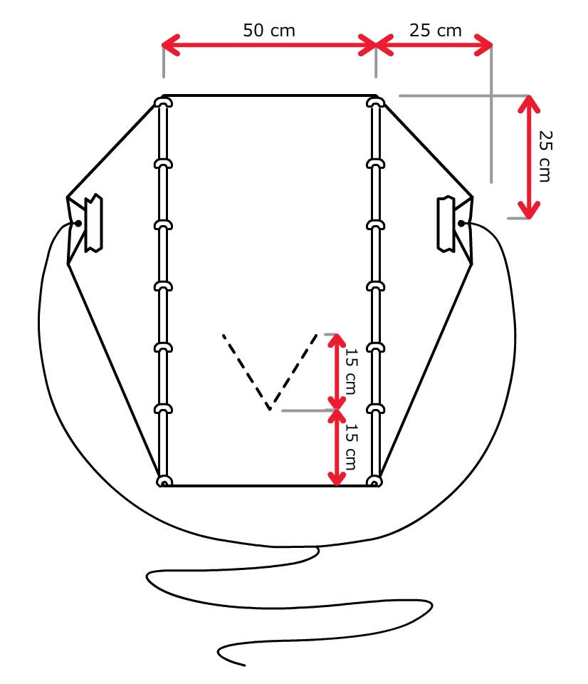
- Measure and mark 25 cm across from the top end of the cane as shown. Measure 25 cm down from that mark and make another mark. Draw a line from that point to the top end of the cane and a line from the same point to the bottom end of the cane. Cut along those lines.

- To strengthen the corners of the sail wing for attaching the bridle, fold each corner of the kite over a match. Stick it down with masking tape, and make a small hole on the kite side of the match.

- Cut a piece of string the length of the kite to make the bridle and tie the ends through the corners of the wing.

- Make a small V-shaped cut in the kite, as shown. This lets the air through and helps the kite to stay level. The stronger the wind, the bigger the cut needs to be.

- Attach the ball of string to the bridle at the tow point.

- Fly your kite. In strong wings, you may need to add a tail, which can be made from refuse bag off-cuts.

