ACTIVITY: Tracking E7

Activity idea

In this activity, students track the incredible flight of a special bird known as E7 to learn about the migratory flight of godwits.

By the end of this activity, students should be able to:
- explain the migratory patterns of the New Zealand bar-tailed godwit
- understand and explain a major threat to the survival of the godwits
- engage in ethical discussions concerning the use of tracking devices on migratory birds
- identify with justification some of the characteristics birds need for long-distance flight
- explain in simple terms the concept of migration timing concerning godwits.

Introduction/background notes
What you need
What to do
Flyway map
New Caledonia tracking map
How did E7 do it?
E7’s migratory flight

Introduction/background

In 2007, scientists discovered that bar-tailed godwits fly further in one flight than any other known bird – about 12 000 km non-stop. Godwits were tracked from New Zealand to China (where they refuelled), from China to Alaska (where they bred) and from Alaska to New Zealand – the entire journey a staggering 30,000 km!

Each godwit studied was tagged, and some were fitted with additional tracking devices. One such bird was tagged E7, and as she was tracked around the world, she became known not as a statistical number for data entry but as an identity in her own right. E7 became an affectionate name for a special bird. This student activity focuses on E7 as students learn about the astonishing journey of flight these birds are capable of.

E3 Call Home
Janet Hunt wrote a book called E3 Call Home. This book is the true story of two godwits – E3 and E7. The book is recommended for this student activity because it includes the story of E7 and her astonishing flight. It also gives scientific background information about migratory birds and is beautifully written for young students.

Threats to migration
As well as learning about this wonderful feat of flight, students should also be aware of potential threats to this migration. Increasing population and economic development has involved reclaiming bird estuaries in some countries.

An example of this is in Saemangeum, south-west of Seoul in Korea. A seawall was built across the Saemangeum estuary, destroying 400 km² of top wading-bird habitat. The wall was bad news for two endangered species – the spoon-billed sandpiper and Nordmann’s greenshank – both of which relied on Saemangeum as a refuelling stop.

Students should be aware that the Chinese government is also reclaiming tidal flats. The bar-tailed godwits leaving New Zealand stop at Yalu Jiang estuary on the edge of the Yellow Sea. What would happen if the Chinese government uses these tidal flats along the Yellow Sea for buildings, farms, roads and airfields? What would these birds do?

Some scientists are already preparing to study the effects on the godwits should they lose their fuelling estuaries.

Migration timing
Students will also learn that the scientists who tracked E7 continue to study godwits, and further research has shown that groups of godwits leave for migration in a certain order and then return to New Zealand in that same order. Discoveries in 2009–2010 show that migration timing is linked to breeding grounds in Alaska – when the grounds thaw enough to be inhabited by the breeding godwits.

What you need

- Access to or copies of the articles Flight of the godwit, Tracking godwits and How birds fly, Feathers and flight
- Access to the video clips The longest flight, Satellite tagging, The impact of transmitters, Capture and stress, Geolocators, How do they do it?, Wings with feathers, Godwits in flight and Migration timing
- A copy of E3 Call Home by Janet Hunt (available from libraries or online)
- Copies of the Flyway map
- Copies of the New Caledonia tracking map
- Access to the Ethics thinking tool
- Copies of How did E7 do it?
- Copies of E7’s migratory flight

What to do

- Read and discuss the articles The flight of the godwit and Tracking godwits with the class. Watch the video clip The longest flight and discuss.

- Read Janet Hunt’s book E3 Call Home to the class discussing the footnotes (extra scientific background information) as you go. Discuss E7.
- Where in New Zealand did she leave from?
- What type of transmitter did she have attached to her?
- How did the scientists attach the transmitter?
- How did the scientists track her?
- How long did it take her to reach the Yalu Jiang estuary?
- How long did it take her to reach Alaska from the Yalu Jiang estuary?
- What did E7 do in Alaska and how long did she spend there?
- How many kilometres did she fly from Alaska to New Zealand?
- How many kilometres did she fly altogether?
- Why did E7 become famous?

- Have students look at the flight path of E7 on the map in Flight of the godwit and redraw the journey on the Flyway map. Explain how the scientists knew where E7 went.

- Look at the New Caledonia tracking map and discuss. (This Google image shows the actual tracking of E7 along the coast of New Caledonia with the time of each record. The actual godwit track would be a zigzag but a straight line is used between points while the transmitter is off. E7’s transmitter was on a cycle – on for 6 hours and off for 36 hours. The location of the bird is determined using the Doppler effect where a single moving satellite picks up the signal as it passes overhead and calculates its position. Several orbiting satellites pick up these signals.)

- Discuss threats to the flight of the godwits. (Probably the biggest threat is possible destruction of bird estuaries along the coast of the Yellow Sea. Godwits use these estuaries to rest and refuel on their journey to Alaska.) You may like to rewatch the video clip The longest flight and revisit E3 Call Home pages 28–29.

- Examine the ethical considerations. Reread Tracking godwits and watch the video clips Satellite tagging, The impact of transmitters, Capture and stress and Geolocators.

- Explore the question ‘Should scientists use satellite tracking devices on migratory birds?’ In pairs, have students use the Ethics thinking tool to explore this question using the ethical approach of consequentialism or rights and responsibilities (or both).

Consequentialism is to do with the consequences of actions. Using this ethical approach, we weigh the benefits and harms resulting from our actions. Questions to consider:
- Who/what is affected by this issue? (Birds like E7, scientists, people interested in saving migratory birds, vets etc.)
- What are the benefits for those involved? (Benefits the birds because our understanding of their habits may lead to people helping them to survive, benefits scientists in terms of furthering research – giving them credit and keeping them in paid work, benefits interested people by increasing their understanding and appreciation of migratory birds, benefits vets because it gives them work etc.)
- What are the harms for those involved? (The birds may suffer stress during capture and having the devices attached or implanted, are not able to complete the journey because of extra weight or drag, as in the case of E3, or the device may affect the bird in some other way that may not be so obvious, for example, the external device may prevent the birds from sitting on their eggs properly so that the eggs are not incubated well and don’t hatch. The scientists may suffer abuse from people who consider they are being cruel to animals. Interested people may be concerned about the suffering of the birds and the possibility that they may die, especially in the process of surgery. The vet may get the blame for injury or death of birds during surgery.)
- Are some consequences greater or lesser than others? (Students may feel it is better to use the satellite devices to track the birds to gain an understanding of their migration and then use that knowledge to help them survive as a species, if possible.)
- If one is harmed and another benefits, how do you decide who or what matters most? (Student pairs might share their ideas about what matters the most with the class so that the class comes to a general consensus about what is important in this issue.)

Rights and responsibilities are closely related – the rights of one imply the responsibility of another to ensure those rights. Questions to consider:
- Who/what is affected by this issue? (This could include people who believe they have a responsibility to protect estuaries as a result of information gained through satellite tracking and developers and governments who believe they have a right to turn estuaries into urban developments and might be against satellite tracking devices on migratory birds because these devices show which estuaries are used by such birds.)
- Which groups have rights associated with this issue? (Scientists, conservation groups such as Miranda’s Naturalists’ Trust, which operates from Miranda’s Shorebird Centre, animal rights groups, New Zealand, Chinese and Alaskan governments etc.)
- What are their rights? (Scientists have rights – subject to ethical considerations – to carry out research. Conservation groups have rights to prevent animals from becoming endangered or extinct. Animal rights groups have rights to protect animals from harm. Governments have a right to protect people and make sure they have what they need.)
- Do these same groups also have responsibilities? What are their responsibilities? (Scientists have responsibilities under the Animal Welfare Act 1999 to minimise harm to the best of their ability during research. Animal rights groups should be responsible to consider the bigger picture – possible harm of an animal (for example, E3) may contribute to the understanding and greater good of many animals (saving the godwits). The governments of countries should be responsible for paying attention to the research resulting from the satellite tracking and balance their care of people with the needs of migratory birds.)
- Do we value some rights more than others? Whose rights do we want to protect? (Students could weigh up the rights of scientists to attach/implant satellite tracking devices with the rights of animal rights groups who may consider that these harm individual birds. Students could weigh up rights of scientists and conservation groups working to protect godwits from becoming extinct with the rights of governments and people who might destroy estuaries to extend land for people to live and work in.)
- Do any codes, declarations and/or conventions relate to this issue? (Animal Welfare Act 1999, particularly Part 6: Use of animals in research, testing, and teaching. University codes for ethical approval. Conservation Department codes.)

As part of the decision-making process, students could also consider and discuss the pros and cons of using alternative tracking methods such as geolocators.

- How did E7 fly all that way? Read and discuss How birds fly, Feathers and flight and Flight of the godwit and watch the video clips How do they do it?, Wings with feathers and Godwits in flight.

- Have students work through How did E7 do it? Working in pairs or small groups, cut out and sort the requirements that relate to E7’s flight. These could be glued onto a sheet of paper with a reason written beside each characteristic or item explaining in what way it is necessary for migratory flight. (This activity can also be used on an IWB with a group or the class. Students take turns to choose, drag and drop a card into the E7’s migratory flight box and give a reason for choosing that characteristic or item.)

- Research beyond E7. Read the section on migration timing from the article Flight of the godwit and watch the video clip Migration timing.
- What was Jesse researching?
- What did he find out?
- How do you think godwits know when to go?
Flyway map

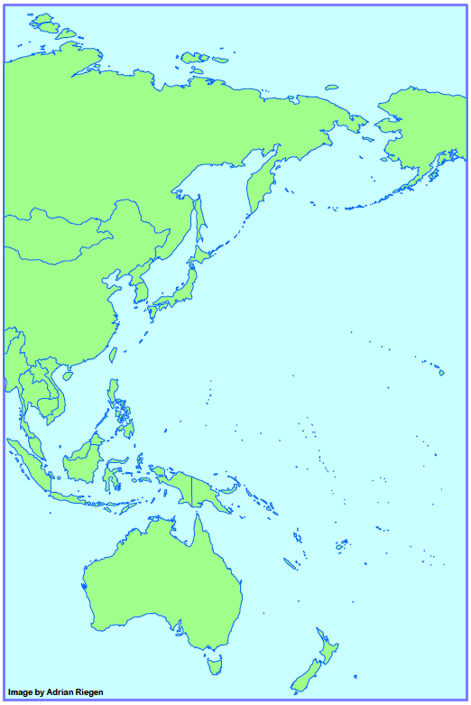

New Caledonia tracking map

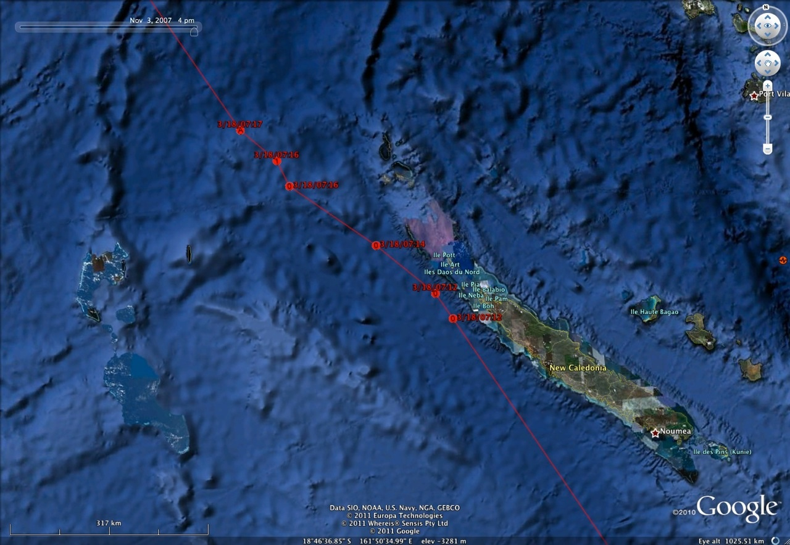

How did E7 do it?

What did E7 need to make the incredible journey? Work out what items listed below were necessary for E7 to make the migratory journey to her breeding ground in Alaska and back again.

Cut out each requirement that you think was necessary for E7’s flight, glue it on a sheet of paper and write a reason explaining why it is necessary for migratory flight. For example, powerful flight muscles were necessary to enable E7 to keep flapping her wings for days on end but her long beak (although she needs one) was not a necessary requirement for the migratory flight (non-migratory birds have long beaks for feeding).

colour band and E7 tag | orange-red chest feathers
contour feathers | pale grey-brown feathers
coverts | powerful flight muscles
doubling her weight by eating fish | primary feathers
doubling her weight by eating marine worms, bivalves and crabs | rectrices
flexible tips on her beak | remiges
fluffed up feathers | satellite transmitter
geolocator | secondary feathers
hollow bones | small breastbone
large breastbone | small intestines
light feathers | smooth, sleek feathers
long beak | tertiary feathers
long pointed wings | to fly alone
long toes | to fly in a group
new, smooth flight feathers | to fly in V-formation

E7’s migratory flight

