**ACTIVITY: Earthquake location**

**Activity idea**

In this activity, students are introduced to some of the methods scientists use to record earthquakes. They obtain data from tables and graphs, carry out simple calculations and draw results on a map.

By the end of this activity, students should be able to:

* use seismograms from three recording stations to locate the epicentre of an earthquake
* measure the difference in arrival time of P and S waves, and read the distance from epicentre from a graph
* plot the epicentre location on a map
* investigate the area affected by the earthquake
* write a report that includes a prediction of possible damage, based on type of landscape, human and environmental features.

This activity was developed for the Earthquake Commission (EQC) and has been kindly provided for use on the Science Learning Hub.



Introduction/background

What you need

What to do

Student instructions

Seismograms from three North Island recording stations

Graph for calculating distance from epicentre

Outline map of North Island

**Introduction/background**

There is a network of recording stations throughout New Zealand (linked to a worldwide network) that provides continuous data on earthquakes.

You can find out more, and see records of recent and historic earthquakes on the GeoNet website [www.geonet.org.nz/index.html](http://www.geonet.org.nz/index.html).

Although epicentre locations are provided on this site, by plotting data themselves, students should gain a better understanding of how earthquakes are recorded.

The event used in this activity is fictional, so don’t try and find it in the GNS archives! For this reason, the seismograms do not have a date on them – you could insert the date on which you are doing the activity

The activity refers to P and S seismic waves – it is not necessary to know about these in detail – just that they are different kinds of waves generated by earthquakes, and they travel through the earth at different speeds.

**What you need**

* Student instructions
* Seismograms from three North Island recording stations
* Graph for calculating distance from epicentre
* Compass
* Pencils
* Outline map of North Island
* Topographical map of North Island
* Access to Google Earth (optional)

**What to do**

1. Discuss with the class what is meant by the epicentre of an earthquake. (The point on the surface directly above the focus of the earthquake.) This is the nearest place to the focus that seismic waves reach the surface. The focus is the place on the fault that ‘snapped’ under pressure and generated the seismic waves.

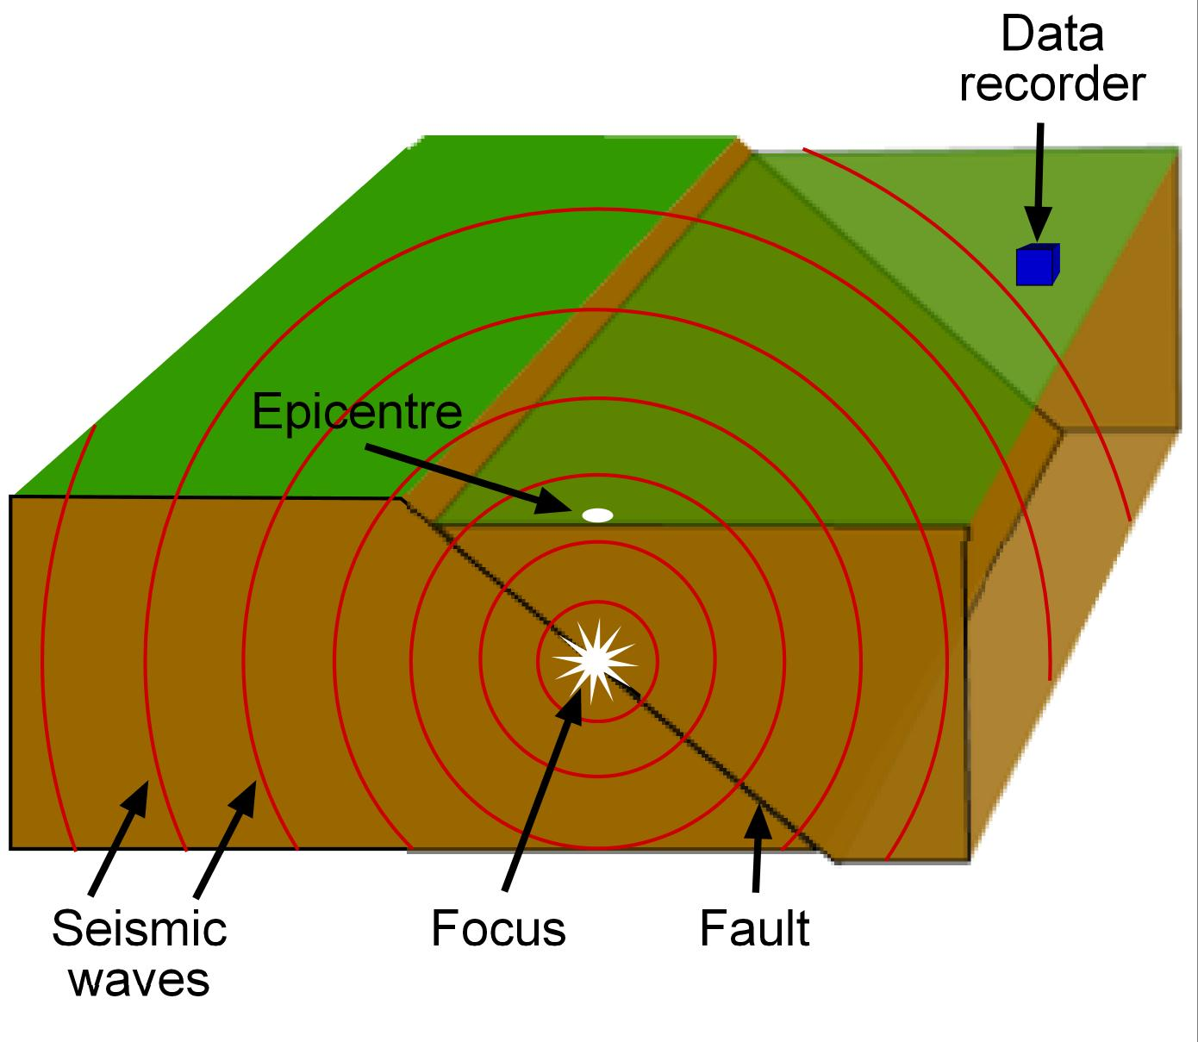

1. Give out copies of the student instructions and seismograms from three North Island recording stations and ask students to work through steps 1–3 to fill in the data table. Below is a table completed with values similar to those your students should get. They may vary slightly, as different people might obtain slightly different readings from the graphs (a point to discuss?).

|  |  |  |  |  |
| --- | --- | --- | --- | --- |
| **Station**  **code** | **P wave**  **arrival time** | **S wave**  **arrival time** | **Time difference** | **Distance from epicentre (km)** |
| MRZ | 09:16:35 | 09:17:00 | 25 s | 190 |
| URZ | 09:16:15 | 09:16:27 | 12 s | 90 |
| HIZ | 09:16:25 | 09:16:42 | 17 s | 130 |

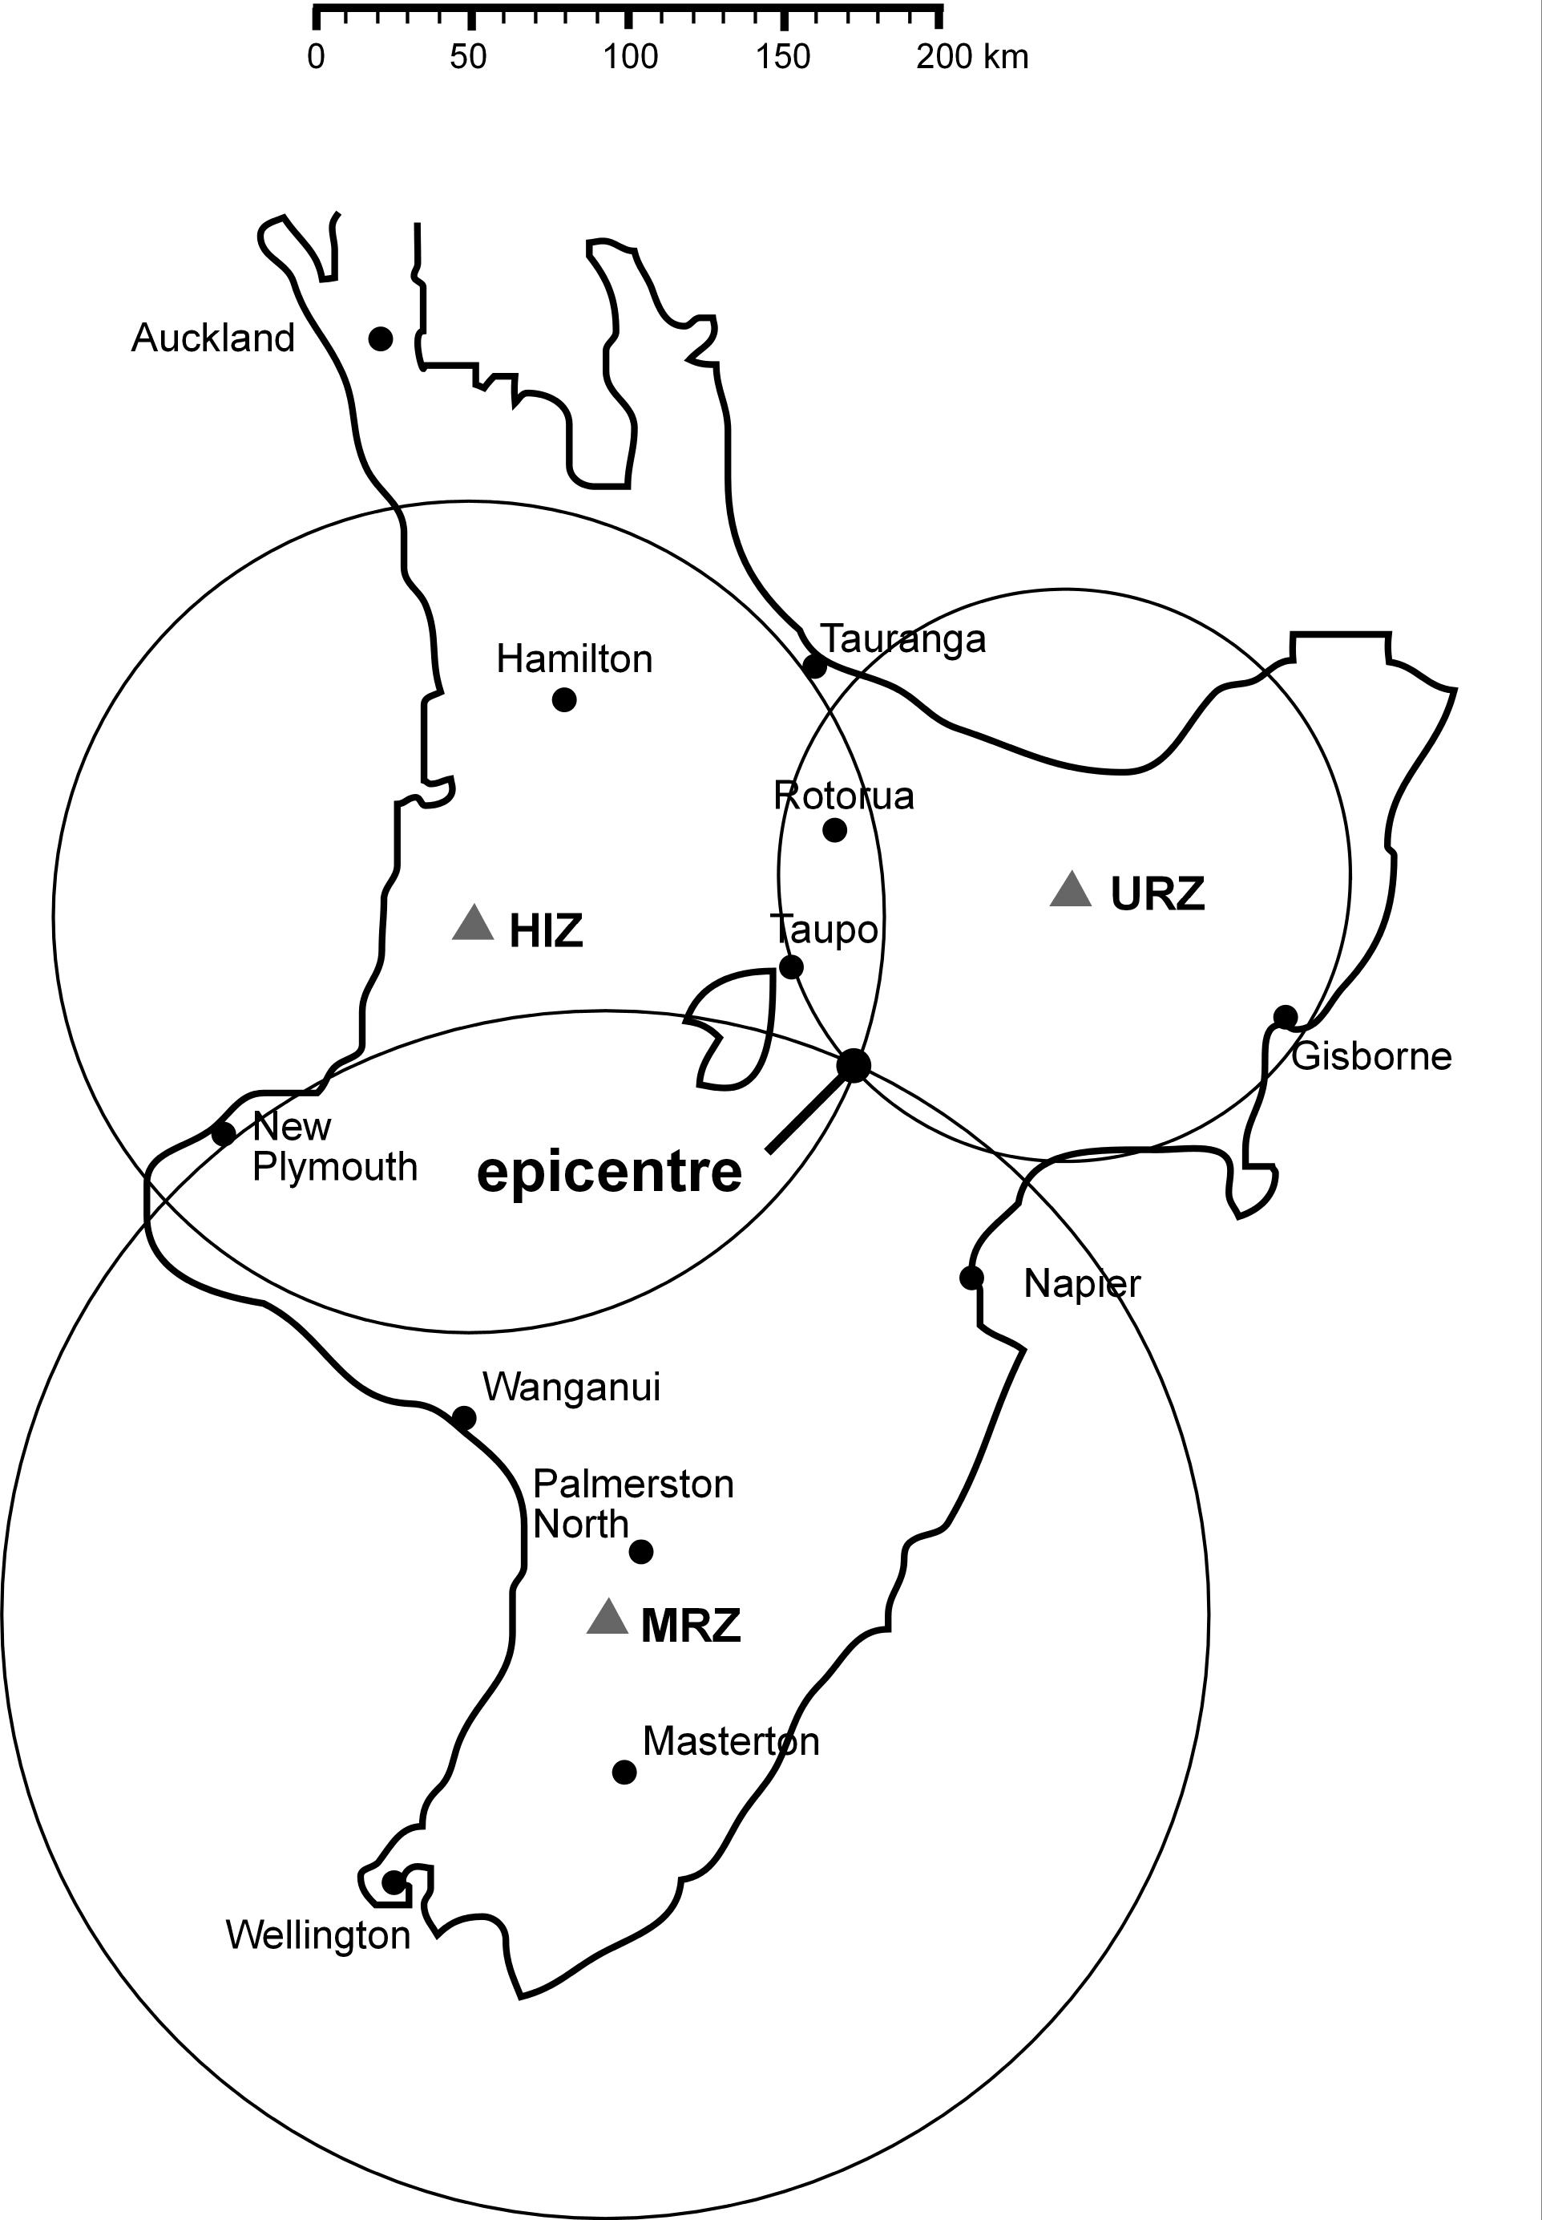

1. Give out copies of the graph for calculating distance from epicentre (or challenge students to use the equation below) and outline map of North Island and have students work through steps 4–5 to plot the location of the epicentre. The map with epicentre plotted on should like something like the map on the right.

***Using an equation rather than the graph***

An earthquake happens at a certain distance from a recording station. If we knew how long it took the S and P waves to reach the station, we could find the distance by multiplying the time by the velocity of the waves. (Velocity is the speed of something in a given direction.) Since we don’t know the travel time, we can use the difference in arrival times instead.

In the following equation:

D = distance

Vs = velocity of S wave (3.4 km per second)

Vp = velocity of P wave (6.2 km per second)

ts = arrival time of S wave

tp = arrival time of P wave.

The full equation is ts – tp = D(1 / Vs – 1 / Vp).

This can be simplified, because (1 / Vs – 1 / Vp) will be the same for each calculation:

(1/3.4 – 1/6.2) = 0.13 so ts – tp = D x 0.13. Since D is the value we don’t know, we can rearrange the equation to D = (ts – tp) / 0.13. For example, if the time difference between the arrival of the P and S waves was 20 seconds: D = 20 / 0.13. The distance of the recording station from the epicentre is 154km.

1. Using a detailed topographical map and/or viewing the area on Google Earth, discuss step 6 as a class.
2. Have students write a report about the earthquake (step 7). If they are unsure what to write about, you could provide some clues:
   * The land is very hilly, so landslides would be expected. Landslides could block streams and cause flooding; they could block roads (SH5 between Napier and Taupo is close, and so is SH1 on the edge of Lake Taupo) and make access for emergency services hard; they could destroy power and phone lines.
   * There are no large towns near the epicentre, but several isolated settlements. Even a few buildings destroyed could be a disaster. Finding who needs help could take a long time. No emergency services close at hand.
   * Taupo is not that far away and could well be affected. How would the situation there be different?
3. You may like your students to now complete the [Earthquake intensity](http://link.sciencelearn.org.nz/resources/353-earthquake-intensity) activity, where they allocate a Modified Mercalli Intensity (MMI) number to some historic New Zealand earthquakes and number to the area near the epicentre that they have just plotted.

**Student instructions**

You are a seismologist on duty in the Earthquake Data Centre. Data coming in from recording stations in the North Island indicates that a medium-sized earthquake has occurred. You must analyse the seismograms from these stations and locate the epicentre of the earthquake. You will then be able to assess possible damage near that location.

An earthquake makes several different types of seismic waves, which travel through the Earth at different speeds. P waves are fastest, so they arrive at a seismograph first. S waves are a bit slower, so arrive after the P waves. S waves also have larger amplitude (cause bigger peaks on the seismogram). You can use the difference in arrival time of the P and S waves to work out the distance from the epicentre. By doing this for at least three widely spaced recording stations, you can work out the epicentre of the earthquake.

1. Look at the seismograms from three North Island recording stations.

***What to look for on a seismogram***



1. Read the P and S wave arrival times off the three seismograms and enter your answers in this data table

|  |  |  |  |  |
| --- | --- | --- | --- | --- |
| **Station**  **code** | **P wave**  **arrival time** | **S wave**  **arrival time** | **Time difference** | **Distance from epicentre (km)** |
| MRZ |  |  |  |  |
| URZ |  |  |  |  |
| HIZ |  |  |  |  |

(In this activity, time zero for each seismogram is 09:15:00, so if you think a wave arrives at 100s (1 minute and 40s), record this as 09:16:40.)

1. Calculate the difference in time between the arrival of the P waves and the S waves, and enter your answers in the table above. Time difference = (S wave arrival time) minus (P wave arrival time).
2. Use the graph to determine the distance of each recording station from the epicentre.

***How to use the graph***

For example, if your time difference is 32 seconds, find 32 on the y-axis of the graph. Use a ruler to draw a horizontal line from that point, until it meets the line of the graph. From this intersection point on the line, draw a vertical line down to the x-axis, and read the distance (240km).

1. You are now ready to plot the location of the epicentre on a map:

* Find the three recording stations on the outline map of the North Island.



* For Station MRZ, use the scale at the top of the map to set a drawing compass to have a radius equal to the distance to the epicentre. Place the point of the compass on the MRZ triangle on the map and draw a circle.
* Repeat this for the other two stations.
* The earthquake epicentre is located near where all three circles intersect. (On the right is an indication of what it might look like, but it’s not the answer!)

You now know where and when the earthquake occurred. The computer linked to the recording stations tells you that the magnitude of the earthquake was 5.2, and it was 9km deep.

1. Look at a detailed map of the North Island and decide what sort of landscape the earthquake happened in. Try and answer the following questions, and others you may think of:

* Is it hilly or flat?
* Are there rivers?
* Are there any big towns nearby?
* Are there any small settlements nearby?
* What is the land communication like (are there roads or railways)?

1. Write a short report about the earthquake:

* Start with all you know about the earthquake – where, when and how big.
* Then write about the damage that could be expected. Your report could be used to tell emergency services what to expect before detailed reports from the area come in. Think about how many buildings are in the area and what would happen if they were destroyed.
* What is the chance of people being killed or injured? This might depend on the time of day – where will people be at the time of the earthquake?
* What could happen if there were landslips?
* Don’t forget that not all the damage happens at the epicentre – quite a large area could be affected in some way.

