SCIENCE EDUCATION PLANNER: EARTHQUAKES
SCIENCE STRANDS Living World  Material World | Physical World  Planet Earth & Beyond |  | MACRO TASK:  Develop an understanding of the connections between tectonic movements and earthquakes; how we can design buildings to more safely withstand tectonic movement. |  | LEVEL: 1 2 3 4  YEARS: 4–6  TEACHER: Angela Schipper  Hillcrest Normal School, Hamilton
NATURE OF SCIENCE:
Understanding about science; investigating in science; communicating in science; Participating and contributing.
Big questions: What is the connection between processes within the Earth and what happens on the surface? Does our location on tectonic plate boundaries affect New Zealand? What can we do to protect ourselves during earthquakes?
KEY COMPETENCIES:
- Thinking – making connections between tectonic plate movements and earthquakes; how changes in building design can lead to safer buildings.
- Language – using scientific and technical language associated with tectonic movements and building safety.
- Managing self – correct use and sharing of resources while working on individual and group activities.
- Relating to others – listening, discussing and sharing ideas within groups and in class.
- Participating and contributing – working together in investigating activities and subsequent discussions, making informed decisions.
INTENDED LEARNING OUTCOMES: The children will have an understanding that:
Conceptual LOs |  | Procedural LOs |  | Nature of Science |  | Technical LOs
- The Earth is made up of layers.  - The Earth’s crust (lithosphere) is underlain with tectonic plates.  - Earthquakes occur on/near plate boundaries.  - Technological advances are making buildings safer. |  | - Research/fact-finding using the Science Learning Hub to explore plate tectonics, earthquakes and New Zealand research into making buildings safer.  - Investigate the effects of tectonic movement and advances in building safety through the use of simple, hands-on activities. |  | - Science knowledge is subject to change. What we now know as tectonic movement was once thought the result of angry gods, underground winds, etc.  - Scientists use models to test ideas.  - Individual values play a part in decisions we make.  - Investigation and debate lead to more critical, informed and responsible decision-making. |  | - View/gather information, discuss ideas, listen to students’ interpretations and/or concepts.  - Hands-on activities and analogies to illustrate concepts.  - Further discussions to ensure analogies are understood in relation to the concepts.  - Evaluate the investigations and report back to the group.
MANAGEMENT/MATERIALS:
Resources: http://www.sciencelearn.org.nz, www.whatstheplanstan.govt.nz (Civil Defence), www.teara.org.nz, www.eq-iq.co.nz (Earthquake Commission)
Artefacts: see individual activities
ASSESSMENT:
Students explain through print or illustration how various analogies and models relate to the scientific concepts they represent.
Students write about how they can protect themselves during an earthquake.

SCIENCE: PLANNING FOR TEACHING AND LEARNING: EARTHQUAKES
MACRO TASK: Develop an understanding of the connections between tectonic movements and earthquakes; how we can design buildings to more safely withstand tectonic movement.
MESO TASK: Finding out about tectonic movement.

Micro tasks | Focal artefacts | Planned  interactions | Intended learning  outcomes | Reflections
Investigate the Earth’s layers. | - SLH information sheet: Inside the Earth  - Hardboiled egg  - Skittles, marshmallows, melted chocolate, skewers  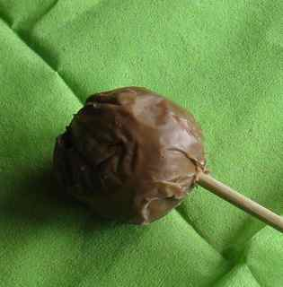 | - View the SLH article http://link.sciencelearn.org.nz/resources/337-inside-the-earth  - Cut a hard boiled egg in half, look at the layers.  - Make edible Earth analogies. Place a hard Skittles lolly (core) inside the centre of a marshmallow (mantle). Use a wooden skewer to dip the marshmallow in melted chocolate. The chocolate crust firms up and develops cracks, similar to tectonic plates. | - Students will understand that the Earth has a solid inner core made up of iron and nickel, a liquid outer core, a viscous mantle, and a silicate crust  - Ensure students understand relationships between analogies and the science concepts.
Investigate tectonic plates. | - Hot steak pie  - Student handout: Earth’s structural layers  - Colour copies of image from SLH tectonic plate boundaries, cut along boundaries | - Meat pie/Earth analogy (both solid and viscous materials inside, a crust on the outside). What happens if the crust is pushed, cracked, pulled?  - Students draw a sketch of the various analogies and label/describe how the analogy portrays the actual layers of the Earth.  - Look at image on IWB and discuss. Why is New Zealand nicknamed the Shaky Isles? http://link.sciencelearn.org.nz/images/350-tectonic-plate-boundaries  - In groups, students assemble tectonic puzzles. | Students will understand:  - the Earth’s crust (lithosphere) is composed of several major plates and many minor plates that change shape and position  - the zones along plate boundaries are the most geologically active regions on Earth.
Investigate divergent, convergent and transform boundaries. | - SLH image: Plate boundaries  - Tectonic cake  - Edible items to make model (Sliced bread, Nutella for soil, coloured coconut for grass, carrot and celery pieces for houses, choc drops for roads etc.)  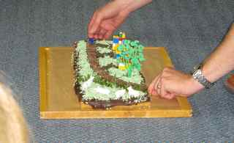  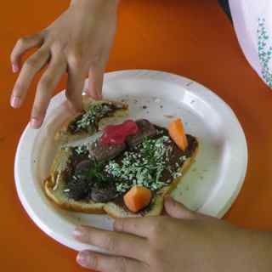 | - View Plate boundaries image: http://link.sciencelearn.org.nz/images/351-plate-boundaries  - Discuss the types of movement, where they most often occur and the common result (mountain, sea building etc.)  - Cut a sponge cake into several pieces. Add a layer of icing to cover the cuts, decorate with coloured coconut for grass, pineapple lumps to make roads, plastic animals, Lego houses, etc.  - Use cake to demonstrate how plate movement affects the land.  - Students build models to demonstrate the 3 boundaries and how plate movement affects the land. | Students will understand:  - three main types of boundaries exist between tectonic plates: divergent, convergent and transform  - each boundary is associated with different types of surface phenomena and are characterised by the way the plates move relative to each other:  - transform boundaries – the plates move past each other  - divergent boundaries – the plates slide apart from each other  - convergent boundaries – the plates slide towards each other.  - when one plate moves underneath the other, it is a subduction zone  - when two plates collide, they either buckle or compress.
MESO TASK: Learn about seismic engineering and building techniques to prevent damage in a minor quake and to avoid serious damage or collapse in a major shake.
Investigate ductile design to demonstrate flexibility | - SLH article: Seismic engineering  - Popsicle sticks, PVA glue, straws, rubber bands  - Lego and Magnetix, cardboard  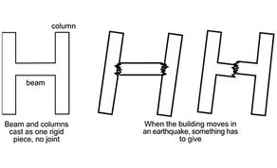  http://link.sciencelearn.org.nz/images/336-rigid-building  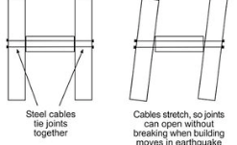  http://link.sciencelearn.org.nz/images/337-ductile-building | - View and discuss SLH article, noting the rigid building and ductile building images http://link.sciencelearn.org.nz/resources/331-seismic-engineering  - Glue popsicle sticks together to represent a rigid structure. Place rubber bands around straws to represent the ductile structure.  - Use Lego and Magnetix to build both rigid and ductile buildings. Place on cardboard and shake to simulate an earthquake. | Students will understand that:  - seismic engineers are building ‘smarter, not stronger’.  - ductile design allows buildings to flex or deform.
Investigate how base isolators protect buildings from damage during an earthquake. | SLH resources:  - How do base isolators work?  - The base isolation principle  - Shaken not stirred  - How safe is my house (and necessary materials). I used 10x10 place value blocks for the base; rice, jelly lollies, 10x1 place value blocks, coins and cotton wool as isolators.  - Student handout: Testing base isolators  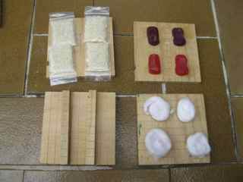  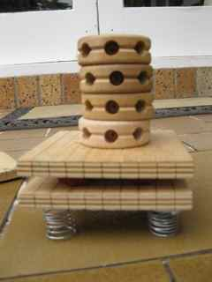  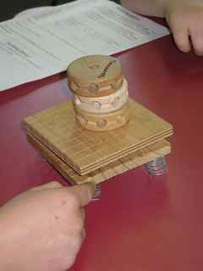 | - Look at article: How do base isolators work? http://link.sciencelearn.org.nz/resources/1022-how-do-base-isolators-work  - View videos: The base isolation principle http://link.sciencelearn.org.nz/videos/556-the-base-isolation-principle  - and Shaken not stirred http://link.sciencelearn.org.nz/videos/558-shaken-not-stirred  - Discuss the engineering principles.  - Activity: How safe is my house? http://link.sciencelearn.org.nz/resources/355-best-base-isolator  - Groups use design from How safe is my house and test various base isolators.  - Compare results between groups and discuss outcomes, and possible reasons for differences.  - Students record findings about base isolators and building design. | - When a building is built away (isolated) from the ground, resting on flexible bearings or pads known as base isolators, it will only move a little or not at all during an earthquake.
Investigate the costs associated with seismic engineering.  Make informed choices about which buildings we choose to protect with seismic engineering.  Investigate the steps to making our classroom and/or our homes safer during an earthquake. | - Copies of Get Ready Get Thru Household Emergency Plan | View:  - Building for earthquake resistance www.teara.govt.nz/en/earthquakes/4  - Is base isolation always appropriate? http://link.sciencelearn.org.nz/videos/153-is-base-isolation-always-appropriate  - Protecting Wellington Hospital http://link.sciencelearn.org.nz/videos/865-protecting-wellington-hospital  - Discuss the costs involved with seismic engineering and decide/debate which buildings should be most eligible.  - View simulation involving a sliding scale of intensity to demonstrate the effects of an earthquake on the contents of a home www.eq-iq.co.nz/quakehouse/index.htm l  - www.whatstheplanstan.govt.nz/mcdem/teacher.html  - Discuss the classroom and school setting – where is the safest place to be during an earthquake? In class, during assemblies, at playtime, etc.  - Practise earthquake drills in the various locations.  - Students take the plan home and discuss it with their families. | - Individual values play a part in decisions we make. Investigation and debate lead to more critical, informed and responsible decision-making.
MESO TASK: Evaluation
Students explain through print or illustration how various analogies and models relate to the scientific concepts they represent.  Students write about how they can protect themselves during an earthquake. | - Student handout: Earthquakes | - Review the activities and concepts involved with the earthquake unit. Students complete the evaluation.

Earth’s structural layers: some analogies

The Earth has a solid inner core, a liquid outer core, a viscous mantle and a crust. These analogies help us imagine what the inside of the Earth looks and feels like.

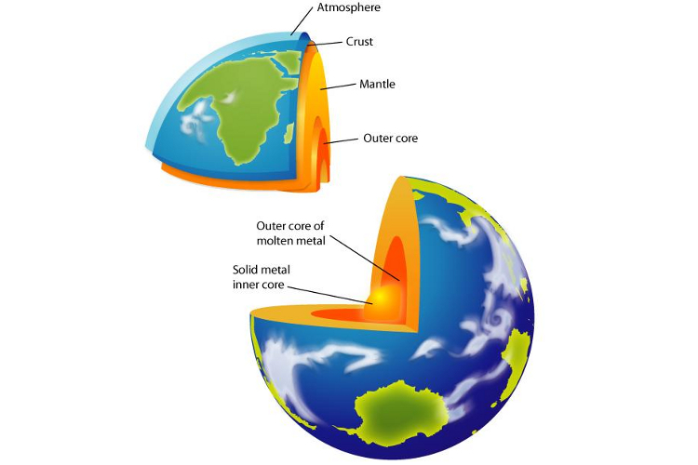  The real Earth | A meat pie
A hard boiled egg | Skittle/marshmallow/chocolate creation

Testing base isolators

Base isolators protect buildings from damage during an earthquake. They act in a similar manner to the shock absorbers on a car. This technology was developed by New Zealand scientists and is used all over the world.

Your job is to test new materials for their effectiveness as base isolators. To do this, you will use a model earthquake platform. To keep things fair, try and use the same amount of pressure each time you use the platform.

My results:
Base isolator material | Properties of the material | Time it took for the house to fall | Is this material effective?
Coins
Rice
Jelly lollies
Cotton wool
Wooden blocks

Which material do you think makes the most effective base isolator?

Could you use this in a building?

Why do you think scientists use models when testing materials for earthquakes?

Building design
I’ve built and tested several buildings to withstand damage during an earthquake. This is my strongest design.

Earthquakes

Nature of science (level 3):
- Students will ask questions, find evidence and carry out appropriate investigations to develop simple explanations.
- Students will explore various aspects of an issue as they make decisions about possible actions.

We cannot see the layers of the Earth so we use analogies to help us understand what they look like. Write about two of the analogies we used and how they helped you to visualise the inside of the Earth.

We learned that earthquakes are a result of tectonic plate movement. We cannot see tectonic plates so we made models to show how they move. Write about one type of tectonic movement. Then describe how you used your model to demonstrate the movement.

New Zealand scientists developed base isolators to help protect buildings from earthquake damage. We made model earthquake platforms to test the effectiveness of various base isolation materials. Write about your conclusions.

Earthquakes are part of life here in New Zealand. Here are two ways I can protect myself during an earthquake:

