ACTIVITY: Detecting toxins

Activity idea

In this activity, students are introduced to the interactive What killed the dogs? After working through the interactive, they consider the processes used by the scientists in this detective work a little more closely.

By the end of this activity, students should be able to:
- identify a given toxin using known chemical structures
- explain what a molecular formula is
- explain in simple terms how liquid chromatography-mass spectrometry (LC-MS) can be used to detect toxins
- show an understanding of the concept of LD₅₀.

Introduction/background notes
What you need
What to do
Student handout: Learning about marine toxins
Student handout: Information on five marine toxins
Student handout: Liquid chromatography-mass spectrometry (LC-MS)
Student handout: Lethal dose 50

Introduction/background

In the interactive What killed the dogs?, we can follow the procedure, in a broad sense, of how the Cawthron scientists tracked down what killed the dogs and how they identified the toxin involved. To understand these procedures, students need to have an idea about some of the things the scientists did, such as the use of liquid chromatography-mass spectrometry (LC-MS), and of some of the terms they use, such as daltons and LD₅₀.

Students are encouraged to try the interactive first. This will allow them to work out what killed the dogs before they read about it elsewhere. It may also introduce them to ideas and terms that are new to them – some of which are explored in this activity.

The chemistry of toxins
First, students are introduced to four well known shellfish toxins and tetrodotoxin – made famous by its existence in pufferfish and its recent discovery in a New Zealand sea slug. Students are introduced to the chemical make-up of the toxins through their formulae, structures and molecular mass. They are encouraged to identify toxins using their chemical structures.

Students need to understand that everything is made up of chemicals and that it was through the scientists’ knowledge of the chemical make-up of toxins that they were able to identify tetrodotoxin in the sea slug.

Liquid chromatography-mass spectrometry
Liquid chromatography-mass spectrometry is quite complex, but students can grasp the basic concept without going into detail. Basically, it is a method for separating out individual molecules within a mixture and then determining their molecular mass.

LC-MS is a useful method for identifying what molecules are in an unknown substance. Scientists know the molecular mass of most molecules. Once they have a molecular mass for a molecule in a sample, they can identify it by matching it against the molecular mass of known molecules. The chance of being right is high, as LC-MS is very accurate. Besides separating out different molecules, this method can also record the amount or mass of molecules that are the same, so it can tell you how much of something is in the mixture.

Lethal dose
Students should also have some idea about lethal dose. LD₅₀ is a measurement in toxicology that indicates how poisonous something might be, which is really important for people to know. It is the dose required to kill half of a specific animal population. Since LD₅₀ is obtained through causing the death of animals, it may be a problem for some students. The video The ethics of research animals introduces some ethical considerations associated with the use of animals in research.

Finally, students should be encouraged to try the What killed the dogs? interactive again, this time focusing more on the procedures used to identify the sea slug and the toxin rather than the result.

What you need

- Access to the interactive What killed the dogs?
- Access to or copies of the articles Monitoring shellfish, Sea slugs and TTX, Chemicals everywhere and Measuring toxicity
- Access to the video clip Identifying the toxin
- Copies of the student handouts Learning about marine toxins, Information on five marine toxins, Liquid chromatography-mass spectrometry (LC-MS) and Lethal dose 50

What to do

- Have students work through the interactive What killed the dogs? in pairs and make a list of terms and ideas they found difficult to understand.

- Have students find out about some marine toxins. Read Monitoring shellfish, Sea slugs and TTX and Chemicals everywhere in groups or as a class. Use this information plus the Information on five marine toxins to answer the questions in Learning about marine toxins in pairs.

- Have students learn about liquid chromatography-mass spectrometry. As a class, watch the video clip Identifying the toxin, then have students work through Liquid chromatography-mass spectrometry (LC-MS) with a partner.

- Have students learn about LD₅₀. Read Measuring toxicity as a class or in groups, then have students read and discuss Lethal dose 50 using the questions in pairs.

- Work through the interactive What killed the dogs? again.

Student handout: Learning about marine toxins

- What is okadaic acid? How are people poisoned by okadaic acid? What is the origin of okadaic acid? What type of poisoning does it cause (in relation to how it affects people)? What are the symptoms of the poison?

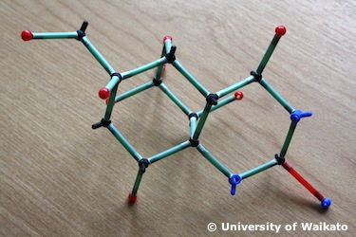
- What is tetrodotoxin (TTX)? How might people be poisoned by TTX? What type of toxin is it? What are the symptoms of the poison?

- What are the molecular formulae for okadaic acid and tetrodotoxin? What do the letters C, H, O, and N stand for? Check the periodic table in Chemicals everywhere. Explain the numbers that follow each element.

- Here are some chemical structures for some marine toxins. These structures show how the molecules in the toxin are made up or formed. Use the student handout Information on five marine toxins to identify the chemical structures of these toxins.

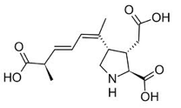 | 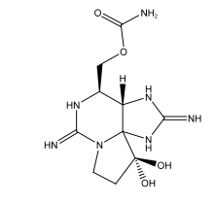
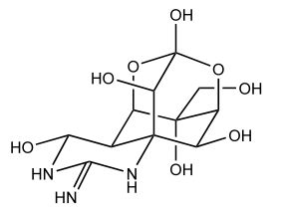 | 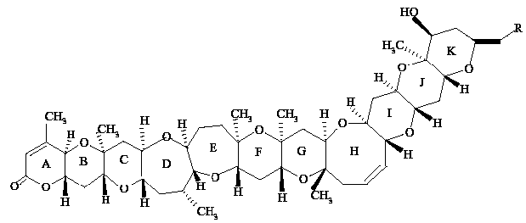
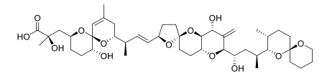

Student handout: Information on five marine toxins

Toxin | Molecular formula and structure | Molecular mass (daltons) | LD₅₀  (µg/kg in mice)
Brevetoxin  Neurotoxic shellfish poisoning (NSP) | C₅₂H₇₄NO₁₇SNa | 1039 | 200
Okadaic acid  Diarrhetic shellfish poisoning (DSP) | C₄₄H₆₈O₁₃ | 805 | 200
Tetrodotoxin  (TTX)  Neurotoxin | C₁₁H₁₇N₃O₈ | 319.28 | 10
Saxitoxin  Paralytic shellfish poisoning (PSP) | C₁₀H₁₅N₇O₄  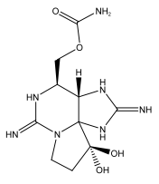 | 294 | 10
Domoic acid  Amnesic shellfish poisoning (ASP) | C₁₅H₂₁NO₆ | 311.14 | 3600

Student handout: Liquid chromatography-mass spectrometry (LC-MS)
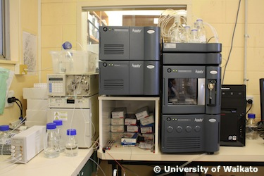
Liquid chromatography-mass spectrometry is a sophisticated laboratory technique.

Very briefly, when samples are loaded into the instrument, the liquid chromatography (LC) part separates the molecular components present.

These then enter the mass spectrometer (MS) where the molecular mass of each component is determined. The amount of a given component (pure substance) present can also be determined.

The unit for this measurement of molecular mass is given in daltons. One dalton is approximately equal to the mass of one proton or one neutron. Scientists have already worked out and recorded the molecular mass for most molecules. This means that, when they are given a molecular mass through LC-MS, they can look up that mass to find out what the molecule is.

Using the student handout Information on five marine toxins, answer the following questions:

- Which of the five toxins has the heaviest molecule?

- Which has the lightest?

- What is the molecular mass of tetrodotoxin?

- What is the molecular mass of okadaic acid?

- According to the interactive What killed the dogs?, which toxin was found in the greatest quantities?

- What was the name of the other toxin detected?

- Molecular mass is measured in daltons. This was named after John Dalton. Find out who John Dalton was.

Student handout: Lethal dose 50

Lethal dose 50 (LD₅₀) is a very useful measurement in toxicology. It is the dose required to kill half of a specific animal population. It tells us how poisonous a substance is. In the example given in Measuring toxicity, salt has an oral (means it was fed to an animal) LD₅₀ of 3 gm/kg in rats. Paracetamol has an oral LD₅₀ of 1.944 gm/kg in rats. This means paracetamol is more poisonous than salt because a smaller amount of paracetamol will get the same result in rat deaths.

The LD₅₀ of the toxins in the student handout Information on five marine toxins was calculated using mice and is measured in micrograms (µg). A microgram is just one-millionth of a gram. A small paper clip might weigh a gram, so a microgram is one-millionth of that. It is not something you can see with your eyes. A kilogram is a billion micrograms, so one part per billion of solid measure is equal to a µg/kg.

Discuss these questions together:

- What is the LD₅₀ of okadaic acid?

- What is the LD₅₀ of tetrodotoxin?

- Which is more toxic? Explain why

- Which of the five toxins is/are the most deadly? Explain why.

