ACTIVITY: Balloon car challenge

Activity idea

In this activity, students design and build a balloon-powered car to better understand the science ideas related to rocket propulsion. They use ideas of mass and force to work out ways to improve the distance travelled by their car.

By the end of this activity, students should be able to:
- design and build a balloon-powered car
- describe how their car is designed to go as far as possible
- use ideas of mass and forces (such as thrust, air resistance and wheel friction) to describe what might help their car travel further
- explain what causes the balloon car to start moving, using ideas of action and reaction forces
- explain that momentum keeps their balloon car moving once the balloon is no longer applying a force and that it will slow down because of the force of friction.

This activity is ideally done after the teaching and learning activities Introduction to rockets and space and Film canister rockets.

Introduction/background

What you need

What to do
Discussion questions
Extension ideas
Student worksheet: Make and race a balloon-powered car

Introduction/background

This activity allows students to develop their ideas about forces and motion as they relate to rocket propulsion. Their goal is to make a balloon-powered car that travels the greatest distance. They have 1 week at home to design and test their cars before the class competition.

Newton’s third law
For every action, there is an equal but opposite reaction. This means that, for every force pushing on an object, there is an equal but opposite force pushing back. The balloon pushes the air in one direction, and the air pushes back on the balloon to make it go in the other direction. A rocket works by pushing gases out one end very quickly, which results in a large force that pushes the rocket in the other direction. If the gases are pushed out faster, this will produce more force to push the rocket.

A good example of Newton’s third law is to think of two people standing on skateboards. If one skateboarder pushes the other, both skateboarders will be pushed apart because there is an equal but opposite force acting on each of them.

Mass
A lighter mass will speed up more quickly than a heavier mass if the same force is applied. A lighter rocket will speed up more quickly and will also be easier to launch because it will have less gravity acting on it. A good example of the effect of mass is to think of a light person and a heavy person sitting on two swings. If each person is given the same size push, the lighter person will speed up more quickly. A light balloon car will speed up more quickly.

Force
A larger force will cause an object to speed up more. For a balloon car, it is good to use a fresh balloon each time and blow it up well. To maximise the forward force, friction from the wheels (and perhaps from air resistance) also needs to be minimised.

Momentum
Once the car is moving, it will keep moving because of its momentum, even though the balloon is deflated. Momentum is equal to mass multiplied by velocity. Newton’s first law states that an object at rest will tend to remain at rest and that an object that is moving will tend to keep moving at a constant speed in a straight line until an external force acts on it.

Friction
The car will slow down and stop due to the opposing force of friction. There are two kinds of friction: air resistance and the friction as the surfaces of the axle, body of the car, wheels and ground move past each other. Ideas of streamlining and designing good axles and wheels are intended to reduce friction. In this challenge, minimising friction caused by surfaces rubbing together is more important than streamlining.

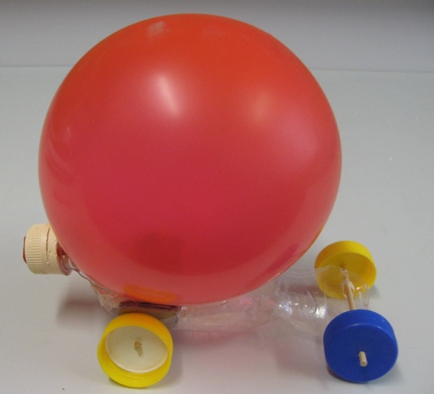
Examples of student design
The car in the photos shows how one student used a bottle cut into shape. A piece of cardboard was included after initial trials to stop the balloon from rubbing on the wheels. A flame was used to gently melt the bottle into a different shape to help with steering. A hole was cut into the lid of the bottle and the end of the balloon pushed through to hold it in place and for the air to come out. The balloon was blown up and a finger held over the hole before it was ready to be released. This car travelled over 10 metres!

What you need

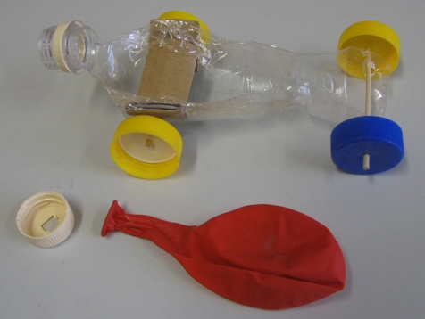
- Copies of the student worksheet: Make and race a balloon-powered car
- Balloons
- Anything you might find useful such as empty plastic bottles or containers, cardboard boxes and any other bits and pieces
- Bottle tops can make good wheels
- Wooden skewers inside straws can make good axles
- Tape and cardboard

What to do

- Explain the challenge to the class: To build a balloon-powered car that travels the greatest distance. They will have 1 week to build and test their cars at home before the class competition to see whose car travels the furthest. Give a copy of the student worksheet Make and race a balloon-powered car to each student and ask them to complete it as they work through the activity.

- Discuss some of the variables that might affect how far the car travels. (Students may come up with ideas about minimising the mass, maximising the force, friction, streamlining, how big the balloon is inflated, the size of the hole or tube that the air comes out, direction of the air as it comes out. Suggest using a fresh balloon for each trial and for the competition.)

- Allow the students come up with their own ideas to develop their problem-solving skills and creativity. Encourage them to build and test their models and then to try out different ideas to find out what works best.

- To run the competition, line the students up on a line at the competition area – a school hall with wooden floors or an outside court with smooth concrete will work well. Count down from 10 to allow students time to blow up their balloons ready to release on “Go!” You may like to repeat the competition several times.

- Ask the winning students to explain their designs.

- Discuss the science ideas. In small groups, ask students to describe and evaluate how their cars worked using at least five science words and ideas from this list: force, mass, action-reaction, momentum, friction, speed up, slow down.

- Ask students to draw and label their cars. Use ideas of force and mass as well as action and reaction forces to explain what made their car work. Write an evaluation of their car and what they would do to improve their designs. Some students will appreciate an opportunity to rebuild their cars for a rematch a few days later.

- Have students complete the ‘Thinking about science ideas’ section of the student worksheet and discuss the results.

Discussion questions

- Which cars worked best? Why?
- How does the mass of the car make a difference? What would happen if the car could be made lighter?
- How could a greater force be applied to the car? How would this affect the speed?
- What is pushing on the car?
- What is the ideal direction for the air to be pushed out the back? (Ideal hole/tube design?)
- Why does the car keep moving even when the balloon has deflated?
- What caused the car to slow down and stop?

Extension ideas

- Experiment to find out what happens if the car has a greater mass.
- Experiment to find out what happens if a greater force is used. (Two balloons? One balloon inside another balloon?)
- Experiment to find the ideal size for the air hole/tube.

Make and race a balloon-powered car

Challenge: To build a balloon-powered car that travels as far as possible.

Before the competition

- What things might affect how far a balloon-powered car can travel?

- What ideas do you have for building your car? Draw some possible ideas below:

- Build and test your car. What happened?

- What ideas do you have for improving your design? Draw some possible ideas below:

- How did you develop these ideas for your car?

- Build and test your improved car. What happened?

- How does the mass of the car affect how far it travels? Why?

- What things did you do to reduce the mass of the car as much as possible?

- What produces the force that pushes on the car to make it speed up?

- What things did you do to make the force to push the car forwards as high as possible?

- What things did you do to reduce friction caused by surfaces rubbing together and from air resistance?

- How far did your balloon car travel during trials at home?

After the competition

- How far did your car travel?

- Evaluation of your car’s performance in the competition:

- How far did the winning car travel?

- Draw the winning car.

- What features made this car so successful?

Thinking about science ideas

- For each of the following stages of a balloon car’s motion:
- describe the motion of the car using words such as speeding up, slowing down, moving quickly, moving slowly, stopped and so on
- explain what is causing this motion using science ideas such as mass, force, momentum, friction and so on.

A.  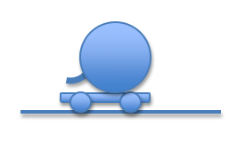  Balloon car just released | The balloon car…(Describe motion)  This is because… (Explain motion)
B.  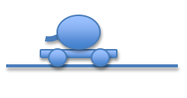  Balloon half deflated | The balloon car…  This is because…
C.  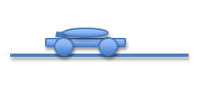  Balloon just finished deflating | The balloon car…  This is because…
D.  After balloon finished deflating | The balloon car…  This is because…

For each of the following situations, predict which car speeds up or slows down more quickly. For your reasons, include science ideas such as force, mass, momentum and friction.

E.  Car 1 – balloon fully inflated  Car 2 – same mass as car 1 but balloon only half inflated | Different force, same mass  Car ____ speeds up more quickly  This is because…
F.  Car 1 – balloon fully inflated  Car 2 – twice as much mass as car 1, balloon fully inflated  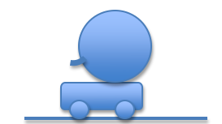 | Same force, different mass  Car ____ speeds up more quickly  This is because…

G.  Car 1 – balloon fully inflated  Car 2 – same mass as car 1, balloon fully inflated, more friction acting (friction is a force caused by surfaces rubbing together) | Same force from balloon, same mass, different friction  Car ____ speeds up more quickly  This is because …  What things might cause this extra friction?

Extension

- For each of the balloon car diagrams A–G above:
- use a ruler to draw arrows of different lengths to show the relative sizes of the individual forces acting on the balloon car (e.g. weight, thrust, friction, support of ground).
- label these forces
- use a ruler and a red pen to draw an arrow to show the size and direction of the resultant force.

