ACTIVITY: Water bottle rockets

Activity idea

In this activity, students make a water bottle rocket. They investigate the variables that affect the height and distance travelled by the rocket.

By the end of this activity, students should be able to:
- build a rocket out of a plastic bottle, using water and air pressure to generate the thrust
- design a nose cone and fins that help the rocket travel as far as possible by increasing stability and minimising drag
- investigate some of the variables that may affect the distance travelled or height reached by the rocket.

This activity is ideally done after the teaching and learning activities Film canister rockets and Balloon car challenge.

Introduction/background
What you need
What to do
Discussion questions
Extension ideas
Student worksheet: Make and launch a water bottle rocket
Student worksheet: Make an advanced launcher

Introduction/background
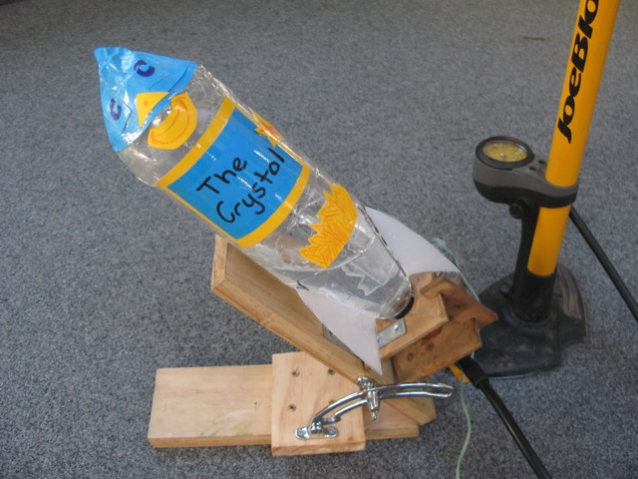
This activity reinforces ideas learnt about action and reaction forces for rockets. Making the water come out the end of the water bottle rocket more quickly will make a rocket travel further, but only if the rocket has been well designed.

A well designed water bottle rocket may travel well over 100 metres when it is launched at an angle!

Nose cone
This is the first part of the rocket that punches its way through the air. Its shape is important to reduce drag (air resistance).

Students could investigate which shape makes the rocket go further.

Fins
These help to keep the rocket pointing in the correct direction in the same way that fins are used on an arrow. Students could investigate how curving of the fins will make the rocket spin.

Extra mass
This helps to keep the rocket stable as well as to give it extra momentum so that drag doesn’t slow it down as quickly.

Stability
Once the rocket has been made, it can be tested by tying a 1 metre piece of string around it at the centre of gravity (the point where the rocket is balanced like a see saw and hangs horizontally). If the rocket is then swung around in a horizontal circle, it will keep pointing in the forward direction if it is balanced and stable.

What you need

- Access to the video clip Making a water bottle rocket
- Copies of the student worksheet Make and launch a water bottle rocket
- 1.5 litre plastic fizzy drink bottle for each group
- Coloured card or extra plastic bottles to make a nose cone
- Ice cream containers to make fins
- Plasticine (or similar) or a golf ball for extra mass
- Tape
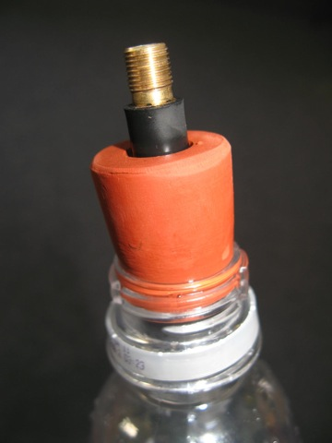
- Hot glue guns
- Scissors
- String
- Valve from a bike or car tyre
- Rubber bung – a rubber bung with a 19 mm small end fits nicely into a bottle. The bung needs to have a 4 mm hole in it if you are using a narrow bike valve. It needs a 10 mm hole if you are using a larger valve. If your bung does not already have a hole in it, you may be able to ‘drill’ one with a 4 or 10 mm sharpened metal tube using plenty of detergent. Your science technician may be able to help with these bungs or you can purchase bungs from:
  - Delta Educational Supplies
www.deltaed.co.nz
0508 654 321 or (09) 629 3234
47RSH19: Rubber stopper – 19mm bottom diameter, 1 hole +- 4mm
  - Biolab Scientific Ltd
410 Hutt Rd, Lower Hutt (04) 586 1200 or 29 Shakespeare Rd, Christchurch (03) 366 3663
20 rubber stoppers (22mm – 19mm, +- 5mm hole) in a case - $36.85. Takes 3 weeks to order.
  - Crescendo Enterprises
www.crescendo.co.nz
(09) 336 1001
BRE19/24/1 – 19mm bottom, 24 top, 1 hole +- 5mm
  - Brew Your Own
www.brewyourownliquor.co.nz
(07) 849 8484
545 Te Rapa Road, Hamilton
- Launcher – options are:
  - Floor standing pump or retort stand and clamp to hold the bung tightly for the launch
  - Make an advanced launcher that allows the bottle to be launched at any angle and pressure
  - Purchase a launcher – some suppliers carry a bottle rocket launcher that releases the rocket at your desired pressure. The Aquapod bottle rocket launcher may be purchased online for about $50.00. No further bung or valve required.

What to do

- Discuss rocket science ideas: action and reaction forces, changes in momentum, nose cone, fins, extra mass, stability.

- Explain to students that they will be making and launching a water bottle rocket. As a class, view the video clip Making a water bottle rocket. Hand out copies of the student worksheet Make and launch a water bottle rocket and discuss. Students may choose to make a rocket differently to the methods described. For safety reasons, ensure that the rockets have at least 3 fins.

- Assist students to gather the materials and equipment they need and construct their rockets.

- During construction, students may like to investigate the effect of different fin shapes. You may like to cut a few templates out of card to give to students in case they want to use them. One example for a template is shown below:

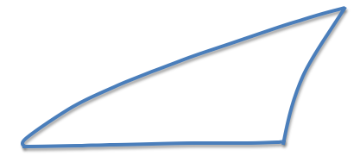

- For the class launches, have all students lined up behind a marked off area, positioned so that they can all see each launch. The field should be at least the length of a rugby field. If you don’t have this much room, don’t push the bung in so hard or angle the rockets more vertically.

- Do not let the students retrieve their rockets until all have been launched. You may like to award prizes for different categories (furthest, highest, most stable, most spin, attractive design).

Discussion questions

- What is pushing the rocket to make it go faster?
- What keeps the rocket moving once the water has all come out?
- How does aerodynamic drag affect the motion of the rocket?
- How does gravity affect the motion of the rocket?
- What effect do the nose cone and fins have?
- What effect does the angle of the launch have?
- What things might reduce the aerodynamic drag?
- What things might increase the thrust?

Extension ideas

- Investigate what amount of water makes the rocket travel the furthest.
- Investigate different nose cone designs.
- What effect do the fins have? Try different sizes, shapes and number of fins. Try attaching the fins at slight angles to make the rocket spin more or less.
- Build a launcher that releases the rocket at any chosen pressure. Investigate how pressure affects the distance travelled by the rocket.

Make and launch a water bottle rocket

Making your rocket
- Cut at least 3–4 fins from a flat section of an ice cream container. Make sure none of the curved parts of the container are included. Use a template to draw fins that are exactly the same size and shape.

- Fill the bottle with water before using hot glue or duct tape to attach the fins near the open end of the bottle. Run a strip of hot glue down both sides of each fin. Make sure they are evenly spaced (at the 4, 8 and 12 o’clock positions for 3 fins or at the 3, 6, 9 and 12 o’clock positions for 4 fins). Make sure there is enough room for the bung and launch clamp.

- To make a simple nose cone, cut a circle with a diameter twice that of the bottle onto a piece of coloured card. Cut a straight line from the edge of the circle to the exact centre of the circle. Overlap these cut edges around on each other until the circle has been curved into a perfect cone. Tape this cone along the edge so that it keeps this shape.  Alternatively you can use another bottle for the nose cone. Cut the top third off and then also cut off the spout. A golf ball can be glued into the hole left from removing the spout to create the extra mass needed at the tip of the nose cone. | 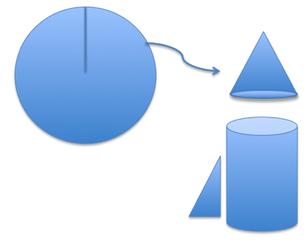
- To add extra mass to the front end of the rocket before attaching the coloured card nose cone – add about a golf ball-sized amount of plasticine (modelling clay) or similar soft material. (Softness ensures slightly increased safety if the launch goes wrong.)

- Tape the cone to the top of the rocket. In the case of a plastic bottle nose cone, use hot glue.

- Test the rocket for stability by emptying any water and tying a 1 metre length of string around the bottle at the centre of gravity. To find this point, balance the bottle horizontally on your finger. Swing the bottle around you in a horizontal circle. If the bottle is stable, it will turn to point in the direction it is travelling. (If it is unstable. it will start spinning.)

Launching your rocket
- Fill the rocket approximately a quarter full with water. This is often just up to the first line in the bottle when it is held with the open end pointing downwards.

- For a simple launch system, push the bung with the valve into the bottle as hard as you can and tightly clamp the bung at an angle so that the bottle is pointing slightly higher than 45°.

- Attach the pump and start pumping. The rocket should launch once the pressure is close to 70 psi (depending on how hard you have pushed in the bung). A well made rocket will travel 50–100 metres, or even much further.

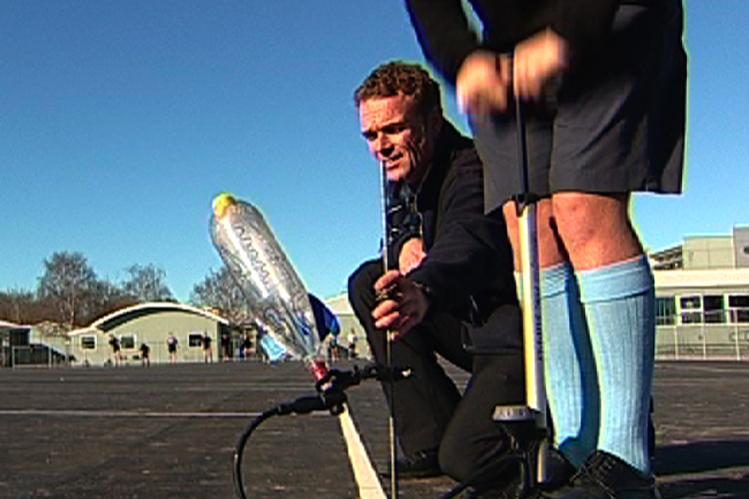
Make an advanced launcher
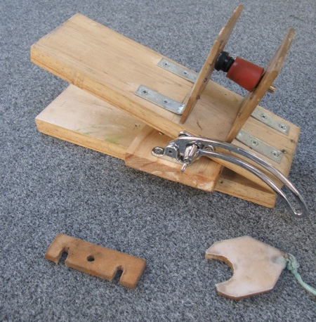
This launcher allows a bottle rocket to be launched at any angle.

What you need

- 75 cm length of 100 x 25 mm wood
- 4 metal angle brackets and screws
- 30 mm or similar hinge
- Adjustable window latch
- 250 x 100 x 5 mm hardboard
- Screws
- Power drill and screwdriver
- 10 mm drill
- 28 mm and 37 mm wood auger or similar
- Screws
- Weight to hold the front end down during launch
- Floor-standing pump
- Milk bottle
- Thin rope or twine

What to do

- Cut 2 x 30 cm lengths of wood and attach these with a hinge.

- Cut 2 x 1100 x 100 squares of 5 mm hardboard. Mark the centre of each. Drill a 10 mm hole in one and a 37 mm hole in the other.

- Attach these as shown to the board at a spacing of 43 mm accurately measured between the faces. The one with the 10 mm hole should be 60 mm from the hinge end.
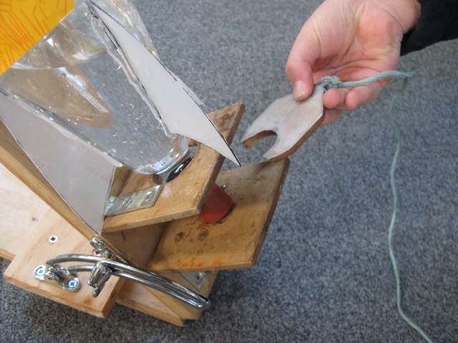
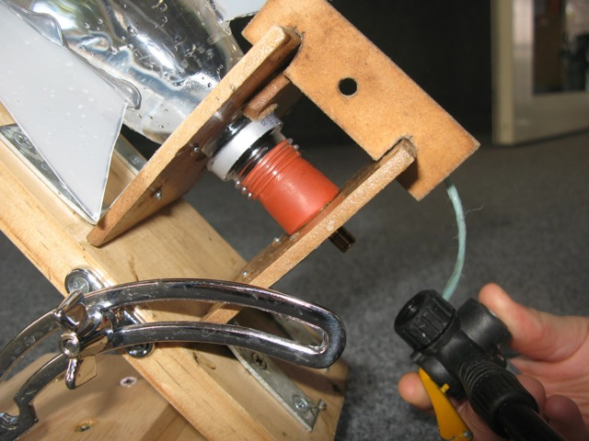
- Attach the changeable window latch as shown. Set positions so that the launcher can be extended to any angle up to a vertical position. A good place for the wing nut attachment is half way between the two upright parts.

- Drill a 28 mm hole in a small piece of the hardboard and shape as above. This is to be used to fit over the collar of the bottle to lock it into place until it is ready to be launched. Glue a piece of milk bottle plastic over this shape so that it can slide easily over the other hardboard during release. Drill a hole in one end and tie a 3 m length of thin rope or twine.

- Cut an 80 x 30 mm section of hardboard to be used as a brace at the top of the upright sections. This stops them being pushed apart as pressure builds up. The slots as shown in the brace should be 6 mm wide by about 12 mm long, and the measurement between the outside parts of these slots should be 57 mm (you may need to experiment to get the exact size required).

The launch

- Make your bottle with fins and nose cone as desired.

- Fill with your chosen amount of water (1/3–1/2 full works quite well).

- Push the bung with the valve into the bottle firmly and place on your launcher.

- Place the locking/release piece (the part with the string on it) snugly between the front upright part of the launcher and the collar of the bottle.

- Place the small brace on the top.

- Attach your pump.

- Angle the launcher in the direction as desired. You need to allow for a successful launch that may go well over 150 metres!

- Place a weight (or another piece of wood with holes in it, held in place with screwdrivers or similar arrangement) so that the launcher is not pulled off angle during the launch

- For your first launch, do not exceed 50 psi. Maximum recommended launch pressure is 60 to 70 psi maximum.

