Rockets teaching sequence – unit plan

Curriculum links

Levels 4/5/6
Nature of Science: Understanding about science
- Identify ways in which scientists work together and provide evidence to support ideas.
Nature of Science: Investigating in science
- Ask questions, find evidence, explore simple models and carry out appropriate investigations to develop simple explanations.
Physical inquiry and physics concepts
- Explore, describe and represent patterns and trends for everyday examples of physical phenomena, such as movement and forces, for example, identify and describe the effects of forces on the motion of objects.

Introduction

What is the history of rockets?
www.sciencelearn.org.nz/resources/1868-brief-history-of-rockets-timeline
- Students view a timeline showing a brief history of rockets beginning with Chinese fire arrows in 1232 through to on-going international space exploration.
- Use this as a whole class presentation/discussion or encourage students to work through the timeline in pairs.

Rockets today
www.sciencelearn.org.nz/resources/402-introduction-to-rockets-and-space
- View a slide show presentation introducing some rockets, their purposes and distances travelled in space.
- Discuss some of the questions from the penultimate slide.
  - What makes a rocket start moving?
  - What keeps a rocket moving once the rocket engines have finished?
  - Why do some rockets stay in space and some fall back to the Earth?
  - What challenges does the New Zealand space industry
  - What countries have launched rockets into space?
  - What are some of your favourite images from space (e.g. Hubble Space Telescope images)?
  - What are some of NASA’s current and future missions?

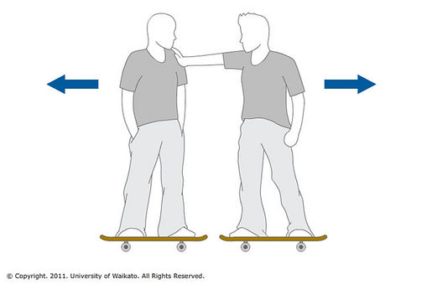
Science concepts: forces

What makes a rocket start moving?
Use skateboards to demonstrate how forces always come in pairs.

Demonstrate the concept of equal but opposite forces:
- Students stand on skateboards.
- When one person pushes the other person, both skateboarders are pushed apart with equal but opposite forces.

Demonstrate with a skateboard the two factors that affect a rocket when it starts moving:
- A student stands on the skateboard in the school playground and throws a heavy object away from them and then throws a light object at the same force. (Which action made the skateboard move the most?)
- The student then throws a heavy object with little force and with lots of force. (Which action made the skateboard move the most?)

Back in the classroom, discuss the following:
- Newton (1643-1727) said that, for every force there is an equal and opposite force. What do you think this means when we are talking about rockets and skateboards? Think, pair, share.
- Follow up student sharing/discussion by asking them to read this article on Lift off: www.sciencelearn.org.nz/resources/389-lift-off.
- Were student ideas correct?

Review student actions while on the skateboards. Reinforce the following concepts:
- The throwing of an object is called thrust.
- The heaviness of an object (or stuff) is its mass. The name for the stuff that comes out of a rocket is the propellant.
- Thrust and mass of the propellant cause the object to start moving.

Refer students to the following articles to learn more about the concepts of thrust and mass:
- Rockets and thrust – www.sciencelearn.org.nz/resources/390-rockets-and-thrust
- Rockets and mass – www.sciencelearn.org.nz/resources/391-rockets-and-mass

Student activity: Water bottle rocket design and launch

Students build water bottle rockets to investigate the variables that affect the height and distance travelled by the rocket. In a water bottle rocket, the mass of the propellant is the mass of the water that goes into the bottle. Thrust is provided by pumping air into the rocket using a bike pump.

Watch the video to learn how to make a water bottle rocket:
- www.sciencelearn.org.nz/videos/183-making-a-water-bottle-rocket

Download the instructions and templates for making the rocket. Discussion questions and extension ideas are included with the activity:
- www.sciencelearn.org.nz/resources/406-water-bottle-rockets

Find out more about rocket design and aerodynamics with the following article:
- www.sciencelearn.org.nz/resources/392-rocket-aerodynamics

Putting it all together: Rocket launch simulation

This Flash interactive allows students to set mass, thrust, thrust time, drag and mass change variables before launching a rocket to see how high their rocket goes:
- www.sciencelearn.org.nz/embeds/25-rocket-launch-simulation

Download the activity document for instructions on how to introduce/use the simulator with the class. The document includes a student handout (Analysing rocket launches) for students to work through as they use the simulator:
- www.sciencelearn.org.nz/resources/407-launch-simulator-challenge

Rockets in New Zealand

Watch these videos to learn more about New Zealand’s rocket industry:
- www.sciencelearn.org.nz/videos/177-new-zealand-s-place-in-space
- www.sciencelearn.org.nz/videos/174-rocket-lab-launches-into-space-industry
- www.sciencelearn.org.nz/videos/175-new-zealand-s-first-space-rocket

Students may enjoy reading these follow-up articles about Peter Beck and Rocket Lab:
- www.sciencelearn.org.nz/resources/398-peter-beck
- www.sciencelearn.org.nz/resources/2431-rocket-lab

Further investigation and/or evaluation

The Question bank provides a list of questions about rockets and some of the science ideas and concepts involved in launching a rocket. Students can choose one or more questions for investigation or to answer as part of an evaluation:
- www.sciencelearn.org.nz/resources/2498-investigating-rockets-question-bank

