ACTIVITY: Toilet roll geologic timescale

In this activity, students construct a modified geologic timescale using a roll of toilet paper. Each piece of the toilet roll represents a time period, and major New Zealand geologic events are to be marked on the paper.

By the end of this activity, students should be able to:
- understand that time periods in the geological history of the Earth are exceedingly long
- recall that geologic time is for convenience sectioned into eons, eras, periods and epochs
- put into the context of geologic time some of the changes that have shaped the evolution of the landscape of modern New Zealand
- better understand the terms Oligocene and Miocene in relation to New Zealand limestones
- realise that, in this analogy, the length of one toilet roll is representative of only 65 million years in the 4.6 billion year geologic record of the Earth.

Introduction/background notes
What you need
What to do
Discussion questions
Cenozoic era
Labels
Events

Introduction/background

The geologic timescale is one way of dividing up the 4.6 billion years of the Earth’s history into intervals of time. These are variable in length because significant events in the history of the Earth have been used as markers.

For example, the boundary between the Mesozoic era’s Cretaceous period and the Cenozoic era’s Paleogene period is marked as a significant extinction event that occurred 65 million years ago. There is evidence to suggest that this extinction was caused by an asteroid impact with the Earth. Dinosaurs along with many other species of plants and animals died out as a consequence of this.

The timescale is divided up into eons, eras, periods, epochs and ages.

There are three eons – the most recent of which is the Phanerozoic. The Phanerozoic eon extends from the present to 545 millions of years ago (mya) and is divided into three eras: Paleozoic, Mesozoic and Cenozoic.

The focus of this activity is on the Cenozoic – an era that extends from the present to 65 mya. The Cenozoic era is divided into three periods:
- The Paleogene from 23–65 mya.
- The Neogene from 2.8–23 mya
- The Quaternary from the present to 2.8 mya.

Each period is further divided into epochs – the Paleogene has three epochs, and the Neogene and the Quaternary have two each.

In this activity, students construct a modified geologic timescale using a roll of toilet paper. The length of the paper represents a geologic time period (the Cenozoic era) of only 65 million years in the 4.6 billion year history of the Earth. Each piece of the 500-sheet toilet roll represents a time period of about 130 000 years.

Due to the space needed this activity could be run as a class demonstration or as a large group activity. If the weather is fine and calm, it could be completed outside as a small group activity. Judicious use of paperweights may be needed. The label size can be increased to suit.

Greek/Latin rooted geological terms
- Phanerozoic = visible life (encompasses the period of abundant, complex life on the Earth)
- Cenozoic = new life (the age of recent life)
- Quaternary = four at a time
- Neogene = newborn
- Paleogene = ancient born
- cene = new
- holo = entire
- Holocene = entirely new life
- pleisto = most
- Pleistocene = mostly new life
- plio =more
- Pliocene = more that is new life
- mio =less
- Miocene = less that is new life
- oligo = little
- Oligocene = little that is new life
- eo = dawn
- Eocene = dawn of new life
- paleo = ancient
- Paleocene = ancient new life

What you need

- One 500-sheet roll of toilet paper (Purex Mega brand works well)
- Suitable dry area to roll out the toilet paper (it is ~57 m long!!)
- Access to the graphic The Cenozoic era
- Cut up labels and events
- A supply of paper weights (5 or so small books) to hold the toilet paper in position

What to do

- Roll out the toilet paper up and down the length of the classroom/gym/hall (it is ~57 m long!!). The length of the paper represents a geologic time period of only 65 million years in the 4.6 billion year history of the Earth. The toilet roll represents the extent of the Cenozoic era, which is the final era of the Phanerozoic eon.

- Using a permanent marker, rule vertical lines to mark the following periods and epochs of The Cenozoic era and clearly label each of the periods and epochs using the labels provided.

Cenozoic era (Present –65 mya) | Quaternary period  (Present to 1.8 mya)  13 sheets (1.48 m) | Holocene epoch  (Present to 10 000 years ago)  0.1 sheet (1.15 cm)
Pleistocene epoch (10 000 years ago to 1.8 mya)
12.9 sheets (1.46 m)
 | Neogene period  (1.8–24 mya)  171 sheets (19.67 m) | Pliocene epoch (1.8–5 mya)  24.6 sheets (2.83 m)
Miocene epoch (5–24 mya)
146 sheets (16.8 m)
 | Paleogene period  (24–65 mya)  316 sheets (36.3 m) | Oligocene epoch (24–34 mya)  77 sheets (8.86 m)
Eocene epoch (34–55 mya)
161.7 sheets (18.6 m)
Paleocene epoch (55–65 mya)
77 sheets (8.86 m)

- Given that each sheet represent a time length of 130 000 years (0.13 mya), add the events in the appropriate place.

- When all labels and events are in place, view the whole timescale off to one side of the display. This should give students an indication of the true extent of geologic time that this length of toilet paper represents. (Taking a photo of the display from an elevated position and making a copy available to students to post in a note/lab book or paste on the classroom wall will serve as a reminder that the Holocene, sometimes referred to as the ‘Age of Modern Man’, is a mere blip in the greater scheme of things geologically.)

Discussion questions

- If one roll of toilet paper represents 65 million years of geologic time, how many rolls are needed to represent the 4.6 billion years of total geologic time?
- If each roll is 57 m long, what length of toilet paper would you need to represent total geologic time?

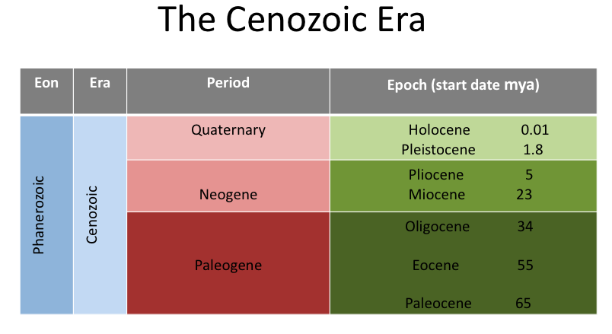
e

Labels

Quaternary period

Neogene period

Paleogene period

Halocene epoch

Pleistocene epoch

Pliocene epoch

Miocene epoch

Oligocene epoch

Eocene epoch

Paleocene epoch
Events

Dinosaur extinction 65 mya.
End of the last glacial period occurred 10 000 years ago.

Throughout the Pleistocene, there were about 20 cycles of cold glacial and warm interglacial periods at intervals of about 100 000 years.

The coalfields of Huntly as well as the natural gas and oil fields of southern Taranaki were formed around 36 mya.

The Tasman Sea reached its current extent 55 mya.
Australian and Pacific plate boundary forms around 23 mya.

Limestone deposition in New Zealand began in late Eocene time and continued into early Miocene time 37–16 mya.

The Ōruanui eruption occurred 26 500 years ago. It was this event that largely determined the shape of Lake Taupō.

Dunedin sits on the eroded remains of a volcano that first exploded to life about 13 mya.

Fossilised giant oysters in the Orahuri limestone date from about 28 mya.

