ACTIVITY: Some properties of carbon dioxide

Activity idea

In this activity, students investigate some of the physical, chemical and physiological properties of carbon dioxide gas. In addition, a model demonstrating the amount of carbon dioxide in the atmosphere will be constructed.

By the end of this activity, students should be able to:
- describe a chemical test for CO₂
- relate the water solubility of CO₂ to temperature
- describe some of the uses of carbon dioxide
- describe the effects rising levels of CO₂ in inhaled air can have on the body
- gain an appreciation of the meaning of the term part per million.

Introduction/background notes
What you need
What to do
Student handout: Investigating CO₂
Investigating CO₂ answers

Introduction/background

Carbon dioxide is a colourless, odourless gas that is one of the most important compounds on Earth. All food chains dependent on photosynthetic producers would collapse without the presence of CO₂ in the air. All human life would cease to exist without it.

Carbon dioxide has important uses in the home and in industry:
- Solid carbon dioxide (dry ice) is used as a refrigerant.
- In baking, the release of carbon dioxide gives cakes and bread their spongy texture.
- In fizzy drinks, dissolved carbon dioxide converts to gas bubbles when the top is removed.
- Some fire extinguishers use carbon dioxide because it does not burn and, being denser than air, smothers the flame.
- In the Earth’s atmosphere, carbon dioxide helps regulate the planet’s temperature.

Carbon dioxide is naturally present in the atmosphere at levels of approximately 0.038%. In the workplace environment, it is recommended that, for an 8-hour working day, the level of carbon dioxide in the air should not exceed 0.5%. A full, poorly ventilated classroom of students could result in CO₂ levels rising well above this figure. Some students could experience drowsiness followed by headache as a consequence of this. Short-term exposure to levels of 8% and above can result in loss of consciousness. At higher levels, death is the most probable outcome.
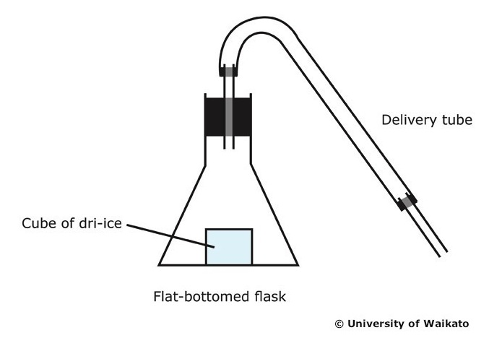
In 1986, volcanic activity under Lake Nyos, situated in the African country of Cameroon, caused a release from the lake of a huge volume of carbon dioxide gas. This toxic ‘cloud’ engulfed villages situated on the hillsides below the level of the lake, and as a result, 1700 residents died of carbon dioxide asphyxiation.

Making a CO₂ generator
There are several ways to make a CO₂ generator:
- Reaction between calcium carbonate and hydrochloric acid in a flat-bottomed flask with delivery tube. (Standard lab preparation that each student group can set up.)
- Small piece of dry ice placed in a flat-bottomed flask and delivery tube. (Care is needed in handling the dry ice, but with this method, it leads to a discussion about the various states of carbon dioxide and their uses.)
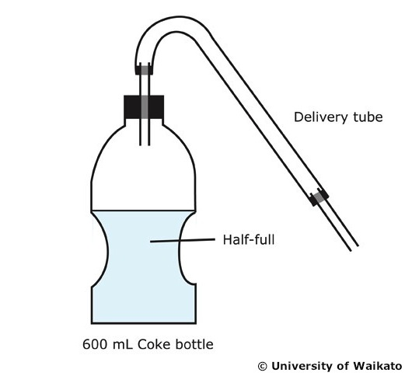
- A bottle of Coke (chilled and just over half full) fitted with a one-hole bung and delivery tube. By gently shaking the bottle, a stream of CO₂ can be generated. (Each student group can bring in their own bottle of Coke, and this leads to a discussion about carbonated drinks and the solubility of CO₂.)

What you need

- Copies of the student handout Investigating CO₂
- CO₂ generator (see above)
- Glass boiling tubes and bungs to fit
- 100 mL glass beakers
- Crushed ice
- Stirring rod thermometer
- Limewater
- Bromothymol blue indicator
- Small candle
- 1 kg pack of rice (class demonstration)
- Weighing balance
- Food colouring
- Large tray

What to do

- Hand out copies of the student handout and discuss. Assist students to carry out the first three investigations and complete the worksheet:
- Solubility of CO₂ in water at various temperatures
- Chemical test for CO₂
- Density of CO₂ and its effect on a candle flame

How much CO₂ in the air? (Teacher demonstration)

- Mark out a 900 x 600 mm area on a lab benchtop or use a suitable sized tray. Pour the contents of a 1 kg bag of rice onto the area and spread the grains over the whole area. Take 20 of the grains and colour them red using a felt-tip pen. Place them back in the pile and mix the grains up. Explain that, at 0.038% of the Earth’s atmosphere, this is a pictorial representation of the level of CO₂ in the air.

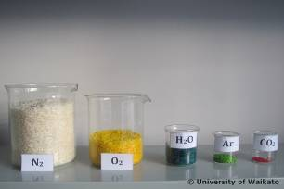
- To show all the atmospheric gases present in air at sea level on a typical early summer day, take a 1 kg packet of white rice (about 50,000 rice grains) and weigh out into separate containers each of the following amounts, soak in food colouring and allow to dry.
- N₂ – 758.8 g (off white)
- O₂ – 203.6 g (yellow)
- H₂O – 28.2 g (blue)
- Ar – 8.9 g (green)
- CO₂ – 0.4 g (red)

- Empty each container onto the tray. Thorough mixing reveals that the amount of CO₂ in the atmosphere (represented by the red grains) is very low by comparison with other gases. It is indeed a trace gas sitting at about 380 ppm, but an extremely important one. (It is advisable to set up two lots of containers with the different amounts and colours. One is used for mixing together and one to show relative amounts.)

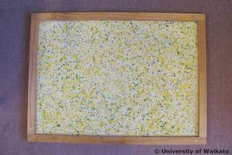

- Have students complete the last section of the handout and discuss.
Student handout: Investigating CO₂

Solubility of CO₂ in water at various temperatures

- Fill three boiling tubes with CO₂ and stopper.

- Two thirds fill a 100 mL beaker with water at 15°C and add 5 drops of bromothymol blue indicator.

- Invert one of the test tubes full of CO₂ into the beaker and carefully remove the bung.

- Rock the test tube back and forwards for several minutes, and with the rim of the test tube touching the bottom of the beaker, note the height of water that has risen into the tube. Note also any colour change to the water.

- Repeat steps 1 to 4 with an ice/water mix at 0°C.

- Compare the heights of water for each of the tubes:

15°C __ ___ mm
0°C ______ mm

- What do these results tell you about the solubility of carbon dioxide in water?

- What do these results tell you about the solubility of carbon dioxide in water at various temperatures?

- The oceans contain a huge amount of dissolved CO₂. If global warming continues and the temperature of the oceans rises accordingly, what could happen to the atmospheric level of CO₂ gas?

- Bromothymol blue is an acid base indicator similar to litmus paper. It is yellow in acidic solutions and blue in neutral solutions. Did any colour changes occur in this experiment? If so, can you explain why?

Chemical test for CO₂

- Half fill a boiling tube with limewater.

- From the CO₂ generator, slowly bubble CO₂ gas through the limewater and note what happens.

- Continue to bubble the CO₂ through the limewater and note any changes.

- What did you observe when the CO₂ was bubbled through the limewater?

- On continued bubbling, did you observe any further changes?

- If changes did occur, write word equations to show any chemical reactions taking place.

Density of CO₂ and its effect on a candle flame

- Place a small candle at the bottom of a 500 mL beaker and light it.

- Using the CO₂ generator and a length of tubing, play a jet of the gas into the beaker, keeping the jet just below the beaker rim level to one side. Note what happens to the candle flame.

- What happened to the candle flame?

- If there was an effect, how did the CO₂ manage to reach the flame if it entered the beaker from the top?

- Is there a possible industrial use for CO₂ based on the results of this experiment?

How much CO₂ in the air? (Teacher demonstration)

- What does ppm stand for?

- At about 350 ppm, what impression did you get from mixing the grains of rice about the amount of CO₂ in the air compared to other atmospheric gases?

- Although very low, this level is extremely important. Why?

- The amount of one of the other gases used in this demonstration can vary quite markedly from day to day. Which gas is this and why does it vary?

- Exposure to high concentrations of CO₂ gas can be life threatening. In 1986, volcanic activity under Lake Nyos, situated in the African country of Cameroon, caused a release from the lake of a huge volume of carbon dioxide gas. This toxic ‘cloud’ engulfed villages situated on the hillsides below the level of the lake, and as a result, 1700 residents died of carbon dioxide asphyxiation. The graphic below has some information about the toxicity of CO₂.

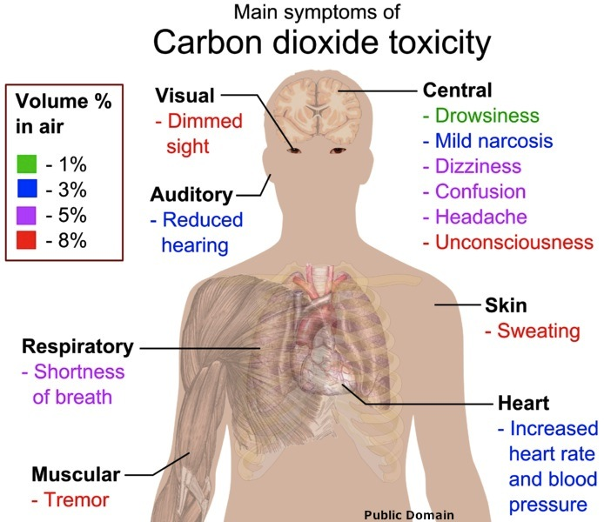

Why it is a necessary requirement to have windows open when student groups, experimenting in the lab, are using Bunsen burners?

Investigating CO₂ answers

Solubility of CO₂ in water at various temperatures

- Fill three boiling tubes with CO₂ and stopper.

- Two thirds fill a 100 mL beaker with water at 15°C and add 5 drops of bromothymol blue indicator.

- Invert one of the test tubes full of CO₂ into the beaker and carefully remove the bung.

- Rock the test tube back and forwards for several minutes, and with the rim of the test tube touching the bottom of the beaker, note the height of water that has risen into the tube. Note also any colour change to the water.

- Repeat steps 1 to 4 with an ice/water mix at 0°C.

- Compare the heights of water for each of the tubes:

15°C __10___ mm
0°C __20___ mm

- What do these results tell you about the solubility of carbon dioxide in water?
Carbon dioxide is soluble in water (2 g/L at 15°C).

- What do these results tell you about the solubility of carbon dioxide in water at various temperatures?
The higher the temperature, the lower is the solubility.

- The oceans contain a huge amount of dissolved CO₂. If global warming continues and the temperature of the oceans rises accordingly, what could happen to the atmospheric level of CO₂ gas?
The level could rise to be well above the current 350 ppm level.

- Bromothymol blue is an acid base indicator similar to litmus paper. It is yellow in acidic solutions and blue in neutral solutions. Did any colour changes occur in this experiment? If so, can you explain why?
A colour change was observed. The change was from orange-yellow to orange-red. Carbon dioxide is a weakly acidic gas. A small amount of the dissolved gas reacts with water to produce a weak acid commonly known as carbonic acid.
CO₂(g) + H₂O(l) → H₂CO₃(aq)

Chemical test for CO₂

- Half fill a boiling tube with limewater.

- From the CO₂ generator, slowly bubble CO₂ gas through the limewater and note what happens.

- Continue to bubble the CO₂ through the limewater and note any changes.

- What did you observe when the CO₂ was bubbled through the limewater?
The limewater slowly turned milky.

- On continued bubbling, did you observe any further changes?
The milky appearance of the limewater slowly changed back to a clear solution.

- If changes did occur, write word equations to show any chemical reactions taking place.

- The milkiness is due to the formation of solid calcium carbonate.
carbon dioxide + limewater → calcium carbonate solid + water
CO₂(g) + Ca(OH)₂(aq) → CaCO₃(s) + H₂O(l)

- The milkiness clears due to the formation of calcium bicarbonate solution.
milky limewater + carbon dioxide → clear solution of calcium bicarbonate
CaCO₃(s)+H₂O(l) + CO₂(g) → Ca(HCO₃)₂(aq)

Density of CO₂ and its effect on a candle flame

- Place a small candle at the bottom of a 500 mL beaker and light it.

- Using the CO₂ generator and a length of tubing, play a jet of the gas into the beaker, keeping the jet just below the beaker rim level to one side. Note what happens to the candle flame.

- What happened to the candle flame?
The flame was extinguished.

- If there was an effect, how did the CO₂ manage to reach the flame if it entered the beaker from the top?
It must have dropped down onto the flame. In order to do this, it must be denser than air.

- Is there a possible industrial use for CO₂ based on the results of this experiment?
It could be used in fire extinguishers that operate by directing a jet of the gas down onto the burning object.

How much CO₂ in the air? (Teacher demonstration)

- What does ppm stand for?

Parts per million.

- At about 350 ppm, what impression did you get from mixing the grains of rice about the amount of CO₂ in the air compared to other atmospheric gases?
The 20 red rice grains are completely swamped by the other grains. Difficult to see the red grains amongst all of the others. 350 ppm is a very small concentration.

- Although very low, this level is extremely important. Why?

- Green plants use carbon dioxide in photosynthesis to make simple sugars. All food chains dependent on photosynthetic producers would collapse without the presence of CO₂ in the air. All human life would cease to exist without it.

- In the Earth’s atmosphere, carbon dioxide helps regulate the planet’s temperature.

- The amount of one of the other gases used in this demonstration can vary quite markedly from day to day. Which gas is this and why does it vary?
Water vapour. The amount of water vapour in the air can vary during the day and from day to day. It is the heating effect of the Sun on the oceans that causes water to evaporate, effectively leading to this change.

- Exposure to high concentrations of CO₂ gas can be life threatening. In 1986, volcanic activity under Lake Nyos, situated in the African country of Cameroon, caused a release from the lake of a huge volume of carbon dioxide gas. This toxic ‘cloud’ engulfed villages situated on the hillsides below the level of the lake, and as a result, 1700 residents died of carbon dioxide asphyxiation. The graphic below has some information about the toxicity of CO₂.

Why it is a necessary requirement to have windows open when student groups, experimenting in the lab, are using Bunsen burners?
As the gas burns, carbon dioxide is generated and will build up to high levels if not suitably ventilated. A 1% CO₂ level can lead to drowsiness – not an ideal condition for students in a science laboratory.

