ACTIVITY: Modelling animal cells in 3D

Activity idea

In this activity, students make 3D models of specialised animal cells, imitating what can be seen under high-resolution microscopes.

By the end of this activity, students should be able to:
- name some animal cells that have distinctive shapes
- describe how these distinctive shapes help the cells carry out their specialised roles
- describe some of the features of cells (e.g. organelles) that are common to all cell types
- discuss how model-building can aid understanding of cell structure and function
- identify which microscopes scientists use to generate 3D cell images.

Introduction/background notes

What you need

What to do

Discussion questions

Extension ideas

Student handout: Examples of animal cell types

Introduction/background

This activity allows students to develop their understanding of cell structure and function through the hands-on approach of model building.

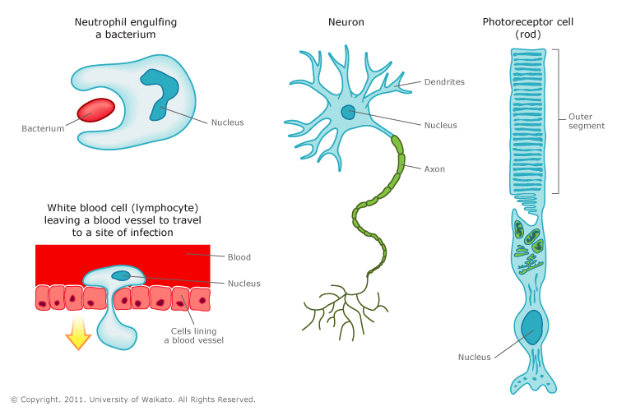
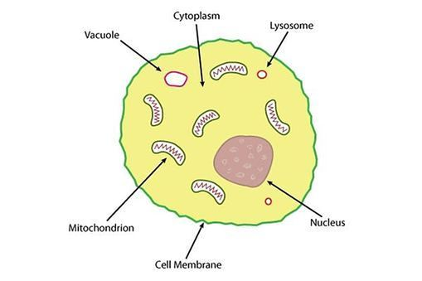
Students are often taught about the key differences between animal and plant cells. This approach sometimes leads to the alternative conception that all animal cells are fundamentally similar in shape, size and contents. Students may have seen diagrams such as the one on the left below of a ‘representative’ animal cell. Although the diagram is correct, it represents a generic cell, rather than any particular cell type. The diagram on the right gives a clearer sense of the diversity in shape of animal cells.

Cells: similarities and differences
Eukaryotic cells (and animal cells in particular) come in a wide range of shapes and sizes. In humans, for instance, red blood cells are around 7 micrometres (µm) in diameter, whereas megakaryocytes (which are responsible for platelet production) are 10–15 times bigger – about 100 µm in diameter. Different cell types in the same animal look different because they have different functions in the body – their specialised shapes and contents help them to do their jobs better.

The articles Animal cells and their shapes and Cell organelles give further information about the differences between different animal cell types.

Understanding cell shape through modelling
All cells are three-dimensional objects, but we often have to rely on two-dimensional information when studying them. This is because scientists who study cells (cell biologists) often do most of their experiments using microscopes. Microscopy is a powerful way of getting detailed information about cells, but the information is usually in the form of two-dimensional (flat) images. Even for experienced scientists, it can be difficult to make the conceptual leap from two-dimensional images to what a cell actually looks like. For this reason, scientists often ‘build’ computer models of the cells that they are studying, based on their microscope images.

Two of the scientists featured in Exploring with Microscopes (Dr Rebecca Campbell and Associate Professor Tony Poole) work with 3D computer models of the cells they study. This has helped them to understand the shapes of their cells of interest much more clearly.

The articles Making connections in the brain and A closer look at the cell’s antenna and the accompanying videos Brain cells in 3D and A 3D model of the primary cilium give insight into how these two researchers are using modelling in cell biology.

Choosing the level of challenge
In the video A 3D model of the primary cilium, Associate Professor Tony Poole extols the accuracy of the 3D images but also acknowledges that generating them is a lengthy and challenging process. Using less information is quicker, but does not provide the same detail. The same holds true with this activity. Teachers can modify or extend the activity to suit student needs and teaching timeframes.

What you need

- Access to or copies of the articles Animal cells and their shapes, Cell organelles, Making connections in the brain and A closer look at the cell’s antenna
- Access to the video clips Brain cells in 3D and A 3D model of the primary cilium
- Copies of the student handout Examples of animal cell types
- Access to cellular images (from the Science Learning Hub, textbooks and other online sources
- Materials for building cell models (for example, play dough and plasticine for the most basic of models; shoeboxes, stockings, balloons, water, food colouring, jelly beans, latex gloves for more complex models; cake, icing, jelly, various sweets for edible models)
- Toothpicks or stickers to label organelles and so on

What to do

- Read and discuss the articles Animal cells and their shapes and Cell organelles. Discuss the extent to which animal cells are similar and the ways in which they differ. Why do animal cells have such different shapes? (They play specific roles within the body, and their shapes help them carry out these roles effectively.)

- Watch the videos Brain cells in 3D and A 3D model of the primary cilium. If desired, watch the videos a second time and ask students to write down which microscopes the scientists used to extract the information to build their 3D images. (Confocal laser scanning fluorescence microscope and electron tomography.)

- Provide access to the student handout Examples of animal cell types and ask students to choose a cell type to model (individually, in groups or as a class). In addition, ask students to seek out images (diagrams and micrographs) of their cell type (for example, from the Science Learning Hub, textbooks and other online sources). Explain that they will use the information and 2D images to build a 3D model of one of the three cells.

- Show students images of 3D animal cells from www.squidoo.com/3d-cell-model#module153172956. These images may provide inspiration, but it is important to remind students that many of these cells model the ‘representative cell’ shape. Their challenge is to model distinctive cell shapes.

- Choose one of the following methods to build the cell. Consider whether students will need to provide written information by means of labels or a more detailed report including scale, cell function and the reason the cell is shaped as it is.
- Simple cell-shape models: Use play dough or plasticine to model one or all of the cell shapes in the student handout. Use different colours to add content characteristics (organelles). If time is short, concentrate on overall cell shape rather than content characteristics.
- Collage models: Students choose a cell type and use materials from home or school to build up a 3D model. (For example, a small cardboard box forms an intestinal epithelial cell, balloon or rubber glove is cut and shaped to form microvilli, etc.)
- Models you can eat: Students use cake, jelly and/or lollies to build cells. Models are built at home and brought to school or videoed or photographed for presentation.

Discussion questions

- To what extent do the models you have made help you to understand how a cell looks and works?
- Do they raise any questions about how the cells work?
- In what ways are models limited (or even misleading)?
- How do the models compare in size with a real animal cell?

Extension ideas

- Students could do independent research on other cell types and their shapes.
- Explore the Which microscope? interactive to learn more about different microscopes and their strengths and limitations when looking at animal cells.

Examples of animal cell types

Cell type | Role in the body | Special size and shape characteristics | Special content characteristics | Further information on the Science Learning Hub
Neuron | - Conducts electrical messages within the brain and between the brain and the rest of the body. | - Very long thin branches (one axon and many dendrites) that conduct electrical signals.  - Cell body is approximately 20 µm wide.  - Branches may be hundreds of times longer than cell is wide. | - Axons are covered in a myelin sheath – a fatty coating that acts like the plastic round an electrical wire (insulating, improves transmission of electrical signal down axon). | Making connections in the brain  Understanding brain development
Intestinal epithelial cell | - Absorbs nutrient molecules from the small intestine during digestion, then pumps the nutrients out into the bloodstream from the opposite end of the cell. | - Overall cell shape is columnar, quite long and thin, about 20 µm high and 10 µm diameter.  - Cells are squashed tightly together in a layer.  - Contains many finger-like projections (microvilli) on the surface that faces the intestine. These increase the surface area facing the intestine to maximise the amount of nutrient molecules that can be absorbed. | - Nucleus usually towards bottom of cell (opposite end from microvilli).  - Mitochondria are also clustered at bottom of cell (they are harnessing energy that is used to pump nutrients out of the bottom of the cell). | Human digestive system  Digestion of food
Skin cell (keratinocyte) | - Acts as a barrier and protective layer for the body by stopping infection, water infiltration and UV damage. | - Wide, flat (squamous) cells (about 30 µm wide).  - Form a layer of flattened cells that is many cells thick.  - The outer cells in the layer (the widest and flattest of all) are no longer alive. | - Outer keratinocytes lack a nucleus and are filled with keratin granules. | Skin structure

