ACTIVITY: Using lolly slices to build 3D images

Activity idea

In this activity, students model how scientists interpret microscope data by using thin slices of jelly lollies to build up a 3D image.

By the end of this activity, students should be able to:
- describe how they used thin, 2D-like slices to visualise a 3D object
- explain how this process relates to actual data interpretation when using microscopes and other imaging technologies
- describe some of the methods scientists use to help them interpret the data from 2D images.

Introduction/background notes
What you need
What to do
Discussion questions
Extension ideas
Images: What food is this?
Student worksheet: Using 2D sections to build a 3D image

Introduction/background notes

Interpreting scientific data
No matter what kinds of experiments or observations they do, scientists need to interpret the data that they receive. Interpreting data is a skill – to do it well, you need to know as much as possible about the thing you’re studying and also about the approach you’re using to study it.

It’s also important to look at the data you’ve gathered as objectively as possible and to try to avoid ‘seeing what you want to see’.

Interpreting microscope data: going from 2D to 3D
For scientists using microscopes and other imaging technologies – such as computed tomography (CT) – an important aspect of interpretation is moving from 2D images (the raw data that’s gathered) to an understanding of the 3D structure of the object they’re interested in.

Scientists use several approaches to ‘work backwards’ from 2D data to an understanding of their object of interest in 3D. One approach is to use 2D sections (thin slices such as you’d see in a compound light microscope or a transmission electron microscope) to build up a 3D image. This approach is the focus of the activity.

A second approach, using 2D images taken from different angles through the whole thickness of a sample to build up a 3D image, is explored in the activity Using shadows to build 3D images.

What you need

- Images of familiar foods in What food is this?
- Access to the video Interpreting microscope data
- Access to the video Cutting ultra-thin slices
- Jelly lollies in a variety of shapes (for example, jet planes, snakes, dinosaurs, gummy bears, wine gums, cola bottles)
- Knives or scalpels
- Copies of the student worksheet Using 2D sections to build a 3D image

What to do

- Begin by showing the images in What food is this? Elicit student ideas of what the thin 2D sections represent. The first image should be quite easy to guess (a banana), but it gets more difficult as they work through the images (courgette, spring onion, unripe nashi pear, elbow macaroni).

- Discuss how students came to guess the 3D object based on its 2D slices. (Familiarity with the object is the most likely reason. Colour is another.)

- Discuss the ways in which the slices were made: through the objects’ width, down the entire length or at an angle. Did this help or hinder the way in which they interpreted the images? Did scale of size make a difference? Would staining the object or viewing the image in black and white make a difference to ease of interpretation?

- View the video Interpreting microscope data. Discuss some of the points Alan Mitchell raises and refer to the food images to illustrate these points:
- The importance of understanding the sample well enough to be able to interpret what one sees.
- Enormity of information available.
- Sample preparation.
- Introducing bias.

- View the video Cutting ultra-thin slices. Discuss:
- how the ultra microtome works
- why such thin pieces are needed.

- Explain that students will need to cut thin slices for this activity, but they are limited to knives (or scalpels) rather than special and costly machinery. Discuss safety protocols around the use of these tools.

- Discuss class protocols surrounding eating in the classroom/lab and what will be done with leftover lolly pieces. One suggestion is giving students a lolly to eat before the activity starts so students can shift their focus from the sweets to the science. Explain that all further lollies will be exposed to potentially unclean surfaces and utensils and are unsafe to eat.

- Divide students into groups of three. Each student in a particular group receives identical jelly lollies. For example, Group A gets a number of jelly snakes, Group B gets jet planes, Group C gets gummy bears, etc.

- Each group has the task of cutting thin sections from their lollies. The sections represent the 2D shapes someone might see under a microscope. Remind students that the sections must be representative of the lolly. For example, if the student cuts the tips off of the gummy bear’s ears, the two tips must be laid on the student worksheet equidistant to how they appear on the whole lolly.

- Students lay the thin sections on the left-hand column of the student worksheet.

- Display the worksheets around the classroom. Students view each worksheet and try to identify the lolly based on the sections.

Discussion questions

- Were you able to identify each type of lolly? What made the process easy or difficult?
- Was familiarity with lollies helpful or a hindrance? Think about Allan Mitchell’s comments concerning bias.
- With thin sections showing an object in so many different ways, how do scientists manage to understand what they are seeing? (They rely on familiarity with their object, knowing what they expect to see, repetition and reading the literature to compare their experience with that of others in the field.)
- Was it easy or difficult to cut thin sections? What might scientists use when preparing a sample?
- What is the value in having thin sections? (More light can pass through the slice, increasing the ability to see more detail.)

Extension ideas

Slice a piece of frozen lolly cake into several thin slices. Arrange the slices in order and photograph the entire array for your own use later in the activity. Mix up the slices, photograph the array again and number the slices by some means of annotation. Use a data projector to display the annotated image. Challenge the students to recreate the whole lolly cake by sequencing the numbered slices. Use the initial photograph to check results. Then, direct the students to the From mountains to microscopes interactive. Challenge them to see how this activity relates to techniques Dave Prior uses when looking at rock core samples.

Check out the interactive Which microscope? to learn more about the techniques and uses of various microscopes.

What food is this?

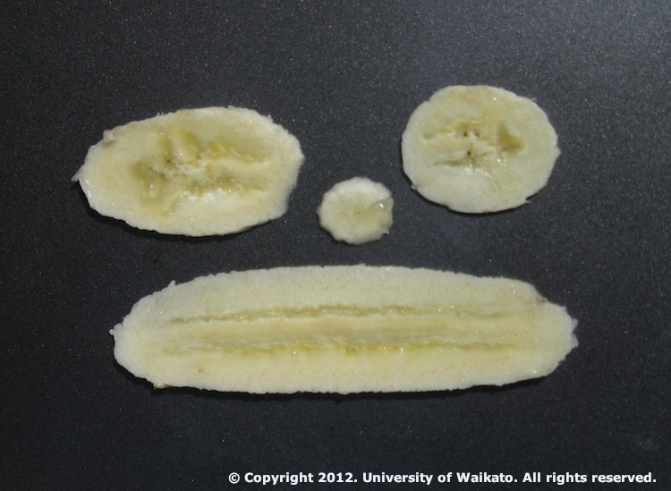
Image 1

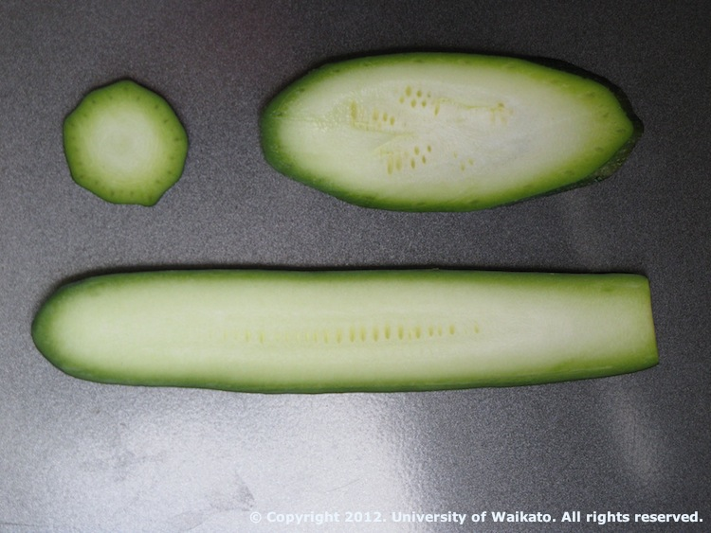
Image 2

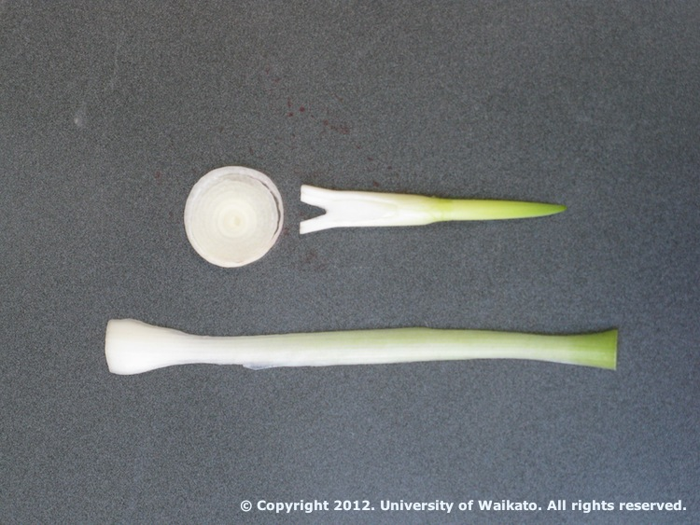
Image 3

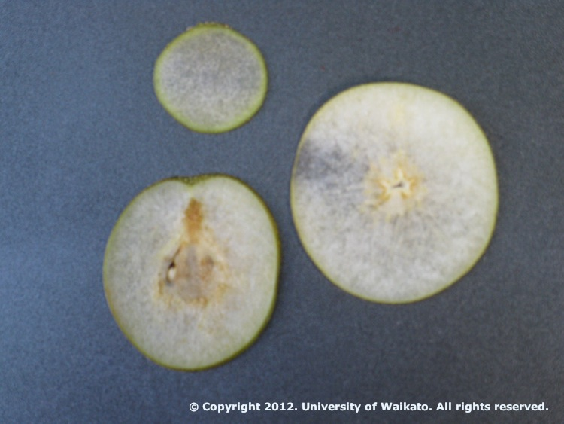
Image 4

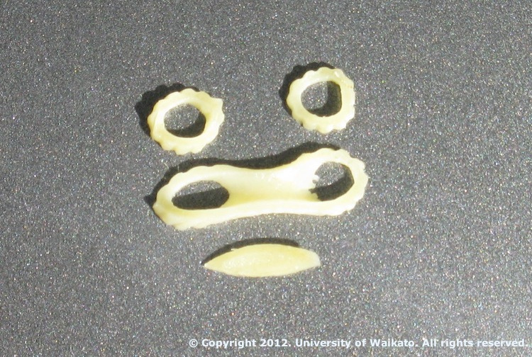
Image 5
Using 2D sections to build a 3D image

Cut your sample into thin slices. You can cut through the entire width or length or at an angle. Lay the slices randomly on the left-hand side. Use the right-hand side for others to record their guesses.

2D sample slices | I think this 3D object is ...

