STUDENT ACTIVITY: Write a secret message

Activity idea

In this activity, students use a UV light-emitting diode pen to write secret messages and investigate a range of objects to see if or how they fluoresce.

By the end of this activity, students should be able to:
- explain why an invisible dye fluoresces when UVA shines on it
- use UV light to investigate objects to see if and how they fluoresce.

Introduction/background notes
What you need
What to do

Introduction/background

The pen ink in a UV light-emitting diode (LED) pen contains an invisible dye that fluoresces yellow when UVA from the LED shines on it.

This activity is suitable for younger students – Teachers should read UV and fluorescence to offer students an explanation about fluorescence appropriate to the age group. Older students could read and discuss the article themselves.

What you need

- UV LED pen (purchase these from science-based toy shops or online for under $10)
- Credit cards
- New Zealand and foreign banknotes
- Fluorescent pictures
- Toys
- Highlighter pens
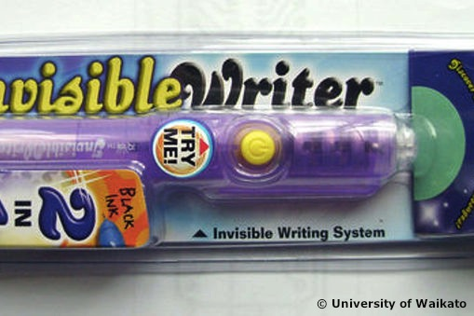
- UV beads
- Various kinds of paper

What to do

- Have students use the pen to write a secret message or draw a hidden picture:
- Make up clues guiding their partner to where the message/picture is hidden.
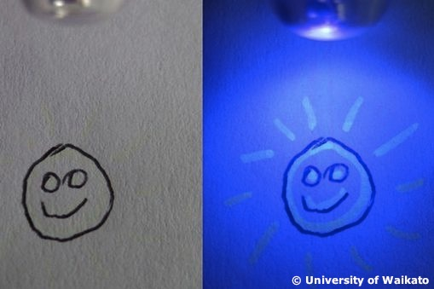
- Their partner solves the clues and uses the LED to search for and reveal the hidden message/picture.
- Swap over roles.

- Have students use the UV LED part of the pen to investigate a range of objects to see if or how they fluoresce (they may need to investigate some of these in a dark place to reduce the effect of daylight) – credit cards, New Zealand and foreign banknotes, fluorescent pictures, toys, highlighter pens, UV beads and various kinds of paper.

