ACTIVITY: I love fibre

Activity idea

In this activity, students listen to AgResearch’s Dr Matthew Barnett, the singing scientist, performing his latest YouTube release called I love fibre. Students then answer sets of questions and complete activities.

By the end of this activity, students should be able to:
- explain the importance of fibre in the diet
- give examples of fibre rich foods that could be included in the diet
- describe how bacteria present in the large intestine use fibre
- label a simple diagram of the large intestine
- define the term ‘complex carbohydrate’.

Introduction/background
What you need
What to do
Question set 1 – what do you remember?
Question set 2 – finding out more information
Label the large intestine
Question set 1 – what do you remember? (Teacher answers)
Question set 2 – finding out more information (Teacher answers)
Label the large intestine (Teacher answers)

Introduction/background

Dr Matthew Barnett, a senior research scientist in the Food Metabolism and Microbiology Section at AgResearch in Auckland, has hit the world stage again with another classic YouTube music video called I love fibre. It’s a country and western style song on the importance of fibre in the diet.

This activity involves students listening to the song as well as viewing the excellent video graphics. Students are then presented with sets of questions to answer and activities to complete.

What you need

- Access to the YouTube video clip – www.youtube.com/watch?v=zGqHuKcbu6c
- Student handout: Question set 1 – what do you remember?
- Student handout: Question set 2 – finding out more information
- Student handout: Label the large intestine

What to do

- Access the YouTube video clip www.youtube.com/watch?v=zGqHuKcbu6c and play it through to the class.

- Play the clip though again but pause when a graphic shows and have students note any relevant information.

- Hand out copies of Student handout: Question set 1 – what do you remember? and ask students to complete. Discuss responses.

- Hand out copies of Student handout: Question set 2 – finding out more information and ask students to complete. Discuss responses.

- Hand out copies of Student handout: Label the large intestine and ask students to complete. Discuss responses.

- Allocate or ask students to choose one of the following activities and present the results to the class:
- Fibre rap: Using the dietary fibre theme and your musical skills, develop a rap to highlight the ‘get more fibre into diet’ idea.
- PowerPoint: Using information from the I love fibre song, prepare a PowerPoint presentation that could be shown to a group of middle primary school children.
- Fibre poetry: Using the lyrics of the I love fibre song to inspire you, write a poem that emphasises the benefits of fibre in a well balanced diet.
- Wall chart: Using the dietary fibre theme and your artistic skills, develop a wall chart that could be used as the poster in a national campaign to convince people of the benefits of fibre in the diet.
- 2-minute video: Using the dietary fibre theme and your film producer and acting skills, produce a 2-minute video that highlights the benefits of fibre in the diet.

Question set 1 – what do you remember?

Name:

- List the foods that help to “keep your fibre uptake up”.

- Fibre in the diet “curbs my appetite so I don’t eat too much you see...” and reduces the risk of two health-related problems. Name them.

- What do the colon microbes do to soluble fibre?

- What does insoluble fibre do?

- List the four benefits of fibre.

- In the graphic showing the structure of the large intestine, how many colons are there?

- What is Matthew going to gobble as long as he can chew?

Question set 2 – finding out more information

Name:

- Dietary fibre is found mainly in cereal foods, beans, lentils, fruit and vegetables. Think about your food intake over the last few days and list the fibre-rich foods that you consumed.

- The average daily fibre consumption for adults is estimated to be about 12g. The recommended intake is 18g per day. What are possible reasons for this difference?

- What is meant by the term ‘complex carbohydrates’?

- Fibre in the diet can help to curb appetite, and this can reduce the risk of atherosclerosis and obesity. What do these two terms mean?

- Gut bacteria, or colon microbes, ferment soluble fibre into short-chain fatty acids like butyrate. This process also produces gases. Can you name any of these?

- Mention is made in the song of the body’s ‘cholesterol pool’. What is cholesterol? Do we need it in our diet?

- Matthew not “overfilling his plate” saves him from myocardial infarction. What is myocardial infarction?
Label the large intestine

Write the number of each part on the diagram.
- anus
- appendix
- ascending colon
- descending colon
- rectum
- sigmoid colon
- transverse colon

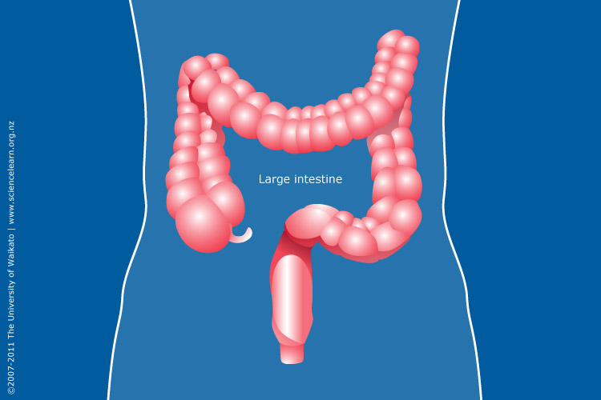
Question set 1 – what do you remember? (Teacher answers)

Name:

- List the foods that help to “keep your fibre uptake up”.

Fresh fruits, whole grains, nuts and seeds.

- Fibre in the diet “curbs my appetite so I don’t eat too much you see...” and reduces the risk of two health-related problems. Name them.

Atherosclerosis and obesity.

- What do the colon microbes do to soluble fibre?

Convert it into short chain fatty acids such as butyrate.

- What does insoluble fibre do?

It adds bulk to your stool.

- List the four benefits of fibre.

May reduce appetite, reduces risk of heart disease, facilitates regularity, alleviates constipation.

- In the graphic showing the structure of the large intestine, how many colons are there?

Four.

- What is Matthew going to gobble as long as he can chew?

Complex carbohydrates.

Question set 2 – finding out more information (Teacher answers)

Name:

  - Dietary fibre is found mainly in cereal foods, beans, lentils, fruit and vegetables. Think about your food intake over the last few days, and list the fibre-rich foods that you consumed.

  - The average daily fibre consumption for adults is estimated to be about 12g. The recommended intake is 18g per day. What are possible reasons for this difference?

- Over-consumption of processed foods that are low in fibre.
- The recommended five-serve rule for fruits and vegetables not being observed.

  - What is meant by the term ‘complex carbohydrates’?

Carbohydrates are generally classed into two groups, simple and complex.
Simple sugars, or monosaccharides, are carbohydrates like glucose and fructose. Cane sugar (sucrose) is a disaccharide. Complex carbohydrates are made of two or more simple sugars linked together, for example, the starch found in grains like wheat is a complex carbohydrate (polysaccharide) made up of several thousand glucose units linked together.

When eaten, simple sugars are readily absorbed directly into the bloodstream whereas complex carbohydrates need to be broken down by digestive enzymes in the gut to release the sugar units they are made up of. This slows the uptake of sugar units into the bloodstream. Insoluble complex carbohydrates like cellulose (fibre), although indigestible, have an important role to play such as:
- reducing appetite
- reducing the risk of heart disease
- facilitating regularity
- alleviating constipation.

  - Fibre in the diet can help to curb appetite, and this can reduce the risk of atherosclerosis and obesity. What do these two terms mean?

Atherosclerosis is the hardening of the arteries caused by the build-up of fatty materials on their walls. It is associated with increased risk of heart disease and strokes.

Obesity is a medical condition in which excess body fat has accumulated to the extent that it may have an adverse effect on health, leading to reduced life expectancy and/or increased health problems.

  - Gut bacteria, or colon microbes, ferment soluble fibre into short-chain fatty acids like butyrate. This process also produces gases. Can you name any of these?

Carbon dioxide, hydrogen, methane.

  - Mention is made in the song of the body’s ‘cholesterol pool’. What is cholesterol? Do we need it in our diet?

Cholesterol is a member of a group of compounds called sterols. It is a key constituent of cell membranes. Cholesterol acts as the precursor for the synthesis of various steroid hormones such as the sex hormones progesterone, oestrogen and testosterone. It is continuously synthesised in the body, primarily in the liver. Although present in commonly eaten foods of animal origin, it is not needed in the diet.

Its level in the bloodstream can influence the development of atherosclerosis. Normal adult levels of blood cholesterol are 3.9 to 5.2 mmol/L.

  - Matthew not “overfilling his plate” saves him from myocardial infarction. What is myocardial infarction?

The interruption of blood supply to a part of the heart, causing heart cells to die. It is commonly known as a heart attack.
Label the large intestine (Teacher answers)

Write the number of each part on the diagram.
- anus
- appendix
- ascending colon
- descending colon
- rectum
- sigmoid colon
- transverse colon

