ACTIVITY: How’s your memory?

Activity idea

In this activity, students memorise a number of items from the star compass as wayfinding navigators would have to do. This experience may help students understand how and why wayfinders use the star compass to memorise stars. Games are used to help consolidate the learning.

By the end of this activity, students should be able to:
- explain that memory is important for wayfinding
- describe what the star compass is and how it helps wayfinders
- recite the houses in the star compass
- name at least five stars and the houses they rise from and set to on the star compass.

Introduction/background notes
What you need
What to do
Extension activities
Star compass
House cards
Star compass and star positions
Star cards

Introduction/background

Wayfinding relies heavily on the navigator’s memory. There are many things to remember.
Wayfinders have to develop very good memories. They need to remember at least 220 stars – their names and where they rise and set.

Memory is helped by the use of a framework (to hang the memory on) or technique. For example, wayfinders use the star compass (with all the houses) to help them memorise the stars and where they rise and set. The star compass is the framework for memorising the stars and their places on the horizon.

In this activity, students are introduced to the star compass and are required to memorise its layout and the Māori names of its houses in much the same way as a navigator would be required to do.

The next step requires the memorising of 28 stars and the houses they rise from and set to. The memorising is made into games to help students become familiar with the star compass. Memorising requires familiarity, so the games should be repeated often.

Check that the students are very familiar with the compass houses before attempting to add the stars.

Read The star compass – kāpehu whetū to get an understanding of the star compass and Wayfinding to get an idea of some of the things navigators need to remember.

What you need

- Access to the article The star compass – kāpehu whetū
- Copies of the Star compass
- Copies of the Star compass and star positions
- House cards
- Star cards

What to do

- Explore the article The star compass – kāpehu whetū as a class. Explain that wayfinders have to develop very good memories. They need to remember at least 220 stars – their names and where they rise and set. They also need to remember stories concerning locations and landfall that have been passed on by others. They need to remember many things about the Moon, waves, swells, winds, clouds and the ocean. Wayfinders use their memory for navigation. It’s important that it’s as accurate as possible.

- Hand out copies of the Star compass and discuss. Explain that wayfinders use the star compass (with all the houses) to help them memorise the stars and where they rise and set. The star compass is a framework for memorising. Set the challenge for students to learn:
- the names of the houses in each of the four quarters
- the names of 28 stars and the houses those stars rise from and set to.

Memorising the houses

- Hand out copies of the House cards and have students cut these into individual cards to use to memorise the houses.
- What are the Māori house names for north, south, east and west? Chant them in class. Ask students at random: What’s the north house? South? East? West? What’s opposite Raki? What’s opposite Whitinga?
- Learn the quarter sections – Whakararo, Tokerau, Marangai and Whakarunga. Get students to visualise where they are on the star compass. Work on these for a few days using cards to check.
- Encourage students to use the rising/setting Sun to work out Whitinga and Tomokanga on the horizon. Then they can identify Raki and Tonga and the four quarter sections – Whakararo, Tokerau, Marangai and Whakarunga. Use the names for team games, group work – wherever applicable – to become familiar with them.
- Now there are just seven houses to learn the names for! Rā, Kāinga, Ngoi, Manu, Ngā Rangi, Ngā Reo and Haka. Put the house cards in order of the compass and learn them in order. Students test each other. Practise over a few days. Learning what each house means may help with memory – read The star compass – kāpehu whetū.

Playing the house game

- Students become the ‘houses’ and sit in a circle (the horizon). There should be 32 places to cover all the houses, so cones or markers could be used where there are not enough students. Use cones for Raki, Tonga, Tomokanga and Whitinga first. Other cones could be randomly placed depending on how many students you have. Label Raki and Tonga so students can work out their house name depending on where they are sitting in relation to Raki (North Pole) and Tonga (South Pole).

- Choose a student to start. Have them chant their house name and tag the person next to them lightly on the arm to go next. That student chants their name and tags another student to do the same. The direction of the tagging and chanting around the circle can change at any time – a student may tag the student to the right or the left of them. Limit tagging going backwards and forwards between two students by allowing only one repetition before having to move on in one direction.

- If a student gives the wrong house name or hesitates too long (you judge), they get a black dot (which either they or you record). Check they know their house name before continuing.

- Students need to be aware that cones are also ‘houses’ with names – these houses need to be taken into account as students work out their house names within the circle.

- At some point, you can call “scramble” or something similar, and all students need to get up and move into a different quarter of the horizon.

- Repeat the memory game, chanting the house names and appointing black dots. Those without dots or with the least amount of dots may get to go to interval or lunch early.

Adding the stars

- Give out copies of the Star compass and star positions and the Star cards and have students cut these into individual cards to use to memorise the stars. (This could take a number of days.)

- Set up a large circle with 32 cones, markers or chairs. These are the houses. Students randomly sit/stand in a house in the eastern horizon. They are the stars – allocate a star to each of them.

- You call a star name. That star ‘rises’ from their house and goes across to the western side to the house they ‘set’ in. Continue calling various stars to rise and move to their setting place.

- If students are wrong, they sit in a designated ‘out box’. Once all stars are called, the winners are those who are seated correctly in their houses in the west.

- At any time, you can call “all stars rising”, and all remaining stars must go to the appropriate place. A wrongly placed star or the last star to find its house is out and goes to the out box.

- You can also call “ready to rise”, and all stars (including those in the out box) return to their houses from which they rise, and you begin again.

- At the end of a game or during a game, you can call “change houses”, and students change to a different house in the east – consequently becoming a different star. They then respond accordingly – setting in the appropriate house for that particular star when they’re called. Stars in the out box can join in with this call and find a new house also.

- Note that the shift is smaller for stars close to north or south of the equator, and stars such as Polaris and the Southern Cross don’t rise or set but circle the poles – so they don’t move from their houses (they could spin around on the spot).

- Once the students are familiar with the star names and their houses, keep the game moving at a fast pace.

Extension activities

- Students could be given a star card each to research at another time (possibly for homework). During the game at the extension level, the teacher could sometimes call “freeze” as a star is in mid-flight. While that star is frozen, its researcher could share with the class some current facts about it. The game then continues.
- The star compass – with students as rising and setting stars – could be choreographed into a dance set to music to perform to other classes to show students’ learning.

Star compass

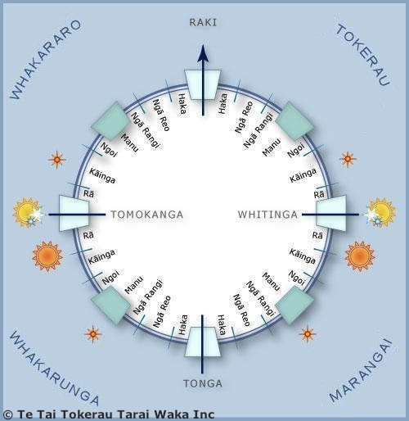

House cards
Raki | Tonga | Tomokanga | Whitinga
Rā  Tokerau | Rā  Marangai | Rā Whakarunga | Rā Whakararo
Kāinga Tokerau | Kāinga Marangai | Kāinga Whakarunga | Kāinga Whakararo
Ngoi  Tokerau | Ngoi Marangai | Ngoi Whakarunga | Ngoi Whakararo
Manu Tokerau | Manu Marangai | Manu Whakarunga | Manu Whakararo
Ngā Rangi Tokerau | Ngā Rangi Marangai | Ngā Rangi Whakarunga | Ngā Rangi Whakararo
Ngā Reo Tokerau | Ngā Reo Marangai | Ngā Reo Whakarunga | Ngā Reo Whakararo
Star compass and star positions
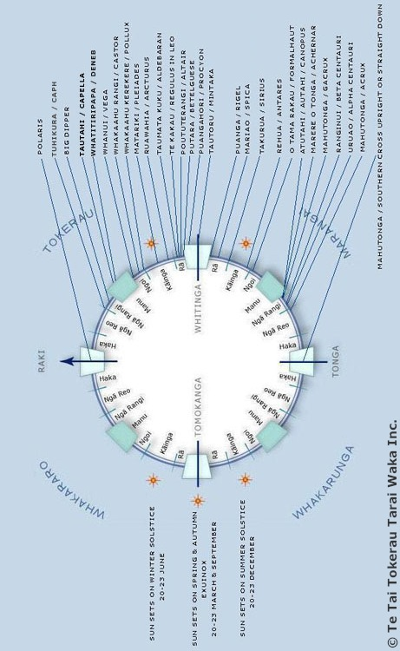
Star cards
Polaris | Caph  (Tuhikura) | Big Dipper | Capella  (Tautahi)
Deneb  (Whatitiripapa) | Vega  (Whanui) | Castor  (Whakaahu Rangi) | Pollux  (Whakaahu Kerekere)
Pleiades  (Matariki) | Arcturus  (Ruawahia) | Aldebaran  (Taumata Kuku) | Regulus  (Te Kakau)
Altair  (Poututerangi) | Betelgeuse  (Putara) | Procyon  (Puangahori) | Mintaka  (Tautoru)
Rigel  (Puanga) | Spica  (Mariao) | Sirius  (Takurua) | Antares  (Rehua)
Formalhaut  (O Tama Rakau) | Canopus  (Atutahi/  Autahi) | Achernar  (Marere o Tonga) | Gacrux  (Mahutonga)
Beta Centauri  (Ranginui) | Alpha Centauri  (Uruao) | Acrux  (Mahutonga) | Southern Cross  (Mahutonga)

