ACTIVITY: Making lava fudge

Activity idea

In this activity, students make chocolate fudge using three slightly different combinations of ingredients to model the different proportions of minerals in basalt, andesite and rhyolite rocks.

By the end of this activity, students should be able to:
- describe the features that are similar between the three varieties of fudge and the three volcanic rocks
- match which fudge ingredients correspond to which rock minerals
- describe ways in which the fudge models do not match volcanic rocks well.

Introduction/background
What you need
What to do
Extension activities
Fudge recipes

Introduction/background

There are a number of published activities that use sweets and foods to model particular rocks, for example:
- making hokey pokey can help students understand the formation of vesicles in pumice or scoria
- New Zealand lolly cake resembles conglomerate rock
- sandwiches can be used to model layering in sedimentary rock.

This activity uses a range of chocolate fudges to model three common volcanic rocks.

Rhyolite, andesite and basalt differ in their silica content and in how much magnesium and iron they contain.
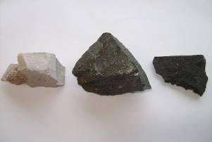
This picture shows specimens of the 3 rocks:
- Basalt, on the right, is rich in magnesium and iron, and this gives it a dark colour. Dark chocolate buttons are used in the fudge recipe to model these minerals.
- Rhyolite, on the left, is poor in magnesium and iron, so the recipe uses white chocolate buttons with one or two dark ones added. Rhyolite is also rich in silica giving it a light grey colour. The recipe uses desiccated coconut to model silica.
- Andesite, in the centre, is intermediate in its silica, magnesium and iron content, so this recipe uses even amounts of white chocolate and dark chocolate buttons.

Being volcanic, all three types of rock are formed as lava is erupted at the surface and cools quickly. Fine crystals form as the minerals solidify.

Making fudge has some similar features chemically, since hot fudge is essentially a supersaturated solution of chocolate-flavoured sugar. When hot fudge cools, the sugar crystallises. Most recipes give directions that promote rapid crystallisation to form tiny sugar crystals. This gives the fudge a more creamy texture when eaten.

What you need

- A stove element or portable cooker
- A small non-stick frying pan
- A wooden spoon
- 3 tinfoil pie plates
- Measuring spoons
- A packet of dark chocolate buttons
- A packet of white chocolate buttons
- A packet of desiccated coconut
- Sugar
- Milk

What to do

- Make up basalt fudge, andesite fudge and rhyolite fudge according to the recipes.  This photo shows the ingredients for basalt fudge placed in the frying pan. | 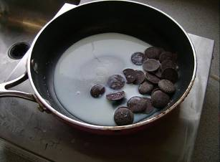
This photo shows the basalt fudge boiling strongly and almost ready to pour out. | 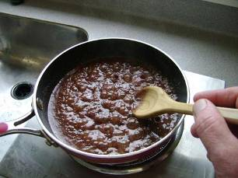
- Pour each fudge into a plate. This picture shows rhyolite, andesite and basalt fudge in pie plates. The variation in colour is easily seen.  However, the fudge models are not perfect as the desiccated coconut pieces are relatively large. The rhyolite fudge ends up a bigger amount than the basalt fudge due to the greater amount of coconut added. | 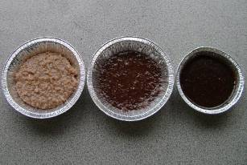
- Remove each slab of fudge and break it in half. Examine the broken surface for each type of fudge and draw a labelled diagram of the features seen.  This picture shows the broken surface of andesite fudge. It has a remarkable likeness to volcanic rock features. However, most volcanic rocks are not normally that shiny. | 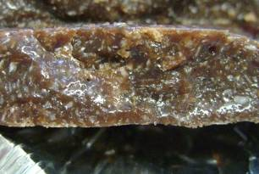

Extension activities

If possible, obtain specimens of rhyolite, andesite and basalt rocks. The three fudges could then be compared with the actual rock specimens.

Realising that models are never perfect is an important thing to know. In science, models always have aspects that do not agree with the actual thing they model. Students could make a list of ways in which the fudge models work well and another list of ways where the models do not compare well with the actual rocks.

Scientists use models to help them understand how a system works, but often these models are imperfect – a little like the fudge models. Occasionally as new information is discovered, it is decided that the model is no longer correct and a whole new model must be proposed. See Exploring magma formation for more information on changing models.
Fudge recipes

Basalt fudge ingredients
- 35 grams chocolate buttons – all dark
- 1 teaspoon desiccated coconut
- 2 tablespoons sugar
- 2 tablespoons milk

Andesite fudge ingredients
- 35 grams chocolate buttons – half dark and half white
- 2 tablespoons desiccated coconut
- 2 tablespoons sugar
- 2 tablespoons milk

Rhyolite fudge ingredients
- 35 grams chocolate buttons – all white, but replace 2 white buttons with 2 dark buttons
- 4 tablespoons desiccated coconut
- 2 tablespoons sugar
- 2 tablespoons milk

Method
- Measure all ingredients into a non-stick frying pan.
- Bring to the boil and cook for about 5 minutes on a high heat stirring all the time until very little steam is released.
- Pour into a greased tinfoil pie plate and allow to cool a little.
- Refrigerate or place pie plate in cold water to speed cooling.

