ACTIVITY: Making a core sample

Activity idea

In this activity, students use (or observe the teacher using) a small coring tool to make a core sample from some available waste ground and examine the resulting sample for features such as particle size, colour variation and layering.

By the end of this activity, students should be able to:
- describe the steps in taking a small soil core sample
- describe some of the features that can be observed in a soil core sample.

Introduction/background notes
What you need
What to do
Extension activities

Introduction/background

Taking a core sample is a widely used technique in science fieldwork:
- A small core sample can be taken from a tree in order to count its rings and so find out its age without killing the tree.
- Core samples are taken in ice to obtain samples of water and air from many thousands of years ago.
- Core samples can be taken from the ground to find out what has happened in the ancient past and recorded in layers of soil, silt, clay, ash and rock.

This activity gives students a feel for what is involved in taking a soil core sample and then examining it. Unfortunately, the PVC coring tool made for this activity is only suitable for less compacted, non-rocky and preferably wet soil, sand, silt and clay. You may wish to determine the site selected is suitable by conducting your own practice run with the coring tool. For more challenging sites, a spade could be used instead to expose the layers.

What you need

- A small coring tool (see instructions below on how to construct one)
- A small block of waste wood
- A hammer or mallet
- A screwdriver (bayonet or Phillips head to match the clamps on the coring tool)
- A small sharp knife or short length of fine wire
- A magnifying glass
- A pair of tweezers and tray

What to do

- Construct the coring tool. The coring tool pictured is made from a 30cm length of PVC pipe purchased from the plumbing section of a large retail building supermarket. The pipe used is 35mm outside diameter but this is not critical.

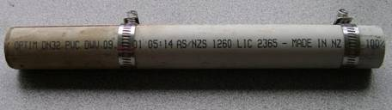
- Choose one end to be the bottom that will be driven into the ground. File that end so that the pipe becomes sharper and will be easier to push its way through the ground material.

- Use a hacksaw and a vice to cut the pipe lengthwise into two half barrels. Use 2 suitably sized metal hose clamps from the same plumbing supplier to hold the 2 halves of the coring tool together

- Select a suitable site for taking a core sample. If you do not have a site of particular interest, you could choose one on waste ground or on a spot of a lawn where a small hole will not be noticed. The wetter the ground, the easier it will be to take a core sample. Do not try to take a sample in heavily compacted or rocky ground material or where soil has been artificially dumped. Slopes often provide interesting results for this study.

- Tighten the top clamp on the coring tool tightly with the screwdriver and adjust the bottom clamp so that it holds the two halves of the coring tool together but can still slide along the barrel.

- Start to hit the coring tool firmly into the ground using the hammer to hit the block of wood placed on top of the coring tool. The picture shows this arrangement and the sharp knife and screwdriver.  - As you hit the coring tool into the ground, stop several times to slide the bottom clamp a few centimetres up from the ground surface. | 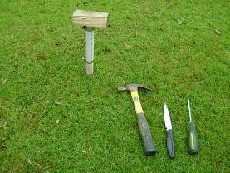
- Stop when the coring tool is 20–25cm in the ground. This gives enough of the tool to hold when you now pull it slowly out of the ground. Wiggle the tool gently from side to side if it is difficult to pull out. You may have to dig into the ground a little way around the tool if it is more firmly stuck. Alternatively, you could take smaller core samples a few centimetres long at a time and assemble them together. This method involves more work in taking the coring tool apart and assembling it repeatedly, but it easier to pull the tool out of the ground each time.

- When the tool is removed from the ground, use the screwdriver to unfasten both clamps. Hold the coring tool horizontally and gently pull one half of the barrel off the other to reveal the coil sample. You will find the core sample has been compacted a little in the coring process.

- Carefully cut the sample lengthwise in half along the sides of the half-barrel. The photo shows a core sample from a grass lawn as an example of what you could end up with.

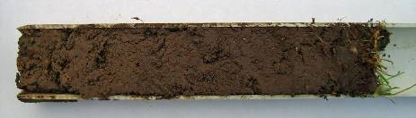

- Examine the sample closely using the magnifying glass. No layering is seen in the sample above, but the gradual colour change towards the bottom (left) shows more clay deeper in the soil. You could also use a digital camera set on macro to record details of interesting features that may be revealed.

- Use tweezers to tease through the material in the sample and lift out items of interest that can be placed in a tray. Several tiny pieces of dark rock (2–3 mm in diameter) were found towards the bottom of this sample. Another feature that could be measured is the depth to which plant material penetrates the soil. In the sample above, the deepest roots were approximately 5cm down.

Extension activities

Students (or teachers) could dig down further using a spade to remove most of the vegetation and topsoil and expose deeper layers. If the material exposed is not too compacted, the procedure above could be used to take a deeper sample that might reveal more interesting features.

