ACTIVITY: Making a model cylinder cone

Activity idea

In this activity, students make a simple model of a cinder cone by pouring a granular material such as rice bubbles into a conical pile and measuring its slope. This is then related to the shape and formation of cinder cone volcanoes.

By the end of this activity, students should be able to:
- describe the shape of a pile of granular material poured from above
- relate the shape of their model cinder cone to that of real cinder cones
- explain the concept of ‘angle of repose’
- describe the formation of cinder cones.

Introduction/background
What you need
What to do
Extension activities

Introduction/background

In certain types of volcanic eruptions (called pyroclastic eruptions), lava sprays out of a crater in a spectacular display. The droplets of lava sprayed out cool and crystallise rapidly as they fly through the air. These cinders (or pyroclasts) are a range of sizes. The larger ones fall near the vent and, over time, build up a cinder cone. The cone’s slope increases until it reaches the greatest angle that the loose cinders can lie on without tumbling down the slope. This slope is usually over 30 degrees and depends on the general size of the cinders that form the sides of the cone. At this maximum slope, called the ‘angle of repose’, the force of gravity that tends to make the cinders slide down is balanced by the friction between the cinders. In this activity, students model the formation of cinder cones and find the angle of repose for the granular materials they use.

What you need

- A large bag of cereal such as rice bubbles
- A large sheet of paper
- A large plastic funnel
- A stand to hold the funnel above the paper (optional)
- A piece of stiff card
- A pair of scissors
- A protractor
- A digital camera (optional)

What to do

- Place a large sheet of paper on a flat table. Hold the funnel about 20cm above the paper and pour the rice bubbles through the funnel to form a symmetrical pile. (The yellow pipe cleaner shown in the photo was used to free rice bubbles when they became stuck in the funnel!) Alternatively, you could simply use a cup to repeatedly pour rice bubbles onto the pile without using a funnel. The pouring height is not critical. | 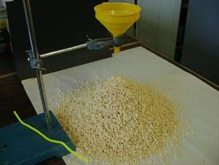
- Towards the end of pouring, you should see that the slope of the pile’s sides stays constant, and pouring more rice bubbles simply makes the pile larger but keeps the same shape. In this analogy, the rice bubbles are the cinders and the rice bubble pile is the volcanic cinder cone.

- Use the scissors to cut the stiff card to fit the side profile of the rice bubble volcano. Transfer this profile onto paper and measure the angle of the profile using a protractor.

- Alternatively take a digital photo side-on of your rice bubble pile, download it to a computer and use the protractor directly on the computer screen to measure the slope angle. This picture shows an example side-on photo. Place a protractor on this picture to measure the angle of this slope and compare it with your one. | 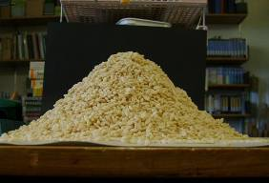
- Other granular material could be used as well as or instead of rice bubbles, for example, depending upon availability and cost, barley, beans, sand or gravel. This photo shows a cone formed from very fine sand. Measure this slope. Is it smaller or greater than the slope for rice bubbles?  - Finally on a side-on photograph of a volcanic cinder cone such as Rangitoto or Maungakiekie (One Tree Hill), measure its ‘angle of repose’. Is the angle fairly close to the angles you have measured in this activity? | 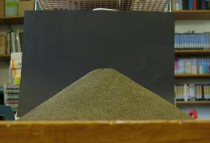
Extension activities

The size and shape of the particles used in the activity have an effect on the final angle of repose for cones formed from that particle. Students could:
- make cones using a range of different sized materials (and preferably use materials that have the same particle shape
- measure the average diameter of each material’s particles and their corresponding angle of repose
- plot a graph of angle of repose against particle diameter
- describe the relationship that the graph shows.
A set-up using flexible tubing and an air-blower (such as a portable hair dryer) could be constructed to simulate the formation of cinder cones more closely. Using this set-up, the granular material is blown vertically upwards forming a cone with a central crater.

