ACTIVITY: Using radiocarbon carbon dioxide data

Activity idea

In this activity, students interpret graphs from a long-term study of carbon dioxide in the atmosphere of New Zealand. They explore how the interval between samples affects the conclusions we are able to make.

By the end of this activity, students should be able to:
- draw and/or interpret simple line graphs
- think critically about the information data and graphs can provide
- understand the need for the careful planning of experiments
- understand long-term changes in radiocarbon carbon dioxide in the atmosphere

Introduction/background
What you need
What to do
Pair A worksheet
Pair B worksheet
Pair C worksheet
Pair D worksheet
Whole group worksheet
Pair A worksheet (graph drawn)
Pair B worksheet (graph drawn)
Pair C worksheet (graph drawn)
Pair D worksheet (graph drawn)

Introduction/background

This activity involves real data from a long-running project studying radiocarbon carbon dioxide in the atmosphere. Students use the data to make some observations about changing levels of this gas. They also look at different sampling intervals to help them understand how this affects what we can learn from the data. They will come to realise that a poorly planned experiment could provide misleading results.

The instructions for this activity assume that students draw the graphs themselves, but teachers may prefer interpreting graphs that are supplied already drawn (worksheets for both approaches are supplied).

Radiocarbon carbon dioxide (¹⁴CO₂)
Atoms of the element carbon come in several forms, called isotopes. Most carbon has a nucleus with 6 neutrons and 6 protons, written ¹²C.

About one in a trillion carbon atoms have 8 neutrons and 6 protons, written ¹⁴C. This isotope is radioactive and is often called radiocarbon. The radioactivity of ¹⁴C means that it can be detected amongst all the non-radioactive ¹²C. There is also a ¹³C, which is not radioactive.

Most of the carbon in the atmosphere is in carbon dioxide made from ¹²C, but small amounts of ¹⁴C carbon dioxide (¹⁴CO₂) also occur naturally. In the late 1950s and early 1960s, humans added a lot more radioactive ¹⁴C to the atmosphere through the testing of nuclear weapons. One good thing came of this – scientists have been able to study the carbon cycle by following what happens to the ¹⁴C.

Link to New Zealand research
This activity uses real data from a long running atmospheric ¹⁴CO₂ study at Baring Head. NIWA scientist Dr Kim Currie is involved in the project, which she combines with her research into ocean CO₂ to help understand the way ocean and atmosphere interact in the carbon cycle.

What you need

- Copies of or online access to the article Carbon dioxide in the atmosphere
- Copies of worksheets for pairs A, B, C and D (with or without the graph drawn) and the whole group worksheet

What to do

- As a class, read and discuss the article Carbon dioxide in the atmosphere. Reinforce that radiocarbon carbon dioxide measurements have been collected from the air near Wellington since 1954 (firstly at Makara, now at Baring Head) – this is the longest continuous record of its kind in the world. When collecting data over time like this, it is important to choose how often to take a sample. A sample at Baring Head takes 2 days to collect, and then it is sent to the Rafter Radiocarbon Laboratory at GNS Science for analysis. This means daily sampling is not possible – even weekly is impractical and expensive – so samples in this study are collected each month. Discuss these questions:
- When you plan an experiment that involves change over time, do you want to make a measurement once every minute? Once an hour? Every 2 hours? Once a day? Once a year? (Of course it depends what you are measuring and what you hope to find out.)
- If you want to know how quickly someone’s pulse returns to normal after exercise, how often would you need to take their pulse? (You’d need to take your measurements at least twice a minute for just a few minutes. In a healthy person, pulse settles down quite quickly after exercise.)
- If you want to measure someone’s increase in height over time, how often would take measurements? (You’d probably choose once a week or month, even once a year. You know that people don’t normally grow fast enough to notice a difference between one day and the next.)

- Divide the class into groups of 8, each with 4 pairs of students – pairs A, B, C and D. Explain that these pairs will work independently to start with to analyse data on radiocarbon carbon dioxide measurements, then the whole group will get together to share results and observations. Give each pair in a group the appropriate worksheet (with or without the graph completed) and have them work through it. Sometimes it may not be possible to answer the question or at least not accurately – that is part of the point of the activity.

- Have the group of 8 get together and share information using the whole group worksheet, then consider more questions.

Discussion questions

  - What might have caused the peak in ¹⁴CO₂ levels?
  - What might have happened to cause the drop in ¹⁴CO₂ since then?
  - Several countries started testing nuclear weapons in the atmosphere in the late 1950s and early 1960s. Get students to use their graphs to discuss when they think the testing of nuclear weapons stopped.

There was a Test Ban Treaty in 1963, but France carried on testing until 1968, China until 1980 (in the northern hemisphere). The ¹⁴C has become part of the natural carbon cycle. Most of it has ended up in the ocean, some in plants and soil on land. Because ¹⁴C is radioactive, it will eventually decay to ¹²C, but not for thousands of years.

Students may mention all the CO₂ added to the atmosphere through the burning of fossil fuels as a possible reason for the increase in ¹⁴CO₂. However, fossil fuels do not contain ¹⁴C because it all decayed away long ago. The addition of lots of ¹²CO₂ to the atmosphere, including from volcanoes, dilutes the ¹⁴CO₂, so is one of the reasons levels of ¹⁴CO₂ have gone down.
Pair A worksheet: ¹⁴CO₂ collected every 10 years between 1960 and 2000

Year (in December) | ¹⁴CO₂ (parts per thousand – ppt)
1960 | 194
1970 | 496
1980 | 269
1990 | 163
2000 | 97

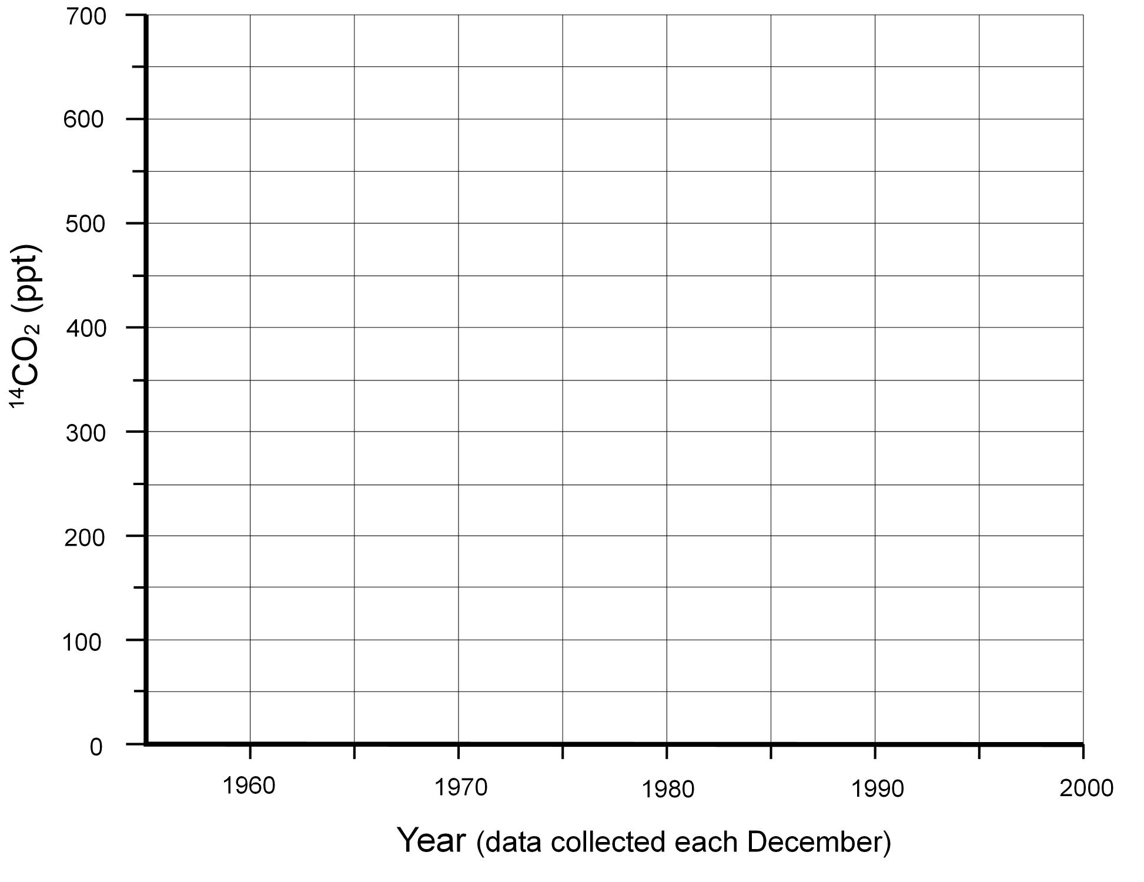

In which year was ¹⁴CO₂ at its highest level?
In which month was ¹⁴CO₂ at its highest level?
How much ¹⁴CO₂ was there in | 1965
 | 1970
 | 1975

(No samples were taken in 1965 and 1975, so you will need to estimate the figures using the graph.)
Pair B worksheet: ¹⁴CO₂ collected every 5 years between 1955 and 2005

Year (in December) | ¹⁴CO₂ (parts per thousand – ppt)
1955 | 0.1
1960 | 194
1965 | 634
1970 | 496
1975 | 371
1980 | 269
1985 | 205
1990 | 163
1995 | 107
2000 | 97
2005 | 70

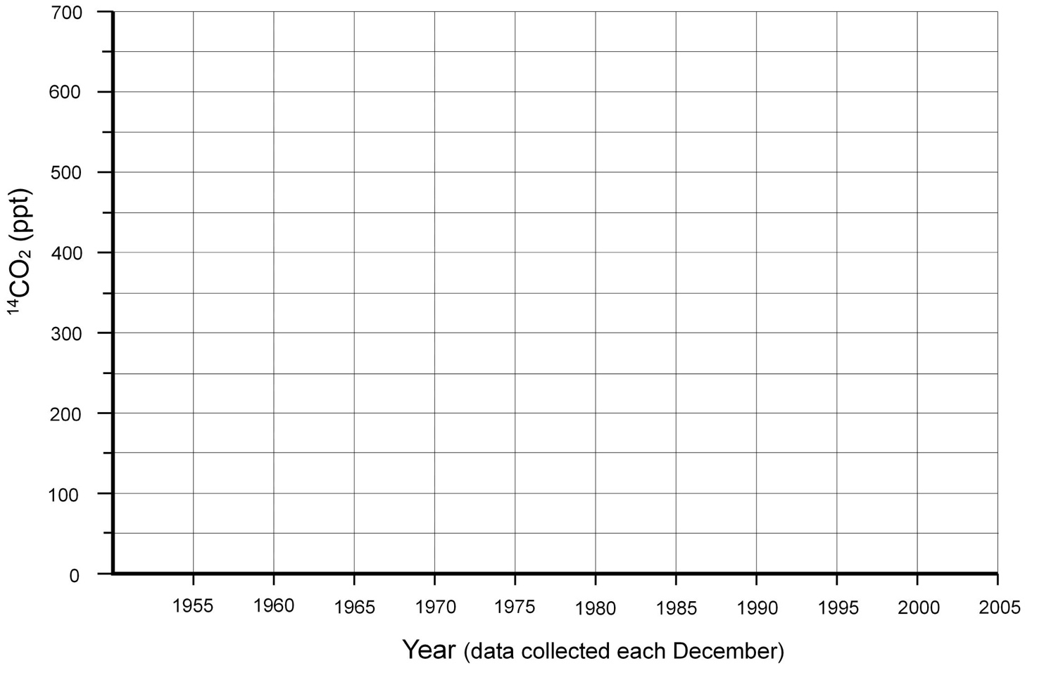

In which year was ¹⁴CO₂ at its highest level?
In which month was ¹⁴CO₂ at its highest level?
How much ¹⁴CO₂ was there in | 1965
 | 1970
 | 1975

Pair C worksheet: ¹⁴CO₂ collected once a year from December 1960–December 1970

Year (in December) | ¹⁴CO₂ (parts per thousand – ppt)
1960 | 194
1961 | 227
1962 | 267
1963 | 430
1964 | 616
1965 | 634
1966 | 628
1967 | 580
1968 | 540
1969 | 510
1970 | 496

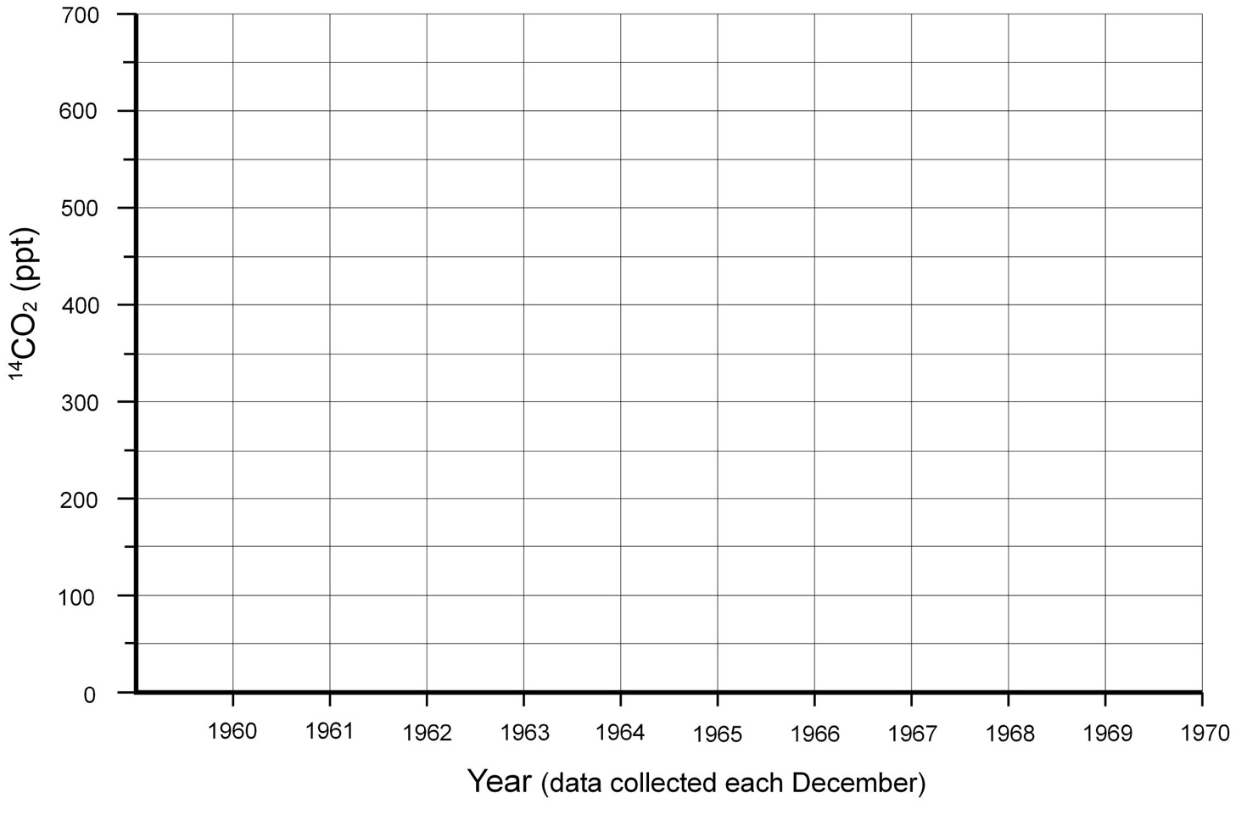

In which year was ¹⁴CO₂ at its highest level?
In which month was ¹⁴CO₂ at its highest level?

Pair D worksheet: ¹⁴CO₂ collected once a month from December 1964–June 1966

Month and year | ¹⁴CO₂ (parts per thousand – ppt)
Dec 1964 | 616
Jan 1965 | 689
Feb 1965 | 634
Apr 1965 | 634
May 1965 | 615
Jul 1965 | 695
Aug 1965 | 614
Sept 1965 | 634
Nov 1965 | 626
Dec 1965 | 634
Feb 1966 | 647
Mar 1966 | 647
Apr 1966 | 632
May 1966 | 622
Jun 1966 | 612

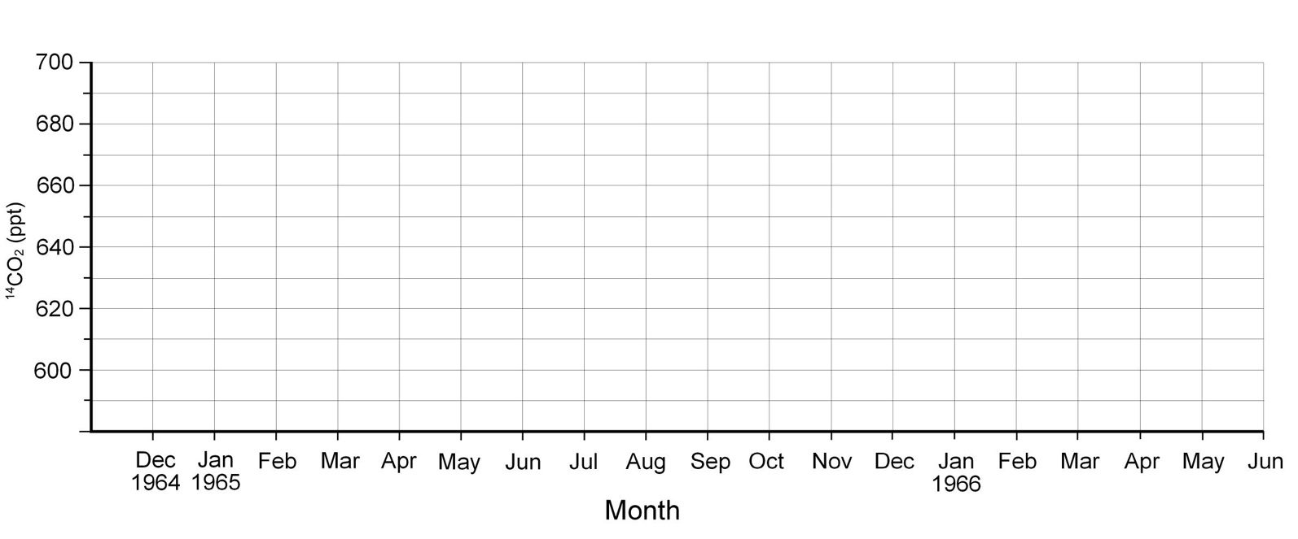

In which year was ¹⁴CO₂ at its highest level?
In which month was ¹⁴CO₂ at its highest level?

Whole group worksheet

Each pair fill in their row of the table:

Pair | Year ¹⁴CO₂ was at its highest level | Highest level of ¹⁴CO₂ | Month ¹⁴CO₂ was at its highest level
A
B
C
D

Did all pairs find the highest level in the same year? Why or why not?

Did each pair record the same value for the highest level of ¹⁴CO₂? Why or why not?

Decide on the best or most accurate answers:

The year in which ¹⁴CO₂ was at its highest level was

The highest level of ¹⁴CO₂ was

The month in which ¹⁴CO₂ was at its highest level was

Group D’s graph showed a pattern of highs and lows during 1965. Discuss if the same pattern might be seen every year. How would you find out?

Describe what happened to the level of ¹⁴CO₂ between 1955 and 2005.

Pair A worksheet (graph drawn): ¹⁴CO₂ collected every 10 years between 1960 and 2000

Year (in December) | ¹⁴CO₂ (parts per thousand – ppt)
1960 | 194
1970 | 496
1980 | 269
1990 | 163
2000 | 97

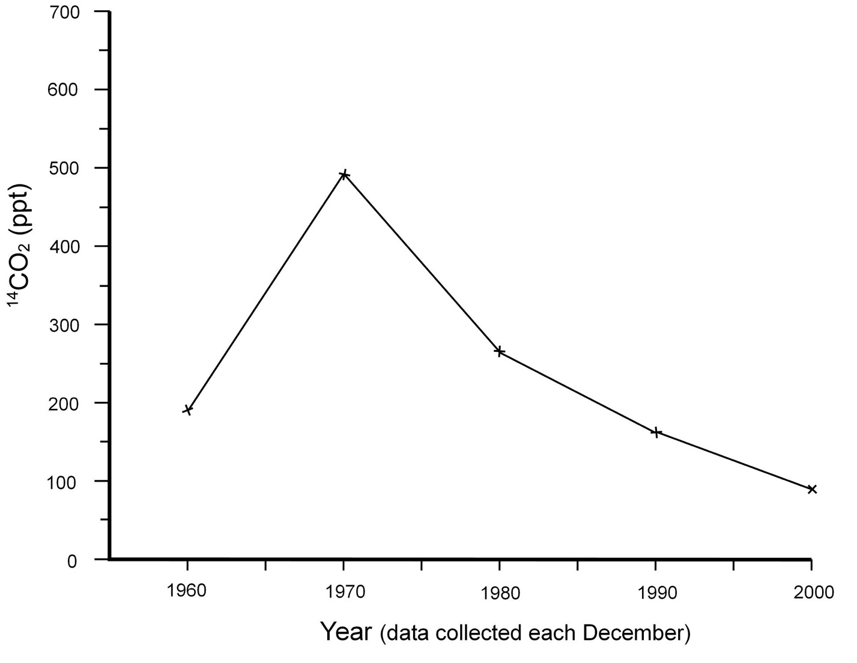

In which year was ¹⁴CO₂ at its highest level?
In which month was ¹⁴CO₂ at its highest level?
How much ¹⁴CO₂ was there in | 1965
 | 1970
 | 1975

(No samples were taken in 1965 and 1975, so you will need to estimate the figures using the graph.)
Pair B worksheet (graph drawn): ¹⁴CO₂ collected every 5 years between 1955 and 2005

Year (in December) | ¹⁴CO₂ (parts per thousand – ppt)
1955 | 0.1
1960 | 194
1965 | 634
1970 | 496
1975 | 371
1980 | 269
1985 | 205
1990 | 163
1995 | 107
2000 | 97
2005 | 70

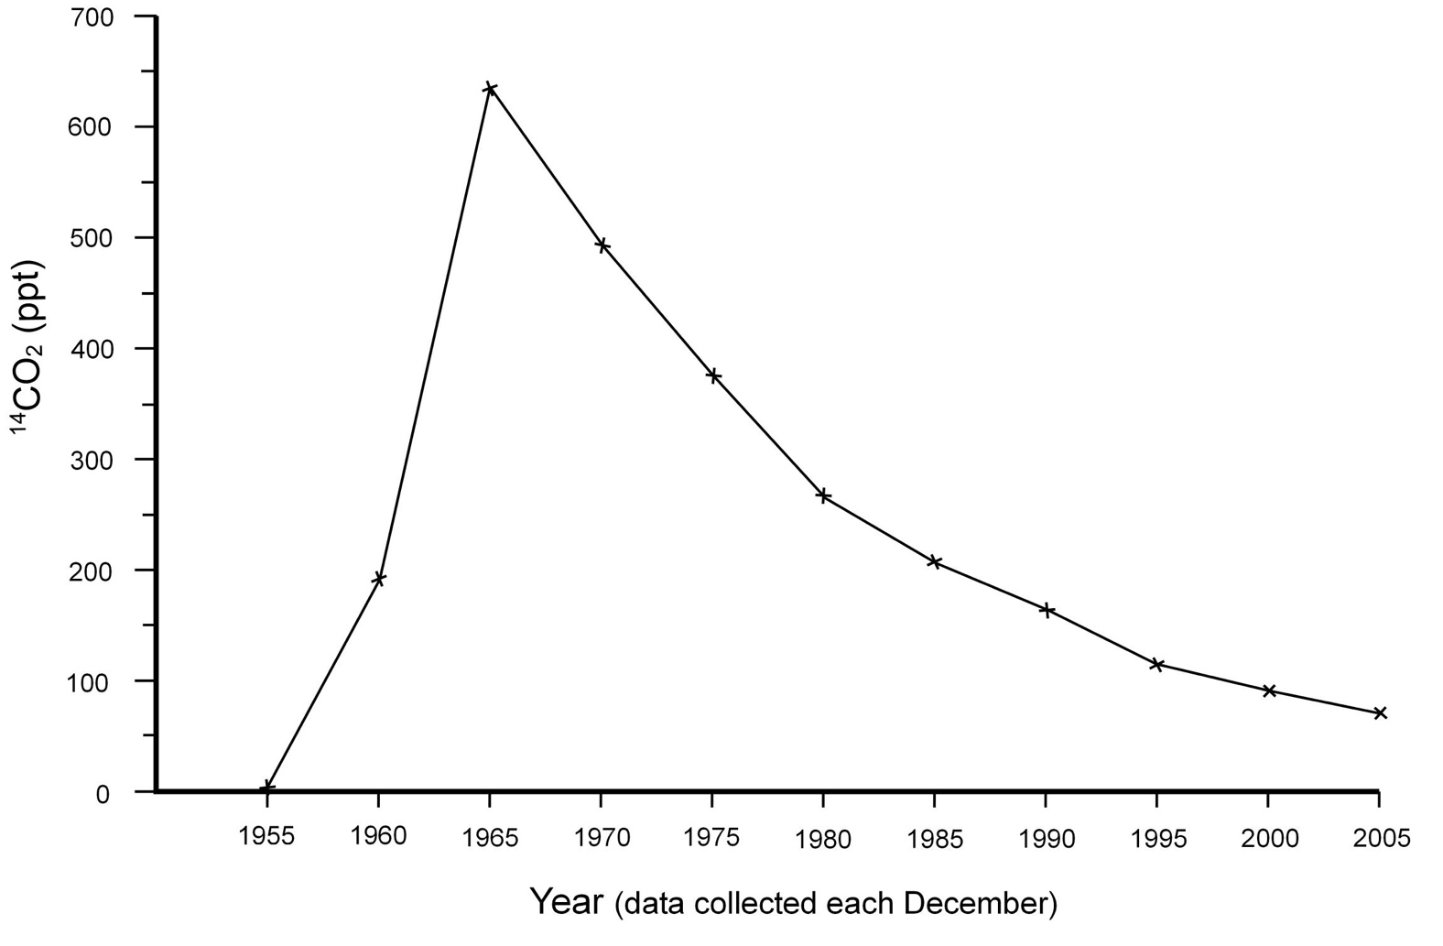

In which year was ¹⁴CO₂ at its highest level?
In which month was ¹⁴CO₂ at its highest level?
How much ¹⁴CO₂ was there in | 1965
 | 1970
 | 1975
Pair C worksheet (graph drawn): ¹⁴CO₂ collected once a year from December 1960–December 1970

Year (in December) | ¹⁴CO₂ (parts per thousand – ppt)
1960 | 194
1961 | 227
1962 | 267
1963 | 430
1964 | 616
1965 | 634
1966 | 628
1967 | 580
1968 | 540
1969 | 510
1970 | 496

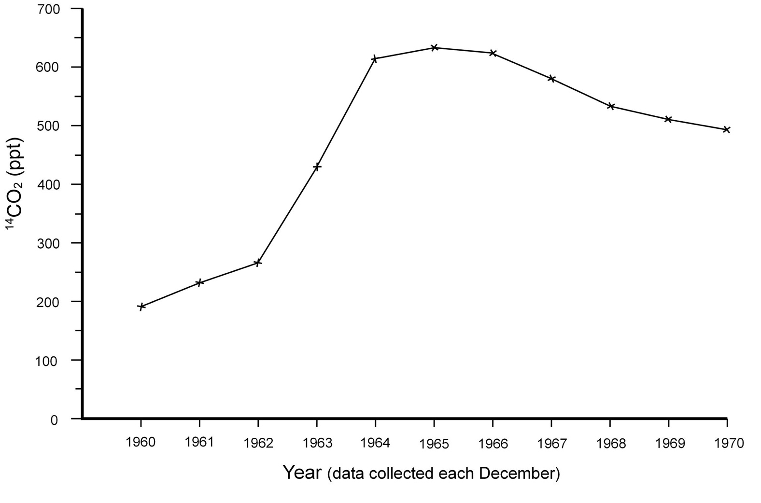

In which year was ¹⁴CO₂ at its highest level?
In which month was ¹⁴CO₂ at its highest level?

Pair D worksheet (graph drawn): ¹⁴CO₂ collected once a month from December 1964–June 1966

Month and year | ¹⁴CO₂ (parts per thousand – ppt)
Dec 1964 | 616
Jan 1965 | 689
Feb 1965 | 634
Apr 1965 | 634
May 1965 | 615
Jul 1965 | 695
Aug 1965 | 614
Sept 1965 | 634
Nov 1965 | 626
Dec 1965 | 634
Feb 1966 | 647
Mar 1966 | 647
Apr 1966 | 632
May 1966 | 622
Jun 1966 | 612

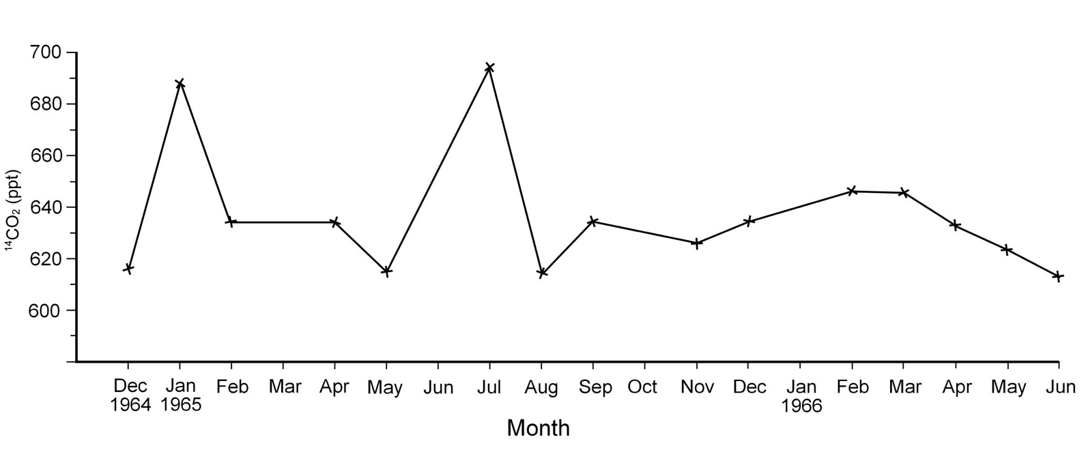

In which year was ¹⁴CO₂ at its highest level?
In which month was ¹⁴CO₂ at its highest level?

