Activity: Investigating how pea crabs affect supermarket mussels

In this activity, students investigate farmed mussels and explore the impact of pea crabs on mussel growth. They use methods that have recently been used in a large-scale study of pea crab impacts by marine scientists at the University of Auckland. Students collect data from a set of supermarket mussels and analyse their results in small groups and as a class.

This activity can be readily adapted to suit different age groups and abilities.

By the end of this activity, students should be able to:
- explain that pea crabs live within green-lipped mussels
- effectively carry out a series of observations and measurements on mussels and any pea crabs within them
- analyse and report the findings of a range of tests that assess the size and weight of green-lipped mussels and how pea crabs affect this
- describe how pea crab infestation can affect farmed green-lipped mussels.

Introduction/background
What you need
What to do
Discussion points
Extension activities
Data sheet
Activity cards

Introduction

The New Zealand pea crab (Nepinnotheres novaezelandiae) is a parasite of green-lipped mussels (Perna canaliculus, kūtai). It lives within mussels, stealing food and using the mussel for shelter. It is very common in both wild and farmed populations of green-lipped mussels.

Recently, Oliver Trottier, a scientist at Leigh Marine Laboratory (University of Auckland), conducted a study to determine the impact of pea crab infestation on the mussel farming industry. He collected thousands of mussels across numerous sites on a mussel farm, recorded whether they contained a pea crab and measured the length and weight of each mussel.

Oliver found that farmed mussels that contain a pea crab are, on average, about 30% smaller than mussels without pea crabs. On the farm he studied, about 5% of the sampled mussels contained a pea crab (a surprisingly low proportion). Using these results, Oliver calculated that pea crab infestation could cost mussel farmers about $2 million annually (about 1% of the annual export earnings of $200 million).

Now that Oliver has shown that pea crabs affect the profitability of mussel farming, he and other scientists at Leigh Marine Laboratory are investigating ways to decrease levels of pea crab infestation on New Zealand’s green-lipped mussel farms.

Note that the number of pea crab parasites in a batch of supermarket mussels can vary widely. This is because some farms have high infestation rates and others are virtually free of pea crabs. Pea crab infestation can also vary seasonally. It is therefore possible that students carrying out this experiment will find few or no pea crabs within the mussels they analyse. Discussion questions below provide an opportunity to explore why this might be.

Safety considerations
Students should not eat the mussels they are studying. They should wash their hands before and after handling the mussels. Care should be taken when handling shells, as the shells themselves (particularly when broken) and any barnacles on them can be sharp.

What you need

- Access to or copies of the articles Testing how pea crabs affect mussel farming and Life of a pea crab
- Access to the video clips Collecting and analysing mussels, Running a pilot study, Pea crabs: male vs female and How mussels spawn
- Approximately 100–200 farmed green-lipped mussels
- Access to the image How pea crabs affect farmed mussels
- Copies of the data sheet, which can be modified (columns/rows added or removed) so it fits the investigations students will carry out and the number of mussels they will assess – select analyses that are appropriate for the age group, class size and equipment availability
- Copies of the activity cards
- Spatulas
- Tweezers
- Petri dishes
- Magnifying glass
- Digital balance
- Callipers
- Digital camera

What to do

- The day before the activity is carried out (or earlier), purchase approximately 100–200 green-lipped mussels from a live display at the supermarket or fish shop. Try to find out from the shop staff where in New Zealand the mussels were farmed. Discard any broken mussels, then steam the mussels lightly (approximately 6 minutes). This cooks the mussels, kills any pea crabs and makes the shells easy to open. If you are purchasing the mussels more than a day in advance, store them in the freezer before steaming them.

- As a class, discuss what students know about farming green-lipped mussels. Have any of them found a pea crab within a mussel they were eating? Discuss the students’ impressions of whether pea crabs are common. Ensure that students are aware that live mussels at the supermarket are sourced (with minimal processing) from mussel farms in New Zealand.

- As a class, read the article Testing how pea crabs affect mussel farming and view the video clip Collecting and analysing mussels.

- Explain that students will be collecting similar data to that collected by Oliver Trottier in his study. They will be investigating a different group of farmed mussels. The information they gather will form a valuable comparison with Oliver’s data. Let the students know that Oliver Trottier would be very interested to hear the students’ results, as his study assessed pea crabs in mussels on one farm only. Further information from students will help Oliver to build up a broader picture of pea crab infestation in New Zealand’s farmed mussels.

- Divide the class into approximately 10 small groups and provide each group with about 10–20 mussels and a selection of the six activity cards:
- Is there a pea crab in the mussel?
- If there is a pea crab, is it male or female?
- If the pea crab is female, are any eggs visible?
- Is the mussel male or female?
- What is the wet weight of the mussel?
- What is the length of the mussel shell?

- Have groups, carry out analyses of each mussel and any pea crab inside using the activity cards as guides. Students should record their findings on the data sheet. If digital cameras are available, students can make a record of their findings (for example, pea crab inside a mussel, colour of mussel flesh, length of mussel in callipers).

Looking at the results

- After analyses have been completed, results from each group can be collated, either on the whiteboard or in a shared online document (such as a Google spreadsheet).

- Once collected, the data can be plotted (perhaps in small groups) and reported on to the class. Students can present the data using pie charts, bar graphs and visual evidence (from digital photographs). They should use Oliver’s presentation of his own data as a guide (see the image How pea crabs affect mussel farming).

Discussion points

- How do the students’ results compare to Oliver’s findings?
- Why might the pea crab infestation rate differ from the one recorded by Oliver? (Discussion starters: different farm with higher/lower infection rate, different season, mussels at different stage of maturity – 10 months for Oliver’s vs approximately 18 months for supermarket mussels, some loss during processing or storage in supermarket tanks.)
- Note that Oliver was surprised by the low pea crab infection rate on the farm he studied. Students could view the video clip Running a pilot study to hear Oliver speak about how he responded to the results.

Extension activities

- Plot the class data in additional ways. Students can be encouraged to generate their own ideas about how to plot the data. Some possible approaches: Are male or female mussels more likely to contain a pea crab? What is the ratio of male to female pea crabs? What is the ratio of male to female mussels? Is there any link between the sex of a mussel and its weight?
- Estimate the monetary impact of pea crab infestation on the mussel industry, based on the class’s results. On the basis that Oliver saw a one-third loss in weight in pea crab-infested mussels and 5% of all mussels were pea crab-infested, he estimated that pea crab infestation costs the industry approximately $2 million. The industry as a whole is worth $200 million. What loss do the class’s results indicate?
- Prepare a report about the class’s results and send it to Oliver Trottier. Any reports can be sent to the Science Learning Hub enquiries@sciencelearn.org.nz, from where they will be forwarded to Oliver. Oliver has indicated that he would be happy to respond to students’ reports if appropriate.

Data sheet

Mussel  ID | Pea crab inside? (Y/N) | Pea crab: male or female? (M/F/ND) | Female pea crab: eggs visible? (Y/N) | Mussel: male or female? (M/F/ND) | Wet weight of mussel (grams) | Length of mussel shell (millimetres) | Any other observations
1
2
3
4
5
6
7
8
9
10
11
12
13
14
15
16
17
18
19
20

- Is there a pea crab in the mussel?  Open the mussel shell wide and look around the outside of the mussel and within the folds of the flesh. Any pea crabs should be clearly visible.  This photograph shows an example of a pea crab within a mussel shell.  Note, though, that this photograph shows a raw mussel – the cooked mussels you are working with will have come away from the shell.  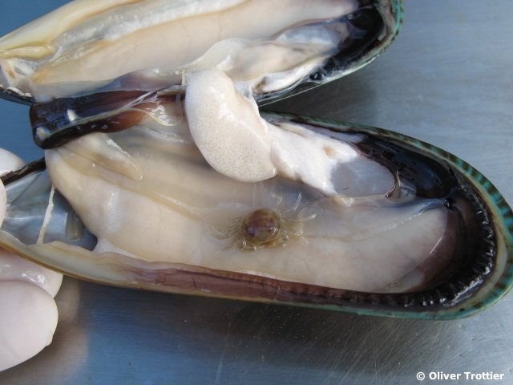 |  | - If there is a pea crab, is it male or female?  Using tweezers or a spatula, carefully remove the pea crab from the mussel into a Petri dish. Observe the pea crab – is it yellow and rounded (female) or a darker mottled colour and flattened (male)?  This photograph shows a male and a female pea crab. You can also learn more about the appearance of male and female pea crabs by viewing the video clip Pea crabs: male vs female and reading the information sheet Life of a pea crab.  If it’s unclear whether the crab is male and female, you can write ND (not determined) on the data sheet.  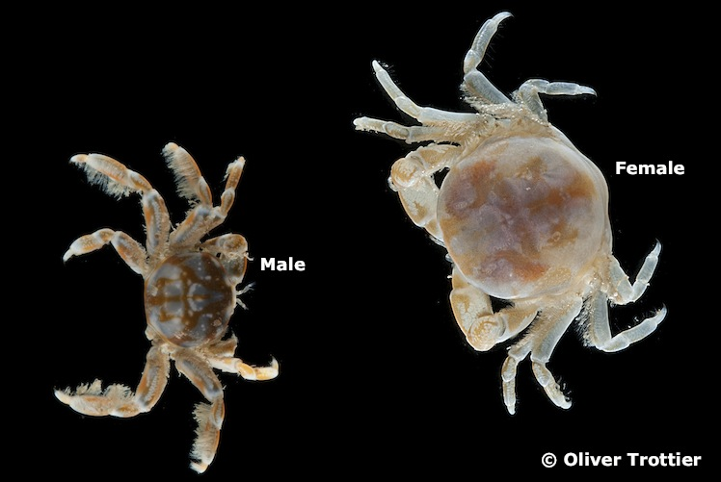

- If the pea crab is female, are any eggs visible?  Look for the presence of a mass of eggs below the female’s abdomen. The mass may be as large as the crab’s abdomen.  This photograph shows how a mass of mature eggs looks.  You can learn more about the development of pea crab eggs in the information sheet Life of a pea crab.  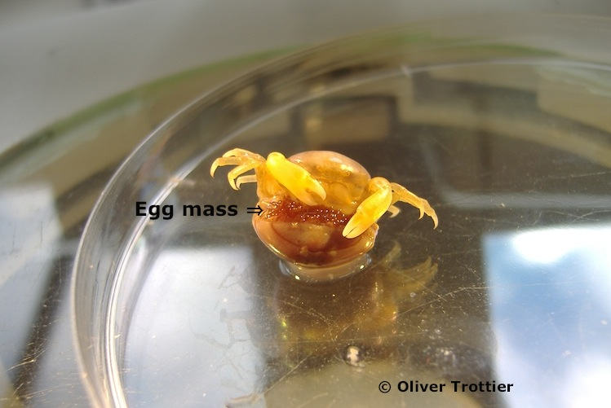 |  | - Is the mussel male or female?  Look at the colour of the mussel flesh. Female mussels have pinkish orange flesh (because of the colour of the developing eggs). Male mussels have off-white flesh (because of the colour of the sperm).  This photograph shows the colour of the flesh in cooked male and female mussels. You can also learn more about why male and female mussels look different in the video clip How mussels spawn.  It can sometimes be difficult to distinguish between male mussels and immature female mussels (because the orange colour is not fully developed in female mussels). If this is the case, you can write ND (not determined) on the data sheet.  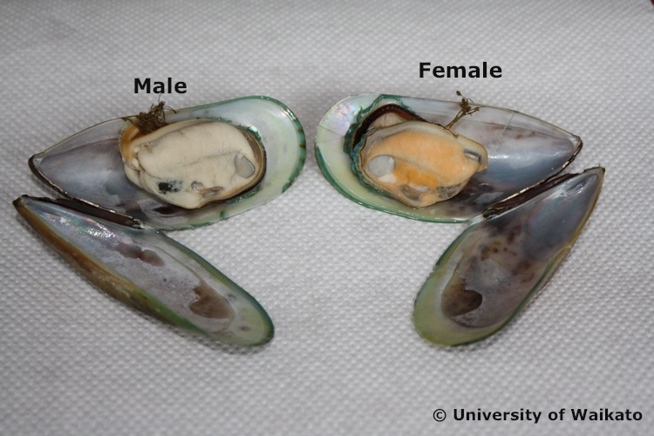

- What is the wet weight of the mussel?  Zero the balance with a weighing boat on it, then place the entire opened mussel (without pea crab) onto the weighing boat. Record the measurement on the data sheet.  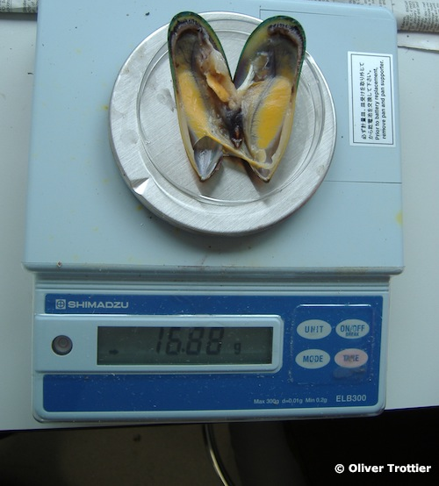 |  | - What is the length of the mussel shell?  If the two mussel shells are still connected, carefully break them apart with your hands.  Measure the length (called the height by scientists) of one of the shells using callipers (as in the photograph below).  Record the measurement on your data sheet.  If you do not have access to callipers, you could use two hardcover books. These can be placed upright at either end of the mussel shell The shell can then be removed and the distance between the two books measured with a ruler.  