ACTIVITY: Putting out the fire

Activity idea

In this activity, students investigate different ways of extinguishing fire and how this is related to their knowledge of the fire triangle and fire chemistry.

By the end of this activity, students should be able to:
- understand the 3 aspects of the fire triangle – heat, oxygen and fuel
- understand that one of the items of the triangle needs to be removed to extinguish a fire.
- understand that extinguishing a fire also occurs by adding gases or chemicals that will interfere with the combustion process.

Introduction/background notes
What you need
What to do
Discussion questions

Introduction/background

This activity involves the students thinking about the fire triangle in terms of how to extinguish fire – by removing heat, by removing oxygen or by adding carbon dioxide. A discussion considers the removal of fuel. This could be a group or class activity or could be demonstrated by the teacher.

Warning

Any activity involving fire is inherently dangerous. Students need to be made very aware of the dangers and the need to work as safely as possible:
- Students should be taught how to strike a match – firmly and away from you – so that they can do this with confidence. Burning matches are often dropped by students who are unsure what to do and are making nervous attempts. Alternatively, the teacher might be the only one to light the candles.
- Teach students to check that the match is completely out. Have a saucer handy to put used matches in.
- If a candle is accidently tipped over, use a damp towel to cover it.

What you need

- Copies of What is fire? to read or access to the article online
- Candles
- Extra long safety matches
- Water in a spray container
- Tea towel or similar piece of material
- Damp towel
- Large bowl
- Vinegar
- Baking soda
- Aluminium foil
- Candlestick holder

What to do

Have the students read What is fire? Discuss that, to extinguish a fire, you will need to remove one of the items of the triangle – heat, oxygen or fuel. Explain that extinguishing a fire also occurs by adding gases or chemicals that will interfere with the combustion process.

- Light a candle. Spray the flame with water. What happens? Try a very small amount of water. Spray the minimal amount of water you need to put out the flame. Try spraying just above the flame. How is adding water taking away one of the components of the triangle?

Explanation
Water is an excellent extinguisher because it absorbs a lot of heat energy – in other words, it removes heat. A new technique used by some structural firefighters is to direct the water above the flames. Since hot air rises, it becomes extremely hot near the ceiling. A quick spray or two of water in this area has an instant cooling effect and the flames are reduced to almost nothing. Any flames left can quickly be extinguished by spraying them directly.

Water is also used in sprinkler detectors. Sprinklers have different sized water droplets coming from them. The larger droplets are heavy and fall onto the furniture in the room to cool it. Smaller, misty droplets are dispersed into the hot air and gases to cool those.

- Light a candle. Fold the damp tea towel up and place it over the candle. What happens? Why?

Explanation
The tea towel stops oxygen getting to the flame. Sometimes, it’s better to use this method of extinguishment than water. If you had an oil fire (for example, the chip pan catches fire), it is better to smother the fire. If you add water, it will spatter the oil around and spread the fire even further. You can smother a fire by putting another pan or lid on top to keep out the oxygen.
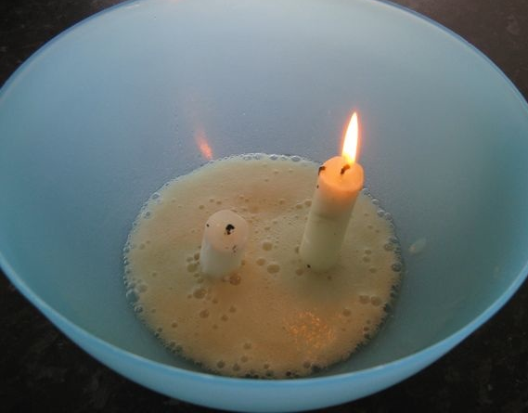
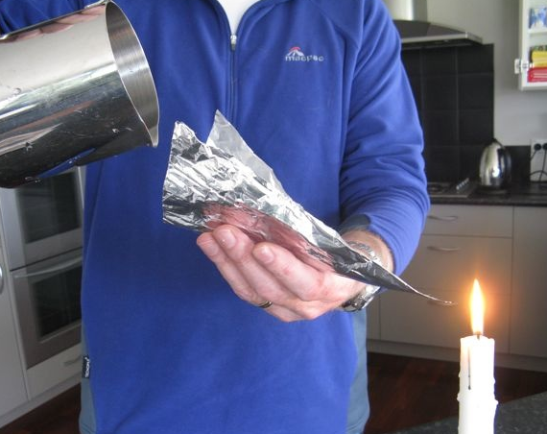
- Fix 2 candles to the bottom of a bowl (one should be taller than the other). Pour 100ml of vinegar into the bowl. Light the candles. Add a tablespoon of baking soda to the vinegar. What happens?

Explanation
The chemical reaction between the vinegar and the baking soda produces carbon dioxide and water vapour. Carbon dioxide is more dense than air and is incombustible (does not support combustion). Being more dense than air, the carbon dioxide rests below the air in the bowl. Since the carbon dioxide is continually produced, it pushes the air out of the bowl as it fills up the bowl. The candles go out because carbon dioxide is incombustible (does not support combustion). The shortest candle will go out first followed by the taller candle, which shows that the bowl fills with carbon dioxide from the bottom up. Some fire extinguishers use carbon dioxide to extinguish flames.

- Make a V-shaped trough out of aluminium foil. Place a candle in a candlestick holder. Light the candle. Place 60ml vinegar and half a tablespoon of baking soda in a jug and let it fill with carbon dioxide (CO₂). Hold one end of the aluminium foil trough just above the flame and the other end higher. ‘Pour’ the carbon dioxide from the jug into the higher end of the trough. What happens?

Explanation
The carbon dioxide, being more dense than air, actually does pour down the trough. Once it reaches the other end, it pours out of the trough and over the candle flame. Since the gas is incombustible, the flame flickers and goes out.

Discussion questions

- What would happen if you took away the wax in the candle? (The fuel is one side of the triangle. A fire must have fuel to burn. You have lots of oxygen and you might have some heat from a source but you have no fuel.)
- How could this apply to forest fires?
- What can fire managers do to help stop wildfires? (Fire managers help to stop wildfires by making firebreaks. This is when they clear an area of land from all vegetation so that, if a fire does occur, it will not be able to burn beyond the firebreak. You often see fire breaks in forest areas. A burn-off is another way of reducing fuel. This is when fire managers burn off an area where there might be a lot of dead and dry vegetation. Reducing this helps to reduce wildfire.)

