**ACTIVITY: New Zealand soil creatures**

**Activity idea**

In this activity, students use Hub resources to learn about two unusual native New Zealand soil creatures. This cross-curricular activity combines science with reading, viewing, writing and presenting.

By the end of this activity, students should be able to:

* use video and text to answer questions about a bioluminescent earthworm
* use text to write a narration/voiceover for the Mummified caterpillar animation.

Introduction/background notes

What you need

What to do

Student handout: A glow-in-the-dark earthworm

A glow-in-the-dark earthworm – answers

Student handout: Mummified caterpillars

**Introduction/background**

One quarter of all living things use soil as a habitat. New Zealand soils are home to some unusual soil dwellers. This activity features a glow-in-the-dark earthworm and a fungus that turns porina moth caterpillars into mummies.

Students view a video about the bioluminescent native earthworm *Octochaetus multiporus* and then use the video and/or video transcript to answer questions.

Students read and/or listen to an article about a fungus that mummifies caterpillars in underground burial chambers. Students use the information to write a narration/voiceover for an animation.

Teachers can choose to do either one or both parts of the activity.

**What you need**

* Access to the video [New Zealand native earthworm *O. multiporus*](https://www.sciencelearn.org.nz/videos/5-new-zealand-native-earthworm-o-multiporus) and copies of the video transcript
* Copies of the student handout: A glow-in-the-dark earthworm
* Access to the article [Vegetable caterpillar](https://www.sciencelearn.org.nz/resources/1435-vegetable-caterpillar)
* Access to the animation [Mummified caterpillar](http://link.sciencelearn.org.nz/videos/799-mummified-caterpillar)
* Copies of the student handout: Mummified caterpillars

**What to do**

***Part 1: Glow-in-the-dark earthworm***

1. As a class, watch the video [New Zealand native earthworm *O. multiporus*](https://www.sciencelearn.org.nz/videos/5-new-zealand-native-earthworm-o-multiporus) once or twice, answering student questions and helping them with scientific vocabulary.
2. Hand out copies of the video transcript, located below the video. (Cut and paste the transcript into Word using a font and font size appropriate for the students, or students can access the transcript online.)
3. Play the video on an interactive whiteboard or similar. Ask students to read the transcript while listening to the video.
4. Pass out copies of the student handout A glow-in-the-dark earthworm and have them complete it. (It is in Word, so you can alter it to suit your students’ learning needs.)
5. Discuss the students’ responses.

***Part 2: Mummified caterpillars***

1. If appropriate, read the article [Vegetable caterpillar](https://www.sciencelearn.org.nz/resources/1435-vegetable-caterpillar) with students. View the images. (The web article is written for teachers so the language is fairly sophisticated – a simplified version of the article forms part of the student handout.)
2. Discuss the mummification process.
3. Watch the animation [Mummified caterpillar](https://www.sciencelearn.org.nz/videos/799-mummified-caterpillar). Watch it again and narrate the process as it happens. Consider watching the animation a third time, using a student volunteer to narrate.

1. Pass out copies of the student handout Mummified caterpillars. Students use this to create their own narration/voiceover using words and ideas from the modified article.
2. Students can present or record their narrations/voiceovers.

**Student handout: A glow-in-the-dark earthworm**

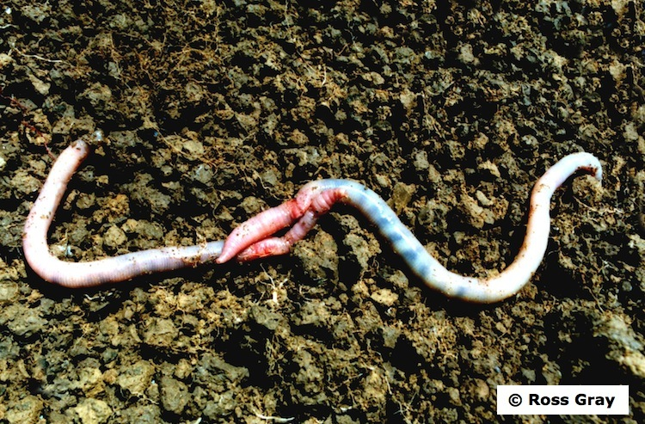

1. How long is the *O. multiporus* earthworm?
2. What colour is the earthworm?
3. The video says its movements are sluggish. What does this mean?
4. What does bioluminescent mean?
5. What did Māori use *O. multiporus* earthworms for?
6. Why do you think *O. multiporus* earthworms are found in areas that are protected from the Sun?
7. *O. multiporus* is a scientific name and difficult to say. What name would you give this earthworm?
8. Write down two other things that are luminescent. They don’t have to be alive.

**A glow-in-the-dark earthworm – answers**

1. How long is the *O. multiporus* earthworm?

*They grow up to 30 cm in length and can have a width of up to 1 cm.*

1. What colour is the earthworm?

*They are pale white with a purple streak running the length of the body. Adults have a dark pink clitellum.*

1. The video says its movements are sluggish. What does this mean?

*They move slowly compared to other earthworms.*

1. What does bioluminescent mean?

*Bioluminescence is light produced by a living organism.*

1. What did Māori use *O. multiporus* earthworms for?

*Māori used the earthworms as bait when fishing.*

1. Why do you think *O. multiporus* earthworms are found in areas that are protected from the Sun?

O. multiporus *live in moist soil. Sun dries out the soil.*

1. *O. multiporus* is a scientific name and difficult to say. What name would you give this earthworm?

*Individual answers will vary.*

1. Write down two other things that are luminescent. They don’t have to be alive.

*Examples include glow sticks, glow in the dark stars, glow worms, fireflies, exit signs, etc.*

**Student handout: Mummified caterpillars**

***Vegetable caterpillar***

Imagine a fungus that turns caterpillars into mummies by trapping them underground. The fungus grows out of the mummy’s head to infect other caterpillars and begin the cycle again. This fungus lives in New Zealand native forests.

***How it happens***

The caterpillars of the native porina moth accidentally eat spores from the fungus when they feed on leaf litter. The insides of the caterpillar are an ideal place (habitat) for the fungus spores to live and grow.



The caterpillar goes into the soil when it’s ready to turn into a pupa. The fungus starts to grow and uses the caterpillar’s body for food. The fungus forms a shell around the caterpillar’s body. The caterpillar slowly dries out and turns into a mummy.

The fungus inside the caterpillar grows a small stem through the head of the caterpillar. The stem slowly grows, pushing through the soil. Once above ground, the fungus produces spores. Other porina moth caterpillars eat the spores and the cycle begins again!

***Vegetable caterpillar animation voiceover***

The Mummified caterpillar animation does not have a sound track. Write a narration (story) to go with the animation. Use words and ideas from the story to narrate each part of the animation.

|  |
| --- |
| Part 1. Eating the spores |

|  |
| --- |
| Part 2. Going underground |

|  |
| --- |
| Part 3. The fungus grows |

|  |
| --- |
| Part 4. Cycle begins again |