RESOURCE: Alternative conceptions about soil
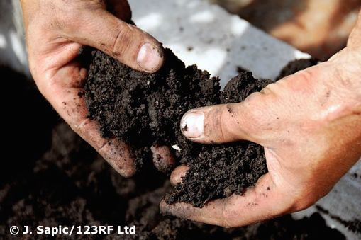
Students do not arrive in the classroom as blank slates. They’ve been exposed to the world around them and may have created their own explanations for how the world works. Educational research shows that, as students learn more about their physical environment, they tend to interpret any new information from the viewpoint of these existing ideas and beliefs. These existing ideas and beliefs may be significantly different from accepted scientific viewpoints (Palmer, 2001).

Osborne (1981) writes, “We believe that children’s non-scientific ideas are not loosely held, isolated misconceptions but are part of a firm and self-consistent viewpoint. If we wish to modify children’s views to make them more scientific then it would appear to us that we need to focus children’s attention very clearly on the differences between their views and the scientific viewpoint.”
This resource introduces common student alternative conceptions about soil. It is important that teachers are aware of these during a sequence of lessons so students have a chance to begin changes in their thinking as the sequence progresses.
Simply telling the student the correct answer will not lead to lasting change. Research has found that children are capable of holding parallel explanations for scientific events – one explanation for the classroom and a second for the ‘real world’. It is suggested that students are given time and the opportunity to conduct repeated hands-on experiences for conceptual change to occur.
Student’s view | Scientist’s view | Teaching points
Soil is dead, inert material. | Soil is a complex habitat of mineral particles, decomposing organic matter, air, water and living organisms. The living organisms include plant roots, bacteria, fungi and larger animals like earthworms or insects. | Use the student activity Observing soil microbes to show students that soil has a living component that we are unable to see – but we can see the results of its work.
Soils are uniformly brown and the same from place to place. | Soils differ from location to location due to how and where they were formed. | One bag of potting mix often resembles another. If possible, dig a hole and compare actual soil with potting mix. Use the phrase ‘soil profile’ to conduct web image searches and view the differences between soils.
Plants eat soil in order to grow. | Plants do not eat because they make their own fuel (food) through photosynthesis. Plants use light energy to combine carbon dioxide and water to form glucose and oxygen. They use this glucose for fuel. Plants absorb minerals such as iron, nitrogen and calcium from the soil.  Some carnivorous plants catch and digest insects. The insects or other prey act as supplements due to nutrient-poor soils. Carnivorous plants still make their own food through photosynthesis. | Tillandsia plant species (epiphytes or air plants) do not require soil to grow. Water and nutrients are absorbed through leaves. Roots are used to anchor the plants.  Show students actual plants or images. If possible, keep an air plant in the classroom so students can observe its growing conditions.
Soil is ‘unchanging’. It must always have been in its present form. | Soil may range in age from days to many millennia. Soil formation is a continuous series of processes. Floods or landslips may deposit materials. Erosion removes and changes soil. | The timescales involved in soil formation are difficult for young students to comprehend. Using images, such as eroded land or an ancient soil, is one way to begin.
Soil is a renewable resource because humans can ‘make’ or buy soil. | Soil is not easily renewable. It can take hundreds to thousands of years to form a few centimetres of soil. | Provide students with rocks, organic materials such as dried leaves and water and ask them to ‘make’ soil. Compare this with an actual soil sample.  Dig down into the topsoil in an out of the way area at the school. Fill a 5 L bucket with soil. A 5 L bag of potting mix costs about $4.00. Estimate how much it would cost to replace a square metre of topsoil. Scale it up to the school playing field – and then consider paddock scales.

References

Lindbo, D. et al. (2012). Know Soil Know Life. Soil Science Society of America.

Osborne, R. and Freyberg, P. (1985). Learning in science – the implications of children’s science. Hong Kong: Heinemann.

Palmer, D. (2001). Students’ alternative conceptions and scientifically acceptable conceptions about gravity. International Journal of Science Education, 23(7): 691–706.

