ACTIVITY: Using soil moisture maps

Activity idea

In this activity, students learn to read and interpret simple soil moisture maps and compare data by location and over time.

By the end of this activity, students should be able to:
- use scientific vocabulary
- find the field capacity of a soil
- identify the elements of soil moisture maps
- discuss the purpose of soil moisture maps
- read/interpret maps to compare data by region
- read/interpret maps to compare data over time.

Introduction/background notes
What you need
What to do
Extension ideas
Student handout: Interpreting soil moisture maps
Interpreting soil moisture maps – answers

Introduction/background

The need to develop visual literacy
Visual literacy includes the ability to read and interpret scientific diagrams and maps. Teachers should not assume that diagrams or maps are self-explanatory. Students need to engage in specific learning activities to develop the knowledge and conventions of visual representations.

This activity uses soil moisture maps to introduce students to some of the elements used by scientists when representing data in visual or pictorial form.

About soil moisture maps
Soil moisture is the water held in pore spaces between soil particles. (Air and water usually make up about half the volume of soil.) Farmers, growers and other land users need to know about soil moisture content to manage their land.
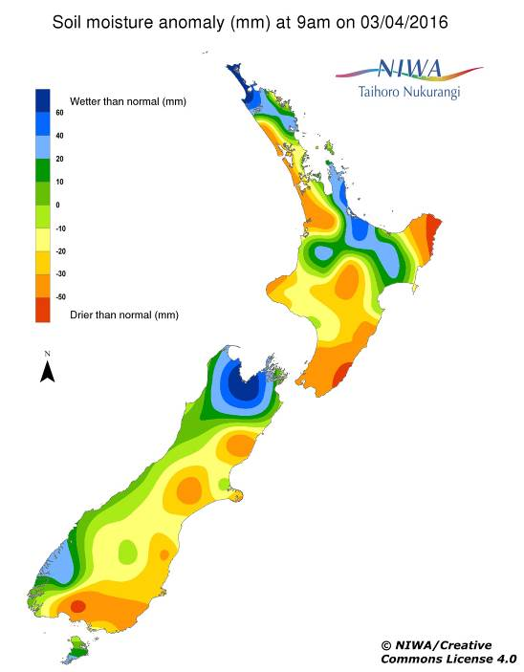
Soil moisture content often changes with seasons. In New Zealand, soils are usually drier in summer than in winter. Soil moisture also varies by location, for example, the South Island’s west coast receives more rain than lands east of the mountain divide.

Learn more about factors that influence soil moisture in the activity Investigating soil moisture content.

Scientists often use maps to represent data. NIWA (the National Institute of Weather and Atmospheric Research) collects soil moisture data from all around New Zealand and displays it in map form.

Visual representations – like maps – are easier to read than tables of numbers.

NIWA publishes two daily soil moisture maps. The soil moisture anomaly map indicates whether soils in an area are wetter or drier than normal.

The soil moisture deficit map is more detailed. The top of the soil moisture scale is water surplus – when more pore spaces than normal are filled with water. Field capacity identifies the upper limit of water a soil can hold once rainfall or irrigation has been allowed to drain away. As moisture levels fall below field capacity, air fills the spaces previously filled with water and the soil is in moisture deficit (less than normal).

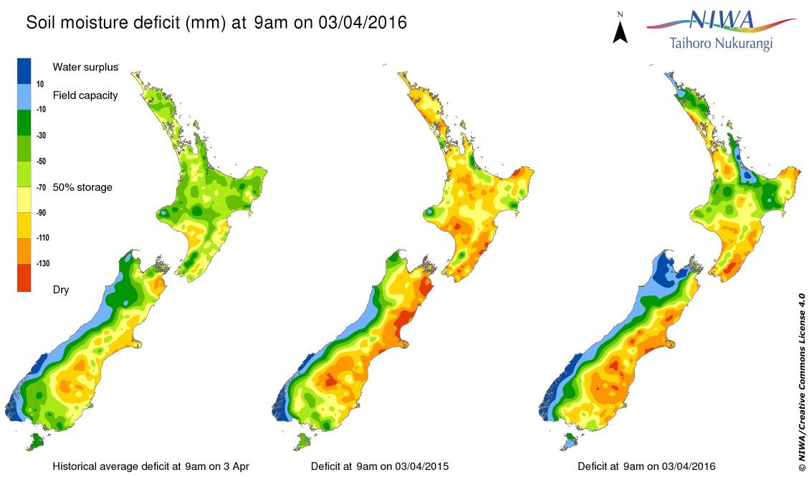

The soil moisture deficit map identifies soil moisture levels over time. Each of the maps indicates moisture levels on a given day. The historical average is based on a 30-year period 1981–2010, while the other two maps are 12 months apart. The maps allow the user to compare soil moisture levels over time.

With both maps, the scales measure soil moisture in millimetres, but for simplicity, this activity will focus solely on the colour scale.
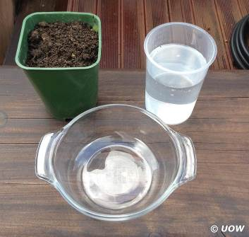
What you need

- Access to NIWA’s daily climate maps
- Soil sample from the school grounds
- 100–200 ml water
- Small plant pot (with holes in the bottom)
- Large clear plastic bowl
- Copies of the student handout: Interpreting soil moisture maps

What to do

- You can adapt this activity to suit the level your class is working at. Choose whether to use one or both of the soil moisture maps. For your advanced learners, choose the soil moisture deficit map as it has more information and is more complex. If you choose not to use the soil moisture deficit map, modify/eliminate steps 2 and 3 below. The student handout is in Word, so you can modify it to suit your students’ needs.

- Building science literacy is an important part of building science capabilities, and providing an opportunity to explore some terms and definitions in this context will be critical to further learning in this activity. Explain that some words scientists use have specific meanings/definitions and sharing a common understanding of these meanings enables them to communicate effectively. Point out these words on the soil moistures maps and review their meanings:
- Anomaly – something that is different from normal.
- Surplus – more than normal.
- Deficit – less than normal.
- Field capacity – the upper limit of water a soil can hold once rainfall or irrigation has been allowed to drain away.
- 50% storage – half the normal amount of soil moisture.

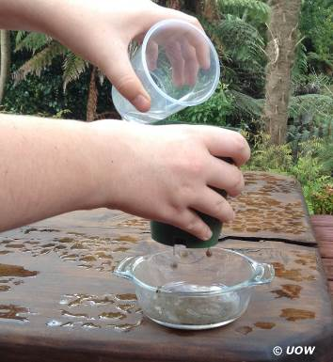
- Find the field capacity of the soil sample you are using:
- Fill the plant pot with soil. Place the plant pot in the bowl.
- Slowly pour water over the soil. Stop when some of the water drains from the pot and begins to fill the bowl. The soil now has a water surplus.
- Hold up the plant pot and let the surplus water drain into the bowl.
- When no more water drips from the pot, the soil is at field capacity. This is the most water the soil can hold in the pore spaces between the soil particles. (Scientists measuring the field capacity of soil samples usually allow the water to drain overnight. Soil in a field or paddock usually reaches field capacity a day or two after it rains.)

- Pass out copies of the student handout Interpreting soil moisture maps. Work through the different sections of the handout.

Extension ideas

- You could measure the amount of water you pour in to the pot of soil and then measure the amount of water left in the large clear plastic bowl. What does this tells you?
- You could weigh the pot of soil before adding water and then again after it reaches its field capacity. What does this tell you?
- Try this with different soil types. What does this tell you about the structure of different soils?

Student handout: Interpreting soil moisture maps

Can you read and interpret soil moisture maps? This activity will help answer that question.

Using the soil moisture anomaly map

- Find the NIWA daily climate maps. Click to enlarge the soil moisture anomaly map.

- Look at the parts of the map.

- What is the title? What is the date in the title?

- What does the scale (sometimes called a legend or key) on the left measure?

- What do the colours represent?

- An anomaly is when something is different from normal. What anomaly is measured in this map?

- Find your location. Use the colour scale to identify whether your location is wetter than normal, normal or drier than normal.

- Look outside. Has it been raining? Is it dry? Compare what you observe and what is on the map. Is it different or the same? Why might this be?

- Look at the map and try to identify cities or other locations you know about. Are they wetter or drier than normal?

- Write down one thing you can say about this map. (This is your interpretation of the map.)

- Is there any information you think is missing from this map?

Using the soil moisture deficit map

- Find the NIWA daily climate maps. Click to enlarge the soil moisture deficit map.

- Look at the parts of this map.

- What is the title? What is the date in the title?

- What does the scale on the left measure?

- What do the colours represent?

- What are the labels under each map?

- Find your location.

- What does the map tell you about the current soil moisture level?

- How does the current soil moisture level compare to the amount of moisture 1 year ago?

- How does the current soil moisture level compare to the historical (30-year) average?

- Are any parts of the map at field capacity or water surplus?

- A deficit means less than normal.

- Do all locations on the map have less water than usual?

- Do you think soil moisture deficit is a good name for the map?

- What name would you give the map?

- Write down one thing you can say about this map. (This is your interpretation of the map.)

- Is there any information you think is missing from this map?

- NIWA updates these maps every day.

- Who do you think uses soil moisture maps?

- Why would they want to know about soil moisture?

Interpreting soil moisture maps – answers

Using the soil moisture anomaly map

- Find the NIWA daily climate maps. Click to enlarge the soil moisture anomaly map.

- Look at the parts of the map.

- What is the title? What is the date in the title?
Soil moisture anomaly (mm) at 9:00 am (date will vary).

- What does the scale (sometimes called a legend or key) on the left measure?
Whether the soil moisture is wetter, the same or drier than normal – by colour and in mm.

- What do the colours represent?
The colours indicate increasing wetness or dryness from normal.

- An anomaly is when something is different from normal. What anomaly is measured in this map?
The anomaly is when soil moisture in an area differs in its wetness or dryness than normal.

- Find your location. Use the colour scale to identify whether your location is wetter than normal, normal or drier than normal.
Answers will vary.

- Look outside. Has it been raining? Is it dry? Compare what you observe and what is on the map. Is it different or the same? Why might this be?
Answers will vary.

- Look at the map and try to identify cities or other locations you know about. Are they wetter or drier than normal?
Answers will vary.

- Write down one thing you can say about this map. (This is your interpretation of the map.)
Answers will vary.

- Is there any information you think is missing from this map?
Answers will vary. They may include city names or regional names.

Using the soil moisture deficit map

- Find the NIWA daily climate maps. Click to enlarge the soil moisture deficit map.

- Look at the parts of this map.

- What is the title? What is the date in the title?
Soil moisture deficit (mm) at 9:00 am (date will vary).

- What does the scale on the left measure?
Whether soils have a water surplus, are at field capacity or are below field capacity (drying out) – by colour and in mm.

- What do the colours represent?
Blue – water surplus, light blue – field capacity, green – moisture content between field capacity and 50% (drier), yellow to red – below 50% field capacity (driest).

- What are the labels under each map?
The labels correspond to dates – historical is the 30-year average for the current day, the middle map shows soil moisture for the day 1 year prior to the current day and the right-hand map shows soil moisture for the current day.

- Find your location.

- What does the map tell you about the current soil moisture level?
Answers will vary.

- How does the current soil moisture level compare to the amount of moisture 1 year ago?
Answers will vary.

- How does the current soil moisture level compare to the historical (30-year) average?
Answers will vary.

- Are any parts of the map at field capacity or water surplus?
Answers will vary.

- A deficit means less than normal.

- Do all locations on the map have less water than usual?
Answers will vary.

- Do you think soil moisture deficit is a good name for the map?
Answers will vary.

- What name would you give the map?
Answers will vary.

- Write down one thing you can say about this map. (This is your interpretation of the map.) Answers will vary.

- Is there any information you think is missing from this map?
Answers will vary. They may include city names or regional names.

- NIWA updates these maps every day.

- Who do you think uses soil moisture maps?
Farmers, horticulturalists, people who manage sports fields, soil scientists and others who study the land or the climate.

- Why would they want to know about soil moisture?
Farmers and horticulturalists need to know when to irrigate, to help predict grass or crop growth, whether to open or close sports fields and so on. Scientists use historical and current data to study changes in weather patterns.

