ACTIVITY: Growing soil microbes

Activity idea

In this activity, students investigate microbial presence in soil by building a habitat suitable for their growth.

By the end of this activity, students should be able to:
- demonstrate that the soil is home to many microorganisms.
- explain that microbes grow in response to different needs such as light, oxygen, no oxygen and various energy sources.

Introduction/background notes
What you need
What to do
Discussion questions
Student handout: Grow some soil microbes

Introduction/background

Building a Winogradsky column
In this activity, students build a habitat suitable for the reproduction of soil microbes. The mud column they build is called a Winogradsky column – named after Sergei Winogradsky, a 19th century microbiologist.

Growing microbes
The Winogradsky column demonstrates that soil is home to many microbes (bacteria). The shredded newspaper provides carbon as a quick energy source for the bacteria. (In a natural habitat, they would use organic matter as a carbon source.)

The bacteria in the mud grow in response to their various needs for light, oxygen and sulfur. The colonies of microbes that develop are seen as bands of vibrant colours. Blue-green bacteria and purple non-sulfur bacteria grow in bands near the top. Brilliant red, magenta or purple sulfur bacteria may make up the bottom band.

The growth is so prolific that students can observe the bacterial growth without the aid of a microscope. The colours are best viewed when intense sunlight or electric light is shone on the column.

Oxygen gradient
Most organisms that students are familiar with require oxygen for growth – they need aerobic conditions to survive. Other organisms, like denitrifying bacteria, are anaerobic – they do not require oxygen to live. The mud in the column develops an oxygen gradient. Air at the top of the column dissolves into the water and supplies oxygen to the top layer of mud, but the deeper the mud in the column, the less oxygen there is. Ideally, the bottom of the column will be oxygen depleted, providing an environment for anaerobic bacteria.

Sulfur gradient
A sulfur gradient also exists in the column. Some bacteria use hydrogen sulfide gas as part of their photosynthetic processes (converting light to energy). Hydrogen sulfide is released naturally as organic matter (the egg yolks in this case) decays. Egg yolks are a quick food source and speed up microbial growth. The sulfur concentration is strongest at the bottom of the column and decreases as the column goes up.

Light
Some bacteria grow in response to light, while others grow better with less light. Students may think light does not penetrate the soil. Some bacteria can use infrared light that shines through to deep soil layers.

Growth time
Allow about 4 weeks for the column to develop. The time taken for the bacteria to flourish varies – depending on the mud. Gooey, smelly mud from a wetland works the best. Noticeable growth can take place in 3–5 days. In 2 weeks, distinct bands of colour can be seen.

Production of gases
Microbial processes often result in the production of gases. Hydrogen sulfide gas – naturally produced in saturated areas such as wetlands – may produce an unpleasant odour (keep in a ventilated area). Tap or squeeze the column daily during the first week to release the gas bubbles. Some of the common processes that occur are listed in the table below.

Microbial processes that occur in anaerobic soils during the decomposition of organic matter
Microbial process | Starting product (dissolved) | End product (gaseous)
denitrification | nitrate  organic matter | nitrogen gas (N₂)  nitrous oxide (N₂O)  carbon dioxide (CO₂)
sulfate reduction | sulfate  organic matter | hydrogen sulfide (H₂S)  carbon dioxide (CO₂)
methanogenesis | organic matter | methane (CH₄)  carbon dioxide (CO₂)

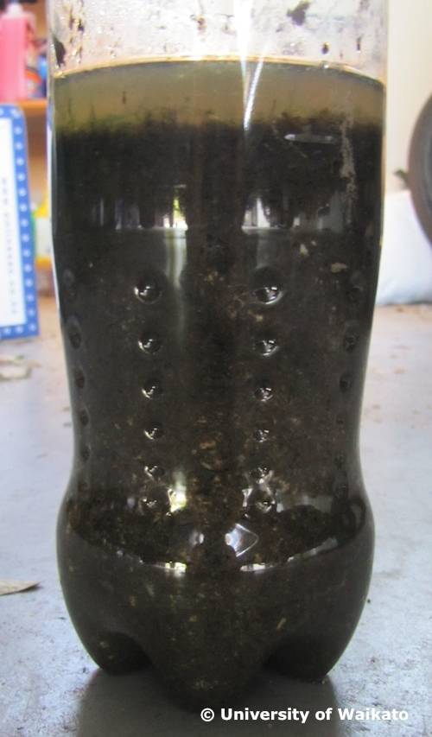 | 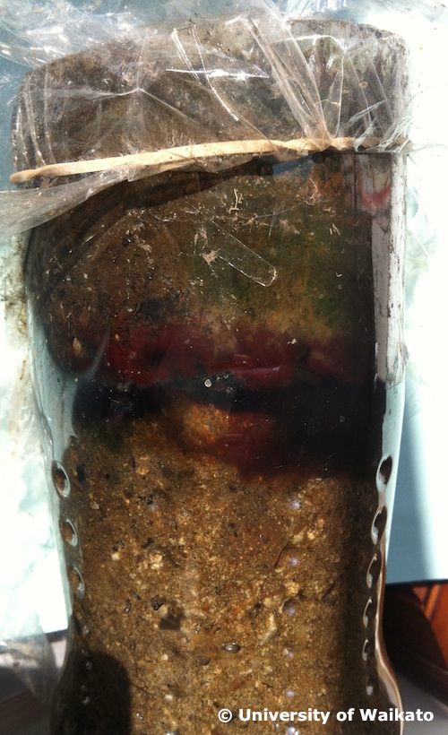
Column on the first day | Column 2 weeks later

What you need

For each group of students:
- Copy of the student handout: Grow some soil microbes
- 1.5 litre plastic soda bottle
- Mud from the edge of a pond, lake or stream
- Two hard-boiled eggs, peeled and finely chopped
- 28 cm x 36 cm piece of newspaper, shredded
- Pond or tap water
- Knife or sharp scissors
- Plastic food wrap
- Rubber band
- Lamp with a 40-watt bulb

What to do

- Hand out copies of the student handout: Grow some soil microbes and discuss.

- Assist groups of students to gather the materials and equipment they need and construct the Winogradsky column.

- Discuss the results.

Discussion questions

  - What energy sources were added to the mud to encourage microbial growth? (Carbon in the form of egg and newspaper.)
  - Why is it important to keep the column from drying out? (To encourage activity from anaerobic bacteria.)
  - Why should the column always be returned to its original position facing the light? (To keep the bacteria that require light growing and developing.)
  - During the first few days, a number of gas bubbles form in the column. What might one of the gases be and why are gases released? (One of the gases is hydrogen sulfide – we know because of the smell. Gases are released due to microbial activity.)
  - Are all of the bacteria growing in the column the same? How do you know? Can you explain why they might be different or the same? (Different bacteria – seen by the different colours. They are different because they are responding to different needs or environments. The green or blue bacteria near the top of the column have responded to oxygen. The more red or purple bacteria have responded to the oxygen-depleted environment near the bottom.)
  - Gases are formed in the column, as you saw when the column was squeezed. Explain how gases are formed naturally in the soil. (Microbial activity occurs in soils naturally. Gases are released in the process.)
  - Do you think this activity would work if we used forest soil? Dry land soil? Why or why not? (Possibly with the forest soil. It would be damp, but it would take longer because there would be fewer microbes to start with and therefore less microbial growth. The growth may not show. Microbial activity in dry soil would be very slow and would not show.)
  - How does this activity relate to the nitrogen cycle? (The anaerobic bacteria are using nitrate in their life processes, and the nitrate is converted into nitrogen gases N₂O and N₂. This is the denitrification process of the nitrogen cycle.)
Student handout: Grow some soil microbes

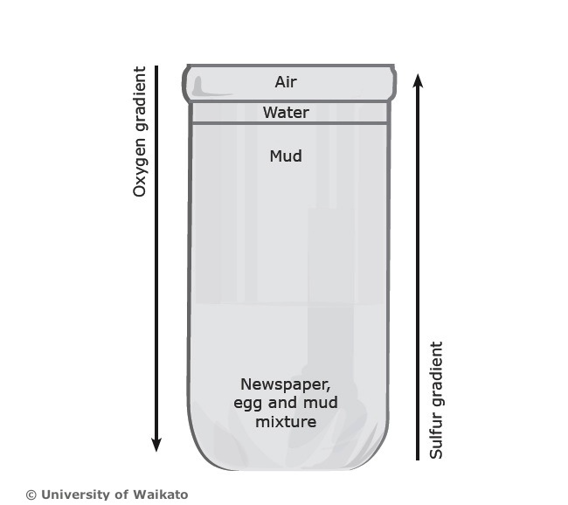

- Use the knife or scissors to cut the top off the soda bottle. Cut just below the shoulder of the bottle to obtain the tallest column possible.

- Remove rocks, sticks, leaves and so on from the mud.

- Mix the mud with the pond or tap water until the mud is the consistency of raw egg whites.

- Fill a quarter of the column with prepared mud. Add the chopped hard-boiled eggs and the shredded newspaper. Stir very well to mix.

- Tap the column to remove air bubbles.

- Gently fill the column with the remaining mud. Leave 5–8 cm of head space to allow for expansion of the mixture as gases are produced. Tap again to remove air bubbles.

- Top the column with 6 mm of water.

- Place the column near a light source or lamp. Position the lamp so that light shines on one side of the column rather than above it. The lamp should be far enough from the column so that mud is not heated. For the quickest results, expose the column to light 24 hours a day.

- Make a mark on the side of the column that faces the light so that the column will be returned to the same position after handling.

- Add water as necessary to keep mud saturated. After several days, you may wish to seal the top with plastic wrap and a rubber band to prevent evaporation. It is important that the column does not dry out.

