ACTIVITY: Visual soil assessment

Activity idea

In this activity, students learn about soil quality and soil properties by conducting a visual soil assessment. The activity involves digging up a 20 cm cube of soil to examine the soil structure and look for earthworms.

By the end of this activity, students should be able to:
- identify why soil structure, porosity and earthworms are indicators of soil quality
- discuss how land use can affect soils
- conduct a simplified version of a visual soil assessment.

Introduction/background notes
What you need
What to do
Discussion questions
Extension ideas
Student handout: VSA scorecard
Visual scoring of soil structure under pasture
Visual scoring of soil porosity under pasture
Visual scoring of earthworm count under pasture

Introduction/background

A visual soil assessment (VSA) is a quick and simple investigation into some of the visual indicators that point to a healthy soil. Scientists originally developed it as an assessment tool for farmers. A VSA involves digging up a 20 cm cube of soil, comparing the soil to sample photos and assigning a score (poor, moderate or good) for different indicators.

This simplified student version uses three indicators – soil structure, soil porosity and earthworm numbers – as a quick means of investigating soil quality.

The structure of soil is important for plant growth and regulating the movement of air and water. It influences root development and has an effect on nutrient availability. Good quality soils are friable (crumbly) and have fine aggregates so the soil breaks up easily if you squeeze it. Poor soil structure has coarse, very firm clods or no structure at all.

Soil porosity refers to the pores within the soil. Porosity influences the movement of air and water. Good quality soils have many pores between and within the aggregates. Poor quality soils have few visible pores, cracks or holes.

Earthworms improve soil porosity through their burrowing. They also help with nutrient cycling and supply. Earthworm numbers tend to be lower in compacted or pugged soils.

Conducting a single VSA is enough to explore the visual indicators of soil quality. Assessing several sites around the school grounds can show the effects of land use on soil quality. For example, compare the soil under a fence line or in an out-of-bounds area with the soil in a high traffic area.

A VSA is best conducted when the soil is moist rather than dry from drought conditions or waterlogged after heavy rain.

Safety note
Identify where any buried cables or water pipes are located. If in doubt, avoid the area completely. Discuss the activity with the school property manager before digging begins.

What you need

- Access to the article Soil properties
- Straight-sided spade
- 2 large plastic rubbish bags (cut along the length and opened up to create groundsheets)
- Large plastic storage box, cube size is ideal
- 2 sports cones
- Copies of the student handout: VSA scorecard
- VSA scoring images: Visual scoring of soil structure under pasture, Visual scoring of soil porosity under pasture and Visual scoring of earthworm count under pasture

What to do

- Discuss the visual indicators we use to tell if a human or animal is healthy (sufficient energy, body shape). Explain that a visual soil assessment (VSA) uses visual indicators as a way to assess soil quality (health).

- Read the article Soil properties and discuss soil structure and soil porosity with students.

- Discuss the land use and land cover around the school. Sites might include areas of heavy use such as playing fields, walking paths between buildings and undisturbed spots like out-of-bounds areas or along the fence lines. Draw out students’ ideas about how land use may have affected the soil.

- Choose two sites to test – the first from a relatively undisturbed area, the second from a high-use area.

- At the first chosen site, spread the sheet of plastic out and place the plastic box next to it.

- Dig out a 20 cm cube of topsoil with the spade. (Many spades are approximately 20 cm in width so cut a square with the spade to remove the soil.) Place this cube of soil to one side – it is no longer needed. Using the edge of the hole as one side, make three more cuts to create a second cube. | 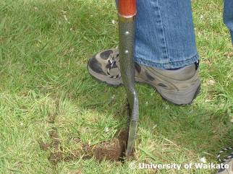 | 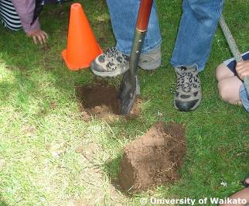
- Hold the soil cube at the height of 1 metre. Drop it a maximum of three times into the plastic box. Empty the broken soil from the box onto the plastic sheet each time the soil cube is dropped. If any large clods break away after the first or second drop, drop them individually again once or twice. If a clod shatters in small pieces after the first or second drop, it does not need to be dropped again. Don’t drop any piece of soil more than three times. Gently separate each clod from the roots. Part it by hand along any visible cracks. | 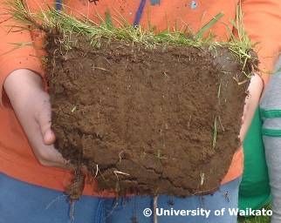 | 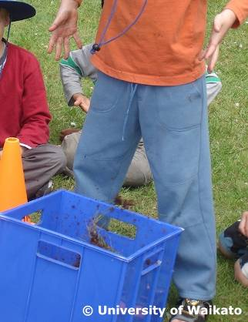
- Transfer the soil onto the large plastic bag and grade it so that the turf is at the top, followed by the coarsest clods and moving down to the finest aggregates (the crumbs) at the bottom. This provides a measure of the aggregate-size distribution. Have students compare the resulting distribution of aggregates with the three photographs in Visual scoring of soil structure under pasture and record the visual score on the student handout VSA scorecard. |  | 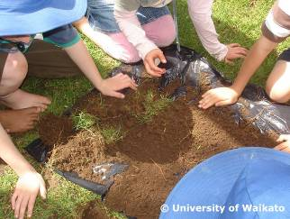
- Remove a spade slice of soil from the side of the hole. Fold it in half lengthwise to break it into two pieces. Examine the exposed face for soil porosity. Have students compare it with the three photographs in Visual scoring of soil porosity under pasture and record the visual score. |  | 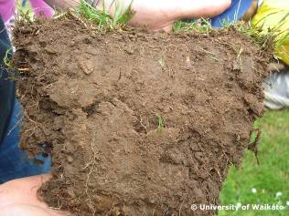
- Have students carefully sort through the soil sample used to assess soil structure and count the earthworms, paying particular attention to the root section, and record the visual score on the VSA scorecard. Use the photograph in Visual scoring of earthworm count under pasture as a reference. | 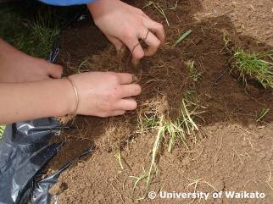 | 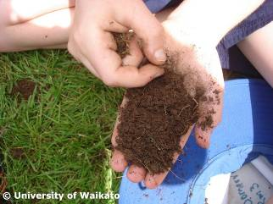

- Return the worms to the hole. Cover with some loose soil. Mark the hole with a sports cone to alert others to an unsafe site. Leave the plastic sheet of aggregates where it is.

- Move to the second site. Dig out the 20 cm cube as before. Mark the hole with a sports cone. Take the cube of soil from the second site back to the first site. Repeat the visual soil assessment. Place the two plastic sheets of soil side by side and discuss any differences.

- Photograph the results (optional). Return the soil to both holes. Place the turf on the top and step on it firmly so the turf is level with the ground.

Discussion questions

- Are the scores the same for each VSA site or are they different?
- Do you think the differences are due to planting, contour of the land or land cover?
- Do you think the differences are the results of human impact? (High foot traffic, popular playing spot, recent or past disturbances due to building construction.)
- Which site might be most suitable for plant life? For soil animals?
- If some of the green spaces are showing signs of compaction, what can the school do to lessen the soil damage? (Establish cobblestone pathways, close off ‘goat tracks’ during wet weather, investigate moving goal posts from season to season to rest some parts of the fields.)

Extension ideas

- Write stories from a worm’s point of view. What kind of soil would they like to live in?
- Use the VSA results to develop an action plan to use during winter to minimise soil compaction. Some ideas include rotating sports fields throughout the week or creating a list of alternative activities that make better use of courts or other paved surfaces (circuits, 4 square and hopscotch). Design posters explaining the action plan and advertising the alternatives.
- Interview the property manager about their approach to soil management around the school. Relay your VSA findings to them.
- If your school is part of an Enviroschools scheme, Enviroagents could do a VSA annually and build up a soil quality database. Discuss how this information could be of use when making decisions about the future placement of buildings, playground equipment or gardens.

Student handout: VSA scorecard

SITE 1

Land use: (sports field, lunch area, etc.) _______________________________________

Location: ____________________________

Date: ____________________________

Visual indicator of soil quality | Visual score (VS)
Soil structure | 0 = poor condition 1 = moderate condition 2 = good condition
Soil porosity | 0 = poor condition 1 = moderate condition 2 = good condition
Earthworm count | 0 = poor (<15) 1 = moderate (16–44) 2 = good (>45)
Total score

SITE 2

Land use: (sports field, lunch area, etc.) _______________________________________

Location: ____________________________

Date: ____________________________

Visual indicator of soil quality | Visual score (VS)
Soil structure | 0 = poor condition 1 = moderate condition 2 = good condition
Soil porosity | 0 = poor condition 1 = moderate condition 2 = good condition
Earthworm count | 0 = poor (<15) 1 = moderate (16–44) 2 = good (>45)
Total score

Visual scoring of soil structure under pasture

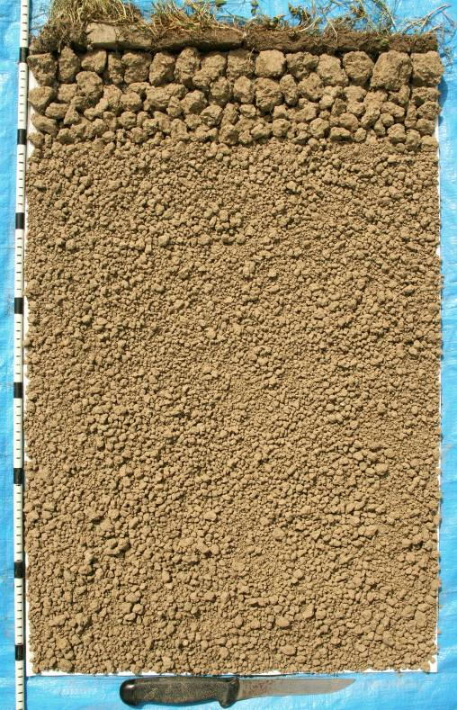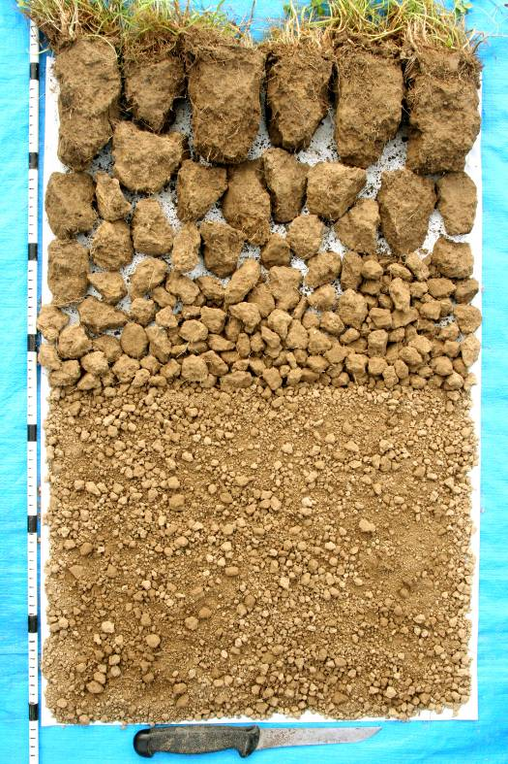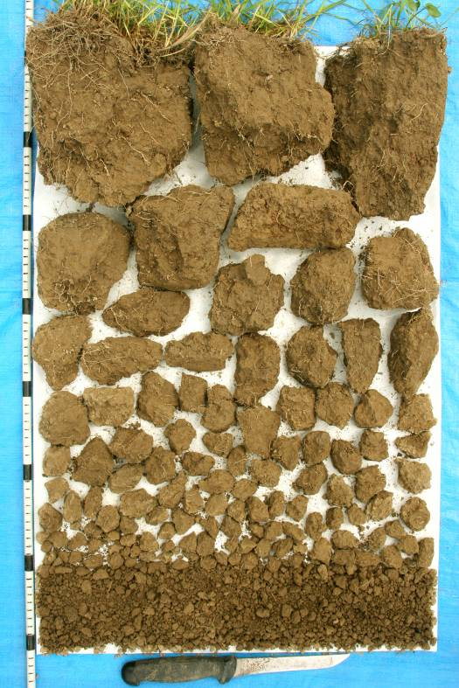

Good condition  Visual score = 2  The soil is mostly fine, crumbly aggregates with very few big clods. | Moderate condition  Visual score = 1  The soil contains both firm clods and fine, crumbly aggregates. | Poor condition  Visual score = 0  The soil is full of large, very firm clods with very few fine, crumbly aggregates.

Images courtesy of Graham Shepherd.
Shepherd, T.G. 2009. Visual Soil Assessment. Volume 1. Field guide for pastoral grazing and cropping on flat to rolling country. 2nd Edition. Horizons Regional Council, Palmerston North. 119 p.
Visual scoring of soil porosity under pasture

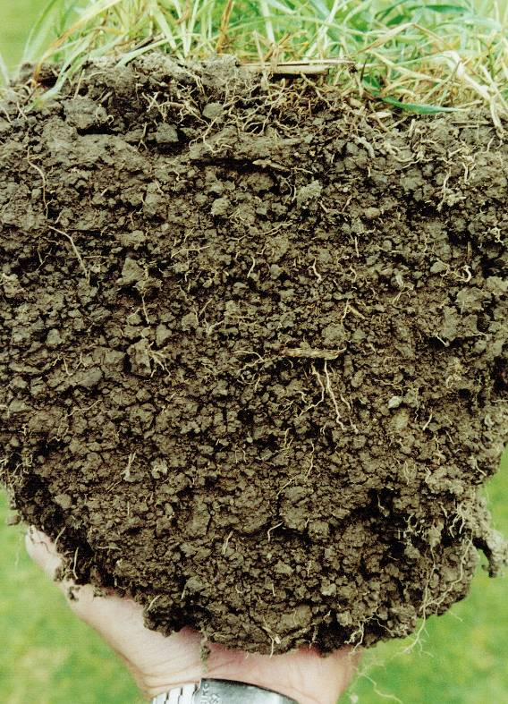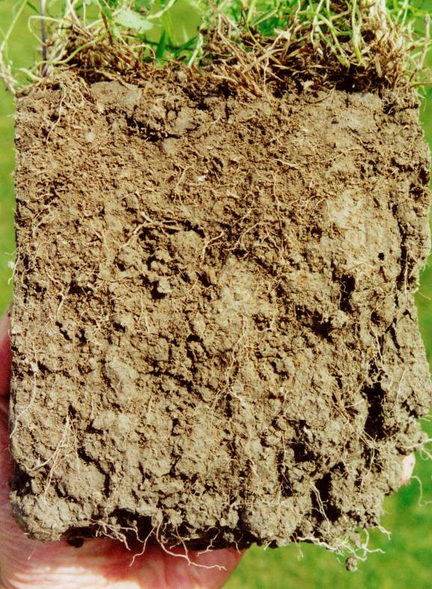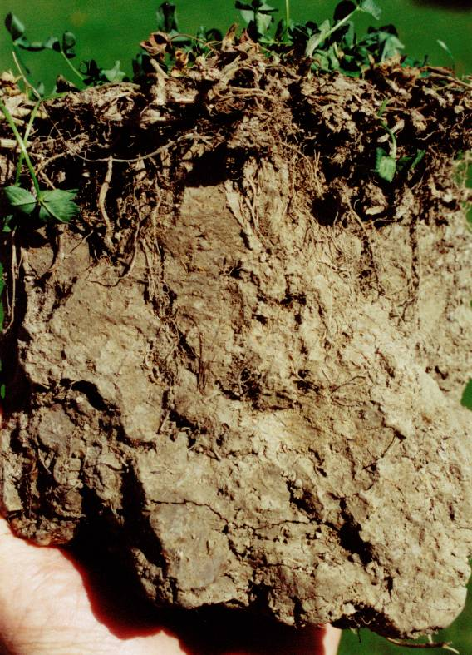

Good condition  Visual score = 2  The soil has large pores between and within the aggregates. | Moderate condition  Visual score = 1  The soil has fewer big pores between and within the aggregates. | Poor condition  Visual score = 0  The soil has no big pores and few cracks or holes. It appears as one big clod.

Images courtesy of Graham Shepherd.
Shepherd, T.G. 2009. Visual Soil Assessment. Volume 1. Field guide for pastoral grazing and cropping on flat to rolling country. 2nd Edition. Horizons Regional Council, Palmerston North. 119 p.

Visual scoring of earthworm count under pasture

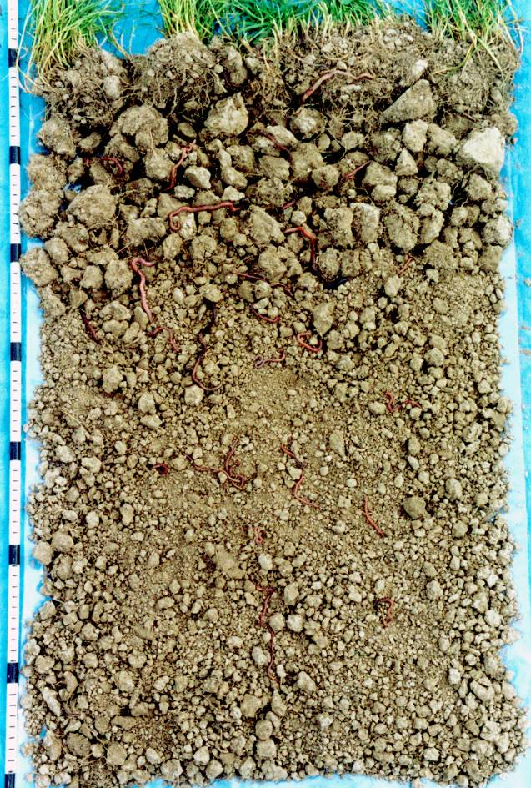

Visual score (VS) | Earthworm numbers  (per 200 mm cube of soil)
2  (Good) | >45  (with preferably 3 or more species)
1  (Moderate) | 25 – 34  (with preferably 2 or more species)
0  (Poor) | <15  (with predominately 1 species)

Image courtesy of Graham Shepherd.
Shepherd, T.G. 2009. Visual Soil Assessment. Volume 1. Field guide for pastoral grazing and cropping on flat to rolling country. 2nd Edition. Horizons Regional Council, Palmerston North. 119 p.

