Activity: Testing the degradability of potato plates
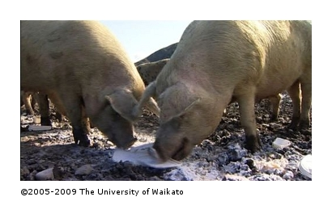
In this activity, students compare the rate of degradation of disposable plates using three different disposal methods.
For this activity, you will need access to:
- a compost bin
- a worm farm
- a small area of ground that can be dug up.
Students will experiment with a range of disposable plates from different materials, including potato plates, and compare the rates of degradation using three different disposal methods. This activity could be used as a starting point or during or after learning about potato plates.
See Unit plan: Promoting potato plates.
- Provide a range of disposable plates in different materials – plastic, paper, polystyrene and potato plates. You will need three samples of each.
- Ask the students about rubbish disposal methods – landfill, compost, worm farm, recycling – and discuss the advantages and disadvantages of each.
- Divide the class into three groups and allocate a different method of disposal to each group. Get the students to label ice block sticks with the name of the material to use as markers at the different disposal sites, and keep a control sample.
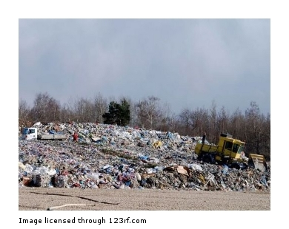
- Get student groups to put their plates into the allocated disposal area and once a week dig them up and compare them with the originals. Photograph and record the changes each time.
- Repeat the process each week for one month or until the potato plate has fully degraded.
- Groups present their results to the class and compare the differences.
- Discuss reasons for the different results between the materials and the disposal methods.

