ACTIVITY: Investigating dampness and mould growth

Activity idea

In this activity, students use bread slices to investigate the role of moisture in mould growth.

By the end of this activity, students should be able to:
- discuss the role of moisture in mould growth
- explain how this activity relates to mould growth in damp houses
- identify methods for minimising moisture levels in homes.

Introduction/background notes
What you need
What to do
Student handout: Growing mould on bread

Introduction/background

Cold, damp houses often provide the ideal conditions for moulds to grow. When temperatures become cooler, the air is not able to hold as much moisture. The moisture condenses on surfaces like walls and windows and provides a favourable environment for mould and other microorganisms to grow.

Breathing in mould spores can cause respiratory and other health problems. The World Health Organisation (WHO) believes that a considerable proportion of childhood asthma cases are due to damp and mouldy homes.

WHO recommends that temperatures inside the home are kept at a minimum of 18–21°C during winter and that humidity levels range between 40% and 60%.

This activity highlights the role that moisture plays in mould growth. A slice of bread dried in the microwave showed no visible mould growth after 14 days, unlike the control slice and moist bread slice.

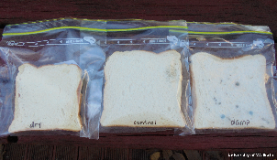 | 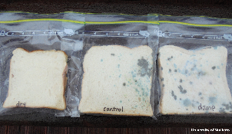
Mould growth after 1 week | Mould growth after 2 weeks

What you need

- Access to the article Damp homes and health risks
- Access to the interactive Moisture sources in our homes
- 3 slices of white bread
- 3 ziplock-type bags
- Microwave oven
- 2 teaspoons water
- Camera (optional)
- Copies of the student handout Growing mould on bread

What to do
- Read and discuss the article Damp homes and health risks.

- Pass out copies of the student handout Growing mould on bread and ask students to follow the instructions.

- Discuss the results:
- Why do you think you were asked to wash and dry your hands before handling the bread slices?
- Why did you dry the bread in the microwave instead of the toaster?
- Why was one bag labelled ‘control’?
- If you left the bags for longer, what do you predict would happen to the bread and mould?
- What is mould? Is it living? Why is it harmful?
- What are the similarities and differences between the mould growing on the bread and the mould that may be growing in a home?
- What actions can be taken to reduce mould growth in homes?

- Use the interactive Moisture sources in our homes to explore sources of moisture in the home.

- Watch the Rongomai S.T.E.M. Mouldy Homes Project video on YouTube. It briefly explains the link between cold, damp conditions and mould growth. The students sing an original song with a checklist for reducing mould.

- Use the video to encourage students to design a poster, song or list of ways students can help their families minimise moisture in the home.

- Older students can debate the issue of substandard housing and rental housing warrants of fitness. For tips on debating ethical issues, refer to Using ethical frameworks in the classroom and Teaching Ethics.

Student handout: Growing mould on bread

Does moisture make a difference to mould growth? This activity will help answer that question.

What to do

- Wash and dry your hands before handling the bread slices.

- Place a slice of bread into a ziplock bag labelled ‘control’.

- Microwave a slice of bread for 2 minutes to dry it out. Allow it to cool then place it in a ziplock bag labelled ‘dry’.

- Sprinkle 2 teaspoons of water onto a slice of bread. Place it in a ziplock bag labelled ‘damp’.

- Observe the bread slices, photographing them every few days, if desired. Do not open the bags. Mould spores may be harmful if inhaled.

- Dispose of the unopened bags when the activity is finished.

