ACTIVITY: Where do I live?

Activity idea.

In this activity, students learn about habitats and why and how animals and plants are best suited to particular habitats.

By the end of this activity, students should be able to:
- define a habitat
- describe why some animals and plants are particularly suited to their marine habitats
- begin to describe how a change in an environment might affect what lives there.

Introduction/background notes
What you need
What to do
Habitat characteristics
Student handout: Habitats
Student handout: Habitat features
Student handout: Plants and animals

Introduction/background

A habitat is a natural environment of an animal or plant where they can grow and reproduce. Animals and plants occupy habitats that they are suited to. For example, some species of spiders, such as the daddy long-legs, like to live in the corners of buildings because it’s a good place to attach a web. Insects flying near lights may get trapped in the web, providing the spider with a good food source. It’s also warm, dry and usually undisturbed. Animals and plants have adapted to particular habitats over time and have features that help that animal or plant grow and reproduce in that environment.

In this activity, the students consider three marine habitats, along with the needs and features of various animals and plants. First, the students consider the characteristics of each habitat. Is the water deep or shallow? Is the seabed rocky, sandy or muddy? Are the waves big or small? While discussing these aspects of the habitats, the students should be considering what could live in them.

The students need to develop a good understanding of the characteristics of each habitat. This will give them clues for matching the animals and plants to the habitats. A class discussion at the end of the first part will indicate whether each group is on the right track. Note that:
- the harbour estuary has shallow water, sand and mud and small waves
- the surf beach has big waves (sometimes), shallow water and sand
- the rocky shore has deep water, big waves and a rocky seabed.

In the second part of the activity, students match animals and plants with one of the habitats, according to their adaptive features. For example, paddle crabs have paddles to dig into the sand and hide for protection. Flounder feed on muddy seabeds, blending with their surroundings for protection. Crayfish are also seabed dwellers, feeding off plants and animals on the seafloor. Their brown/orange colour and lumpy shape allows them to camouflage with their rocky environment. Students could be given time to explore the adaptive features of the animals and plants by researching them on the internet.

Note that some things move easily between two habitats (for example, sharks can be found in deep water by rocky shores or in shallow water off surf beaches). The animals and plants found in each of the areas in this activity are most likely to be:
- rocky shore – pāua, sponges, seaweed, fish, crayfish, shark
- surf beach – tuatua, shark, stingray, snapper, paddle crab, sandhopper
- harbour estuary – mangroves, flounder, pipi, marine worm, cockles, horse mussel.

What you need

- Copy of Habitat characteristics
- Colour copies of the student handout Habitats, cut into 3 cards
- Colour copies of the student handout Habitat features, cut into 9 cards
- Colour copies of the student handout Plants and animals, cut into 18 cards
- Access to the articles Habitats in the Bay of Plenty, Biodiversity in the Bay of Plenty and Adapting to marine habitats

What to do

- Write up the word ‘habitat’ and discuss as a class. Where do you live? Why? How does that environment help you? Where do horses/spiders/mice/sharks/willow trees live? Why? How does it help them?

- Read Habitats in the Bay of Plenty, Biodiversity in the Bay of Plenty and Adapting to marine habitats could also be read now or at the end to reinforce learning.)

- Organise the class in small groups and distribute the three handout Habitats cards to each group. Have them turn these cards face up and spread them out.

- Place Habitat characteristics where the class can view (or write the descriptions up on the board). Ask the students to consider the three habitats according to the descriptions. Which habitat has deep water or shallow water? Which habitat is rocky, sandy or muddy? Which habitat has big waves or small waves? Discuss as a class.

- Distribute the sets of Habitat features cards to each group. Give the groups a limited time to match the features to each habitat.

- Stop the class and discuss the features of each habitat. Check they all have the right descriptive features for each habitat. Ask them to think about what might live in each habitat and why.

- Distribute the set of Plants and animals cards to each group. Give the students a time limit to match six animal and plant cards to each habitat.

- When time is up, tell students to stop work. Groups can move around and look at other groups’ work. Students can tell others if they disagree with their placements, but they must give a reason. (For example, crayfish would be in the rocky area because they hide under rocks for protection from predators. The big waves wouldn’t bother them because the water is usually quite deep or the crayfish can cling to or hide in the rocks.) Student groups can change placements of their own cards if they want to.

- Class discussion – each group can suggest an animal or plant for one of the habitats and explain to the class why they think it should go there. If there was a change in a habitat, for example, run-off causing a build-up of mud in an estuary, do you think the animals or plants would remain there? What might happen?

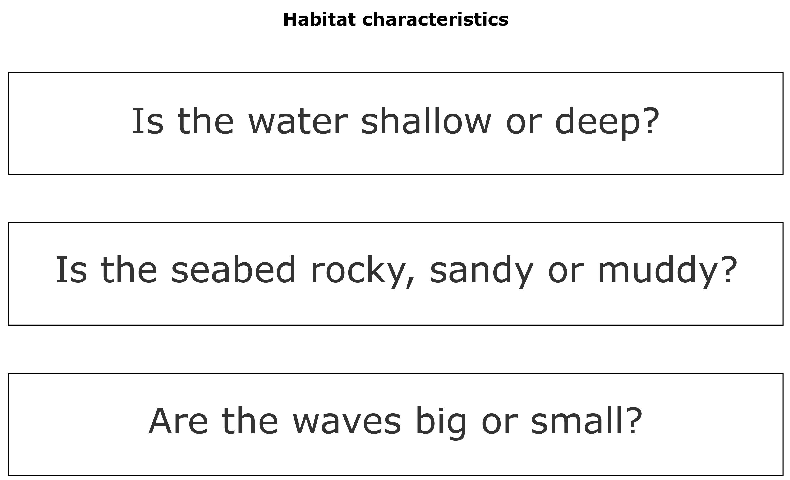
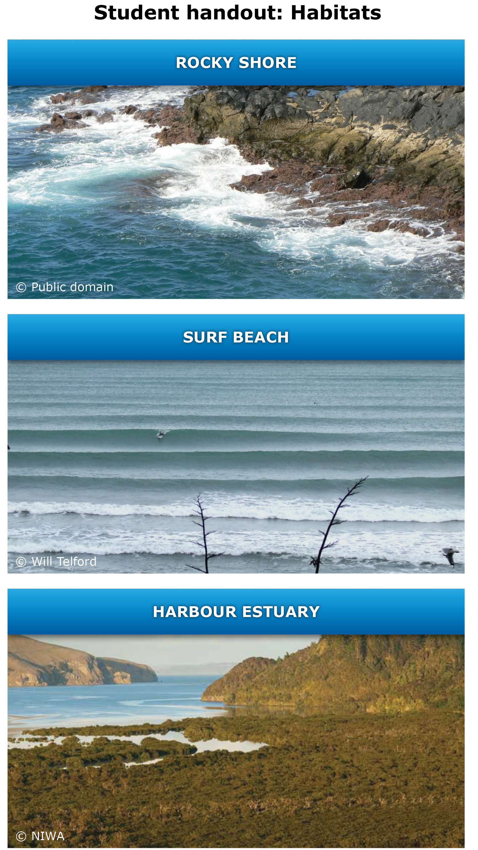
Student handout: Habitat features
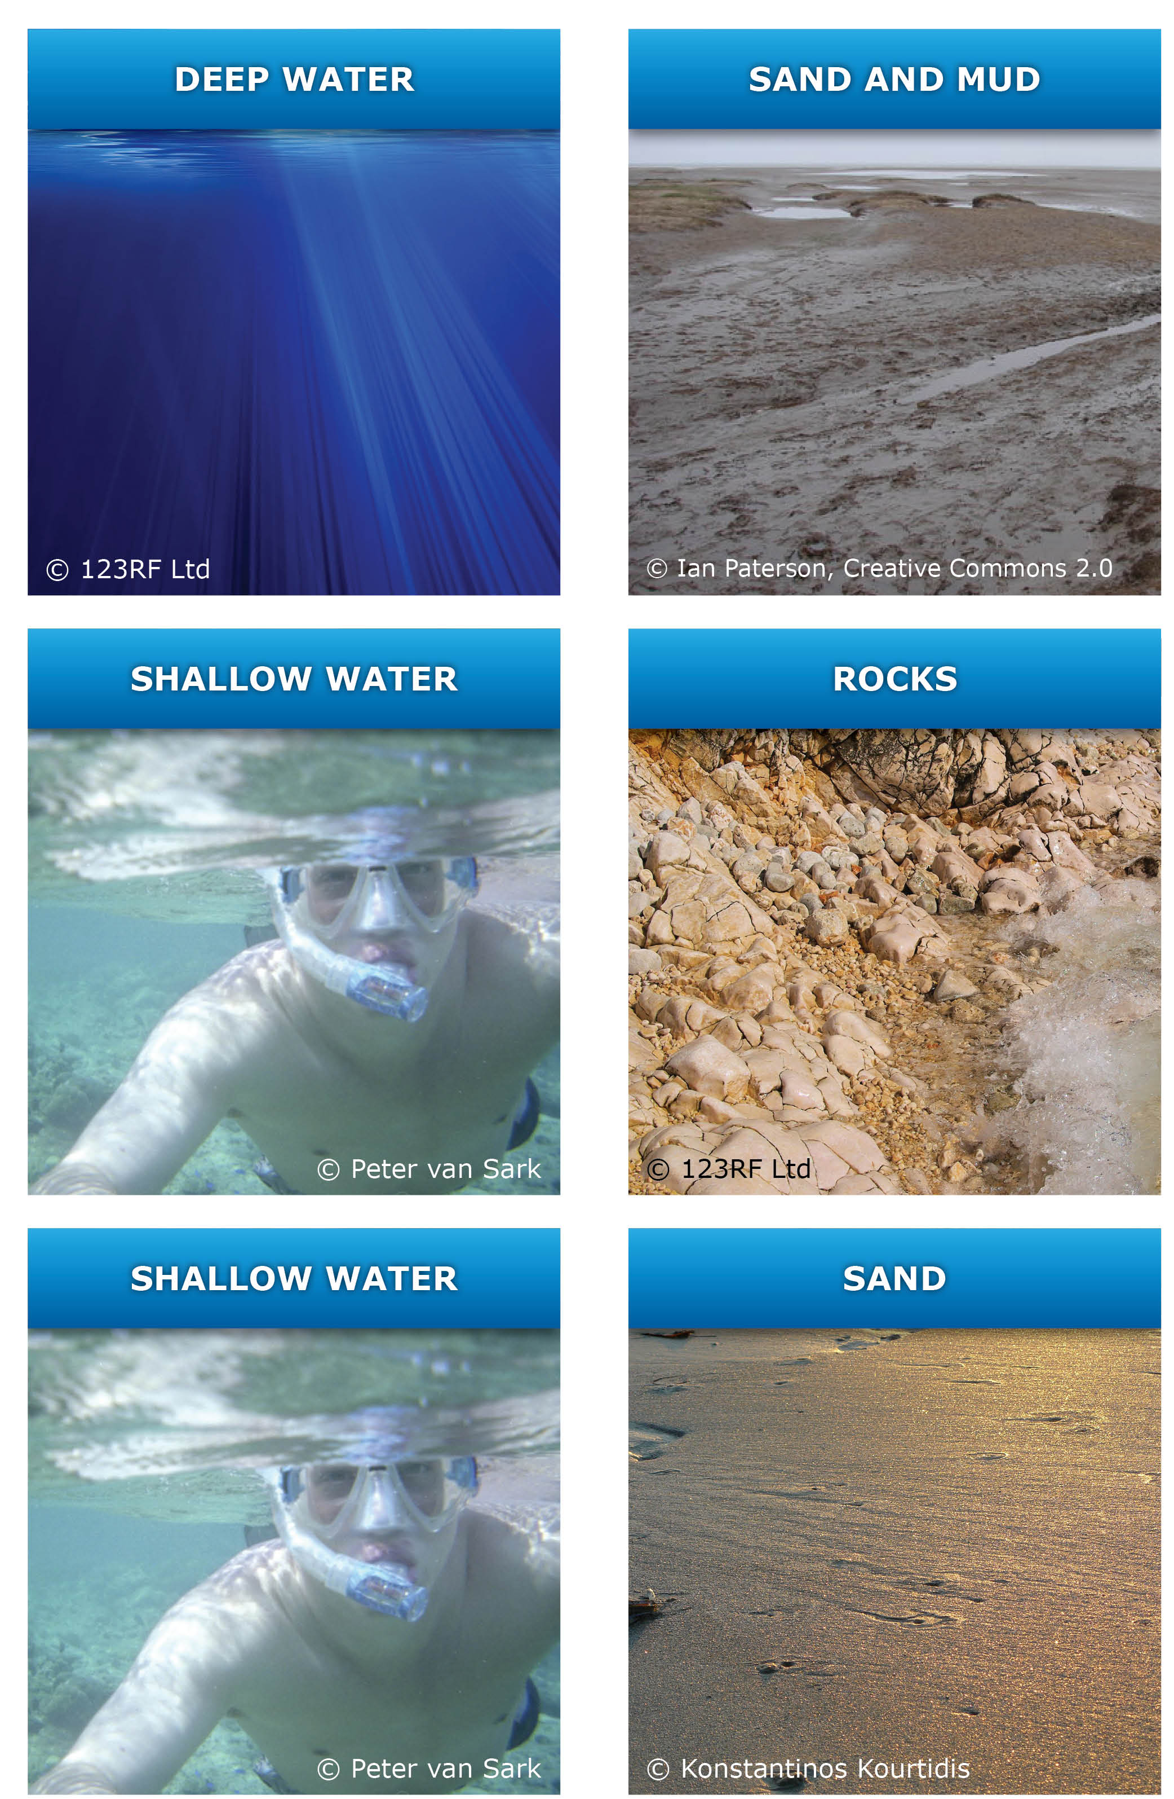

Student handout: Habitat features
