ACTIVITY: Cleaning up oil in water

In this activity, students experiment with oil in water. They observe the effects of oil in water and then attempt to clean up the oil using various sorbents. They also observe what happens when a chemical dispersant is added to the oil in the water and have a go at cleaning oil off bird feathers.

By the end of this activity, students should be able to:
- discuss what a sorbent is and how it works
- identify some sorbents used for cleaning oil spills
- discuss the pros and cons of leaving oil to disperse itself
- explain in simple terms how chemical dispersants work on oil
- discuss the pros and cons of chemical dispersants
- explain why people need to clean oil off birds’ feathers after an oil spill.

Introduction/background notes
What you need
What to do
Student handout: Cleaning up oil

Introduction/background

The grounding of Rena on the Astrolabe Reef in 2011 caused an oil spill in the Bay of Plenty. This affected wildlife and could have long-term implications for the marine environment.
The response to the oil spill was fraught with divided opinions. Scientists working with Maritime New Zealand were initially convinced the chemical Corexit would disperse the oil. Others were not so sure – some felt dispersants were just as damaging to the environment as the oil. Some wanted the oil left to disperse naturally.

Oil close to the shoreline in some places was collected up with booms and skimmers or sorbents (Read Pollution from Rena and Cleaning up the oil spill.)
Oil spills may take months or even years to clean up. The oil may include crude oil, refined petroleum products or byproducts. Oil also enters the marine environment through natural seeps from the seafloor. Most human-induced oil pollution comes from land-based activity, but we are made very aware of spills from seagoing ships and oil tankers.

In this activity, students experiment with oil in water. The first thing they will notice is that oil and water do not mix. Water and oil are chemically different so they are not attracted to one another and will separate into layers. The oil (because it’s less dense) floats on the water. The students then explore ways to remove the oil from the water. As they experiment, students should be mindful that they are working with a small amount of oil in still water. Cleaning up a heavy fuel oil spill in the ocean is a different scenario. Additional factors in the clean-up include the type of oil, vast quantities of saltwater, wave action, Sun, wind, storms, currents and accessibility to the oil.

Gather the groups together after each exploration activity for class discussion. You can add science knowledge as necessary.

Sorbents
In the first activity, students experiment with sorbents. Sorbents are insoluble materials with a large internal surface. They are used to recover liquids through absorption (liquid is picked up and retained) and/or adsorption (the sorbent is coated by the liquid on its surface, including pores and capillaries). Sorbents need to be oil attracting (oleophilic) and water hating (hydrophobic). Although they may be used as the sole clean-up method in small spills, sorbents are most often used to remove final traces of oil.

A common oil-absorbing sorbent is made of synthetic fibres, principally polypropylene. Polypropylene is a synthetic type of oil-based material. Polypropylene and oil are both composed of carbon and hydrogen so their molecules are attracted to one another but do not bond well to water. Polypropylene is used to gather oil spilled on water because it floats and absorbs oil. Polypropylene is often used for winter clothing (undergarments, gloves and sock liners). Students may have old polypropylene clothing that could be used for the experiment.

Polystyrene is an example of an adsorption material. It is also made of carbon and hydrogen and attracts oil. (You’ll notice oil adheres to the surface of the polystyrene.)

Natural sorbents used for cleaning up oil in water include plants that have a high cellulose content, hydrophobic and oleophilic abilities, good absorption capabilities, buoyancy even when saturated with oil, resistance to wave action and the ability to be wrung out and reused to soak up more oil. Examples are grass hay, wheat straw, untreated cotton and cotton stalks.

Sheep’s wool is also used to clean up oil spills from water. Wool has a natural ability to repel water by aggressively attracting and holding grease and oil. It can absorb 10 to 30 times its weight in oil while repelling water, making it significantly more oil absorbent than polypropylene. Oil-sorbent wool products are light and easy to transport, biodegradable, highly efficient at absorbing oil spills and can be wrung out and reused.

The problem with materials the students will trial such as cotton balls or pads is that they absorb water as well as oil – limiting the amount of oil they can absorb and increasing the number of cotton pads needed for the clean-up.

For more detailed, scientific explorations to determine effective sorbents, try experiments at
www.sciencebuddies.org/science-fair-projects/project_ideas/EnvEng_p025.shtml.

Natural dispersion
Sometimes, scientists will leave oil spills to disperse on their own. The Sun, wave action and weather all contribute to the breakdown of oil in water. Eventually, the oil will evaporate. However, this takes time, and scientists need to be sure that the slick doesn’t threaten wildlife, business or civilisation in the meantime.

Chemical dispersants
Oil spills are often treated with chemical dispersants – they break down the oil more quickly than if left alone. They break the oil slick apart, allowing oil droplets to mix with water and be absorbed into the aquatic system more quickly. These chemicals pose their own danger, however. The broken-down oil can be absorbed by marine life and into the food web. Also, the chemical dispersant can itself be toxic to marine life if used in large quantities. In this experiment, students see how detergent can disperse oil.

De-oiling feathers
A number of seabirds and animals died or were affected by the Rena oil spill. Oil makes birds’ feathers heavy and sticks them together, reducing their insulating ability and making them less buoyant in the water. Oil makes it difficult for birds to swim or fly – reducing their ability to obtain food or escape predators. As birds preen, they may ingest oil covering their feathers, causing internal damage. Most birds affected by an oil spill die unless there is human intervention. Read Rena bird recovery.

In this experiment, students explore the effects of oil on feathers. Students look at the natural waterproofing of feathers and then at the effects of oil on a feather. They can then clean the feather in the same way volunteers cleaned oil off feathers following the Rena oil spill. The difference here, though, is that, while students can clean off the oil, they can’t waterproof it again naturally. Live birds can preen and spread natural waterproofing oils through their cleaned feathers.

What you need (per group)

- Copies of the student handout Cleaning up oil
- Large clear bowl or container
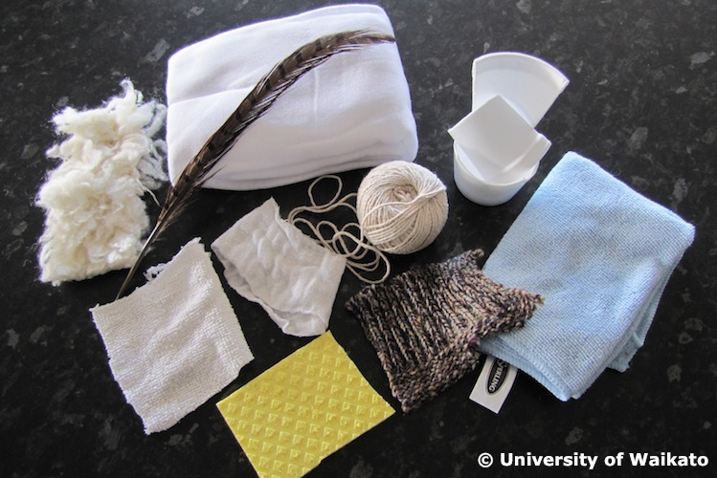
- Water
- Aluminium foil
- Spoon for stirring
- Yellow vegetable oil
- Sorbents cut up into manageable pieces – paper towel, cotton balls or pads, towel rag, polypropylene (old clothing or oil sorbent pads), polyester cloth, kitchen sponge, polystyrene cup, string, cheesecloth or gauze, sheep’s wool or woollen cloth
- Dishwashing detergent
- Bird feathers
- Spray bottle
- Old toothbrush
- Access to the articles Pollution from Rena, Cleaning up the oil spill and Rena bird recovery
- Access to the YouTube clips www.youtube.com/watch?v=rT9HZkzEvRo and www.youtube.com/watch?v=5mW6h0X7uK8
What to do

- Divide the class into groups of about 3–4 and explain that each group will be exploring cleaning up oil from water. They should discuss what they think is happening as they go. Hand out copies of the student handout Cleaning up oil and discuss. What is a sorbent?

- Assist groups of students to gather the equipment they need to conduct the experiments.

- Have students complete steps 1–5 and discuss – why do you think one sorbent might be better than others?

- Watch this experiment on YouTube using a super-absorbent gel (hydrogel) – a super-absorbent polymer used in baby nappies www.youtube.com/watch?v=rT9HZkzEvRo. (You could try the experiment found at http://weirdsciencekids.com/OilspillexperimentPolymer.html.)

- Discuss as a class why polymer products (such as hydrogel, polypropylene, polyester) are effective in cleaning up oil spills. Why is sheep’s wool an effective oil sorbent?

- Have students complete steps 6–8 and discuss.

- As a class, read Cleaning up the oil spill.

- Discuss as a class the pros and cons of leaving oil to disperse naturally and also the use of chemical dispersants.

- Explain that many seabirds are affected in an oil spill. The oil damages their feathers so that they can’t function normally. Have students complete steps 9–12 and discuss.

- As a class, read Rena bird recovery and watch the YouTube clip www.youtube.com/watch?v=5mW6h0X7uK8 and discuss.

Student handout: Cleaning up oil
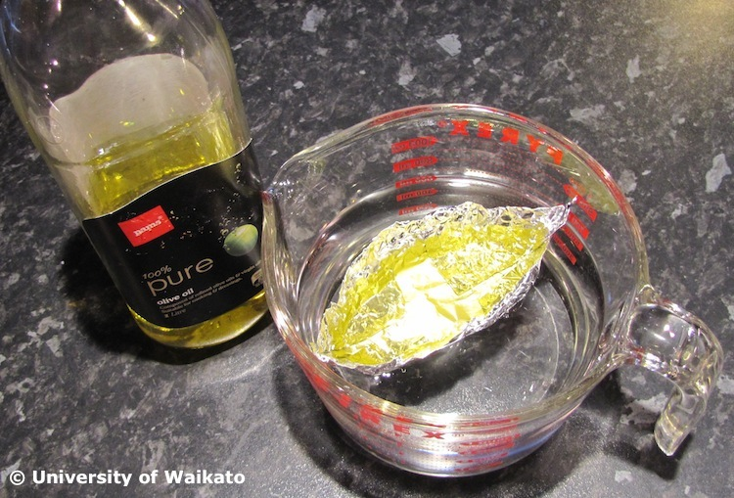
Experimenting with sorbents

- Pour water into a clear bowl or container until it’s about half full.

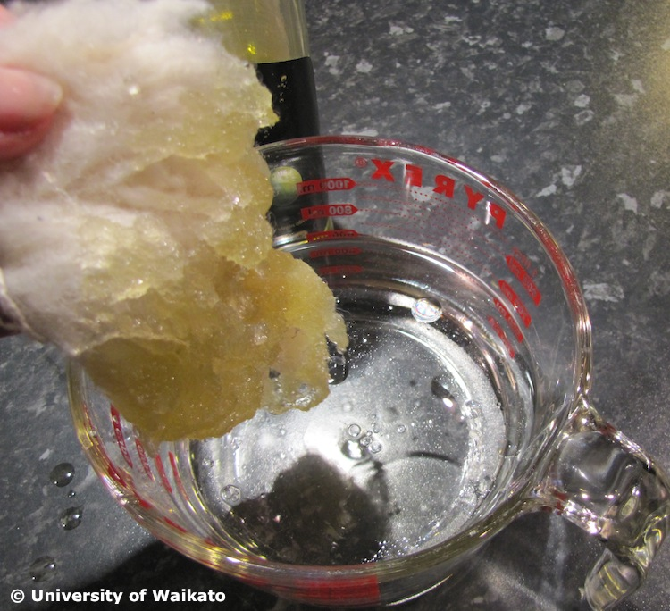
- Simulate an oil spill. Make a small canoe shape with a piece of tinfoil. Fill it with oil and float it on the water. Cause the boat to tip over creating an oil spill.

- Stir up the water and oil. Watch to see what happens. Discuss what you think is happening between the oil and water.

- Predict which sorbent will clean up the oil the best.

- Try all the sorbents to see which one does the best job. (You might need to add some more oil to the water depending on the number of sorbents you are trialling).

Natural and chemical dispersion

- Tip out the water and clean the container. Set up the simulation again and cause an oil spill.

- Try to disperse the oil by ‘wave action’ (agitating the dish around). From your efforts, how long do you think it would take to disperse naturally in the ocean setting? Discuss with your group.

- Add a few drops of dishwashing detergent to the oil spill. Mix it up. What happens? Why?

De-oiling feathers
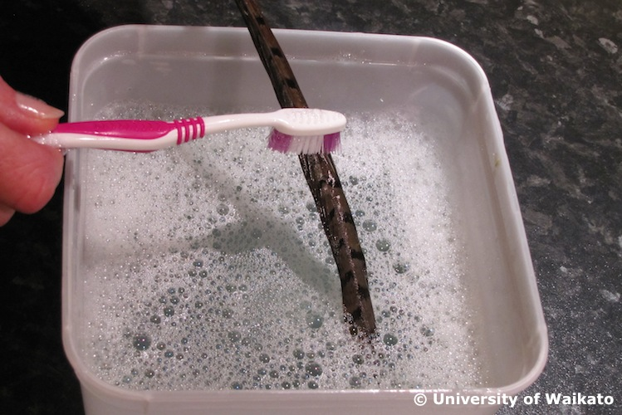
- Fill a spray bottle with water and spray a feather. Note how the feather repels the water.

- Immerse the feather in some vegetable oil. What happens to the feather?

- Spray water onto the feather. What happens?

- Bathe the feather in soapy (detergent added) water, cleaning it carefully with a toothbrush. What happens?

