STUDENT ACTIVITY: Investigating sunscreens

Activity idea

In this activity, students use UV beads to investigate the effectiveness of different sunscreen lotions.

By the end of this activity, students should be able to:
- explain the connection between UV rays from the Sun and sunburn
- explain how our skin can be protected through the use of sunscreen
- explain the Sun protection factor (SPF) and how it relates to different levels of protection.

Introduction/background notes
What you need
What to do
Extension ideas
Student handout: Testing sunscreens

Introduction/background

On Earth, the ozone layer and lower atmosphere help absorb and/or scatter some of the harmful UV rays of the Sun. However, there is still enough radiation to damage our skin and harm our bodies if we are not careful with Sun exposure. One way we can protect our skin from harmful UV radiation is by using sunscreen. Sunscreens work by blocking and/or absorbing some of the UV light.

Different sunscreens provide different levels of protection. The Sun protection factor (SPF) of the sunscreen is given as a number on the bottle. This number, multiplied by 10, gives you an indication of the number of minutes the ‘average’ person can be exposed to the Sun without getting burned. For example, an SPF of 20 provides you with 200 minutes of protection from the Sun’s UV rays. (If we had less ozone, more UV radiation would reach the Earth’s surface, and we would need much more or much stronger sunscreen to protect ourselves from damaging UV rays.)

What you need

For each group:
- 1 x A4 sheet of heavy duty paper or card
- 1 x A4 sheet of OHT or heavy plastic
- Scissors
- A pen
- 8 UV beads – these can be purchased from places such as:
  - www.deltaed.co.nz/product/ultraviolet-detection-beads-pk-250
  - www.kesco.co.nz/product/SER1139926A
  - www.electroflash.co.nz/products/view/603
- 3 different SPF ratings of the same brand of sunscreen
- Blu-Tack/adhesive
- Copies of the student handout Testing sunscreens

What to do

- Hand out copies of the student handout Testing sunscreens and assist students to gather the materials they need, working in small groups. Discuss the results.

Extension ideas

- Follow a similar method using different sunscreens with the same SPF rating to compare the effectiveness of different brands of sunscreen.
- What other kinds of tests could you do? (For example, repeat the test in full shade or on a cloudy day and compare your results with those obtained on a sunny day.)
Student handout: Testing sunscreens

- Use the pen to divide the card into eight sections.

- Use Blu-Tack or adhesive to stick a UV bead to each section.

- Label three sections on the top row and three on the bottom row with the SPF number of the sunscreen you are testing. Use the remaining two sections as controls and label as ‘none’.

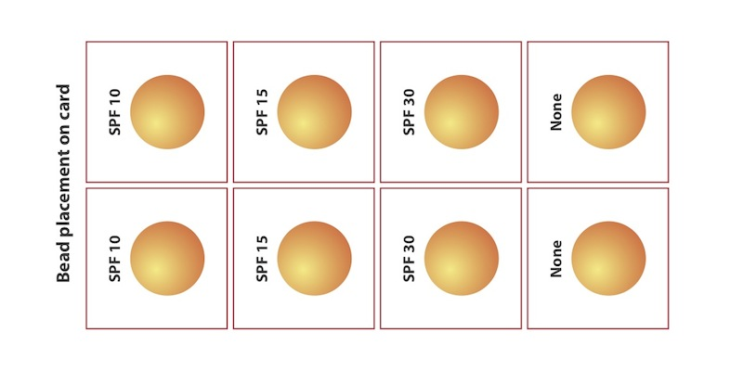

- Fix a UV bead to each section with Blu-Tack or adhesive.

- Either coat six UV beads with the corresponding SPF sunscreen, leaving two beads without sunscreen as controls, or divide the OHT or plastic into eight sections, coat six sections on the plastic with the sunscreen and place the sheet of plastic on top of the card of beads.

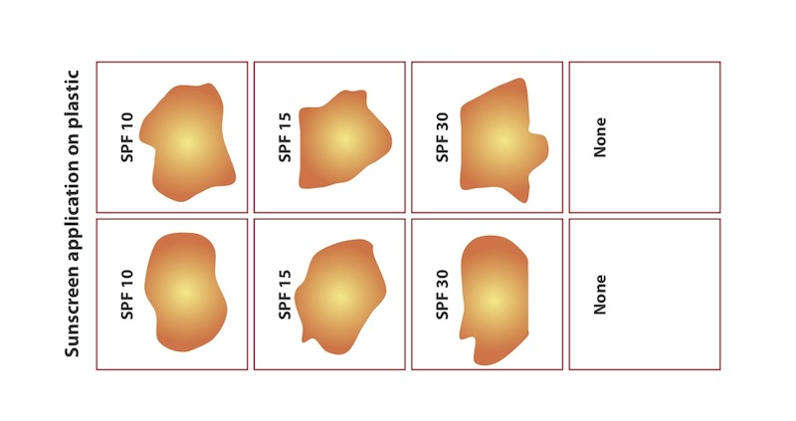
5. Place the UV bead card (and plastic) outside in a very sunny spot.

6. Record your observations.

7. Compare the effectiveness of the different sunscreen SPF ratings.

