ACTIVITY: Investigating UV intensity

Activity idea

In this activity, students use UV beads to investigate the intensity of UV rays in a range of different situations.

By the end of this activity, students should be able to:
- explain that UV rays come from the Sun and can cause sunburn
- demonstrate (through the use of UV beads) that various objects can block UV rays – either partially or completely.

Introduction/background notes
What you need
What to do

Introduction/background

The Sun gives off different kinds of energy including visible light, infrared, ultraviolet light, radio waves, microwaves, X-rays and gamma rays.

Your skin is an excellent detector of UV – it can turn either red (a sunburn) and/or brown (a suntan) when exposed to UV.
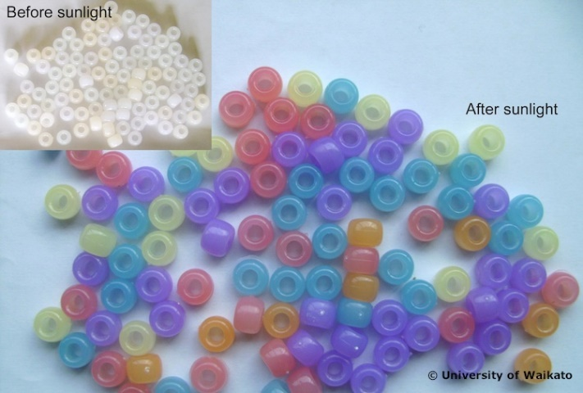
A safer way than using your skin to detect UV is by using UV beads. These plastic beads are a simple tool for measuring UV intensity over time, as they contain a chemical that changes colour when exposed to UV radiation. The more UV there is, the darker the beads become.

For this activity, it is preferable to use beads of one colour only so the colour changes and comparisons are more obvious. Keep the beads in a closed opaque container to prevent UV rays from striking the beads prior to the activity.

What you need

- UV beads – these can be purchased from places such as:
  - www.deltaed.co.nz/product/ultraviolet-detection-beads-pk-250
  - www.kesco.co.nz/product/SER1139926A
  - www.electroflash.co.nz/products/view/603.
- Fluorescent light
- An area of Sun (if carrying out the activity indoors, a sunny windowsill of an open window is fine or use a UV light)
- An area of shade
- String
- Metre ruler
- Bucket of water
- Sunscreen
- Zip-lock bag
- Piece of glass (or a window)
- Sunglasses
- Regular glasses
- Black t-shirt
- White t-shirt
- Wide-brimmed hat
- Access to a tanning booth (if possible)

What to do

- Show students the UV beads and explain that they change colour when exposed to UV light. Explain that you will be testing the beads in a range of environments and have students predict/talk about the following:
- Where do you think the bead will turn the darkest?
- What do you think happens to UV levels on a cloudy day?
- Is the shade really free of UV?
- What will happen to the colour of the beads in the water? Can you get sunburnt while swimming?
- How well will sunglasses and regular glasses protect the beads, and therefore your eyes, from UV?
- Can you get sunburnt sitting next to the window inside a car or building?
- How well does sunscreen protect us from UV?
- Which kind of clothing gives us the best protection from UV?

- Place 2–3 UV beads near a fluorescent light inside.
- Do any beads change colour?
- Can you get sunburn or a tan by sitting next to a fluorescent light?

- Place the beads on the sunny windowsill of a closed window.
- Do any beads change colour?
- Can you get sunburned or tanned sitting next to a closed window in a car or building?

- Take the UV beads to a shady spot outside.
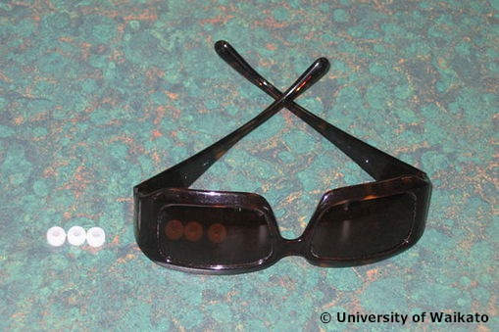
- Do any beads change colour?
- Is there UV radiation in the shade?

- Now place the beads in direct sunlight.
- What do you notice about the intensity of the beads’ colour?

- Place 2–3 beads beneath the glass of a pair of regular prescription glasses and place a second set of 2–3 beads beneath the glass of a pair of sunglasses. Place a third set of 2–3 beads alongside but not beneath any glass.
- What do you observe?

- Tie a UV bead to one end of a piece of string approximately 60 cm long. Mark off the remaining string in 2 cm intervals. Lower the bead 2 cm into water and watch for a colour change. Repeat by lowering the bead 2 cm more each time (using the measurements on the string) until no colour change is observed.
- At what length of string did no colour change occur?
- What can this tell you about how deeply sunlight can penetrate water?
- Can you get sunburned or tanned while swimming outdoors?

- Place 2–3 beads in a zip-lock bag containing a little sunscreen. Close the bag and shake to coat with sunscreen. Make sure the beads are thoroughly coated. Leave the bag in full Sun for 50 minutes. Check the beads every 5 minutes.
- What do you observe?

- Place 2–3 beads beneath a single layer of a dark coloured t-shirt and another 2–3 beads beneath a single layer of a white t-shirt. Leave in full sunlight. Check the beads at 10 minute intervals.
- Is there a difference between the colour changes of the beads beneath the two shirts?
- Which shirt would provide you with better Sun protection?

- We assume that wide-brimmed hats give protection from UV. On a sunny day, preferably with cumulus clouds, have students attach a UV bead as an earring, wear a wide-brimmed hat and ask a partner to observe any colour change of the bead.
- How can you explain your findings?
- What does this indicate about reflecting of UV light?
- How could you relate this to a sport such as skiing?
(Explanation: the beads will still change colour – though to a lesser extent – due to the scattering of UV, particularly by cumulus clouds, and the reflecting of UV light from ground surfaces.)

- If you can, take the beads to a tanning booth and expose them to the UV radiation from the tanning lamps or use a tanning lamp or UV light in the classroom. Safety caution: UV lights and tanning lamps must be used with all due care in classroom situations.
- How does this UV radiation compare to the Sun's UV?

