ACTIVITY: Rock fluorescence

Activity idea

In this activity, students use UVA and UVB light sources to identify certain kinds of materials in rocks.

By the end of this activity, students should be able to:
- explain fluorescence
- use UVA and UVB light sources to identify certain kinds of minerals in rocks.

Introduction/background notes
What you need
What to do
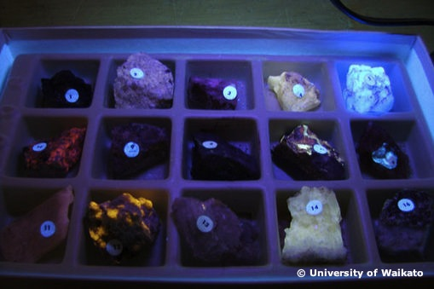
Introduction/background

Not all rocks fluoresce. The rocks shown in the picture are specially selected for their fluorescent properties under either UVA or UVB light.

What you need

- Access to the article UV and fluorescence
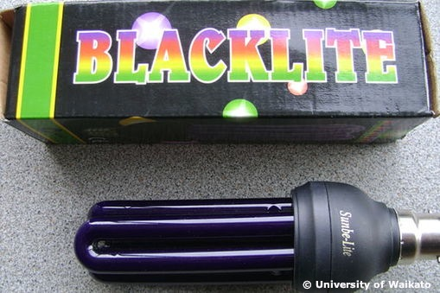
- Variety of rocks (from the school, parent collectors, local rock clubs or a university geology department)
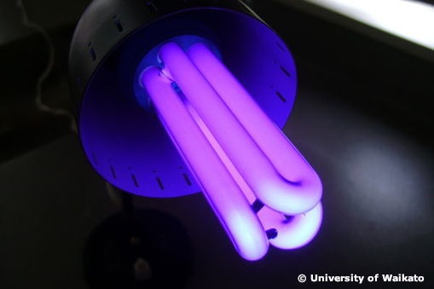
- UV source, for example, from a high school physics department or university geology department; a black light or UV lamp (these can be purchased from a lighting store or electronics store such as Jaycar Electronics); or a UV LED pen (these can purchased from a Nature’s Discoveries store)– the pen’s UVA light output is relatively weak and short range so the investigation would need to be conducted in a dark room

What to do

- As a class, read UV and fluorescence.

- Have students examine the rocks under UVA light (also called long-wave UV) and, if possible, under UVB (short-wave UV).

- Have students identify the colour and patterns of colour of minerals that fluoresce in the rocks and compare them with information and pictures found on this website:
www.wordcraft.net/fluorescent1.html

