ACTIVITY: UV bead items

Activity idea

In this activity, students design and make an item from UV beads that children could easily wear or carry to monitor their exposure to UV.

By the end of this activity, students should be able to:
- explain why people need to be protected from excessive UV
- design and make a UV protector for young children.

Introduction/background notes
What you need
What to do

Introduction/background

New Zealand’s skin cancer rates are among the highest in the world. There is strong evidence that excessive cumulative Sun exposure and incidents of sunburn before 18 years of age leads to increased risk of developing skin cancer later in life. Up to 80% of Sun exposure occurs during childhood. Children in New Zealand schools are generally outside in breaks during the day and for PE activities.

What you need
- UV beads – these can be purchased from places such as:
- www.deltaed.co.nz/product/ultraviolet-detection-beads-pk-250
- www.kesco.co.nz/product/SER1139926A
  - www.electroflash.co.nz/products/view/603
- Thin elastic, bead elastic or string
- Earring hoops (for earrings)
What to do

- Explain to students that they will use UV beads to design and produce an item for a young child to wear to help them be aware of their Sun exposure and to remind them to:
- slip on a shirt
- slop on sunscreen
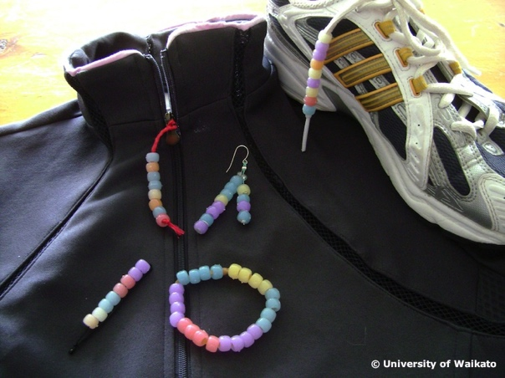
- slap on a hat
- wrap on sunglasses
- slurp water
- seek shade.

- They need to design and make an item children could easily wear or carry. This must be able to be worn in a place exposed to the Sun, such as:
- on a shoelace
- hanging from a belt loop
- as a pin on a t-shirt
- attached to a sweatshirt zip
- a bracelet
- earrings
- cell phone jewellery
- attachment for zipper of backpack
- hair tie.

- Once students have made their UV detector, have them give it to a young child to try out, taking the time to talk with them about minimising their exposure to UV.

