ACTIVITY: Traditional fern collections

Activity idea

In this activity, students collect, press, mount and label ferns to develop a traditional herbarium.

By the end of this activity, students should be able to:
- understand the process used for collecting, pressing, drying and mounting fern fronds
- know what information to include on an identification label
- understand why the documentation is important.

Introduction/background

What you need

What to do

Discussion questions

Extension ideas

Creating a fern herbarium

Introduction/background

A herbarium is a collection of preserved plant specimens. The specimens are usually dried, mounted on sheets and labelled. In some cases, the plants may be dried as a whole (as with fungi) or preserved in alcohol.

The reasons for establishing herbaria are many. Early botanists like Joseph Banks pressed and dried samples of New Zealand plants to preserve them for further study back in England.

Others found they could make money through selling herbaria. Eric Craig and Thomas Cranwell, two Aucklanders, took advantage of the fern craze that swept through Victorian England. They created albums of pressed New Zealand ferns and sent them back to England for sale.

During that era, it was fashionable to own books of pressed ferns for display. These would be similar to our coffee table books today.

Today, herbaria are usually established and maintained to catalogue the flora of an area. Te Papa’s botany department maintains a herbarium of nearly 260,000 dried plant specimens.

Amongst other things, these collections are used to write field guides, to determine the natural distribution of plants and to preserve historical records of change due to human influences.

The 4 main aspects to making good herbarium specimens are:
- collecting
- pressing and preserving
- mounting
- labelling.

Ferns are abundant and essentially 2-dimensional, so they are easy to collect and press. This makes ferns an ideal introduction to this traditional method of plant collection.

Whether this is a whole class activity or a project completed by individual students, the procedure is the same.

Consider where the fronds are to be collected. Never take specimens from DoC reserves or botanic gardens. Ask permission before removing fronds from private land.

What you need

- Access to the video clips The value of early collections and Documenting our fern flora.
- Copies of student instructions: Creating a fern herbarium
Collection:
- Access to fronds from a variety of fern species
- Fern identification book, for example, Which Native Fern? Andrew Crowe. Penguin Books 1994. The New Zealand native ferns PowerPoint is another means of identification.
- Camera (optional)
- GPS, map, or cell phone with GPS capability (optional)
- Notebook and pencil for recording habitat information
- Bags for collecting specimens
- Scissors
Pressing and preserving:
- White A4 paper
- Newspaper
- Corrugated cardboard (roughly A4 size)
- 2 pieces of plywood, wooden lattice, or ceramic tiles (roughly A4 size)
- Luggage strap or string
- Drying cupboard (optional)
- Freezer (optional)
Mounting:
- White A4 card
- Archive box or scrap book to display specimens
Labelling:
- Identification labels (see student instructions)

What to do

- Watch the video clips The value of early collections and Documenting our fern flora. Both videos show examples of collected fern specimens and discuss why collections are valuable.

- Hand out copies of the student instructions and discuss.

- Assist groups of students to select the items required and mount the ferns.

Discussion questions

- Why does the collector need to provide detailed information about where the fern was found?
- Why would it be valuable to have a collection of ferns from your neighbourhood? What information could this give you? Who might be interested in this information?
- Te Papa has over a quarter of a million plants in its botany collection. It is costly to store and maintain such a collection. Why do you think that museums continue to hold on to collections rather than use digital technology to store the information?

Extension ideas

Use the mounted ferns as part of the DIY fern classification activity.

Visit the Te Papa website to view their virtual fern herbarium. Compare your collected fern species to those on the Te Papa site. Are there similarities/differences to where these ferns were collected and their appearance?

Creating a fern herbarium

Collection  - Choose a fern. Use an identification book to find the fern’s name. If possible, photograph the whole plant, an individual frond, the rhizome and the habitat.  - Record these details in your notebook along with a description of the habitat (on a hillside, near a river etc., what other plants are growing around it) and whether the fern is by itself or clustered in a group. If possible, record map coordinates using GPS via a handheld unit or cell phone application and the altitude to the nearest 20 metres. If this is not possible, record where you found the plant as accurately as possible. Cut the frond from the plant. Place it in a bag. Number the bag and your notebook page.  - Continue this process as you collect additional fern species. Each fern should have its own ID number and page in your notebook. Plant specimens without correct identification and accurate labels have little scientific value. |  | 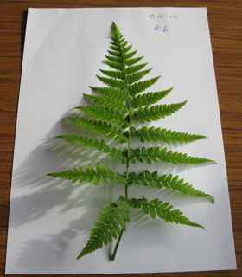
Pressing and preserving  - To press a fern frond, lay down a piece of corrugated cardboard, top it with a piece of newspaper folded into quarters, then a piece of white paper and the fern. If the fern has sori, fold back a section of the frond to display it. Write the fern’s corresponding number on the paper. |  | 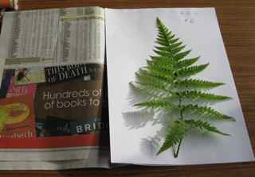
- Cover the fern with paper, newspaper and cardboard. Continue with a second fern, using layers of newspaper and cardboard. (Corrugated cardboard allows air to circulate.) |  | 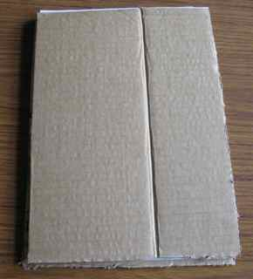
- Place the collection between the plywood, lattice or tiles and secure it with the luggage straps. The collection needs to be tightly pressed.  - Place the fern collection in a dry place such as a drying cupboard or near a heater. The goal is to dry the ferns as quickly as possible to hold their colour. If possible, change the paper or newspaper daily. To test if a fern is dry, hold it up to your lips. If it feels cold, it is not dry yet.  - When a fern specimen is dry, the next step is to place it in a freezer at -20°C. This ensures insect eggs, mould spores or the like are killed. (This step is important for museum collections but can be omitted for school or personal collections.) |  | 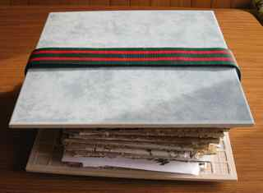
Mounting  - Place the fern on white A4 paper or card. Leave room on the lower right hand side for the identification label. Tape the stipe to the paper. If you need to secure heavier fronds, place thin strips of paper over sections of the frond, taping down the strips, rather than the frond. |  | 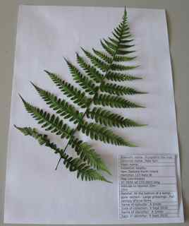
Labelling  - Use your notebook to complete the label. When filling in where the fern was collected, start with the bigger picture and become more precise, i.e. New Zealand, North Island, Hamilton, 123 Rata Street, then give the map coordinates if possible. Glue the label on the lower right hand portion of the page.  - Place the fern in an archive box or scrapbook. Alternatively, create a classroom display. | Scientific name |  | Cyathea dealbata
 | Common name |  | Silver fern
 | Māori name |  | Ponga
 | Collection locality |  | New Zealand, North Island, Hamilton, 123 Rata Street
 | Map coordinates |  | 37.7833 lat. 175.2833 long.
 | Altitude |  | 29m
 | Habitat |  | Damp gully section, upper part of a steep slope. 1 of 3 silver fern trees, emergent part of canopy, ferny undergrowth.
 | Name of collector |  | A Smith
 | Date of collection |  | 25 Nov 2010
 | Name of identifier |  | A Smith
 | Date of identifier |  | 25 Nov 2010

Identification Labels

Scientific name
Common name
Maori name
Collection locality
Map coordinates
Altitude
Habitat
Name of collector
Date of collection
Name of identifier
Date of identification
Scientific name
Common name
Maori name
Collection locality
Map coordinates
Altitude
Habitat
Name of collector
Date of collection
Name of identifier
Date of identification

Scientific name
Common name
Maori name
Collection locality
Map coordinates
Altitude
Habitat
Name of collector
Date of collection
Name of identifier
Date of identification
Scientific name
Common name
Maori name
Collection locality
Map coordinates
Altitude
Habitat
Name of collector
Date of collection
Name of identifier
Date of identification

Scientific name
Common name
Maori name
Collection locality
Map coordinates
Altitude
Habitat
Name of collector
Date of collection
Name of identifier
Date of identification
Scientific name
Common name
Maori name
Collection locality
Map coordinates
Altitude
Habitat
Name of collector
Date of collection
Name of identifier
Date of identification

