**ACTIVITY: Rabbit control**

**Activity idea**

In this activity, students consider the effects of the release of the rabbit haemorrhagic disease virus as a biological control in Otago.

By the end of this activity, students should be able to:

* understand some advantages and disadvantages of biological pest control
* form opinions from written texts
* change their opinions in light of new information
* share their ideas and possibly influence others.

Introduction/background

What you need

What to do

Student handout 1: The use of RHD virus as a biological control

Student handout 2: 5 years on

Student handout 3: 10 years on

**Introduction/background**

New Zealand has a unique native biodiversity, which you will find an introduction to in the article [Biodiversity](https://www.sciencelearn.org.nz/resources/1494-biosecurity). Over the years, this biodiversity has been threatened by the introduction – accidental and intentional – of plants and animals from other countries. Many of these have become pests and need controlling.

Such control can be controversial, the introduction of rabbit haemorrhagic disease (RHD) virus to control rabbits being one example. This activity enables students to consider different aspects of RHD virus use and challenges them to change their views as new information is received.

This activity has three parts, and it is important that you only give students copies of the relevant handouts in the right order.

**What you need**

* Copies of the student handouts The use of RHD virus as a biological control, 5 years on and 10 years on

**What to do**

***Part 1: RHD as a biological control***

1. Divide the class into small groups and give each group a copy of student handout 1: The use of RHD virus as a biological control.
2. After they have read the handout, ask each group to write a list of advantages and disadvantages for using RHD virus as a biocontrol.
3. Compare the answers as a class. Some answers that students might mention:

*Advantages*

* It is very specific for rabbits.
* Once established, it spreads very well naturally and persists in the populations over a number of years.
* It doesn’t cause the animals undue suffering.
* Once established, it doesn’t cost anything.
* A lot less poison is being used.

*Disadvantages*

* It doesn’t kill all the rabbits – 10% survive.
* It doesn’t affect baby rabbits of 8 weeks or younger, and if exposed, these become immune.
* Careful management is needed, as using as a biocide can give rise to an increase in the numbers of immune rabbits.
* Secondary control methods are needed to kill the immune rabbits.

1. As a class, form a continuum line of whether students think RHD should be used as a biocontrol (strongly agree on the left, strongly disagree on the right). Encourage students to give reasons why they choose particular points.

***Part 2: 5 years on***

1. Now give each group a copy of student handout 2: 5 years on.
2. After they have read the handout and discussed it in their groups, form a new continuum line of whether students think RHD should have been used as a biocontrol. Discuss if what happened changed their opinion and in what ways.
3. In groups, discuss and record what students predict will have happened to the rabbit population and the biocontrol system after 10 years has elapsed.

**Part 3: 10 years on**

1. Now give each group a copy of student handout 3: 10 years on.
2. After reading the handout, have students discuss, if they were to go back in time, what their advice would be to the farmers who released the virus. Advice might include:

* The best time to release the virus would be when the rabbits aren’t breeding – there would be fewer rabbits under 8 weeks old, which can become immune.
* It is best not to use baits as this weakens the virus and makes it easier to develop immunity.
* The virus release needs to be followed up with another method of control such as shooting or poisoning to kill any immune rabbits.
* The virus needs to be a pure sample and not contain any less-effective virus that would make the rabbits immune to the lethal strain.

**Student handout 1: The use of RHD virus as a biological control**

***History***

Rabbits were introduced to New Zealand in the 19th century and have reproduced rapidly since then. The population growth of this species has been supported by a favourable climate and large areas of suitable habitats.

Rabbits have had a serious impact both economically and ecologically in New Zealand. The economic impact was the major driving force behind the illegal introduction of rabbit haemorrhagic disease (RHD, previously called rabbit calicivirus) into New Zealand in 1997.

***Costs***

Before the release of RHD, the financial cost of rabbits to New Zealand was estimated at:

* $50 million a year to farm, plant nursery, horticulture, market garden and forestry production
* $25 million a year for the direct costs of destroying rabbits..

***How does the virus kill the rabbits?***

Rabbits are infected via the gut, from where the virus causes the rapid development of blood clots in major organs such as the lungs, heart and kidneys. These clots block blood vessels and quickly result in death from heart and respiratory failure in about 30–40 hours after infection. The rabbits show no distress or bleeding before death. The virus kills around 9 out of 10 infected animals. The virus does not infect hares, but it will infect pet rabbits if exposed.

There are two ways that RHD can be used:

* **As a biocide**, where the aim is to infect as many animalsas possible byspreading large amounts of the virus in an area. This should result in large numbers of rabbit deaths in a short time. A risk is that the virus may not be maintained in the environment, so the remaining immune rabbits can breed to repopulate the area. A large amount of virus would have to be spread again to control rabbit numbers. This pattern would have to continue and is likely to be no more efficient at controlling rabbits than a poison. Eventually, the entire rabbit population will become immune and the virus will no longer work.
* **As a biocontrol**, where a small amount of virus is used to infect a few rabbits. These rabbits then infect other rabbits naturally and spread the virus more slowly. Because the percentage of rabbits infected at any one time is much lower, there is always a pool of virus maintained within the rabbit population. With this method of release of the virus, it should not be necessary to reintroduce the virus at later times.

***How was RHD released in New Zealand?***

The first cases of RHD were found in Otago in the spring of 1997, having presumably been smuggled into the country on dead rabbit carcasses from Australia. The disease was spread by spraying homogenised rabbit organs onto grass and subsequently by moving carcasses of dead animals from place to place. Therefore, the disease was being used as a biocide.

***Immunity***

The major line of defence that rabbits have against RHD is their immune system. Immunity to RHD protects the rabbit from the virus so that immune rabbits will not die from this disease. There are several circumstances that result in immunity rather than disease:

* Young rabbits (less than 8 weeks old) are infected by the virus but do not die, and they develop immunity that will protect them for life.
* Not all adult rabbits die following an infection, and those that don’t (approximately 1 in 10) are then immune to the virus.
* Maternal antibodies temporarily protect rabbits born to immune mothers. If exposed to the RHD virus at this time, these baby rabbits are likely to survive and develop antibodies, which give them lifelong immunity to the disease.
* There may be a non-lethal strain of RHD that was introduced into New Zealand at the same time as the rabbits or the virus. This strain of RHD infects rabbits but does not kill them and results in immunity in the rabbit that protects against the introduced strain of RHD.

**Students handout 2: 5 years on**

Since RHD was released in the spring of 1997, the Otago Regional Council has monitored its impact on Otago’s rabbit population.

5 years after the initial release of RHD in New Zealand, these studies show that:

* rabbit populations have been held at low and stable levels following the initial RHD epidemic in most areas of Otago
* the RHD virus continues to kill rabbits and generally results in two peaks of activity – one in early summer and the other in the autumn
* since the initial epidemic, up-to-date data shows that, where RHD was originally allowed to spread naturally (as a biocontrol) and where landowners have undertaken effective secondary control, low rabbit levels have continued through to 2002
* where higher numbers of rabbits are occurring, typically secondary control, such as shooting or poisoning, has not been effectively undertaken
* if the virus is applied to baits and left exposed to sunlight, inadvertent vaccination of rabbit populations may occur following ingestion of dead virus, with the potential for greater numbers of resistant adults
* high numbers of adults survived exposure to the virus when it was applied as a biocide, suggesting that these rabbits became resistant by eating dead or weakened virus, showing the use of biocide is an unwise practice.

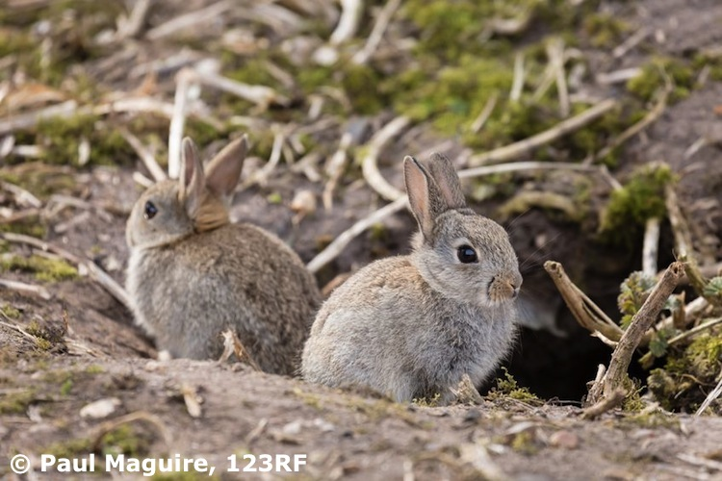

**Student handout 3: 10 years on**

**1080 needed for Mackenzie rabbits**

Station to carry out poisoning programme

By ROB KERR – The Timaru Herald | Saturday 3 May 2008

[http://inl-images.adbureau.net/inl/accipiter/images/AE2.gif](http://inl.adbureau.net/accipiter/adclick/CID=fffffffcfffffffcfffffffc/aamsz=300x600/POS=STORYMIDDLECOLUMN/acc_random=96703224478/pageid=96703224478/site=s/area=s.nznewspapers.timaruherald.localnews)

**Aerial 1080 poisoning is returning to the Mackenzie Basin after a 10-year absence as farmers confront growing rabbit problems.**

Populations of RHD (calicivirus) resistant rabbits are emerging in the high country.

The presence of RHD has removed the need for aerial control for a decade, but this month Sawdon Station will carry out an aerial programme and other stations will follow…

Ecan [Environment Canterbury] southern biosecurity team leader Brent Glentworth said RHD was still effective in some areas and immunity ranged from 35 to 80 percent across populations.

Where the effectiveness of RHD was diminished, populations had reached problem levels, even on par with rabbit numbers before the release of the virus in 1997…

Sue Allan from Sawdon Station said aerial control was a financial burden, but rabbit numbers were affecting stock capacity. The drought had not only increased competition for feed, it had increased rabbit numbers – dry burrows meant increased reproduction.

Haldon Station manager Paddy Boyd said aerial control cost between $40 and $70 a hectare - a major cost when applied to the scale of high country farming…

Both Mr Boyd and Mrs Allen said 10 years of research would have extended RHD usefulness…

Mr Boyd didn’t like returning to 1080, which, in dry conditions, meant land could not be stocked for up to three months. “It’s that dry, we need every bit of land we have got.”…

[Grampians Station farmer Guy King said.] “Rabbits are not just a farmer problem. On erosion grounds, it will just become a desert basin.”

Source: [www.stuff.co.nz/timaru-herald/news/399532/1080-needed-for-Mackenzie-rabbits](http://www.stuff.co.nz/timaru-herald/news/399532/1080-needed-for-Mackenzie-rabbits)

**Additional information**

The government decided against releasing RHD in 1997 because:

* it might infect other animals – kiwi had been shown to develop antibodies to RHD
* it might mutate and increase its host range
* it might mutate and become less effective at killing rabbits while still making them immune to a more lethal strain
* the predators of rabbits might move onto preying on native species
* it was likely that rabbits would eventually become immune and the virus would then be ineffective at controlling numbers
* it wasn’t known whether RHD could infect humans
* if the virus was released at the wrong time, it would be less effective – when the rabbits are breeding and the babies are under 8 weeks, they develop lifelong immunity
* if the virus was released in the wrong way – as a biocide rather than a biocontrol – it would be less effective, but farmers went to Australia to get carcasses and released it anyway.