ACTIVITY: Investigating middens

Activity idea
In this activity, students investigate what historic rubbish dumps (called middens) can reveal about people’s daily lives and the resources they used.

By the end of this activity, students should be able to:
- talk about what ancient middens tell us about past lives
- understand that discarded rubbish can tell us indirectly about the environment
- predict what will happen to today’s rubbish in the future
- extract information from written text.

Introduction/background
What you need
What to do
Extension ideas
Student handout: Questions about middens

Introduction/background

A midden is an historic form of rubbish dump. We can tell a lot about the way people used to live by studying their rubbish. We can also get a good idea of how people used their natural environment – what they ate and gathered, what they made their tools out of and so on. The remains of animals and plants found in middens can also tell us about what the local environment was like in the past. This can give us an idea about how the environment has changed to what it like now.

Remember a midden is defined as an archaeological site. The Heritage New Zealand Act 2014 defines an 'archaeological site' as a place associated with pre-1900 human activity where there may be evidence relating to the history of Aotearoa/New Zealand. It is unlawful to modify or damage an archaeological site and tāngata whenua must be consulted where such sites are culturally significant to Māori.

What you need

- Copies of the student handout Questions about middens
- Access to the article Middens

What to do

- Divide the class into small groups and give them copies of the student handout Questions about middens to work through and write their answers on.

- Discuss some of the questions as a class.

Extension ideas

- Collect some rubbish to represent what we typically throw away nowadays. Use pictures of organic waste rather than the real thing if you wish to avoid the smell.
- Discuss what an archaeologist of the future might learn about us if they found this rubbish preserved. Remember that most organic material does not preserve well, unless under certain special conditions.
- A lot of what we use in our everyday lives does not make it into the rubbish because we recycle it. What sorts of things do you think people recycled in the past (before plastic, for example)?

A more detailed teacher activity resource can be found on the Annenberger Learner website. It is appropriately called Garbage-ology.

Student handout: Questions about middens

Read the information in the article Middens, then answer the following questions:

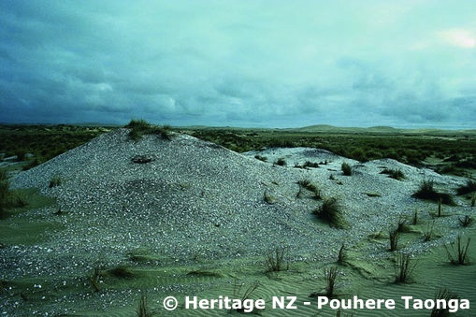
Midden on Ninety Mile Beach, Northland.

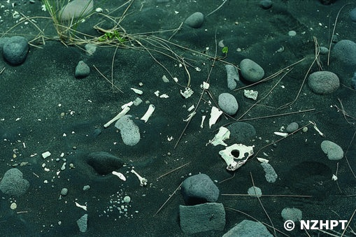
Moa bones excavated from a midden.

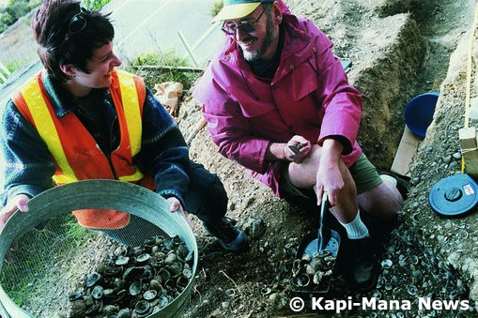
Scientists sieving a midden to determine its contents.

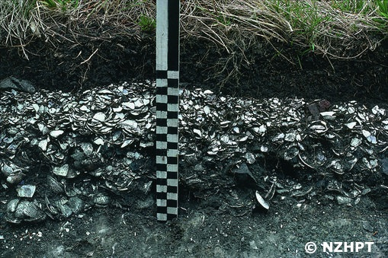
A cut-away section of a midden showing shell layers.
- What is a midden?

- What types of things have been found in Māori middens that have been excavated?

- What are three things a midden can tell us about the past?

- Draw a picture of what you think an ancient Māori midden would have looked like when it was in use.

- What is a modern equivalent of a midden?

- What problems can you think of that we have today with our waste disposal that the people of the past didn’t have?

